24. Prolog Program to Suggest Dieting System Based on Disease
Name:P.Gayathri
Reg.No:192424324

Aim
To write and execute a Prolog program that suggests suitable foods and foods to avoid based on a given disease.
Algorithm
- Start the program.
- Define different diseases in the knowledge base.
- Define recommended foods for each disease.
- Define foods that should be avoided for each disease.
- Create a rule to retrieve the recommended diet.
- Enter the disease as a query.
- Search the knowledge base for the given disease.
- Retrieve the recommended foods and foods to avoid.
- Display the diet recommendation.
- Stop the program.

Code:
% Diet Suggestion Based on Disease

% Diabetes
recommended_food(diabetes, vegetables).
recommended_food(diabetes, whole_grains).
recommended_food(diabetes, fruits).

avoid_food(diabetes, sweets).
avoid_food(diabetes, sugary_drinks).
avoid_food(diabetes, junk_food).

% Hypertension
recommended_food(hypertension, vegetables).
recommended_food(hypertension, fruits).
recommended_food(hypertension, whole_grains).

avoid_food(hypertension, salty_foods).
avoid_food(hypertension, processed_foods).
avoid_food(hypertension, junk_food).

% Anemia
recommended_food(anemia, spinach).
recommended_food(anemia, beans).
recommended_food(anemia, lentils).

avoid_food(anemia, tea).
avoid_food(anemia, coffee).
avoid_food(anemia, junk_food).

% Rule to suggest diet
suggest_diet(Disease, Food) :-
recommended_food(Disease, Food).

% Rule to find foods to avoid
suggest_avoid(Disease, Food) :-
avoid_food(Disease, Food).
Input:
?- suggest_diet(anemia).
OUTPUT:
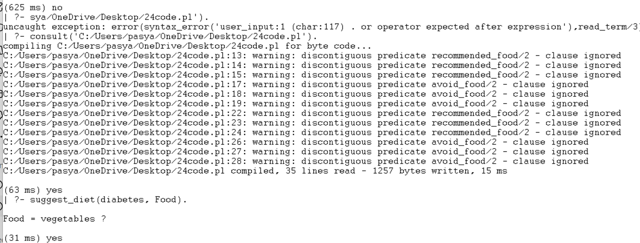

RESULT:
Thus, the Prolog program for suggesting a dieting system based on disease was successfully implemented and executed, and the recommended foods and foods to avoid were obtained for the given disease.

