SIMATS ENGINEERING
ASSESSMENT TOOL 1: Design Task
COURSE NAME: | ARTIFICIAL INTELLIGENCE | COURSE CODE: | CSA17
Name:Gayathri.P
Reg no:192424324

COURSE OUTCOME COVERED

CO5: Design AI-based systems using PySpark, RDD operations, and intelligent agent architectures, using scalable systems and integrate components in distributed AI applications.(BTL 5)

Assessment Tool Weightage: 50%
Code of Conduct:

I Gayathri.P(192424324) (Name / Reg No) certify that this submission is my original work and that I have adhered to the guidelines specified for this assessment.I understand that any violation of academic integrity rules will result in disciplinary action.
Signature of the student:
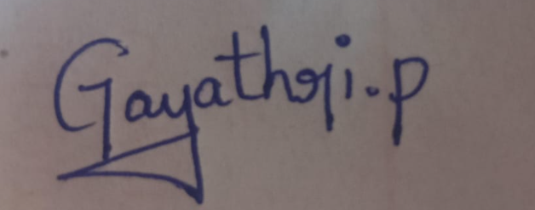
Total Marks: 100
Each question carries equal marks.

1. End-to-End System Design
Design a scalable AI-based system using PySpark and RDD operations to analyze real-time social media data and generate intelligent recommendations, including system architecture, data flow, and agent integration.

2. Distributed Intelligent Agent System
Develop a multi-agent AI system architecture that uses PySpark for distributed data processing and enables agents to collaborate in solving a large-scale optimization problem.

3. Big Data AI Pipeline Design
Design a complete distributed AI pipeline using RDD transformations for data preprocessing, feature engineering, and model training, ensuring scalability and fault tolerance.

4. Real-Time Decision-Making System
Construct an AI-based system integrating RDD-based streaming data processing with intelligent agents for real-time decision-making in applications such as smart traffic or healthcare.

5. Cloud-Based Distributed AI Application
Design a cloud-enabled AI system using PySpark and intelligent agent architectures that supports large-scale data analytics, dynamic resource allocation, and adaptive learning.
RUBRICSFORCALCULATION:

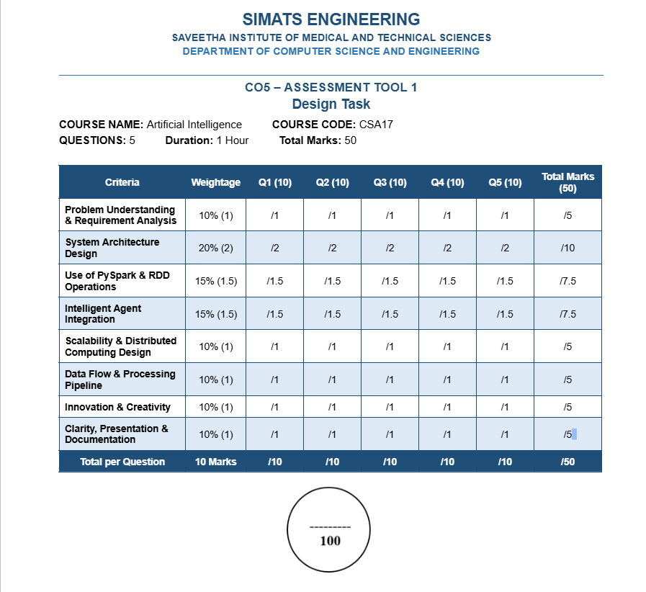

ANSWERS
1) 1. END-TO-END SYSTEM DESIGN
Problem Understanding
The objective is to design a scalable AI system that collects real-time social media data, processes it using PySpark RDD operations, analyzes user behavior and sentiment, and generates intelligent recommendations through an AI agent.
Objectives
- Collect large volumes of social media posts in real time.
- Clean and preprocess the incoming data.
- Use PySpark RDD transformations and actions for distributed processing.
- Extract useful features such as keywords, sentiment, topics, and user interests.
- Generate personalized recommendations.
- Integrate an intelligent recommendation agent.
- Provide scalability and fault tolerance.
Step-by-Step System Design
Step 1: Data Collection
Social media posts, comments, likes, shares, and user interactions are collected continuously.
Step 2: Data Ingestion
The incoming records are divided into small batches/streams and sent to the distributed processing layer.
Step 3: RDD Creation
PySpark creates RDDs from the incoming data so that the data can be processed in parallel across worker nodes.
Step 4: Data Preprocessing
RDD transformations such as map(), filter(), flatMap(), and distinct() are used to remove invalid records, tokenize text, and prepare clean data.
Step 5: Feature Engineering
The system extracts keywords, hashtags, sentiment scores, topics, and interaction features from the processed records.
Step 6: Distributed Analysis
RDD operations calculate trends, popular topics, user interests, and engagement patterns across multiple worker nodes.
Step 7: Intelligent Agent
A Recommendation Agent receives the processed features and decides which content or products are most relevant to a user.
Step 8: Recommendation Generation
The agent ranks candidate items according to user interests, recent activity, sentiment, and popularity.
Step 9: Feedback
User clicks, likes, skips, and shares are collected as feedback and used for adaptive improvement.
Architecture
Social Media Sources → Data Ingestion → PySpark Driver → RDD Processing → Feature Engineering → Recommendation Agent → Recommendation Output → User Feedback → Processing Layer
PySpark RDD Operations
- map() – transforms each record.
- filter() – removes unwanted records.
- flatMap() – creates multiple output elements from one input record.
- reduceByKey() – aggregates values with the same key.
- groupByKey() – groups records by key.
- distinct() – removes duplicate records.
- count() – counts records.
- collect() – returns results to the driver for small result sets.
Agent Logic
Rule 1:
IF the user has shown interest in a topic
AND the topic is currently trending
THEN increase its recommendation score.
Rule 2:
IF sentiment is negative
THEN reduce similar negative-content recommendations.
Rule 3:
IF the user repeatedly interacts with an item category
THEN increase the priority of that category.
Scalability and Fault Tolerance
RDDs provide distributed processing and can recover lost partitions through lineage. The system can add worker nodes when data volume increases. Partitioning allows several tasks to run in parallel.
Expected Result
The proposed system continuously analyzes large-scale social media data and produces personalized recommendations using distributed PySpark processing and an intelligent recommendation agent.

2. DISTRIBUTED INTELLIGENT AGENT SYSTEM
Problem Understanding
The objective is to build a multi-agent AI architecture in which several intelligent agents cooperate to solve a large-scale optimization problem while PySpark performs distributed data processing.
Example Optimization Problem
A smart delivery company needs to assign delivery vehicles to customers while minimizing total travel distance and delivery time.
Agents
- Data Agent – collects and prepares delivery data.
- Route Agent – evaluates possible routes.
- Resource Agent – checks vehicle and driver availability.
- Optimization Agent – searches for a low-cost assignment.
- Coordinator Agent – combines results and selects the final solution.
Step-by-Step Design
Step 1: Collect Data
Customer locations, vehicle capacities, delivery deadlines, and road information are collected.
Step 2: Create RDD
The large dataset is converted into distributed RDD partitions.
Step 3: Parallel Processing
Different worker nodes calculate route costs, travel times, and capacity constraints in parallel.
Step 4: Route Agent Processing
The Route Agent evaluates possible routes and produces candidate route costs.
Step 5: Resource Agent Processing
The Resource Agent checks whether vehicles and drivers are available for each candidate assignment.
Step 6: Optimization Agent
The Optimization Agent compares feasible solutions and searches for the solution with minimum cost.
Step 7: Collaboration
Agents exchange intermediate results through the Coordinator Agent.
Step 8: Final Decision
The Coordinator Agent selects the best feasible assignment and sends it to the application.
PySpark Operations
- map() can calculate the cost of each route.
- filter() can remove routes that violate constraints.
- reduceByKey() can identify the minimum cost for each delivery group.
- groupByKey() can organize candidate solutions by vehicle or region.
Agent Collaboration
Data Agent → Route Agent → Resource Agent → Optimization Agent → Coordinator Agent → Final Solution
Scalability
The optimization problem is divided into partitions. Multiple workers evaluate different candidate solutions simultaneously. More worker nodes can be added when the problem size increases.
Fault Tolerance
RDD lineage allows lost partitions to be recomputed. Independent agent tasks can also be restarted without rebuilding the entire system.
Expected Result
The multi-agent system cooperatively solves a large optimization problem while PySpark distributes computation across the cluster.

3. BIG DATA AI PIPELINE DESIGN
Objective
Design a complete distributed AI pipeline that uses RDD transformations for preprocessing, feature engineering, and model-training preparation while maintaining scalability and fault tolerance.
Step-by-Step Pipeline
Step 1: Data Collection
Collect large datasets from files, applications, sensors, or online sources.
Step 2: Data Loading
Load the data into the distributed processing environment and create RDDs.
Step 3: Data Cleaning
Use filter() to remove null, invalid, or corrupted records.
Step 4: Transformation
Use map() to convert raw records into a standard structure.
Step 5: Tokenization/Expansion
Use flatMap() when one record must produce multiple features, such as words or events.
Step 6: Duplicate Removal
Use distinct() to eliminate duplicate records.
Step 7: Feature Engineering
Generate numerical and categorical features such as frequency, average activity, keyword counts, or behavioral scores.
Step 8: Aggregation
Use reduceByKey() to calculate totals, averages, frequencies, or other grouped statistics.
Step 9: Dataset Preparation
The processed features are organized into training and testing data.
Step 10: Model Training
The prepared data is supplied to a distributed AI/ML training process.
Step 11: Evaluation
The trained model is evaluated using suitable performance measures.
Step 12: Deployment
The final model is connected to the application or intelligent agent for prediction.
Pipeline
Raw Data → RDD Creation → Cleaning → Transformation → Feature Engineering → Aggregation → Training Data → Model Training → Evaluation → AI Agent → Prediction
Important RDD Transformations
- map()
- filter()
- flatMap()
- distinct()
- reduceByKey()
- groupByKey()
Important Actions
- count()
- collect()
- first()
- reduce()
Scalability
RDD partitions allow processing to occur on several worker nodes at the same time.
Fault Tolerance
RDD lineage records how each RDD was produced. If a partition is lost, Spark can recompute it from the required lineage.
Expected Result
The pipeline efficiently converts large raw datasets into useful AI features and supports scalable model development with distributed processing and fault tolerance.

4. REAL-TIME DECISION-MAKING SYSTEM
Objective
Construct an AI-based real-time decision-making system that combines distributed stream processing with intelligent agents. A smart traffic management system is used as the example.
Step-by-Step Design
Step 1: Sensor Data Collection
Traffic cameras, road sensors, GPS devices, and signal controllers generate traffic data.
Step 2: Real-Time Data Ingestion
Traffic records are continuously received by the processing system.
Step 3: Distributed Processing
Incoming data is divided into partitions and processed in parallel.
Step 4: RDD-Based Processing
RDD operations clean records, calculate vehicle counts, identify congestion, and summarize traffic conditions.
Step 5: Feature Extraction
The system derives features such as:
- Vehicle density
- Average speed
- Queue length
- Congestion level
Step 6: Traffic Agent
The Traffic Management Agent evaluates current conditions.
Step 7: Decision Rules
Rule 1:
IF vehicle density is high
AND average speed is low
THEN classify the road as congested.
Rule 2:
IF congestion is detected
THEN increase green-signal duration on the affected route within permitted limits.
Step 8: Coordination
The agent communicates the recommended signal changes to the traffic control system.
Step 9: Feedback
New sensor observations are processed to determine whether congestion has reduced.
Data Flow
Traffic Sensors → Real-Time Ingestion → PySpark Processing → RDD Transformations → Traffic Features → Intelligent Traffic Agent → Signal Decision → Traffic Network → New Sensor Data
Example RDD Processing
- filter() removes invalid sensor readings.
- map() converts raw readings into structured traffic records.
- reduceByKey() aggregates vehicle counts by road.
- groupByKey() groups observations by intersection.
Advantages
- Fast distributed processing.
- Real-time decision support.
- Intelligent response to changing traffic.
- Fault-tolerant distributed computation.
- Scalable for many roads and intersections.
Expected Result
The system continuously monitors traffic conditions and allows the intelligent agent to make timely decisions for congestion management.

5. CLOUD-BASED DISTRIBUTED AI APPLICATION
Objective
Design a cloud-enabled AI system using PySpark and intelligent agents for large-scale analytics, dynamic resource allocation, and adaptive learning.
Example
A cloud-based smart campus system that analyzes student activity and dynamically allocates computing resources for AI applications.
Step-by-Step Design
Step 1: Data Collection
Collect application usage, workload, user activity, and system performance data.
Step 2: Cloud Data Storage
Store large-scale data in distributed cloud storage.
Step 3: PySpark Processing
PySpark processes the data across multiple worker nodes.
Step 4: RDD Creation
Raw records are converted into RDDs for distributed computation.
Step 5: Data Preprocessing
filter(), map(), and flatMap() prepare clean and structured records.
Step 6: Feature Engineering
Generate:
- CPU usage
- Memory demand
- Request rate
- Workload type
- Historical usage features
Step 7: Resource Allocation Agent
The agent monitors demand and decides how many resources are required.
Step 8: Dynamic Allocation
When workload increases, additional cloud resources are requested. When workload decreases, unnecessary resources can be released.
Step 9: Adaptive Learning Agent
The agent studies previous workload patterns and improves future allocation decisions.
Step 10: Monitoring and Feedback
The system continuously monitors performance and feeds new observations back into the learning process.
Architecture
Users/Applications → Cloud Data Sources → Distributed Storage → PySpark Cluster → RDD Processing → Feature Engineering → Resource Allocation Agent → Cloud Resource Manager → Applications
PySpark RDD Use
- map() – transforms workload records.
- filter() – removes invalid monitoring records.
- reduceByKey() – aggregates resource usage.
- groupByKey() – organizes workloads by application.
- count() – calculates workload volume.
Scalability
Cloud resources can be increased or decreased according to demand. PySpark distributes computation across worker nodes.
Fault Tolerance
RDD lineage supports recovery of lost partitions, while distributed cloud services can restart failed processing tasks.
Adaptive Learning
The system stores previous decisions and outcomes. The agent compares predicted resource demand with actual demand and improves future allocation.
Expected Result
The cloud-based AI application provides scalable analytics, intelligent resource allocation, and adaptive behavior while efficiently processing large datasets.

