SIMATS ENGINEERING
ASSESSMENT TOOL 2: Reverse Engineering
COURSE NAME: | ARTIFICIAL  INTELLIGENCE | COURSE CODE: | CSA17
NAME:Gayathri.P
Reg no:192424324

Assessment Tool Weightage: 30%

Code of Conduct:

I _Gayathri.P(192424324) (Name / Reg No) certify that this submission is my original work and that I have adhered to the guidelines specified for this assessment.
I understand that any violation of academic integrity rules will result in disciplinary action.

Signature of the student:
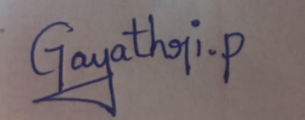

1. System Decomposition & Analysis
Analyze an existing AI-based system and reverse engineer its architecture, identifying key components, data flow, and underlying algorithms.

2. Architecture Reconstruction
Given a black-box software system, reconstruct its system architecture and explain the interaction between modules using appropriate diagrams.

3. Algorithm Identification
Reverse engineer a machine learning application to identify the algorithms, data processing steps, and decision-making logic used in the system.

4. Data Flow & Process Mapping
Examine an existing distributed AI application and map its data flow, processing pipeline, and communication between components.

5. Improvement & Redesign
Perform reverse engineering on an intelligent system and propose enhancements or redesign strategies to improve scalability, efficiency, and performance.

RUBRICS FOR CALCULATION:

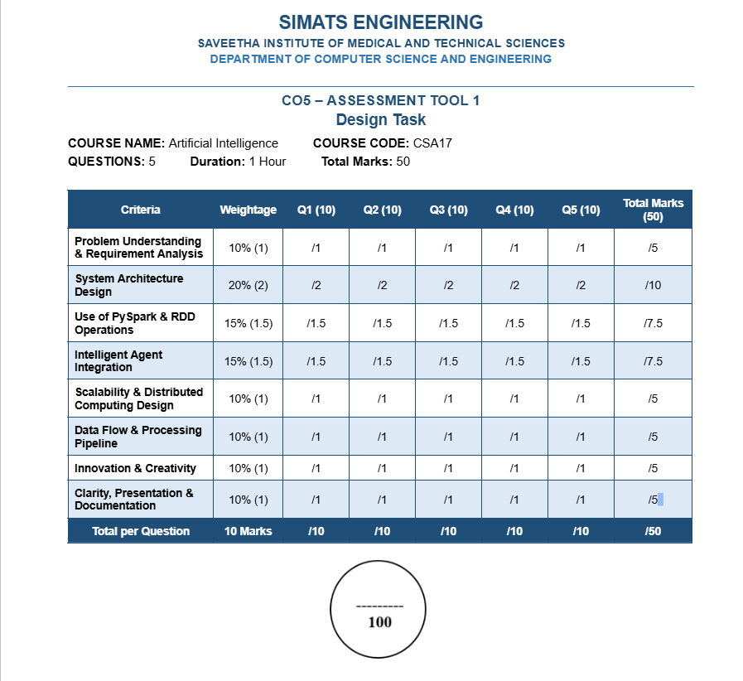

ANSWERS
1. SYSTEM DECOMPOSITION & ANALYSIS
Introduction
System decomposition is the process of breaking an existing AI system into smaller components so that its functionality, data flow, algorithms, and interactions can be understood.
For this analysis, consider an AI-Based Image Classification System that identifies whether an uploaded image belongs to a particular category.
Objective
The main objectives are:
- Understand the purpose of the AI system.
- Identify the major components.
- Understand how data moves through the system.
- Identify the machine learning algorithm.
- Understand how the final prediction is generated.
- Identify possible improvements.
Step-by-Step Reverse Engineering
Step 1: Identify the Input
The system receives an image from the user.
Input:
Image → JPG/PNG image file
The image may contain an object, person, animal, medical image, or other visual information.

Step 2: Input Processing
The uploaded image is passed to the preprocessing module.
The preprocessing module performs operations such as:
- Image resizing
- Normalization
- Noise reduction
- Pixel conversion
- Format conversion
For example:
Original Image → Resize → Normalize → Processed Image
Step 3: Feature Extraction
The processed image is given to the AI model.
A neural network extracts important features such as:
- Edges
- Shapes
- Textures
- Patterns
- Object structures
In a deep-learning image classifier, a Convolutional Neural Network (CNN) can perform feature extraction.

Step 4: Model Prediction
The extracted features are passed through the trained classification model.
The model calculates probabilities for different classes.
Example:
Class | Probability
Cat | 0.10
Dog | 0.82
Bird | 0.08
The class with the highest probability is selected.
Therefore:
Prediction = Dog
Step 5: Decision Module
The decision module examines the model output and selects the final classification.
For example:
IF probability of Dog > probability of Cat and Bird
THEN classify image as Dog.

Step 6: Output
The final result is displayed to the user.
Input Image → AI Model → Prediction → Output

System Components
The major components are:
- User Interface
  - Accepts image from the user.
- Input Handler
  - Receives and validates the uploaded image.
- Preprocessing Module
  - Resizes and normalizes the image.
- Feature Extraction Module
  - Extracts important visual features.
- AI Model
  - Performs classification.
- Decision Module
  - Selects the highest-probability class.
- Output Module
  - Displays the prediction.

Architecture
User
↓
Image Upload Interface
↓
Input Validation
↓
Image Preprocessing
↓
Feature Extraction
↓
Trained CNN Model
↓
Prediction/Decision Module
↓
Classification Result

Underlying AI Algorithm
A suitable underlying algorithm is a Convolutional Neural Network (CNN).
The basic CNN process is:
Input Image → Convolution → Activation → Pooling → Fully Connected Layer → Softmax → Prediction
Convolution
The convolution layer identifies visual features such as edges and shapes.
Activation
An activation function such as ReLU introduces non-linearity.
Pooling
Pooling reduces the size of feature maps while retaining important information.
Fully Connected Layer
The extracted features are combined for classification.
Softmax
Softmax converts the model output into class probabilities.

Reverse Engineering Findings
After decomposing the system, we can determine:
- What the input is.
- How the input is processed.
- Where feature extraction occurs.
- Which AI model performs prediction.
- How the final decision is generated.
- How the result is returned to the user.
Conclusion
System decomposition helps us understand an existing AI system without necessarily having access to its original internal design. By analyzing inputs, processing modules, model behavior, and outputs, the overall architecture and AI decision process can be reconstructed.

2. ARCHITECTURE RECONSTRUCTION
Introduction
A black-box AI system is a system where the internal implementation is not directly visible. We can observe its inputs and outputs and study its behavior to reconstruct its architecture.
Consider a Black-Box AI Recommendation System.
Objective
The objective is to identify:
- Input components.
- Processing modules.
- AI model.
- Database.
- Recommendation logic.
- Output components.
- Communication between modules.
Step-by-Step Architecture Reconstruction
Step 1: Identify Inputs
The system receives:
- User ID
- Search history
- Previous purchases
- Ratings
- Clicks
- Viewed products
Step 2: Identify Data Storage
The collected information is stored in a database.
Example:
User Data → User Database
Step 3: Data Processing
The processing module analyzes user behavior.
It calculates:
- Frequently viewed products
- Frequently purchased categories
- User preferences
- Product popularity

Step 4: Feature Generation
Important features are extracted from the user data.
Example:
User ID → Purchase History → Preferred Category → Recommendation Features
Step 5: AI Recommendation Model
The recommendation model receives the generated features and calculates suitable recommendations.
Possible techniques include:
- Collaborative filtering
- Content-based filtering
- Hybrid recommendation
- Machine learning ranking

Step 6: Ranking
Candidate products are ranked according to their recommendation scores.
Example:
Product | Score
Laptop | 0.92
Mobile | 0.75
Headphones | 0.61
The laptop receives the highest score.

Step 7: Output
The recommended products are displayed to the user.

Reconstructed Architecture
User
↓
Web/Mobile Interface
↓
API Layer
↓
User Data Processing
↓
Feature Extraction
↓
AI Recommendation Model
↓
Ranking Module
↓
Recommendation Database/Cache
↓
User Interface
The database supports the processing modules by providing historical user and product information.

Module Interaction
User Interface → API
The user sends requests through the application.
API → Processing Module
The API forwards the user information to the processing system.
Processing → Database
The processing module retrieves historical information.
Processing → AI Model
The extracted features are given to the AI model.
AI Model → Ranking
The model generates recommendation scores.
Ranking → User Interface
The highest-ranked recommendations are returned to the user.

Reverse Engineering Diagram
User
↓
Application Interface
↓
API Gateway
↓
Data Processing Module
↙ ↘
User Database Feature Extraction
↓
AI Model
↓
Ranking Module
↓
Recommendation
↓
User

Conclusion
Architecture reconstruction helps us understand how an unknown AI application is internally organized. By observing inputs, outputs, database interactions, processing behavior, and model responses, the major modules and their communication paths can be reconstructed.

3. ALGORITHM IDENTIFICATION
Introduction
Algorithm identification is the process of determining which machine learning algorithm is being used by studying the system's input, output, behavior, processing steps, and decision patterns.
Consider an AI-Based Customer Classification System that predicts whether a customer is likely to purchase a product.

Step-by-Step Analysis
Step 1: Identify Input Data
The system may use:
- Customer age
- Income
- Previous purchases
- Website visits
- Product views
- Previous responses

Step 2: Data Preprocessing
The input data is cleaned.
The system may perform:
- Missing-value handling.
- Duplicate removal.
- Data normalization.
- Categorical-value encoding.
- Outlier handling.

Step 3: Feature Selection
Important features are selected.
For example:
Income + Previous Purchases + Website Visits → Prediction Features

Step 4: Model Identification
Suppose the system produces a binary output:
- Yes
- No
A possible algorithm is Logistic Regression.
However, algorithm identification should be based on observed system behavior and available evidence. If only input/output behavior is available, the exact algorithm cannot always be determined with certainty.

Logistic Regression Logic
The model calculates a probability:
P(Y = 1) = 1 / (1 + e⁻ᶻ)
where:
z = b₀ + b₁X₁ + b₂X₂ + ... + bₙXₙ
The probability is compared with a threshold.
Example:
Probability = 0.82
If threshold = 0.50:
0.82 > 0.50
Therefore:
Prediction = Purchase

Decision-Making Logic
The system can be represented as:
Customer Data
↓
Preprocessing
↓
Feature Extraction
↓
ML Model
↓
Probability Calculation
↓
Threshold Comparison
↓
Final Decision

Example
Suppose the model receives:
- Age = 25
- Income = High
- Previous Purchase = Yes
- Website Visits = 10
The model calculates:
Purchase Probability = 0.86
Since:
0.86 > 0.50
The system predicts:
Customer is likely to purchase.

Techniques Used for Algorithm Identification
During reverse engineering, the following can be examined:
1. Input and Output
Determine whether the task is:
- Classification
- Regression
- Clustering
- Recommendation
- Prediction
2. Model Behavior
Observe how predictions change when input values are changed.
3. Feature Processing
Examine whether the system performs:
- Scaling
- Encoding
- Feature selection
- Dimensionality reduction
4. Decision Rules
Analyze thresholds, probability values, and classification boundaries.
5. Model Metadata
If available, inspect:
- Model files
- Configuration files
- Logs
- API responses
- Model parameters
Conclusion
Algorithm identification helps determine the underlying machine learning technique and decision-making process of an existing AI application. However, black-box behavior alone may not uniquely identify the exact algorithm; additional evidence such as model metadata or implementation artifacts may be required.

4. DATA FLOW & PROCESS MAPPING
Introduction
A distributed AI application processes large amounts of data across multiple computers or worker nodes.
Consider a Distributed AI Healthcare Prediction System that predicts the risk of a disease from patient records.
Objective
The system should:
- Collect patient data.
- Process large datasets.
- Distribute computation.
- Extract features.
- Apply an AI model.
- Generate predictions.
- Return results to the application.
Step-by-Step Data Flow
Step 1: Data Collection
Patient information is collected from healthcare systems.
Example data:
- Age
- Blood pressure
- Glucose level
- Weight
- Medical history
- Laboratory results
Step 2: Data Storage
The collected data is stored in distributed storage.
Patient Data → Distributed Database/Storag
Step 3: Data Ingestion
The data is loaded into the distributed processing environment
Step 4: Data Preprocessing
The system performs:
- Missing-value handling
- Duplicate removal
- Data normalization
- Invalid-record removal
Step 5: Distributed Processing
The dataset is divided into partitions.
Each worker node processes a portion of the data.
Example:
Large Dataset
↓
Partition 1 → Worker 1
Partition 2 → Worker 2
Partition 3 → Worker 3
Partition 4 → Worker
Step 6: Feature Engineering
The system creates useful features from the patient information.
Example:
Age + Glucose + Blood Pressure + BMI → Feature Vector
Step 7: AI Model
The processed features are provided to the trained AI model.
The model predicts the disease-risk category.
Step 8: Result Aggregation
The outputs from different processing tasks are combined.
Step 9: Decision Support
The prediction is sent to the healthcare application for decision support.
Data Flow Diagram
Patient Data
↓
Data Collection
↓
Distributed Storage
↓
Data Ingestion
↓
PySpark/Distributed Processing
↓
Data Cleaning
↓
Feature Engineering
↓
AI Prediction Model
↓
Prediction Result
↓
Healthcare Application

Communication Between Components
Data Source → Storage
Patient records are transferred to distributed storage.
Storage → Processing Cluster
The processing cluster reads the stored records.
Driver → Worker Nodes
The driver distributes processing tasks among worker nodes.
Worker Nodes → Driver
Workers return processed results.
Driver → AI Model
The processed dataset is provided to the prediction stage.
AI Model → Application
The prediction is returned to the healthcare application.
Distributed Processing Advantage
Distributed processing allows large datasets to be divided into smaller partitions.
Therefore:
Large Data → Multiple Partitions → Multiple Workers → Parallel Processing → Combined Result
This reduces processing time and improves scalability.
Conclusion
Data-flow mapping helps reverse engineers understand how information moves through a distributed AI system. It identifies data sources, processing stages, worker nodes, AI models, communication paths, and final outputs.

5. IMPROVEMENT & REDESIGN

Introduction
After reverse engineering an intelligent system, weaknesses in its architecture, data processing, AI model, and resource usage can be identified.
Consider an existing AI Recommendation System that becomes slow when the number of users and products increases.

Existing System
The existing architecture is:
User → Application → Database → Recommendation Model → Recommendation → User
The system works correctly for a small number of users but becomes slow under heavy load.

Problems Identified
Problem 1: Centralized Processing
All data is processed by a single server.
Effect:
- Slow processing
- High CPU usage
- Poor scalability

Problem 2: Large Database Queries
The recommendation system repeatedly reads large amounts of historical data.
Effect:
- Increased response time
- Database overload

Problem 3: Repeated Model Computation
Recommendations are calculated repeatedly for the same users.
Effect:
- Unnecessary computation
- Increased resource usage
Problem 4: Poor Fault Tolerance
If the main processing server fails, the recommendation service may become unavailable.
Problem 5: Limited Adaptability
The model may not quickly adapt to changing user preferences.
Proposed Redesign
Step 1: Distributed Data Processing
Use a distributed processing framework such as PySpark.
Instead of:
One Server → Process Everything
Use:
Driver → Worker 1 + Worker 2 + Worker 3 + Worker 4
This allows parallel processing.

Step 2: Use RDD/Data Partitioning
Large datasets are divided into partitions.
For example:
User Dataset
↓
Partition 1 → Worker 1
Partition 2 → Worker 2
Partition 3 → Worker 3
Partition 4 → Worker 4
This improves processing efficiency.

Step 3: Feature Engineering
Generate useful user features such as:
- Frequently purchased categories
- Recently viewed products
- Average purchase value
- Product interaction frequency
- User preferences
These features are provided to the recommendation model.

Step 4: Intelligent Recommendation Agent
Introduce an intelligent agent that makes recommendation decisions.
Agent Logic
IF user frequently views a product category
THEN increase the priority of that category.
IF user purchases a product
THEN recommend related products.
IF user ignores a recommendation repeatedly
THEN decrease its recommendation score.

Step 5: Caching
Frequently requested recommendations can be temporarily stored in a cache.
Instead of calculating:
Every Request → Full Model Processing
Use:
Request → Cache Check → Existing Result → Return
If the result is unavailable:
Request → AI Model → Generate Recommendation → Cache Result

Step 6: Fault Tolerance
Use distributed processing and recovery mechanisms.
If one worker fails:
Failed Worker → Task Recovery → Another Worker → Continue Processing
This prevents complete system failure.

Step 7: Adaptive Learning
The system should continuously learn from user feedback.
Feedback includes:
- Clicks
- Likes
- Purchases
- Product views
- Skips
The recommendation model can use this feedback to improve future recommendations.

Redesigned Architecture
Users
↓
Web/Mobile Application
↓
API Gateway
↓
Distributed Data Processing
↓
PySpark Cluster
↓
Feature Engineering
↓
Recommendation Model
↓
Intelligent Recommendation Agent
↓
Ranking & Filtering
↓
Cache
↓
Personalized Recommendation
↓
User Feedback
↺
Adaptive Learning

Improvements Achieved
Area | Existing System | Redesigned System
Processing | Centralized | Distributed
Scalability | Limited | High
Data Processing | Sequential | Parallel
Fault Tolerance | Low | High
Recommendation | Static/limited | Adaptive
Response Time | High under load | Reduced
Resource Usage | High | Optimized
Learning | Limited | Continuous

Conclusion
Reverse engineering allows us to understand an existing intelligent system and identify its limitations. The redesigned system uses distributed processing, PySpark, intelligent agents, caching, fault tolerance, and adaptive learning to improve scalability, efficiency, reliability, and performance.
The assessment rubric specifically evaluates system understanding, decomposition, architecture reconstruction, algorithm identification, tools and techniques, data-flow mapping, problem-solving, improvements, and documentation, so these aspects should be clearly included in the final submission.

