Name:P.Gayathri
Reg.No:192424324

16. Write the Python Program to Implement a Feed Forward Neural Network (FFNN)
Aim
To implement a simple Feed Forward Neural Network (FFNN) that takes two inputs, computes the hidden layer outputs, and produces the final output using weighted connections.

Algorithm
Step 1:
Start the program.
Step 2:
Read two input values.
Step 3:
Initialize weights and biases.
Step 4:
Calculate the hidden layer outputs.
Step 5:
Apply the Sigmoid activation function.
Step 6:
Calculate the output neuron value.
Step 7:
Apply the Sigmoid activation function to the output.
Step 8:
Display the hidden layer values and the final output.
Step 9:
Stop the program.

PROGRAM:
# Feed Forward Neural Network - Tree Output

import math

def sigmoid(x):
return 1 / (1 + math.exp(-x))

print("FEED FORWARD NEURAL NETWORK")

# Input
x1 = float(input("Enter Input X1: "))
x2 = float(input("Enter Input X2: "))

# Weights
w1 = 0.5
w2 = 0.4
w3 = 0.7
w4 = 0.3
w5 = 0.6
w6 = 0.9

# Bias
b1 = 0.2
b2 = 0.3
b3 = 0.5

# Hidden Layer
h1 = sigmoid(x1*w1 + x2*w2 + b1)
h2 = sigmoid(x1*w3 + x2*w4 + b2)

# Output Layer
y = sigmoid(h1*w5 + h2*w6 + b3)

print("\nNEURAL NETWORK TREE\n")

print(" Output (Y)")
print(" |")
print(" -------------------")
print(" | |")
print(" H1 H2")
print(" / \\ / \\")
print(" X1 X2 X1 X2")

print("\nStep-by-Step Calculation")
print("------------------------")
print("Input Layer")
print("X1 =", x1)
print("X2 =", x2)

print("\nHidden Layer")
print("H1 =", round(h1,3))
print("H2 =", round(h2,3))

print("\nOutput Layer")
print("Y =", round(y,3))
INPUT:
Enter Input 1: 1
Enter Input 2: 0
OUTPUT:
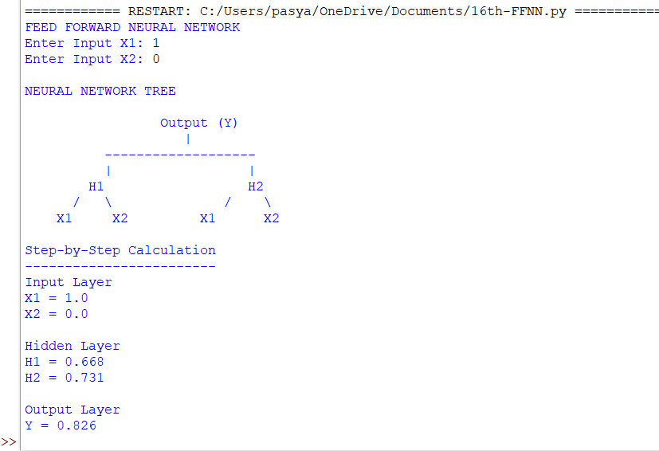

RESULT:
Thus, the Feed Forward Neural Network (FFNN) was implemented successfully in Python, and the output was obtained by propagating the inputs through the hidden layer to the output layer using the sigmoid activation function.

