Name:P.Gayathri
Reg.No:192424324

8.Write a Python program to implement Depth First Search (DFS) traversal on a graph.

Aim:
To implement the Depth First Search (DFS) algorithm in Python to traverse all the nodes of a graph.
Algorithm:
Step 1: Start.
Step 2: Create a graph using an adjacency list.
Step 3: Read the starting node from the user.
Step 4: Create an empty visited set.
Step 5: Visit the starting node and mark it as visited.
Step 6: Display the current node.
Step 7: Recursively visit all unvisited adjacent nodes.
Step 8: Repeat until all reachable nodes are visited.
Step 9: Stop.

PROGRAM:
graph = {
'A': ['B', 'C'],
'B': ['D', 'E'],
'C': ['F'],
'D': [],

'E': ['F'],
'F': []
}

visited = set()

def dfs(node):
if node not in visited:
print(node, end=" ")
visited.add(node)
for neighbor in graph[node]:
dfs(neighbor)

start = input("Enter starting node: ").upper()

print("DFS Traversal:")
dfs(start)

INPUT:
Enter starting node: A

OUTPUT:
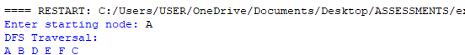

RESULT:
Thus, the Python program to implement the Depth First Search (DFS) algorithm was executed successfully, and the graph was traversed in depth-first order.

