SIMATS ENGINEERING
ASSESSMENT TOOL 1
COURSE NAME: Artificial Intelligence COURSE CODE: CSA17
NAME:Gayathri.P
Reg no:192424324

COURSE OUTCOME COVERED

CO3: Analyze knowledge representation and reasoning using propositional logic, FOL, inference, resolution, chaining methods, knowledge representation to perform logical reasoning for drawing valid conclusions and decision making. (BL4)

Assessment Tool Weightage: 40%

Code of Conduct:

I __Gayathri.P(192424324)__ (Name / Reg No) certify that this submission is my original work and that I have adhered to the guidelines specified for this assessment.
I understand that any violation of academic integrity rules will result in disciplinary action.

Signature of the student:
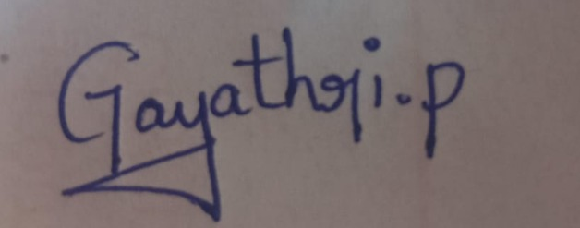
Annexure A
CASE STUDY

Case Study 1 — Smart Medical Diagnosis System
A hospital is designing a rule-based Logical Agent for preliminary patient diagnosis. The system’s knowledge base contains:
I. If a patient has Fever AND Cough → Possible Flu
Ii. If a patient has Fever AND Rash → Possible Measles
Iii. If a patient has Cough AND Breathlessness → Possible Pneumonia
Iv. Facts about Patient A: Fever = True, Cough = True, Breathlessness = True
(a) Represent the above rules and facts precisely using Propositional Logic symbols. Define each symbol used.
(b) Apply Forward Chaining on the knowledge base to derive all possible diagnoses for Patient A. Show each inference step with the rule fired and fact derived.
(c) The goal is to confirm ‘Patient A has Pneumonia.’ Apply Backward Chaining and draw the goal reduction tree to verify this goal.
Case Study 2 — Autonomous Traffic Management Agent
A smart city traffic controller uses a FOL-based knowledge base to manage emergency vehicle routing:
- ∀x: Vehicle(x) ∧ EmergencyType(x) → ClearPath(x) [Rule 1]
- ∀x: ClearPath(x) → GreenSignal(x) ∧ ¬RedSignal(x) [Rule 2]
- ∀x ∀y: Vehicle(x) ∧ Behind(x,y) ∧ GreenSignal(y) → Proceed(x) [Rule 3]
- Facts: Vehicle(Ambulance), EmergencyType(Ambulance), Vehicle(CarA), Behind(CarA, Ambulance)
(a) Apply Unification to match Rule 1 with the given facts. Show the complete substitution set θ (MGU) at each step.
(b) Using the Resolution method, prove that ‘Proceed (CarA)’ is true. Convert relevant clauses to CNF and show each resolution step.
(c) Analyze whether the current FOL knowledge base is sufficient to handle two simultaneous emergency vehicles. Identify what additional rules or facts are needed and justify logically.
Case Study 3 — Agricultural Expert Reasoning System
An agricultural advisory logical agent operates with the following propositional knowledge base (KB):
- P1: SoilDry → IrrigationNeeded
- P2: IrrigationNeeded ∧ CropWheat → ApplyDripMethod
- P3: ¬ApplyDripMethod ∧ CropWheat → CropAtRisk
- Facts: SoilDry = True, CropWheat = True
(a) Convert all sentences P1, P2, P3 and the facts into Conjunctive Normal Form (CNF). Show each conversion step (eliminate implication → move ¬ inward → distribute).
(b) Using Resolution Refutation, prove the theorem ‘ApplyDripMethod’. Negate the goal, combine with the KB in CNF, and derive the empty clause □. Draw the resolution proof tree.
(c) If the fact ‘SoilDry’ is removed from the KB, analyze step-by-step how logical conclusions change. Does ‘CropAtRisk’ still follow? Apply appropriate reasoning patterns to justify.

Case Study 4 — Wumpus World Knowledge Agent
An AI agent navigating the Wumpus World perceives: Stench at [1,2], Breeze at [1,1], Glitter at [2,2]. The agent uses a propositional KB with these rules:
- Stench [1,2] → Wumpus is adjacent to cell [1,2]
- Breeze [1,1] → Pit is adjacent to cell [1,1]
- Glitter [x,y] → Gold is at [x,y]
- ¬Wumpus [x,y] ∧ ¬Pit[x,y] → Safe[x,y]
(a) Construct the agent’s belief state from its percepts. Apply Modus Ponens systematically to derive new knowledge facts. List all derived conclusions.
(b) Using Forward Chaining from the agent’s percepts, identify the possible locations of the Wumpus and Pit. Show each reasoning step precisely.
(c) Evaluate whether the path [1,1] → [1,2] → [2,2] is safe for the agent to collect the gold. Use the knowledge derived in (a) and (b) to justify your conclusion with logical inference.

RUBRICS FOR CALCULATION

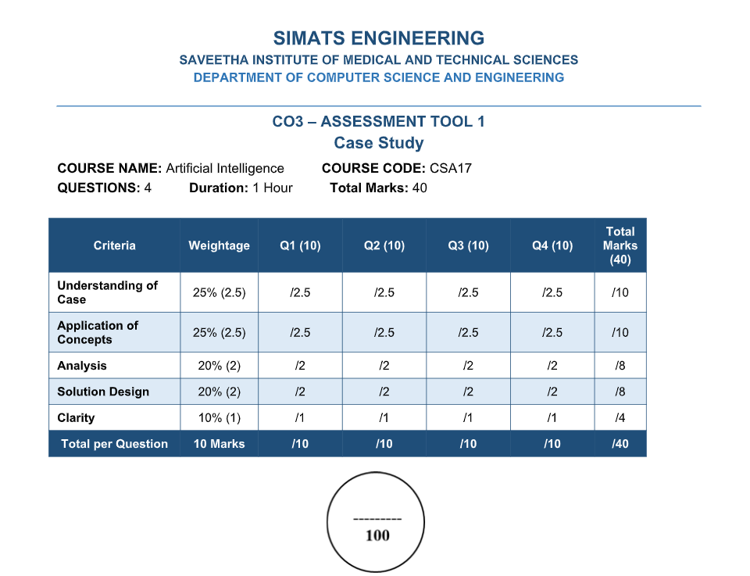

CASE STUDY 1 — SMART MEDICAL DIAGNOSIS SYSTEM

Given Knowledge Base
The hospital uses a rule-based Logical Agent for preliminary patient diagnosis.
Rules:
- If a patient has Fever AND Cough → Possible Flu.
- If a patient has Fever AND Rash → Possible Measles.
- If a patient has Cough AND Breathlessness → Possible Pneumonia.
- Facts about Patient A:
  - Fever = True
  - Cough = True
  - Breathlessness = True

(a) Representation Using Propositional Logic

Step 1: Define the Symbols
Symbol | Meaning
F | Patient has Fever
C | Patient has Cough
R | Patient has Rash
B | Patient has Breathlessness
Flu | Patient has Possible Flu
M | Patient has Possible Measles
P | Patient has Possible Pneumonia

Step 2: Represent the Rules
Rule I:
Fever AND Cough → Possible Flu
F ∧ C → Flu
Rule II:
Fever AND Rash → Possible Measles
F ∧ R → M
Rule III:
Cough AND Breathlessness → Possible Pneumonia
C ∧ B → P

Step 3: Represent Patient A Facts
Fever(A) = True
Cough(A) = True
Breathlessness(A) = True
Therefore, the knowledge base contains:
KB = {F, C, B}
Rules:
F ∧ C → Flu
F ∧ R → M
C ∧ B → P

(b) Forward Chaining
Forward Chaining is a data-driven reasoning technique. It starts with the known facts and repeatedly applies rules whose conditions are satisfied to derive new facts.

Initial Facts
Fever(A) = True
Cough(A) = True
Breathlessness(A) = True

Inference Step 1
Rule I:
Fever ∧ Cough → Possible Flu
Both Fever and Cough are true.
Therefore:
Fever(A) ∧ Cough(A) → PossibleFlu(A)
Derived Fact:
PossibleFlu(A)

Inference Step 2
Rule II:
Fever ∧ Rash → Possible Measles
Fever is true, but Rash is not given as true.
Therefore, Rule II cannot be fired.
Conclusion:
PossibleMeasles(A) cannot be derived.

Inference Step 3
Rule III:
Cough ∧ Breathlessness → Possible Pneumonia
Both Cough and Breathlessness are true.
Therefore:
Cough(A) ∧ Breathlessness(A) → PossiblePneumonia(A)
Derived Fact:
PossiblePneumonia(A)

Forward Chaining Table
Step | Facts Available | Rule Fired | New Fact
0 | Fever, Cough, Breathlessness | — | Initial facts
1 | Fever, Cough | Rule I | Possible Flu
2 | Fever, no Rash | Rule II not fired | No Measles
3 | Cough, Breathlessness | Rule III | Possible Pneumonia

Final Conclusions
PossibleFlu(A)
PossiblePneumonia(A)
PossibleMeasles(A) cannot be concluded because Rash is not known to be true.

(c) Backward Chaining for Pneumonia

Goal
PossiblePneumonia(A)
Backward Chaining is a goal-driven reasoning technique. It starts with the goal and works backward to determine which conditions are required to prove the goal.

Step 1: Start with the Goal
Goal = PossiblePneumonia(A)

Step 2: Find the Rule That Concludes Pneumonia
Rule III:
Cough(A) ∧ Breathlessness(A) → PossiblePneumonia(A)
Therefore, the following two sub-goals must be proved:
- Cough(A)
- Breathlessness(A)

Step 3: Verify Cough(A)
Cough(A) is directly available as a fact.
Therefore:
Cough(A) = True

Step 4: Verify Breathlessness(A)
Breathlessness(A) is directly available as a fact.
Therefore:
Breathlessness(A) = True

Goal Reduction Tree
PossiblePneumonia(A)
|
Rule_III
|
Cough(A) AND Breathlessness(A)
/ \
Cough(A) Breathlessness(A)
| |
FACT = TRUE FACT = TRUE
\ /
Goal_Satisfied
|
PossiblePneumonia(A)

Conclusion
Since both Cough(A) and Breathlessness(A) are true, the goal is successfully proved.
Therefore:
PossiblePneumonia(A) is true.

CASESTUDY 2 — AUTONOMOUS TRAFFIC MANAGEMENT AGENT

Given FOL Knowledge Base

Rule 1
∀x (Vehicle(x) ∧ EmergencyType(x) → ClearPath(x))

Rule 2
∀x (ClearPath(x) → GreenSignal(x) ∧ ¬RedSignal(x))

Rule 3
∀x∀y (Vehicle(x) ∧ Behind(x,y) ∧ GreenSignal(y) → Proceed(x))

Given Facts
Vehicle(Ambulance)
EmergencyType(Ambulance)
Vehicle(CarA)
Behind(CarA, Ambulance)

(a) Unification
Unification is the process of finding substitutions for variables so that two logical expressions become identical.
The substitution is represented by θ.
The Most General Unifier is represented by MGU.

Rule 1
Vehicle(x) ∧ EmergencyType(x) → ClearPath(x)

Step 1: Match Vehicle(x)
Given fact:
Vehicle(Ambulance)
Match:
Vehicle(x) with Vehicle(Ambulance)
Therefore:
θ₁ = {x/Ambulance}

Step 2: Match EmergencyType(x)
Given fact:
EmergencyType(Ambulance)
Match:
EmergencyType(x) with EmergencyType(Ambulance)
Therefore:
θ₂ = {x/Ambulance}

Complete MGU
θ = {x/Ambulance}
Applying this substitution to Rule 1:
Vehicle(Ambulance) ∧ EmergencyType(Ambulance) → ClearPath(Ambulance)
Since both conditions are true:
ClearPath(Ambulance)
is derived.

(b) Resolution Method to Prove Proceed(CarA)
Resolution is an inference method used to prove a conclusion by converting statements into CNF clauses and resolving complementary literals.

Step 1: Convert Rule 1 into CNF
Original:
Vehicle(x) ∧ EmergencyType(x) → ClearPath(x)
Using:
A → B ≡ ¬A ∨ B
We get:
¬Vehicle(x) ∨ ¬EmergencyType(x) ∨ ClearPath(x)
Therefore:
C₁ = ¬Vehicle(x) ∨ ¬EmergencyType(x) ∨ ClearPath(x)

Step 2: Convert Rule 2 into CNF
Original:
ClearPath(x) → GreenSignal(x) ∧ ¬RedSignal(x)
This produces two clauses:
C₂ = ¬ClearPath(x) ∨ GreenSignal(x)
C₃ = ¬ClearPath(x) ∨ ¬RedSignal(x)

Step 3: Convert Rule 3 into CNF
Original:
Vehicle(x) ∧ Behind(x,y) ∧ GreenSignal(y) → Proceed(x)
Therefore:
C₄ = ¬Vehicle(x) ∨ ¬Behind(x,y) ∨ ¬GreenSignal(y) ∨ Proceed(x)

Step 4: Given Facts
C₅ = Vehicle(Ambulance)
C₆ = EmergencyType(Ambulance)
C₇ = Vehicle(CarA)
C₈ = Behind(CarA, Ambulance)

Step 5: Derive ClearPath(Ambulance)
Using:
C₁ = ¬Vehicle(x) ∨ ¬EmergencyType(x) ∨ ClearPath(x)
Substitute:
x = Ambulance
Resolve with:
Vehicle(Ambulance)
and:
EmergencyType(Ambulance)
Therefore:
ClearPath(Ambulance)

Step 6: Derive GreenSignal(Ambulance)
Using:
C₂ = ¬ClearPath(x) ∨ GreenSignal(x)
Substitute:
x = Ambulance
Resolve with:
ClearPath(Ambulance)
Therefore:
GreenSignal(Ambulance)

Step 7: Derive Proceed(CarA)
Using Rule 3:
¬Vehicle(x) ∨ ¬Behind(x,y) ∨ ¬GreenSignal(y) ∨ Proceed(x)
Substitute:
x = CarA
y = Ambulance
Therefore:
¬Vehicle(CarA) ∨¬Behind(CarA,Ambulance) ∨ ¬GreenSignal(Ambulance) ∨ Proceed(CarA)
We have:
Vehicle(CarA)
Behind(CarA,Ambulance)
GreenSignal(Ambulance)
Resolving the complementary literals gives:
Proceed(CarA)

Resolution Chain
Vehicle(Ambulance)
+
EmergencyType(Ambulance)
↓
ClearPath(Ambulance)
↓
GreenSignal(Ambulance)
+
Vehicle(CarA)
+
Behind(CarA,Ambulance)
↓
Proceed(CarA)

Conclusion
Therefore:
Proceed(CarA) is logically entailed by the knowledge base.

(c) Handling Two Simultaneous Emergency Vehicles
The current knowledge base can recognize multiple emergency vehicles because Rule 1 is universally quantified:
∀x
For example, if the following facts are added:
Vehicle(Ambulance1)
EmergencyType(Ambulance1)
Vehicle(Ambulance2)
EmergencyType(Ambulance2)
then Rule 1 derives:
ClearPath(Ambulance1)
ClearPath(Ambulance2)
Rule 2 then derives:
GreenSignal(Ambulance1)
GreenSignal(Ambulance2)
However, the current knowledge base is not sufficient for complete traffic management when two emergency vehicles have conflicting routes.
It does not specify:
- Which emergency vehicle gets priority.
- How conflicting routes are handled.
- Whether both vehicles can receive green signals simultaneously.
- What happens when both vehicles approach the same intersection.
- How one vehicle should wait for another vehicle.

Additional Rules Required
A priority rule can be added:
∀x∀y (EmergencyType(x) ∧ EmergencyType(y) ∧ Priority(x,y) → GivePriority(x))
A conflict-management rule can also be added:
∀x∀y (ConflictingRoute(x,y) ∧ Priority(x,y) → Hold(y))

Additional Facts
Priority(Ambulance1, Ambulance2)
Route(Ambulance1, R1)
Route(Ambulance2, R2)

Conclusion
The current KB can process emergency vehicles individually, but it is not sufficient for resolving conflicts between simultaneous emergency vehicles. Additional priority, route, and conflict-management rules are required.

CASE STUDY 3 — AGRICULTURAL EXPERT REASONING SYSTEM

Given Knowledge Base
P1:
SoilDry → IrrigationNeeded
P2:
IrrigationNeeded ∧ CropWheat → ApplyDripMethod
P3:
¬ApplyDripMethod ∧ CropWheat → CropAtRisk
Facts:
SoilDry = True
CropWheat = True

(a) Conversion into CNF
CNF means Conjunctive Normal Form. In CNF, a logical expression is represented as an AND of OR clauses.

P1 Conversion
Original:
SoilDry → IrrigationNeeded
Using:
A → B ≡ ¬A ∨ B
Therefore:
¬SoilDry ∨ IrrigationNeeded
This is already in CNF.
Therefore:
C₁ = ¬SoilDry ∨ IrrigationNeeded

P2 Conversion
Original:
IrrigationNeeded ∧ CropWheat → ApplyDripMethod
Eliminate implication:
¬(IrrigationNeeded ∧ CropWheat) ∨ ApplyDripMethod
Using De Morgan’s Law:
¬IrrigationNeeded ∨ ¬CropWheat ∨ ApplyDripMethod
Therefore:
C₂ = ¬IrrigationNeeded ∨ ¬CropWheat ∨ ApplyDripMethod

P3 Conversion
Original:
¬ApplyDripMethod ∧ CropWheat → CropAtRisk
Eliminate implication:
¬(¬ApplyDripMethod ∧ CropWheat) ∨ CropAtRisk
Using De Morgan’s Law:
ApplyDripMethod ∨ ¬CropWheat ∨ CropAtRisk
Therefore:
C₃ = ApplyDripMethod ∨ ¬CropWheat ∨ CropAtRisk

Facts in CNF
Fact 1:
SoilDry
Therefore:
C₄ = SoilDry
Fact 2:
CropWheat
Therefore:
C₅ = CropWheat

Final CNF Knowledge Base
C₁ = ¬SoilDry ∨ IrrigationNeeded
C₂ = ¬IrrigationNeeded ∨ ¬CropWheat ∨ ApplyDripMethod
C₃ = ApplyDripMethod ∨ ¬CropWheat ∨ CropAtRisk
C₄ = SoilDry
C₅ = CropWheat

(b) Resolution Refutation for ApplyDripMethod

Goal
ApplyDripMethod
To prove the goal using resolution refutation, first negate the goal:
¬ApplyDripMethod
Add the negated goal to the knowledge base.
C₆ = ¬ApplyDripMethod

Step 1: Derive IrrigationNeeded
Use:
C₁ = ¬SoilDry ∨ IrrigationNeeded
and:
C₄ = SoilDry
Resolve the complementary literals:
¬SoilDry and SoilDry
Therefore:
IrrigationNeeded

Step 2: Derive ApplyDripMethod
Use:
C₂ = ¬IrrigationNeeded ∨ ¬CropWheat ∨ ApplyDripMethod
We have:
IrrigationNeeded
and:
CropWheat
Resolving these literals gives:
ApplyDripMethod

Step 3: Contradiction with Negated Goal
We have:
ApplyDripMethod
and:
¬ApplyDripMethod
Resolving them gives:
□
The symbol □ represents the empty clause, which means contradiction.
Therefore:
KB ⊨ ApplyDripMethod

Resolution Proof Tree
SoilDry
|
|
¬SoilDry∨IrrigationNeeded
|
↓
IrrigationNeeded
|
|
¬IrrigationNeeded∨¬CropWheat
∨ApplyDripMethod
|
CropWheat
|
↓
ApplyDripMethod
|
|
¬ApplyDripMethod
Negated_Goal
|
↓
□

Conclusion
Since the negation of the goal produces a contradiction, the theorem is proved.
Therefore:
ApplyDripMethod is true.

(c) Removing SoilDry from the Knowledge Base
Suppose the fact:
SoilDry
is removed.

Step 1
The rule:
SoilDry → IrrigationNeeded
still exists, but SoilDry is no longer known to be true.
Therefore:
IrrigationNeeded
cannot be derived.

Step 2
P2 requires:
IrrigationNeeded ∧ CropWheat
Although:
CropWheat = True
is still known, IrrigationNeeded is not known.
Therefore:
ApplyDripMethod
cannot be derived.

Step 3: Check CropAtRisk
P3 is:
¬ApplyDripMethod ∧ CropWheat → CropAtRisk
We know:
CropWheat
However, we do not know:
¬ApplyDripMethod
The absence of ApplyDripMethod does not mean that ¬ApplyDripMethod is true.
Therefore:
CropAtRisk
cannot be derived.

Final Analysis
Knowledge | Before Removing SoilDry | After Removing SoilDry
SoilDry | True | Unknown
CropWheat | True | True
IrrigationNeeded | True | Cannot be derived
ApplyDripMethod | True | Cannot be derived
¬ApplyDripMethod | Not given | Not given
CropAtRisk | Cannot be derived | Cannot be derived

Conclusion
Removing SoilDry breaks the reasoning chain:
SoilDry → IrrigationNeeded → ApplyDripMethod
However, it does not imply:
¬ApplyDripMethod
Therefore, CropAtRisk does not logically follow.

CASE STUDY 4 — WUMPUS WORLD KNOWLEDGE AGENT

Given Percepts
The AI agent perceives:
- Stench at [1,2]
- Breeze at [1,1]
- Glitter at [2,2]

Rules
Rule 5:
Stench[1,2] → WumpusAdjacent[1,2]
Rule 6:
Breeze[1,1] → PitAdjacent[1,1]
Rule 7:
Glitter[x,y] → Gold[x,y]
Rule 8:
¬Wumpus[x,y] ∧ ¬Pit[x,y] → Safe[x,y]

(a) Construct the Agent’s Belief State
The initial belief state contains:
Stench[1,2]
Breeze[1,1]
Glitter[2,2]

Step 1: Apply Rule 5
Rule:
Stench[1,2] → WumpusAdjacent[1,2]
Given:
Stench[1,2]
Using Modus Ponens:
If P → Q and P is true, then Q is true.
Therefore:
WumpusAdjacent[1,2]
Assuming standard four-directional adjacency, the cells adjacent to [1,2] are:
[1,1], [1,3], [2,2]
Therefore:
Wumpus ∈ {[1,1], [1,3], [2,2]}

Step 2: Apply Rule 6
Rule:
Breeze[1,1] → PitAdjacent[1,1]
Given:
Breeze[1,1]
Therefore:
PitAdjacent[1,1]
The cells adjacent to [1,1] are:
[1,2], [2,1]
Therefore:
Pit ∈ {[1,2], [2,1]}

Step 3: Apply Rule 7
Rule:
Glitter[x,y] → Gold[x,y]
Given:
Glitter[2,2]
Substitute:
x = 2
y = 2
Therefore:
Gold[2,2]

Step 4: Apply Rule 8
Rule:
¬Wumpus[x,y] ∧ ¬Pit[x,y] → Safe[x,y]
To use this rule, the agent must know both:
¬Wumpus[x,y]
and:
¬Pit[x,y]
These negative facts are not provided.
Therefore, Safe[x,y] cannot be derived for the relevant cells.

Derived Conclusions
- Wumpus is adjacent to [1,2].
- Possible Wumpus locations are [1,1], [1,3], and [2,2].
- Pit is adjacent to [1,1].
- Possible Pit locations are [1,2] and [2,1].
- Gold is at [2,2].
- No relevant cell can be confirmed safe using Rule 8.

(b) Forward Chaining for Wumpus and Pit Locations

Wumpus Reasoning
Initial fact:
Stench[1,2]
Apply Rule 5:
Stench[1,2] → WumpusAdjacent[1,2]
Therefore:
WumpusAdjacent[1,2]
The adjacent cells are:
[1,1], [1,3], [2,2]
Therefore:
Wumpus ∈ {[1,1], [1,3], [2,2]}

Pit Reasoning
Initial fact:
Breeze[1,1]
Apply Rule 6:
Breeze[1,1] → PitAdjacent[1,1]
Therefore:
PitAdjacent[1,1]
The adjacent cells are:
[1,2], [2,1]
Therefore:
Pit ∈ {[1,2], [2,1]}

Gold Reasoning
Initial fact:
Glitter[2,2]
Apply Rule 7:
Glitter[2,2] → Gold[2,2]
Therefore:
Gold[2,2]

Forward Chaining Tree
InitialPercepts
/ | \
/ | \
Stench[1,2] Breeze[1,1] Glitter[2,2]
| | |
Rule 5 Rule 6 Rule 7
| | |
↓ ↓ ↓
Wumpus adjacent Pit adjacent Gold[2,2]to
[1,2] to [1,1]
| |
↓ ↓
[1,1],[1,3],[2,2] [1,2],[2,1]

(c) Safety of the Path [1,1] → [1,2] → [2,2]
The proposed path is:
[1,1] → [1,2] → [2,2]
The goal is to reach [2,2] and collect the gold.

Step 1: Analyze Cell [1,1]
We know:
Breeze[1,1]
Therefore, a Pit may exist in one of its adjacent cells:
[1,2] or [2,1]
Thus:
Pit ∈ {[1,2], [2,1]}
Therefore, the agent cannot establish that [1,1] is completely safe from the given information.

Step 2: Analyze Cell [1,2]
We know:
Stench[1,2]
Therefore, the Wumpus may be located in:
[1,1], [1,3], or [2,2]
Also, [1,2] is adjacent to [1,1], and the Breeze at [1,1] means that the Pit may be at [1,2].
Therefore:
[1,2] is a possible Pit location.
Hence:
[1,2] is not proven safe.

Step 3: Analyze Cell [2,2]
We know:
Gold[2,2]
However, [2,2] is adjacent to [1,2].
The Stench at [1,2] means the Wumpus may be at:
[1,1], [1,3], or [2,2]
Therefore:
[2,2] is a possible Wumpus location.
Hence, [2,2] is not proven safe.

Final Safety Conclusion
The path:
[1,1] → [1,2] → [2,2]
cannot be considered logically safe using the current knowledge base.
The reasons are:
- [1,2] may contain a Pit.
- [2,2] may contain the Wumpus.
- The KB does not contain sufficient negative information to prove these cells safe.
- Rule 8 requires both ¬Wumpus and ¬Pit before Safe can be concluded.
Therefore:
The proposed path is NOT proven safe.
The agent should not assume that an unknown cell is safe simply because a danger has not been explicitly confirmed.

