21)Write a Prolog program to implement a PLANETS database.
Name:P.Gayathri
Reg.No:192424324

Aim
To write and execute a Prolog program to create a database of planets containing their names, types, and positions from the Sun, and to retrieve the required information using queries.

Algorithm
- Start the program.
- Define facts for all the planets.
- Store the planet name, planet type, and position from the Sun.
- Define a rule to find the type of a given planet.
- Define another rule to find the position of a given planet.
- Load the program into SWI-Prolog.
- Enter a query for the required planet.
- Prolog searches the database and matches the given planet.
- Retrieve and display the required information.
- Stop the program.

PROGRAM:
% Prolog Program for PLANETS Databas
% Planet(Name, Type, Position
planet(mercury, terrestrial, 1).
planet(venus, terrestrial, 2).
planet(earth, terrestrial, 3).
planet(mars, terrestrial, 4).
planet(jupiter, gas_giant, 5).
planet(saturn, gas_giant, 6).
planet(uranus, ice_giant, 7).
planet(neptune, ice_giant, 8)
% Rule to find the type of a planet
planet_type(Planet, Type) :-
planet(Planet, Type, _).
% Rule to find the position of a planet
planet_position(Planet, Position) :-
planet(Planet, _, Position).
INPUT:
planet_type(earth, Type).
planet_position(mars, Position).

OUTPUT:
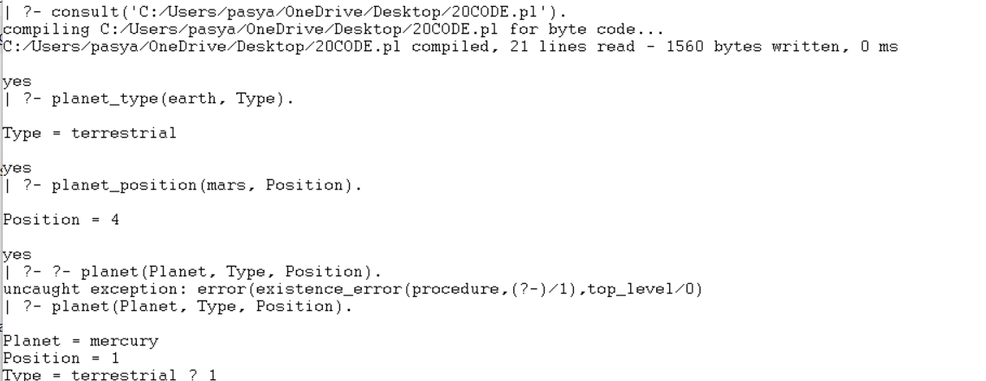

RESULT:
Thus, the Prolog program for the PLANETS database was successfully implemented and executed, and the planet type, position, and other planet details were retrieved successfully.

