31. Prolog Program for Backward Chaining
Name:P.Gayathri
Reg.No:192424324

Aim
To write and execute a Prolog program to implement Backward Chaining by starting with a goal and checking the required facts and rules to prove it.
Algorithm
- Start the program.
- Define the facts.
- Define rules connecting facts to conclusions.
- Set the required conclusion as the goal.
- Start from the goal and check which rule can prove it.
- Check whether the conditions of that rule are true.
- Continue checking the required sub-goals backward.
- If all required facts are true, prove the goal.
- Display the result.
10.Stop the program.

Code:
% Backward Chaining in Prolog

% Facts
sunny.
warm.

% Rules
outdoor :- sunny.
comfortable :- warm.
play :- outdoor.
happy :- comfortable.

% Goal checking rule
check_goal(Goal) :-
call(Goal).

INPUT:
?- check_goal(happy).
OUTPUT:
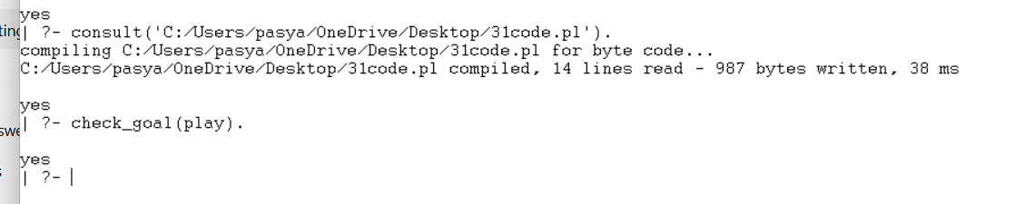
Result:
Thus, the Backward Chaining algorithm was successfully implemented in Prolog. The goal was proved by working backward through the rules until the required facts were found.

