Name:P.Gayathri
Reg.No:192424324

31) Write an HTML program to demonstrate pattern matching using JavaScript.
Aim
To write an HTML program to demonstrate pattern matching using a simple web page with a text input and JavaScript regular expression matching.
Algorithm
- Start the program.
- Create an HTML page with an input field for the text.
- Create another input field for the pattern.
- Add a Match Pattern button.
- When the button is clicked, read the text and pattern.
- Create a JavaScript regular expression using the given pattern.
- Check whether the pattern matches the text.
- Display the matching result.
- Stop.
PROGRAM:
<!DOCTYPE html>
<html>
<head>
<title>Pattern Matching</title>
</head>
<body>

<h2>Pattern Matching Program</h2>

<label>Enter Text:</label>
<input type="text" id="text"><br><br>

<label>Enter Pattern:</label>
<input type="text" id="pattern"><br><br>

<button onclick="matchPattern()">Match Pattern</button>

<p id="result"></p>

<script>
function matchPattern() {
let text = document.getElementById("text").value;
let pattern = document.getElementById("pattern").value;

let regex = new RegExp(pattern);
let result = regex.test(text);

if (result) {
document.getElementById("result").innerHTML =
"Pattern matched successfully!";
} else {
document.getElementById("result").innerHTML =
"Pattern not matched.";
}
}
</script>

</body>
</html>INPUT:
suggest_diet(diabetes, Food).
OUTPUT:
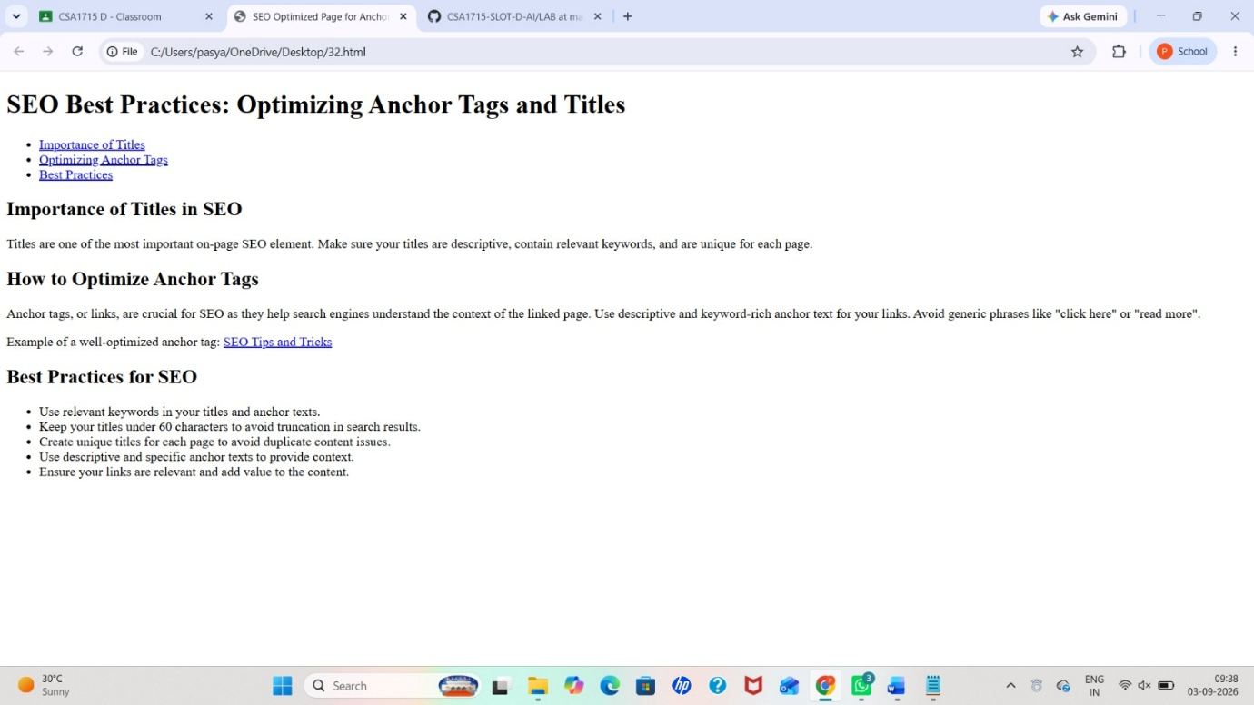

Result:
Thus, the HTML program to demonstrate pattern matching using JavaScript Regular Expressions was successfully implemented and executed.

