SIMATS ENGINEERING (SAVEETHA SCHOOL OF ENGINEERING)
Department of Artificial Intelligence and Data Science

ASSESSMENT TOOL 1 – Experiments

Course Code: | DSA0307 | Course Title: | Natural Language Processing
CO Assessed: | CO3 – Precision | Assessment: | Assessment Tool 1 – Experiments
Weightage: | 50% of CIA
CO5 Statement: | Apply N-gram models, smoothing techniques, part-of-speech tagging systems and to evaluate effective syntactic analysis. (BL-3)
Student Name: | Gayathri.P | Reg. No.: | 192424324
Section / Batch: | AI&DS | Date:
Code of Conduct
I Gayathri.P (192424324) (Name / Reg No) certify that this submission is my original work and that I have adhered to the guidelines specified for this assessment. I understand that any violation of academic integrity rules will result in disciplinary action.
Signature of the Student: P.Gayathri
Instructions
- Perform all experiments using Google Colab.
- Create a separate notebook (.ipynb) for the assessment.
- Ensure all code is executable without errors.
- Include appropriate comments explaining the logic used.
- Complete all three experiments in a single Google Colab notebook.
- Execute all cells and display the outputs for the given test cases.
- Save the notebook with the naming convention: RegNo_Name_CO3-AT1.ipynb
- Upload the notebook to your GitHub repository.
- Ensure the repository is public or accessible to the instructor.
- Submit the following:
- GitHub Repository Link in GCR
- Google Colab Share Link in GCR
- Screenshots of uploaded coding and output files as printout.
- Duration: 30 minutes.

Section / Topic | Focus | Experiment Questions
Context-Free Grammars for English Syntax, Context-Free Rules and Trees, Sentence-Level Constructions, Parsing, Top-Down Parsing, Earley Parsing | Design a Python program to validate sentences using CFG production rules and construct parse tree representations for valid sentences. | Q1
Agreement, Feature Structures, Sub Categorization | Design a Python program to verify subject–verb agreement and validate grammatical constraints using feature structures and subcategorization rules. | Q2
Probabilistic Context-Free Grammars (PCFGs) | Design a Python program to parse sentences and compute sentence probabilities using probabilistic grammar production rules. | Q3

Annexure A – Experiments

Experiment 1: Context-Free Grammar Rule Validation and Parse Tree Construction
Experiment Description
Design a Python program to validate whether a sentence follows the given Context-Free Grammar (CFG) rules and generate its parse tree representation.

Grammar:
S → NP VP
NP → Det N VP → V NP

Task
Det → the | a
N → student | teacher | book
V → reads | likes

- Accept a sentence as input.
- Verify whether it conforms to the CFG.
- Construct and return the parse tree.
- Return "Invalid Sentence" if parsing fails.

Function Prototype def parse_cfg(sentence):
pass

Test Cases
Input | Expected Output
the student reads a book | Valid Parse Tree
a teacher likes the book | Valid Parse Tree
student reads book | Invalid Sentence
the book likes a teacher | Valid Parse Tree
reads the student book | Invalid Sentence

Aim
To design a Python program that validates whether a sentence follows the given Context-Free Grammar (CFG) rules and generates its parse tree representation.

Algorithm
- Import NLTK.
- Define CFG grammar.
- Accept sentence input.
- Tokenize the sentence.
- Parse using RecursiveDescentParser.
- If parsing succeeds:
  - Print "Valid Sentence"

  - Display Parse Tree
- Otherwise print "Invalid Sentence".

Python Code
import nltk
from nltk import CFG
from nltk.parse import RecursiveDescentParser
grammar = CFG.fromstring(""" S -> NP VP
NP -> Det N VP -> V NP
Det -> 'the' | 'a'
N -> 'student' | 'teacher' | 'book' V -> 'reads' | 'likes'
""")

parser = RecursiveDescentParser(grammar) sentence = input("Enter sentence: ").lower().split() parsed = False
for tree in parser.parse(sentence): parsed = True
print("\nValid Sentence") print("\nParse Tree:") print(tree) tree.pretty_print()

if not parsed:
print("\nInvalid Sentence")

Outputs:
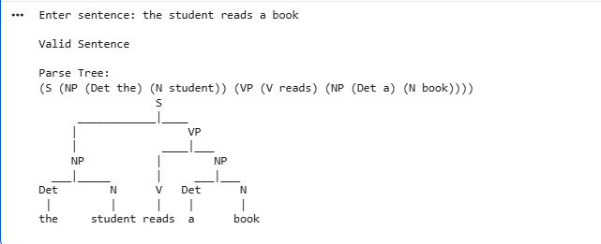

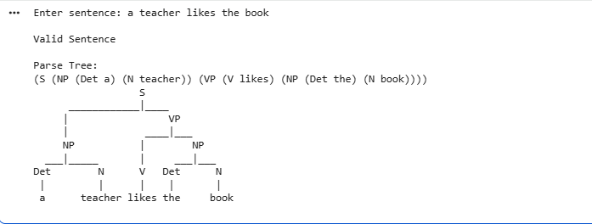
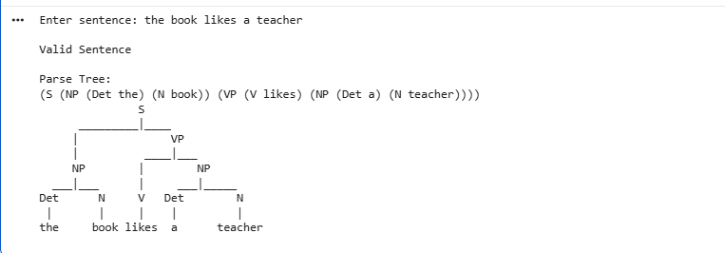

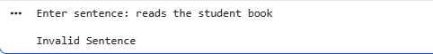

Result Analysis
The parser successfully validates sentences according to the CFG rules. Valid sentences produce a complete parse tree, while sentences violating grammar rules are rejected.

Result
Thus, the Python program successfully validates CFG sentences and constructs parse trees.

Experiment 2: Agreement and Feature Structure Checking Experiment Description
Design a Python program that verifies subject–verb agreement using feature structures containing Number and Person attributes.

Feature Rules
he → singular, third person she → singular, third person it → singular, third person they → plural

runs → singular verb writes → singular verb

run → plural verb write → plural verb

Task

- Accept Subject and Verb.
- Compare feature structures.
- Return True if agreement holds.
- Return False otherwise.

Function Prototype
def check_agreement(subject, verb): pass

Test Cases
Subject | Verb | Expected
he | runs | True
he | run | False
they | run | True
they | writes | False
she | writes | True

Aim
To verify subject–verb agreement using feature structures based on Number and Person.

Algorithm
- Store feature structures for subjects.
- Store feature structures for verbs.
- Read subject and verb.
- Compare Number feature.
- Print True if matched.
- Else print False. Python Code subjects = {
"he": ("singular", "third"),

"she": ("singular", "third"),

"it": ("singular", "third"),

"they": ("plural", "third")

}

verbs = {

"runs": "singular", "writes": "singular", "run": "plural",
"write": "plural"

}

def check_agreement(subject, verb):

if subject not in subjects or verb not in verbs: return False
subject_number = subjects[subject][0] verb_number = verbs[verb]
return subject_number == verb_number subject = input("Enter subject: ").lower() verb = input("Enter verb: ").lower() print(check_agreement(subject, verb))

Outputs:
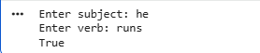

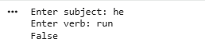
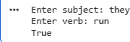

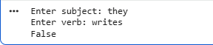
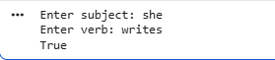

Result Analysis
The program compares the grammatical number of the subject and verb using feature structures. It correctly identifies agreement and disagreement.

Result
Thus, the Python program successfully verifies subject–verb agreement using feature structures.

Experiment 3: Probabilistic Context-Free Grammar (PCFG) Parsing Experiment Description
Implement a Python program to compute the probability of a sentence using the given PCFG.

Grammar
S → NP VP | [1.0]
NP → John | [0.6]
NP → Mary | [0.4]
VP → runs | [0.5]
VP → walks | [0.5]

Probability Formula
P(Sentence) = P(S→NP VP) × P(NP) × P(VP)

Task
- Accept a two-word sentence.
- Parse using the PCFG.
- Compute sentence probability.
- Return 0 if sentence cannot be generated.

Function Prototype

def sentence_probability(sentence): pass

Test Cases
Input Sentence | Expected Probability
John runs | 0.30
John walks | 0.30
Mary runs | 0.20
Mary walks | 0.20
Peter runs | 0.00

Aim
To compute sentence probability using Probabilistic Context-Free Grammar rules.

Algorithm
- Define PCFG probabilities.
- Accept a two-word sentence.
- Split into NP and VP.
- Multiply grammar probabilities.
- Print probability.
- If sentence cannot be generated, return 0.

Python Code
np_prob = { "John": 0.6,
"Mary": 0.4

}

vp_prob = { "runs": 0.5,
"walks": 0.5

}

def sentence_probability(sentence): words = sentence.split()
if len(words) != 2: return 0.0
np = words[0]

vp = words[1]

if np not in np_prob: return 0.0
if vp not in vp_prob: return 0.0
probability = 1.0 * np_prob[np] * vp_prob[vp] return probability
sentence = input("Enter sentence: ") print("Probability =", sentence_probability(sentence))

Outputs:
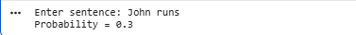
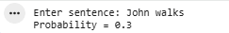
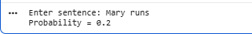
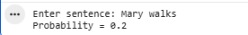
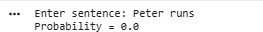

Result Analysis
The program computes sentence probabilities by multiplying the production rule probabilities. Invalid words receive a probability of 0, indicating that the sentence cannot be generated by the grammar.

Result
Thus, the Python program successfully computes sentence probabilities using PCFG production rules.

Rubrics for Calculation

Criteria | Weightage | Level 4 – Exemplary | Level 3 – Proficient | Level 2 – Developing | Level 1 – Beginning
Understanding of Concepts | 25 | Demonstrates thorough understanding and effectively integrates multiple concepts/technologies | Good understanding with proper integration of most concepts | Basic understanding; limited or partial integration | Poor understanding; unable to integrate  concepts
Experimental Design | 30 | Well-planned, systematic implementation with optimal solution | Correct implementation with minor issues | Basic implementation with errors or inefficiencies | Incorrect or incomplete implementation
Use of Tools | 20 | Effective and advanced use of tools/technologies with proper  configuration | Appropriate use of tools with correct  execution | Limited or inconsistent use of  tools | Incorrect or minimal use of  tools
Analysis of Results | 15 | Insightful analysis with accurate interpretation and validation of results | Good analysis with reasonable interpretation | Basic analysis with limited insights | Poor or incorrect analysis of results
Documentation | 10 | Clear, well-structured documentation with diagrams, code, and results | Organized documentation with necessary details | Basic documentation  with missing details | Poor or incomplete documentation

Q. No. / Criteria Level | Understanding of Concepts | Experimental Design | Use of Tools | Analysis of Results | Document ation | Sub. Total | Total  %
1
2
3

Faculty In-charge | Course Coordinator | Program Director
Signature: | Signature: | Signature:
Date: | Date: | Date:

