ActivePulse Agent
Functional Documentation
Backend desktop agent — business behavior and use cases

1. Overview
ActivePulse Agent is a background program that runs silently on each employee's Windows machine. It captures foreground application activity, keyboard/mouse counts, screenshots, and machine location, then syncs this data to the ActivePulse portal every 5 minutes.

What is captured
- Foreground app name, window title, browser URL (Chrome/Edge/Firefox/Safari)
- Keyboard and mouse event COUNTS (never actual keys)
- Screenshot of all monitors every 5 minutes (skipped if screen is locked)
- Machine private/public IP, detected office or WFH city, lat/lng
- Session activity status: ACTIVE / IDLE / AWAY

What is NOT captured
- Individual keystrokes, clipboard, passwords
- Camera or microphone data
- Email, chat, or file contents
- Data from admin/system accounts

2. Core Use Cases
ID | Use case | Trigger
UC-01 | Silent installation via MSI | Admin runs install script
UC-02 | Auto-start at every user login | Windows login (HKLM Run)
UC-03 | Skip admin / system accounts | Agent startup check
UC-04 | Track foreground app every 5 seconds | Scheduled job
UC-05 | Capture browser URL + browser name | Browser is foreground
UC-06 | Detect idle time (no input 5+ min) | Keyboard / mouse tracker
UC-07 | Detect locked screen as idle | LockApp.exe is foreground
UC-08 | Capture screenshot every 15 minutes | Scheduled job
UC-09 | YouTube 30min + no activity -> IDLE | Session flush logic
UC-10 | Browser 30min + no URL -> AWAY | Session flush logic
UC-11 | Apply server-controlled capture settings | Sync response settings block
UC-12 | Detect office by network subnet | Every sync cycle
UC-13 | Detect WFH city via IP geolocation | Every sync cycle if not office
UC-14 | Sync data to server every 5 min | Scheduled job
UC-15 | Buffer data offline (retry sync) | Server unreachable
UC-16 | Upload diagnostic log | ERROR logs
UC-17 | Watchdog auto-restart on crash | Child agent exits
UC-18 | Detect Task Manager kill | Next agent startup

3. Use Case Details

UC-01 Silent installation via MSI
Trigger: Administrator runs the install script on the target machine.
Mechanism: jpackage-built MSI with bundled JRE; silent install via PowerShell.
Reference files: build-installers.yml, pom.xml, install-activepulse-vX.X.X.ps1
The agent ships as a single fat JAR wrapped by jpackage into a machine-wide MSI that bundles its own JRE, so no Java is required on the target. An administrator downloads the MSI and runs the accompanying PowerShell script in an elevated shell; it installs silently, writes the HKLM Run entry, and verifies the install.
The upgrade UUID is fixed permanently so that new versions upgrade in place rather than installing side-by-side.

UC-02 Auto-start at every user login
Trigger: A Windows user logs in.
Mechanism: HKLM Run key launches the agent in the user's context (WindowsAutostartManager).
Reference files: autostart/WindowsAutostartManager.java, autostart/AutostartFactory.java
Installation writes a machine-wide HKLM Run entry that launches ActivePulse with the --watchdog flag whenever any user logs in. Because it is launched in the interactive user's context - not as a service - the agent runs with exactly that user's privileges. On macOS this is a LaunchAgent .plist; on Linux an XDG .desktop file.

UC-03 Skip admin / system accounts
Trigger: Agent startup, before any monitoring begins.
Mechanism: UserFilter.shouldSkipCurrentUser() checks the skip list and admin privilege, then exits early.
Reference files: util/UserFilter.java, Main.java
At startup, before creating folders, locks, or logging, the agent compares the current user against a configurable skip list (case-insensitive) and, if enabled, runs an admin-privilege check by attempting to create a file under C:\Windows\System32. If either matches, it writes a one-line reason to a temp skip-log and calls System.exit(0) immediately - nothing is monitored or stored for that account.

UC-04 Track foreground app every 5 seconds
Trigger: Quartz ActivityJob fires on a 5-second interval.
Mechanism: ActiveWindowTracker resolves the foreground window; ActivitySessionManager aggregates into sessions and flushes to activity_log.
Reference files: monitor/ActivityTracker.java, platform/windows/WindowsActiveWindowTracker.java, monitor/ActivitySessionManager.java, monitor/ActiveWindowInfo.java
Every 5 seconds the tracker resolves the foreground window into an immutable record of process name, title, and (for browsers) URL. The Windows implementation resolves the process name through a four-attempt fallback chain: OpenProcess + GetModuleFileNameExW, then QueryFullProcessImageName (works for most protected apps), then a Toolhelp32 snapshot (covers protected/PPL processes without opening a handle), and finally GetClassName as a window-class fallback. The null-foreground case (lock screen, UAC secure desktop) is tagged as a secure-desktop marker rather than collapsing into an unknown block.

Session semantics
- A session is continuous time with the same process name and title.
- A URL change alone (same browser, new tab) does not split a session.
- Sessions crossing midnight are flushed at 23:59:59 and a new session starts at 00:00:00 for clean daily aggregation.
- Sub-second sessions are ignored to guard against fast focus flicker.

UC-05 Capture browser URL and browser name
Trigger: A supported browser is in the foreground.
Mechanism: BrowserUrlTracker invokes a PowerShell UI Automation helper; BrowserEnricher falls back to title parsing.
Reference files: platform/windows/BrowserUrlTracker.java, platform/windows/BrowserEnricher.java, platform/windows/WindowsActiveWindowTracker.java
For UIA-compliant browsers (Chrome, Edge, Firefox, Brave, Opera, Arc, Vivaldi), the agent reads the address-bar value using a PowerShell UI Automation helper written to disk once per session and invoked with a 2-second timeout. Results are cached for 2 seconds per process+title to avoid repeated process spawns. If UIA fails (timeout, incognito, unsupported version), BrowserEnricher sniffs a domain from the window title and records it as a domain rather than a full URL, so the portal can distinguish the two.
Performance note: because browser titles change frequently, the URL cache should key on process (or process + domain) rather than the full title to prevent excessive PowerShell spawns.

UC-06 Detect idle time (no input for 5+ minutes)
Trigger: Continuous - evaluated at session flush.
Mechanism: KeyboardMouseTracker timestamps + UserStatusTracker classify ACTIVE / IDLE / AWAY.
Reference files: monitor/KeyboardMouseTracker.java, monitor/UserStatusTracker.java, monitor/ActivitySessionManager.java
The keyboard/mouse hook maintains a real-time last-input timestamp and a monotonic input counter. When there is no input for 5 or more minutes, the user status becomes IDLE. The session manager snapshots the input counter at session start and, at flush, uses the delta and the events-per-second rate to decide whether a session was effectively idle even if it was long.
Condition | Status
Input within last 5 min and a real app is foreground | ACTIVE
No input for 5+ minutes | IDLE
YouTube idle for more than 30 min (UC-09) | IDLE
Browser open 30+ min with no URL (UC-10) | AWAY
Foreground is LockApp.exe / LogonUI.exe (UC-07) | LOCKED -> AWAY
Windows session disconnected | AWAY

UC-07 Detect locked screen as idle
Trigger: LockApp.exe or LogonUI.exe is the foreground process.
Mechanism: ActivitySessionManager marks lock/secure-desktop sessions as IDLE; server maps LOCKED to AWAY.
Reference files: monitor/ActivitySessionManager.java, platform/windows/WindowsActiveWindowTracker.java
When the machine is locked, the foreground process is LockApp.exe or LogonUI.exe, and the secure desktop returns a null foreground window. Both are treated as locked and recorded as IDLE so that locked time is never counted as active. Screenshots are skipped while locked. Because LOCKED is not accepted by the server, it is normalised to AWAY in the sync payload.

UC-08 Capture screenshot every 15 minutes
Trigger: Quartz ScreenshotJob fires on its configured interval.
Mechanism: ScreenshotCapture uses java.awt.Robot across all monitors; gated by lock state and server settings (UC-18).
Reference files: screenshot/ScreenshotCapture.java, db/ScreenshotDao.java
On its interval the agent captures all monitors side by side via Robot and encodes JPG at a configurable quality, recording a row in the screenshots table. Capture is skipped when the screen is locked, when the environment is headless, and when the server has disabled screenshots (UC-18). Files remain on disk until a sync uploads them, after which they are deleted; a disk cap (~200 MB) triggers oldest-first cleanup if a sync backlog builds up.

UC-09 YouTube idle for 30 min becomes IDLE
Trigger: Session flush, when the foreground has been YouTube for 1h+.
Mechanism: Rule R1 in ActivitySessionManager.flush().
Reference files: monitor/ActivitySessionManager.java
If a YouTube session (by URL, title, or app) has been in the foreground for at least one hour with input at or below tolerance - an absolute count of ~10 events, or an events-per-second rate below 0.05 - the session is reclassified as IDLE. This distinguishes a video left playing from genuine interactive use.

UC-10 Browser open 30 min with no URL becomes AWAY
Trigger: Session flush, browser foreground with no resolvable URL.
Mechanism: Rule R2 in ActivitySessionManager.flush().
Reference files: monitor/ActivitySessionManager.java
If a browser has been foreground for at least 30 minutes with no resolvable URL and an events-per-second rate below the idle threshold, the session is reclassified as AWAY. This catches a browser left open on a blank or unreadable page while the user is away.

UC-11 Detect office by network subnet
Trigger: Every sync cycle, before building the location block.
Mechanism: MachineInfo.applyOfficeOverride() matches the private IP against configured office subnets.
Reference files: util/MachineInfo.java
Each cycle the agent reads the machine's private IP from the active non-loopback adapter and checks it against configured office subnets (Pune, Nashik, and extra ranges). On a match it forces that office's authoritative city and coordinates and stops - no external call, and no ambiguity. Office detection is therefore always exact.

UC-12 Detect WFH city via IP geolocation
Trigger: Every sync cycle, only if the machine is not on an office subnet.
Mechanism: Optional Google Geolocation (with API key) then IP fallback (ipgeolocation.io, ip-api.com).
Reference files: util/MachineInfo.java
If no office subnet matches, the user is treated as working from home. With a Google API key configured, the agent obtains coordinates via Google Geolocation and reverse-geocodes them to a city; the IP fallback always runs to record the public IP and, if the city is still blank, to fill approximate city and coordinates. Results are cached for 30 minutes when complete and 5 minutes when incomplete.

UC-13 Sync data to server every 5 minutes
Trigger: Quartz SyncJob fires every 5 minutes.
Mechanism: SyncManager.sync() reads unsynced rows, POSTs JSON + screenshot ZIP, marks rows synced on HTTP 200.
Reference files: sync/SyncManager.java, job/JobScheduler.java
Each cycle the agent builds a JSON payload of unsynced activity and stroke rows plus device, user, org, version, OS, and the location block, and POSTs it to /api/sync/data. On HTTP 200 those rows are marked synced and the response settings block is applied (UC-16). Screenshots then upload as a single multipart request if the ZIP is 10 MB or less, otherwise in 5 MB chunks read one at a time from disk. Activity and stroke payloads are chunked at 5000 rows per request. Additional syncs run at end-of-day (23:xx) and at shutdown through the same path.

UC-14 Buffer data offline and retry
Trigger: The server is unreachable or returns a non-200 response.
Mechanism: SQLite synced flag acts as the queue; rows remain synced=0 and are retried next cycle.
Reference files: sync/SyncManager.java, db/DatabaseManager.java
All data is written to SQLite first, independent of connectivity. If the server cannot be reached - captive Wi-Fi, DNS failure, timeout, or a 4xx/5xx - the affected rows simply stay marked unsynced and are retried on the next cycle; the synced flag itself is the offline queue, so there is no separate buffer to corrupt. Network exceptions are classified into friendly deferral messages (SSL/captive-portal, DNS, connect, timeout, reset). There is no exponential backoff; the fixed 5-minute cycle is conservative enough.

UC-15 Upload daily diagnostic log ZIP
Trigger: Quartz cron at 12:00, plus a shutdown upload; gated by server settings.
Mechanism: DiagnosticsUploader time-slices new log bytes, ZIPs them, and POSTs to /api/api/sync/logs.
Reference files: diagnostics/DiagnosticsUploader.java, diagnostics/DiagnosticsJob.java

The agent uploads its own logs on a controlled schedule - normally at shutdown, with a 12:00 daily fallback as a safety net and a catch-up on next start if the previous session ended uncleanly (detected via a stale heartbeat file). For the current day it uploads only the new bytes since the last successful offset; older days upload once in full and are marked synced. Log upload is skipped when the server disables logs (UC-16).
UC-16 Apply server-controlled capture settings
Trigger: A settings block is present in the /api/sync/data response.
Mechanism: SyncManager parses settings into RemoteSettings; capture and upload paths read the flags.
Reference files: sync/SyncManager.java, sync/RemoteSettings.java
The portal can control, per agent, whether screenshots and diagnostic logs are collected, by returning a settings block in the normal sync response. SyncManager parses it into an in-memory RemoteSettings holder whose two flags default to true, so behaviour before the first sync - and against an older server that omits the block - is unchanged. When a flag is false, both collection and upload stop: screenshot capture returns immediately (nothing is captured, no file is written, no row inserted), and diagnostics upload is skipped.
"settings": {
"logsEnabled": false,
"screenshotsEnabled": true
}

UC-17 Watchdog auto-restart on crash
Trigger: The child agent process exits unexpectedly.
Mechanism: WatchdogMode supervises the child and respawns it, with a rate limit against crash loops.
Reference files: WatchdogMode.java, SingleInstanceLock.java, Main.java
The watchdog holds its own per-user lock and spawns the agent with --no-watchdog so the child never tries to become a watchdog itself (the flag is checked first in Main's dispatch, which fixed an early crash-loop). On any child exit the watchdog waits 5 seconds and respawns, up to 20 restarts per hour; hitting that limit logs an error and stops restarting on the assumption of a bad-config crash loop. On watchdog termination the child is stopped gracefully with a 10-second timeout before a forced kill.

Locks
- watchdog.lock - held by the watchdog (per-user, in LOCALAPPDATA).
- activepulse.lock - held by the agent child (per-user).
- Both use NIO FileChannel.tryLock(), auto-released on process death; two AD users each get their own pair.

UC-18 Detect Task Manager kill
Trigger: Next agent startup after a kill or unclean exit.
Mechanism: Heartbeat file staleness on startup signals an unclean previous shutdown and triggers catch-up.
Reference files: diagnostics/DiagnosticsUploader.java
If a user kills the agent from Task Manager, the watchdog restarts the process (UC-17), and on the next start the diagnostics heartbeat mechanism detects the unclean exit: a heartbeat file older than 5 minutes means the previous session did not shut down cleanly, so the agent runs a catch-up diagnostics upload for that session's logs. A clean shutdown deletes the heartbeat file, so a normal restart is correctly treated as clean. By design this is not an anti-tamper tool - a determined user could also disable the watchdog.

4. Business Rules & Thresholds
Rule | Value
Foreground Application | Every 5 sec
Browser URL | Every 5 sec
Keyboard Count | Every 1 min
Mouse Count | Every 1 min
Screenshot | Every 5 min
Machine Location | Every sync cycle
Device Info | Agent startup
Diagnostic Log | 12:00 PM / Shutdown
Offline data retention | Until synced (sync in chunks)

5. Typical Daily Workflow
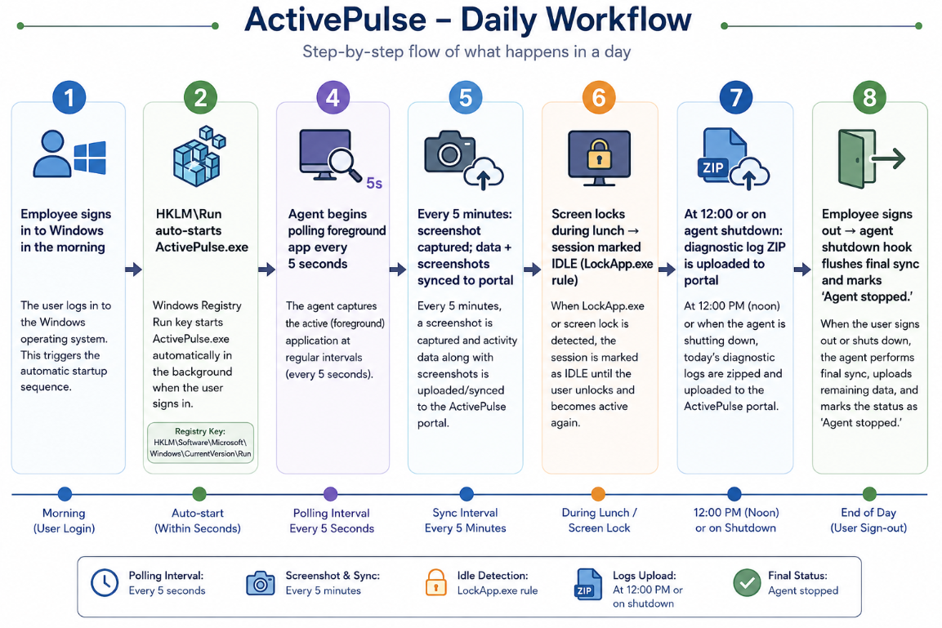

6. Supported Operating Systems
Operating System | Supported Architecture | Status
Microsoft Windows 10 (64-bit) | x64 | ✅ Supported
Microsoft Windows 11 (64-bit) | x64 | ✅ Supported
Linux | x64 | ✅ Supported
macOS (Intel-based Macs) | Intel x64 | ✅ Supported
macOS (Apple Silicon) | Apple M1, M2, M3, M4 (ARM64 | ✅ Supported

7. Configuration reference
Agent behavior is controlled by %LOCALAPPDATA%\ActivePulse\agent.env. On first run, this file is copied from src/main/resources/agent.env.template.
Config key | Purpose
SERVER_BASE_URL | Specify the portal API endpoint. The URL must end with /api and is required for data synchronization.
USER_ID | Portal-assigned user ID for this device.
ORGANIZATION_ID | Portal-assigned org ID.
AGENT_VERSION | Reported to portal in every sync payload.
SYNC_INTERVAL_SECONDS | How often to sync activity + strokes + screenshots (5 min).
SCREENSHOT_INTERVAL_SECONDS | Screenshot capture cadence.
ACTIVITY_POLL_SECONDS | Foreground window poll cadence.
STROKE_AGGREGATE_SECONDS | Keyboard/mouse count aggregation window.
DIAGNOSTICS_UPLOAD_CRON | 12 PM daily log upload (Asia/Kolkata TZ).
DIAGNOSTICS_UPLOAD_ENDPOINT_READY | Set to true once portal /api/api/sync/logs is live.
ENABLE_AUTOSTART | Whether to register HKLM Run key on first startup.
ENABLE_KEYBOARD_MOUSE | Whether to register JNativeHook global hook.
ENABLE_SCREENSHOTS | Whether to schedule Screenshot-Job.
ENABLE_WINDOW_TRACKING | Whether to schedule Activity-Job.
SKIP_USERS | Comma-separated list of usernames that cause silent exit.

8. Location Detection
When the user is working from home (i.e., the device is not connected to a configured office network), the ActivePulse agent determines the user's location using Google Geolocation APIs. The obtained latitude and longitude are converted into a readable address (City, State, Country, ZIP) using Google Reverse Geocoding. The agent also captures the user's public IP address and private IP address. This location information is included in every sync request sent to the server.
Workflow:
- Check if the device is connected to a configured office subnet.
- If not, treat the user as a WFH user.
- Fetch current coordinates using Google Geolocation API.
- Convert coordinates into address details using Google Reverse Geocoding.
- Capture public and private IP addresses.
- Send the location details in the sync payload.

9. API Configuration
Endpoint | Content-Type | Purpose
POST /api/sync/data | application/json | Activity + strokes + machine info
POST /api/sync/screenshots | multipart/form-data | Screenshot ZIP (up to 10 MB)
POST /api/sync/screenshots/chunk | multipart/form-data | 5 MB chunks for large uploads
POST /api/sync/logs | application/gzip | Agent diagnostic logs (planned)

Chunking
- Activity + strokes chunked at 5000 rows per POST (rare in practice)
- Each chunk gets syncId like SYNC-A1B2C3D4-PART-1, PART-2 etc.
- Screenshot ZIP: single upload if ≤5 MB,Chunked zip size > 5 MB

Failure handling
- HTTP 200: mark all rows as synced
- HTTP 4xx: log error, retry next cycle (data likely malformed)
- HTTP 5xx or timeout: retry next cycle (server issue)
- Network unreachable: no retry cost, next cycle just tries again

