Name:GARRE GAYATRI

Superset_ID:4993218

Gmail:2200100025iot@gmail.com

APP.js:

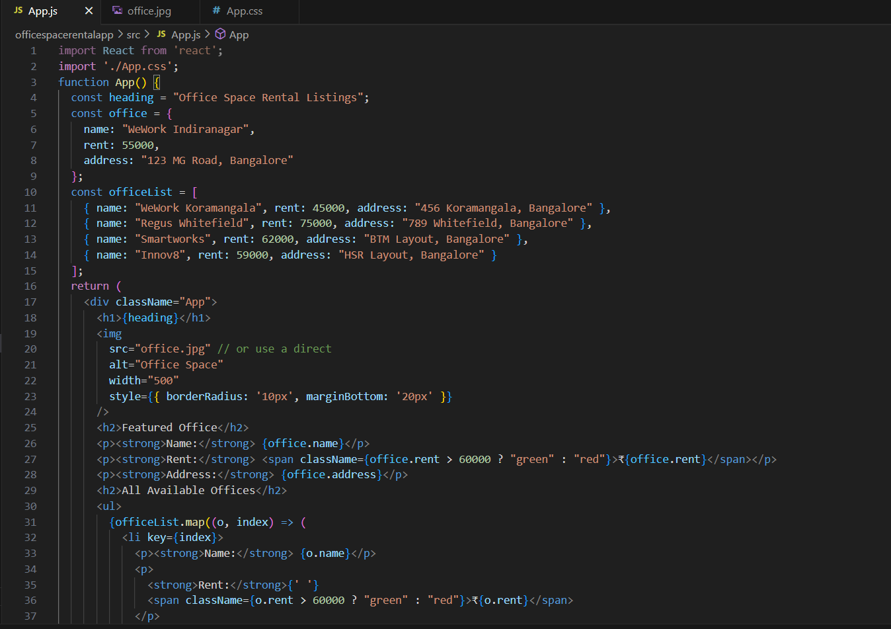

APP.css:

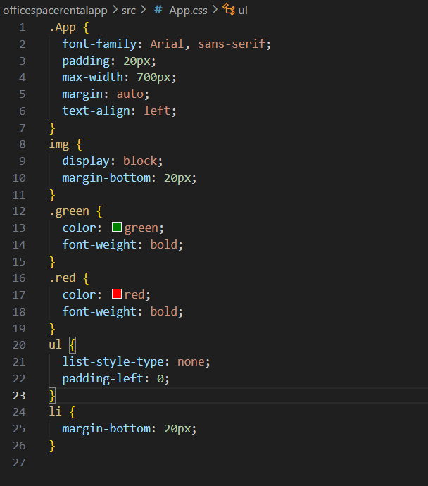

OUTPUT:

