Name:GARRE GAYATRI

Superset_ID:4993218

Gmail:2200100025iot@gmail.com

APP.js: 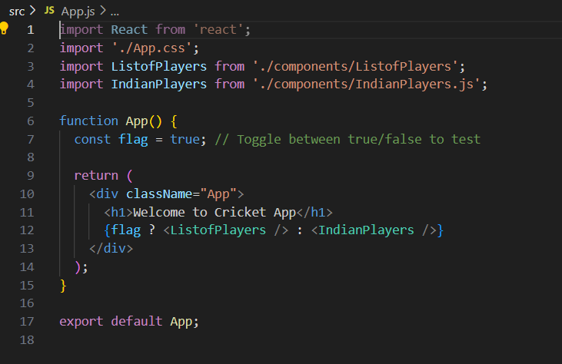

Indianplayers.js:

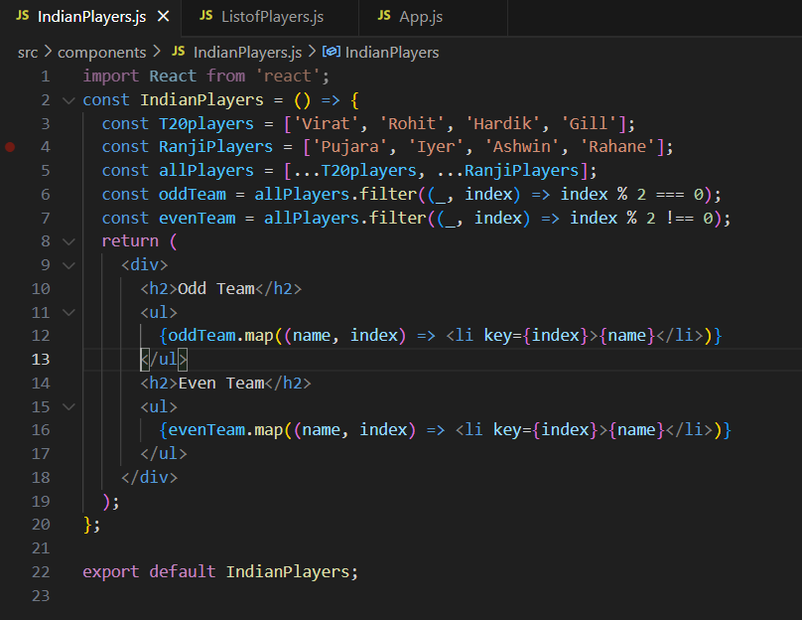

Listofplayers.js: 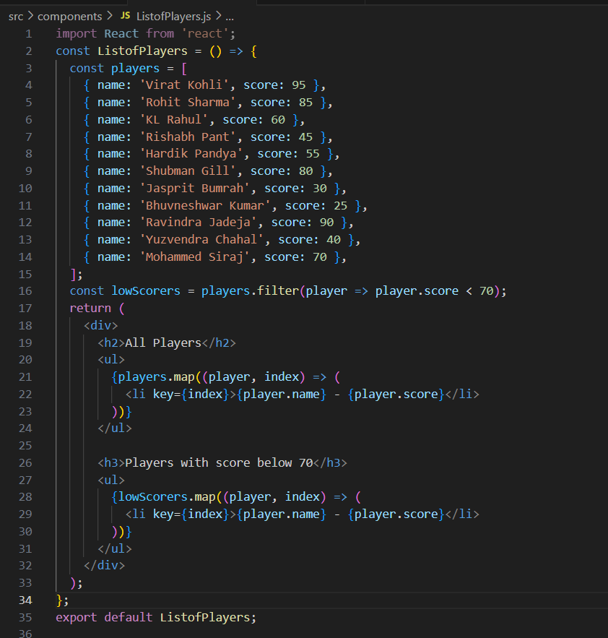

OUTPUT:

