Software Requirement Specification (SRS)
Project: Online Food Ordering Application

1. Document Control
Document Title | Online Food Ordering Application - SRS
Version | 1.0
Prepared By | [Business Analyst]
Reviewed By
Approved By

2. Introduction

2.1 Purpose
The purpose of this document is to define the functional and non-functional requirements for the Online Food Ordering Application. This application will enable customers to browse restaurants, order food online, make payments, and track deliveries in real time. It will also allow restaurants and delivery partners to manage their respective operations.

2.2 Scope
The application will be developed as a mobile-first solution (iOS and Android) with a supporting web admin panel. It integrates with third-party payment gateways and map APIs for location services.

2.3 Definitions, Acronyms, and Abbreviations
BRD – Business Requirement Document
SRS – Software Requirement Specification
FRD – Functional Requirement Document
UAT – User Acceptance Testing
UPI – Unified Payments Interface

3. Overall Description

3.1 Product Perspective
The application is a customer-facing mobile app supported by restaurant and delivery partner apps and an admin web panel. It will interface with payment gateways and mapping services.

3.2 User Classes and Characteristics
- Customers: End users ordering food.
- Restaurants: Vendors managing menus and orders.
- Delivery Partners: Personnel delivering orders.
- Admins: Manage the platform.

3.3 Assumptions and Dependencies
- Stable internet connection required.
- Dependence on third-party payment gateways and GPS services.
- Restaurants and delivery partners are onboarded.

4. Functional Requirements

User Management
Users shall be able to register, log in, and reset passwords.

Restaurant & Menu Management
Restaurants shall be able to create and update menus with prices, categories, and availability.

Order Management
Customers shall be able to add items to cart, place orders, and view order history. Restaurants shall receive notifications of new orders.

Payment Management
The system shall support UPI, credit/debit cards, wallets, and COD. Receipts shall be generated for successful transactions.

Delivery Management
The system shall assign delivery partners automatically and allow status updates (Picked Up, On the Way, Delivered).

Tracking & Notifications
Customers shall track orders in real time. Push notifications and SMS updates shall be sent at each order stage.

Feedback & Ratings
Customers shall rate and review restaurants and delivery partners.

5. Non-Functional Requirements

Performance
App should load within 3 seconds under normal load and support 10,000+ concurrent users.

Security
Sensitive data must be encrypted. Payment processing must comply with PCI DSS.

Availability
System availability of 99.9% required.

Scalability
System must scale to handle peak traffic during high-demand periods.

Usability
Mobile UI should be intuitive and accessible.

Compatibility
Support latest two versions of Android and iOS.

Reliability
Orders must not be lost; failed payments must trigger retry or refund.

6. Use Case Modeling
6.1 Actors: Customer, Restaurant, Delivery Partner, Admin
6.2 Major Use Cases: Register/Login, Browse Restaurants & Menus, Add to Cart, Place Order, Make Payment, Track Order, Update Delivery Status, Provide Feedback
Use Case Diagram: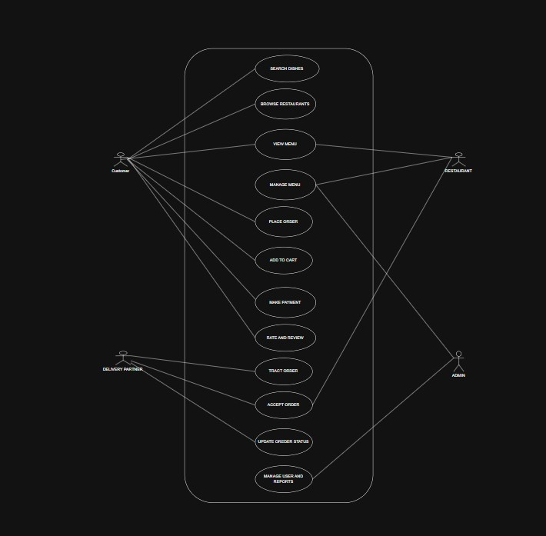

7. Business Process Flow (Flowchart)
The following flowchart shows the detailed order process including decision points such as payment success/failure.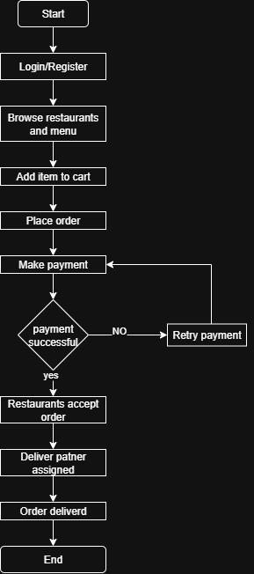

8. Acceptance Criteria
- Users can register, login, and access profiles.
- Customers can browse restaurants and menus.
- Customers can add items to a cart and place orders successfully.
- Payments must be secure and generate receipts.
- Customers can track orders in real time.
- Restaurants can update menus and accept/reject orders.
- Delivery partners can update delivery status.
- System meets defined non-functional requirements.

9. Sign-Off
Role | Name | Signature | Date
Business Sponsor
Product Owner / Client
Project Manager
Business Analyst
Development Lead
QA/Test Lead

