Practicle No :- 2
Laboratory Name :- Operating System Lab
Experiment Name :- Implement producer-consumer problem with
Problem Statement :-Implementation of producer-consumer problem
Student Name :- Gayatri Rajendra Jagadale
Class :- SE(AI&DS)
Roll NO :- 20
Batch :- A

********Program Input*************

#include<pthread.h>
#include<stdio.h>
#include<semaphore.h>
int buffer[100],size=5;
sem_t empty,full;
int i,j,counter;
pthread_mutex_t mutex;
void * producer(void * i)
{
int num=(int)i;
sem_wait(&empty);
pthread_mutex_lock(&mutex);
buffer[counter]=num;
counter++;
printf("\nproduced:%d",num);
pthread_mutex_unlock(&mutex);
sem_post(&full);
}
void * consumer(void * i)
{
int num=(int)i;
sem_wait(&full);
pthread_mutex_lock(&mutex);
num= buffer[counter-1];
counter--;
printf("\nconsumed:%d",num);
pthread_mutex_unlock(&mutex);
sem_post(&empty);
}
int main()
{
pthread_t tid[10];
int noc=5,nop=5;
sem_init(&empty,0,size);
sem_init(&full,0,0);
pthread_mutex_init(&mutex,NULL);
for(i=0;i<nop;i++)
{
pthread_create(&tid[i],NULL,producer,(void *)i+1);
}
for(j=0;j<nop;j++)
{
pthread_join(tid[j],NULL);
}
for(i=0;i<noc;i++)
{
pthread_create(&tid[i],NULL,consumer,(void *)i+1);
}
for(j=0;j<noc;j++)
{
pthread_join(tid[j],NULL);
}
}

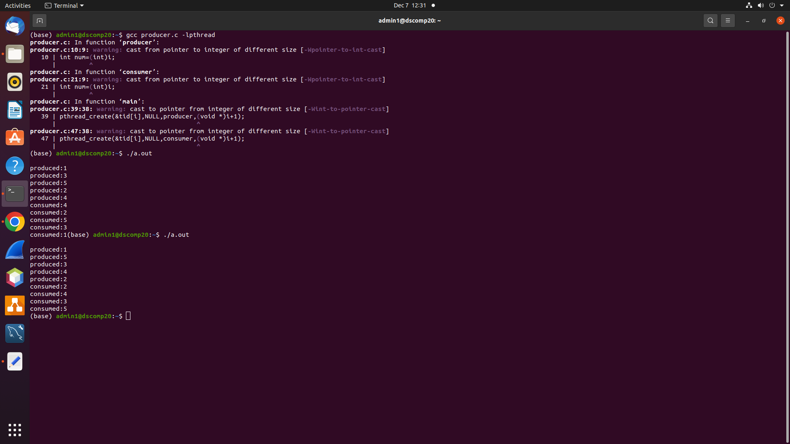
***********Program Output*************

