Experiment No :- 3
Laboratory Name :- Operating System Lab
Experiment Name :- Demonstrate Reader-Writer problem with reader
Problem Statement :-Implementation of reader-writer problem.
Student Name :- Gayatri Rajendra Jagadale
Class :- SE(AI&DS)
Roll NO :- 20
Batch :- A

********Program Input*************

#include<stdio.h>
#include<pthread.h>
pthread_mutex_t ra,wa;
int a=100;
int readcount=0;

void * reader(void *i)
{
int num=(int)i;

printf("\n reader is %d is trying to read the data\n",num);

pthread_mutex_lock(&ra);
readcount++;
if(readcount==1)
{
pthread_mutex_lock(&wa);
}
sleep(1);
printf("\nreader %d is reading data %d",num,a);
pthread_mutex_unlock(&ra);
readcount--;
if(readcount==0)
{
pthread_mutex_unlock(&wa);
}
printf("\nreader %d has released lock\n",num);
}

void * writer(void *i)
{
int num=(int)i;
printf("\n writer is %d try to write the data\n",num);
pthread_mutex_lock(&wa);
sleep(1);
printf("\nwriter %d is writing the data %d",num,a++);
pthread_mutex_unlock(&wa);
printf("\nwriter %d has realease the lock\n",num);

}

int main()
{
pthread_t tid1[10],tid2[10];

int i,j;
int no_r,no_w;
printf("enter the number of readers and writers=");
scanf("%d%d",&no_r,&no_w);
pthread_mutex_init(&ra,NULL);
pthread_mutex_init(&wa,NULL);
for(i=0;i<no_r;i++)
{
pthread_create(&tid1[i],NULL,reader,(void *)i+1);
}

for(i=0;i<no_w;i++)
{
pthread_create(&tid2[i],NULL,writer,(void *)i+1);
}

for(j=0;j<no_r;j++)
{
pthread_join(tid1[j],NULL);
}

for(j=0;j<no_w;j++)
{
pthread_join(tid2[j],NULL);
}

return 0;
}

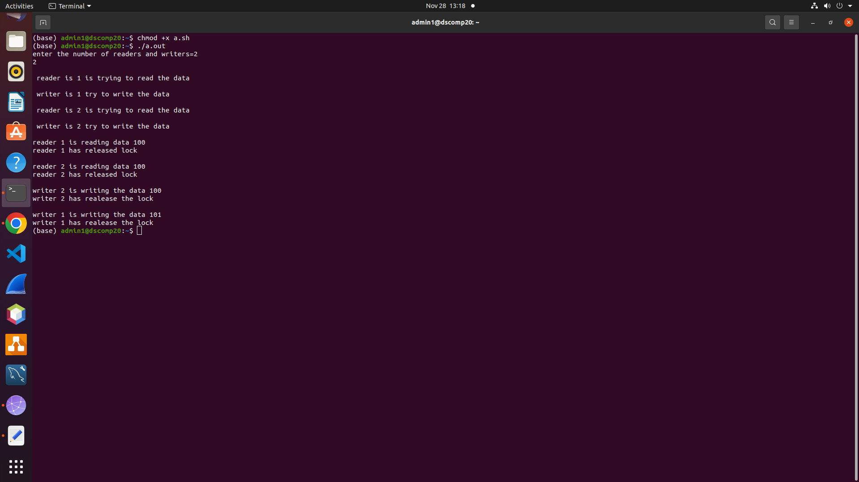
***************Program Output****************

