Practicle No :- 9
Laboratory Name :- Operating System Lab
Experiment Title :- Create a shell program to find string in a file using grep
Problem Statement :-Implementation of grep system call to find the string in a
file in shell programming.
Student Name :- Gayatri Rajendra Jagadale
Class :- SE(AI&DS)
Roll NO :- 20
Batch :- A

***********Program Input************
echo "enter the file name = "
read fname
xy=`ls | grep $fname -c`
if [ $xy -gt 0 ]
then
echo "file found sucessfully..."
echo "enter the word to be search"
read word
yp01=`cat $fname | grep -w $word -c`
cat $fname | grep -w $word > temp_file
if [ $yp01 -gt 0 ]
then
echo "the word is found $yp01 times in the file"
echo " "
echo "The output is"
echo " "
cat temp_file
else
echo "the word is not found"
fi
else
echo "file not found"
fi

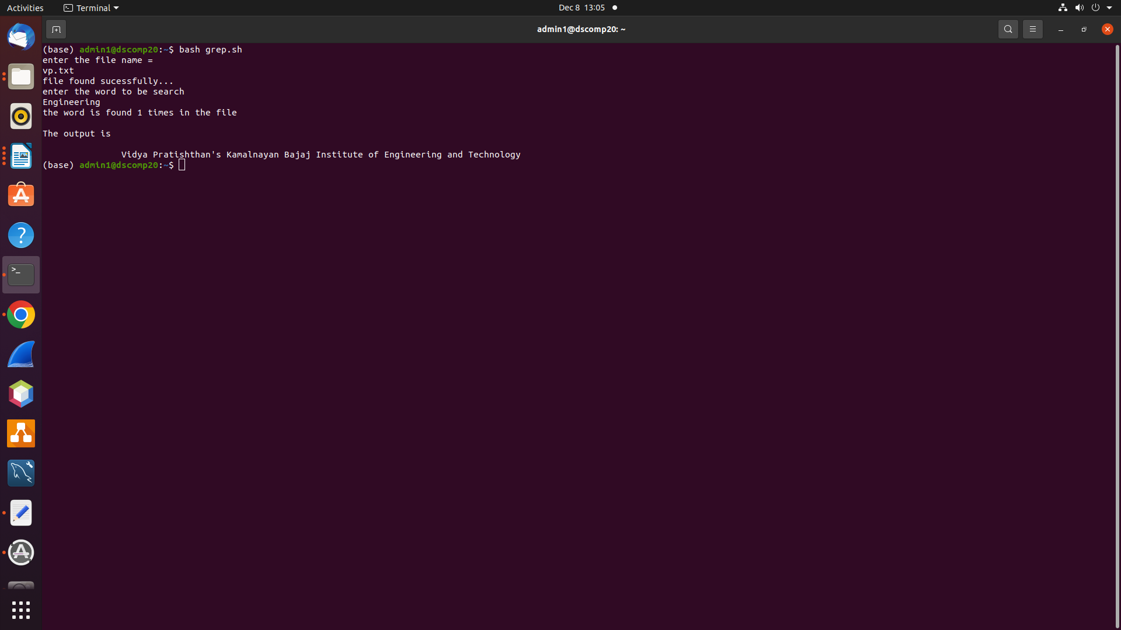
************Program Output******************

