Experiment No :- 7
Laboratory Name :- Operating System Lab
Experiment Title :- Write a program to implement the Bankers Algorithm.
Problem Statement :- Write a program to implement the Bankers Algorithm.
Student Name :- Gayatri Rajendra Jagadale
Class :- SE(AI&DS)
Roll NO :- 20
Batch :- A

*************Progarm Input*************

create()
{
echo "Enter name of address book to be created = "
read fname
ab=`ls | grep $fname | wc -w`
if [ $ab -gt 0 ]
then
echo "File is already present"
else
echo "File is not present"
touch $fname
echo "File created sucessfully"
fi
}
display()
{
echo "Enter name of address book to be display = "
read fname
ab=`ls | grep $fname | wc -w`
if [ $ab -gt 0 ]
then
echo "File is already present"
cat $fname
else
echo "File is not present"
fi
}
insert()
{
echo "Enter name of address book for insertion= "
read fname
ab=`ls | grep $fname | wc -w`
if [ $ab -gt 0 ]
then
echo "File is present"
echo "Enter the series number"
read srno
sr01=`cat $fname | grep $srno | wc -w`
if [ $sr01 -gt 0 ]
then
echo"srno is present"
else
echo "srno is present"
echo "srno is NOT present"
echo "Enter name :"
read name
record=`echo $srno $name`
echo $record >> $fname
echo "Record added successfully"
fi
else
echo "File is not present"
fi
}
delete()
{
echo "Enter name of address book for deletion = "
read fname
File: /home/student/swan_addressbook.sh Page 2 of 3
ab=`ls | grep $fname | wc -w`
if [ $ab -gt 0 ]
then
echo "File is present"

echo "Enter the series number for delete it"
read srno
sr01=`cat $fname | grep $srno | wc -w`
if [ $sr01 -gt 0 ]
then
echo "srno is present"
old=`cat $fname | grep $srno`
echo "old record = $old"
sed -i s/"$old"/"deleted"/g $fname
echo "record deletion successfull"
else
echo "srno is NOT present"
fi
else
echo "file is not present"
fi
}
modify()
{
echo "Enter name of address book for modification = "
read fname
ab=`ls | grep $fname | wc -w`
if [ $ab -gt 0 ]
then
echo "File is present"
echo "Enter the series number for modification"
read srno
sr01=`cat $fname | grep $srno | wc -w`
if [ $sr01 -gt 0 ]
then
echo "srno is present"
old=`cat $fname | grep $srno`
echo "old record = $old"
echo "Enter new name"
read newname
new=`echo $srno $newname`
echo "new record = $new"
sed -i s/"$old"/"$new"/g $fname
else
echo "srno is NOT present"
fi
else
echo "File is not present"
fi
}
while [ true ]
do
echo "******** M E N U *******"
echo "1) Create address book "
echo "2) Display address book"
echo "3) insert a record"
echo "4) Delete a record"
echo "5) Modify a record"
echo "6) Exit"
echo "Enter your choice = "
read choice
clear
File: /home/student/swan_addressbook.sh Page 3 of 3
case $choice in
1) create ;;
2) display ;;
3) insert;;
4) delete;;
5) modify;;
6) exit ;;
*) echo " Please Enter a valid choice..."

esac
done

**********Program Output****************
1) Create address book
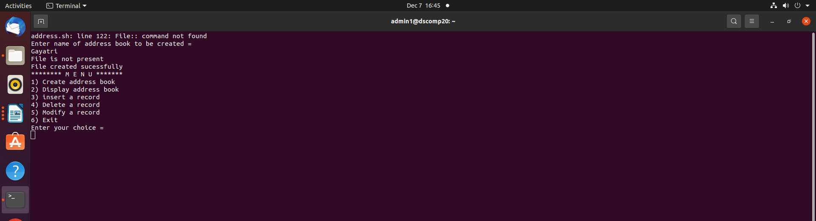

2)Display address book
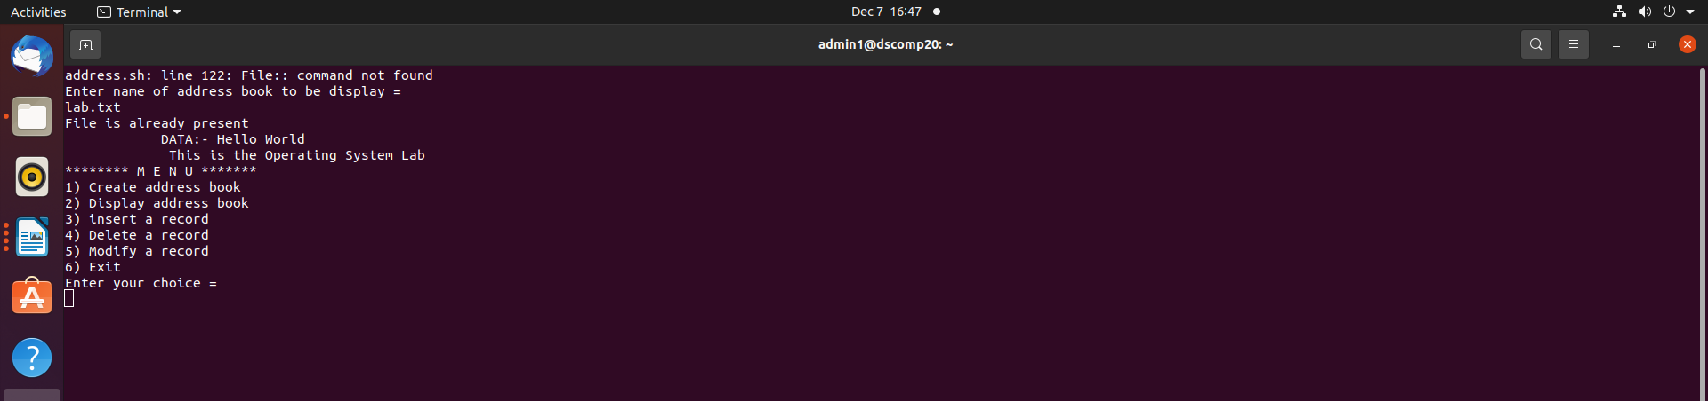

3)Inset record
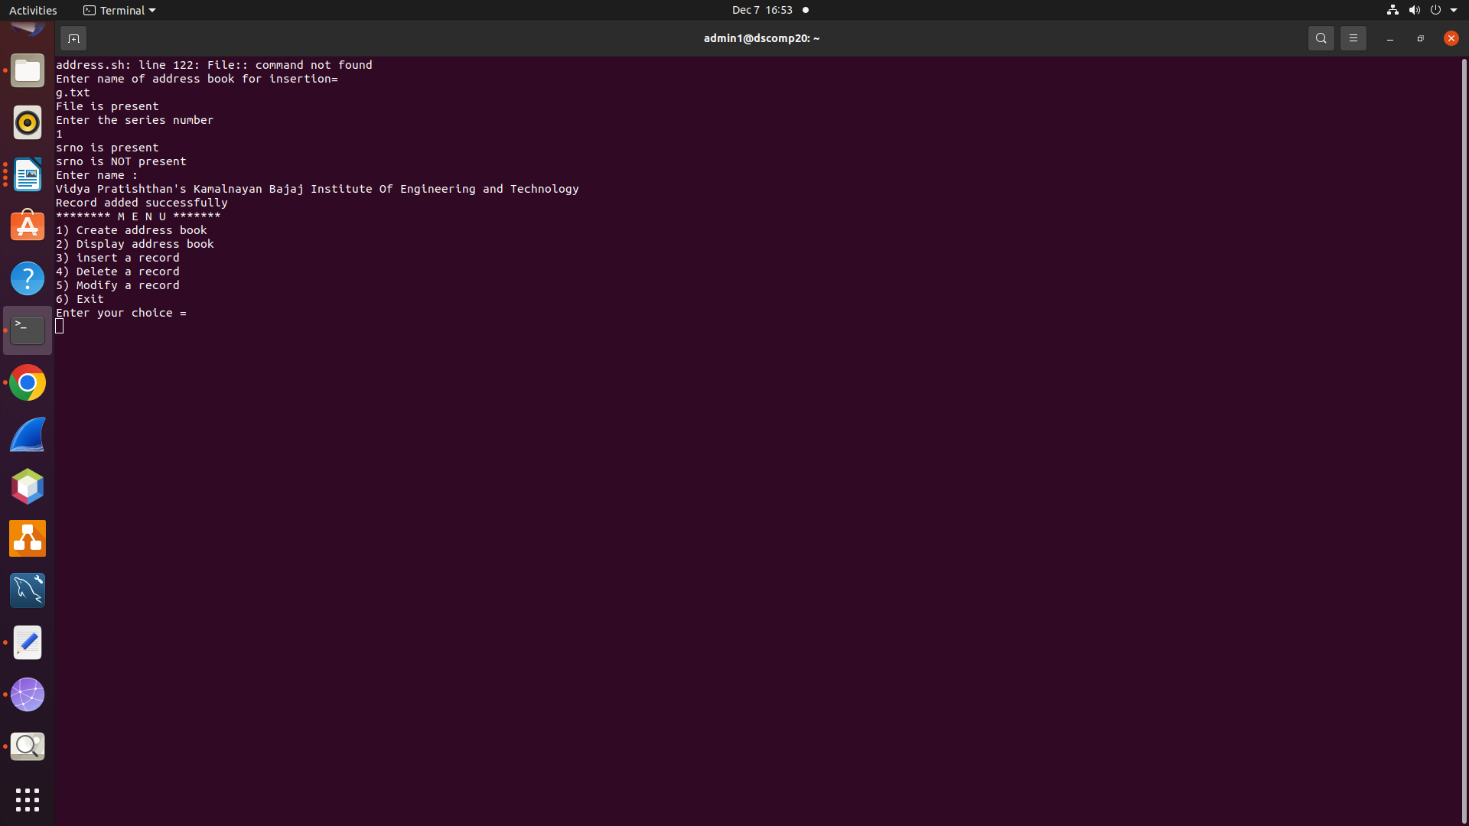

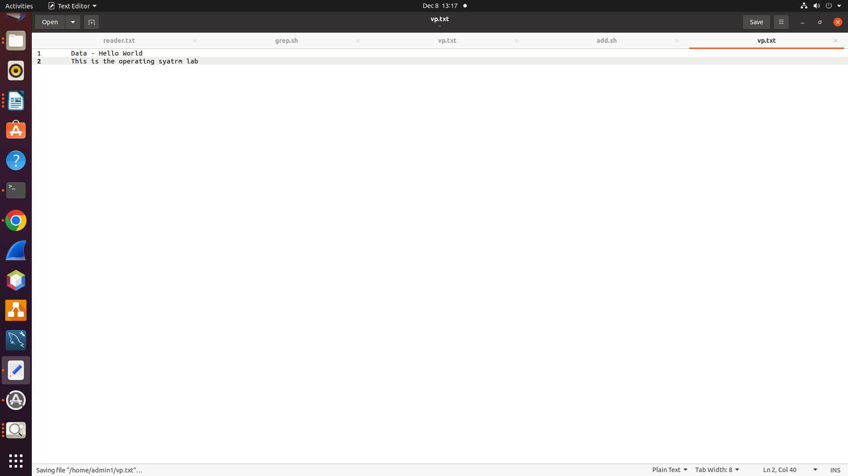

4)Delet the record

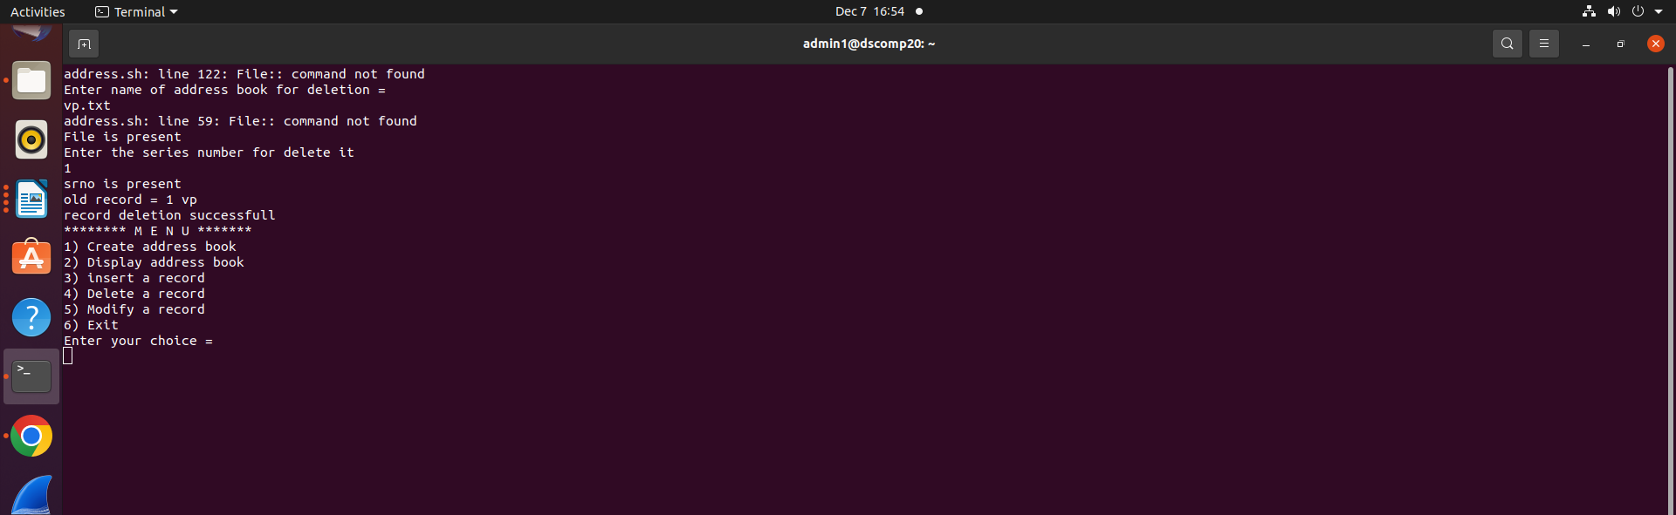
5)Modify record

Befor modification file-
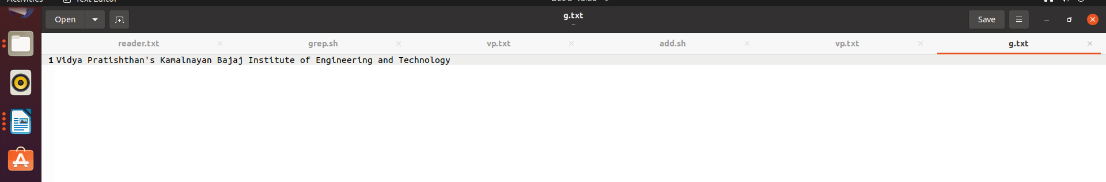
After modification file-

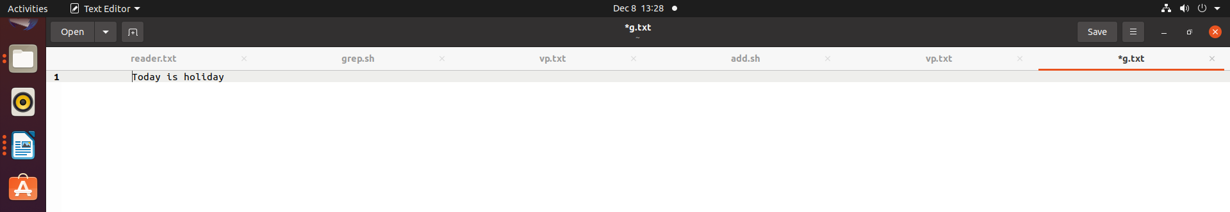

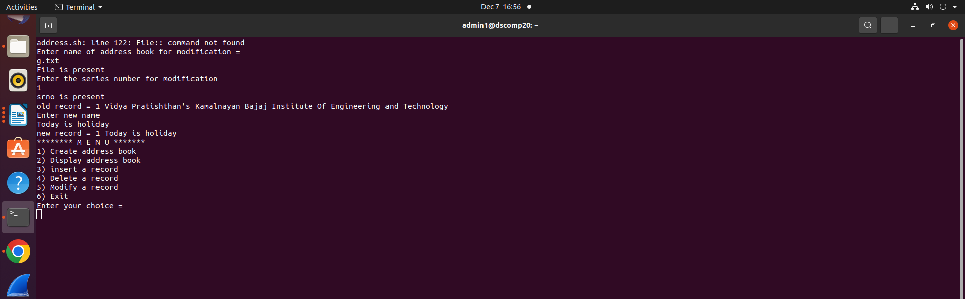
6)Exit

