Experiment No :- 5
Laboratory Name :- Operating System Lab
Experiment Title :- Page Replacement strategies
Problem Statement:-Write a program to implement page Replacement strategies
(FIFO,LRU,Optimal).
Student Name :- Gayatri Rajendra Jagadale
Class :- SE(AI&DS)
Roll NO :- 20
Batch :- A

***********Program Input************

#include<stdio.h>

int n,nf;
int in[100];
int p[50];
int hit=0;
int i,j,k;
int pgfaultcnt=0;

void getData()
{
printf("\nEnter length of page reference sequence:");
scanf("%d",&n);
printf("\nEnter the page reference sequence:");
for(i=0; i<n; i++)
scanf("%d",&in[i]);
printf("\nEnter no of frames:");
scanf("%d",&nf);
}
void initialize()
{
pgfaultcnt=0;
for(i=0; i<nf; i++)
p[i]=9999;
}
int isHit(int data)
{
hit=0;
for(j=0; j<nf; j++)
{
if(p[j]==data)
{
hit=1;
break;
}
}
return hit;
}
int getHitIndex(int data)
{
int hitind;
for(k=0; k<nf; k++)
{
if(p[k]==data)
{
hitind=k;
break;
}
}
return hitind;
}
void dispPages()
{
for (k=0; k<nf; k++)
{
if(p[k]!=9999)
printf(" %d",p[k]);
}
}
void dispPgFaultCnt()
{
printf("\nTotal no of page faults:%d\n",pgfaultcnt);
}
void fifo()
{
initialize();
printf("FIFO\n");
for(i=0; i<n; i++)
{
printf("\nFor %d :",in[i]);
if(isHit(in[i])==0)
{
for(k=0; k<nf-1; k++)
p[k]=p[k+1];
p[k]=in[i];
pgfaultcnt++;
dispPages();
}
else
printf("No page fault");
}
dispPgFaultCnt();
}
void optimal()
{
initialize();
printf("Optimal\n");
int near[50];
for(i=0; i<n; i++)
{
printf("\nFor %d :",in[i]);
if(isHit(in[i])==0)
{
for(j=0; j<nf; j++)
{
int pg=p[j];
int found=0;
for(k=i; k<n; k++)
{
if(pg==in[k])
{
near[j]=k;
found=1;
break;
}
else
found=0;
}
if(!found)
near[j]=9999;
}
int max=-9999;
int repindex;
for(j=0; j<nf; j++)
{
if(near[j]>max)
{
max=near[j];
repindex=j;
}
}
p[repindex]=in[i];
pgfaultcnt++;
dispPages();
}
else
printf("No page fault");
}
dispPgFaultCnt();
}
void lru()
{
initialize();
printf("LRU\n");
int least[50];
for(i=0; i<n; i++)
{
printf("\nFor %d :",in[i]);
if(isHit(in[i])==0)
{
for(j=0; j<nf; j++)
{
int pg=p[j];
int found=0;
for(k=i-1; k>=0; k--)
{
if(pg==in[k])
{
least[j]=k;
found=1;
break;
}
else
found=0;
}
if(!found)
least[j]=-9999;
}
int min=9999;
int repindex;
for(j=0; j<nf; j++)
{
if(least[j]<min)
{
min=least[j];
repindex=j;
}
}
p[repindex]=in[i];
pgfaultcnt++;
dispPages();
}
else
printf("No page fault!");
}
dispPgFaultCnt();
}
int main()
{
int choice;
while(1)
{
printf("\nPage Replacement Algorithms\n1.Enterdata\n2.FIFO\n3.Optimal\n4.LRU\n5.Exit\nEnter your choice:");
scanf("%d",&choice);
switch(choice)
{
case 1:
getData();
break;
case 2:
fifo();
break;
case 3:
optimal();
break;
case 4:
lru();
break;

default:
return 0;
break;
}
}
}

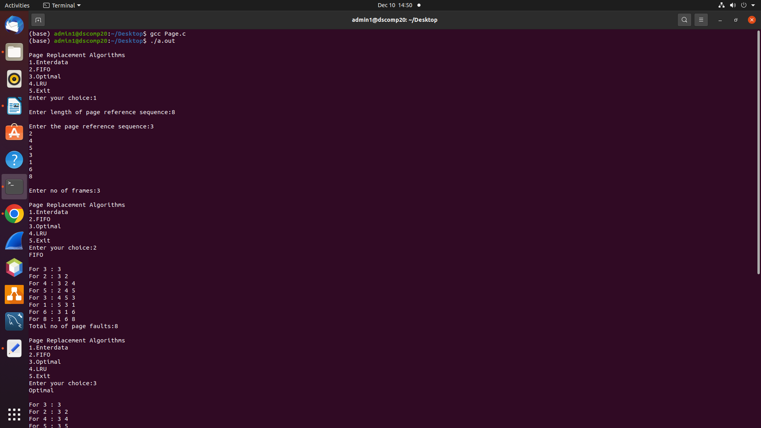
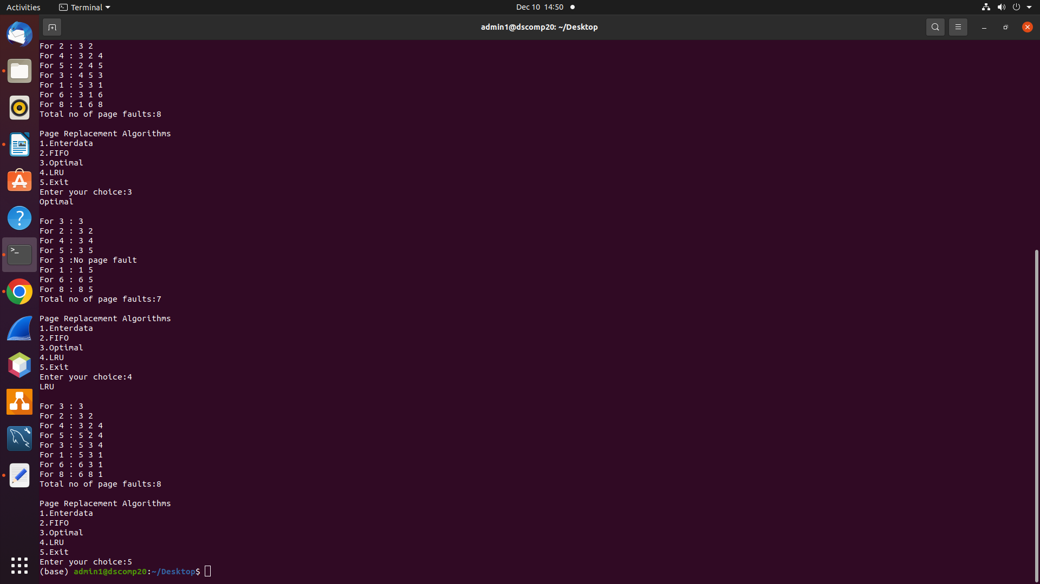
**************Program Output*****************

