Experiment No :- 1
Laboratory Name :- Operating System Lab
Experiment Title:- Given the list of processes, their CPU burst times. Display/print the Gantt
chart for FCFS, SJF, Priority and Round Robin scheduling
algorithm. Compute and print the average waiting time
and average turnaround time.
Problem Statement :- Implementation of CPU scheduling algorithms.
Student Name :- Gayatri Rajendra Jagadale
Class :- SE(AI&DS)
Roll NO :- 20
Batch :- A

#include<stdio.h>
int process[]={1,2,3};
int BT[]={3,5,10};
int WT[]={0,0,0};
int TAT[]={0,0,0};
int priority[]={2,1,3};
void FCFS();
void Priority()
{
int i,j,temp;
for(i=0;i<3;i++)
{
for(j=i+1;j<3;j++)
{
if(priority[i]>priority[j])
{
temp=priority[i];
priority[i]=priority[j];
priority[j]=temp;
temp=process[i];

process[i]=process[j];
process[j]=temp;
temp=priority[i];
priority[i]=priority[j];
priority[j]=temp;
}
}
}
printf("\nSorted on priority");
for(i=0;i<3;i++)
{
printf("P%d %d %d",process[i],BT[i],priority[i]);
}
FCFS();
}
void SJF()
{
float avg_WT=0;
float avg_TAT=0;
int temp;
int i,j;
for(i=0;i<3;i++)

{
for(j=i+1;j<3;j++)
{
if(BT[i]>BT[j])
{
temp=BT[i];
BT[i]=BT[j];
BT[j]=temp;
temp=process[i];
process[i]=process[j];
process[j]=temp;
}
}
}
printf("\nSorted on BT");
for(i=0;i<3;i++)
{
printf("P%d %d",process[i],BT[i]);
}
FCFS();
}

void Round_robin()
{
int i,j,n,time,remain,flag=0,time_quantum;
int wait_time=0,turnaround_time=0,at[10],bt[10],rt[10];
remain=process[3];
for(i=0;i<3;i++)
{
printf("Enter Arrival Time and Burst Time for ProcessProcess Number %d :",i+1);
scanf("%d",&at[i]);
//scanf("%d",&bt[i]);
rt[i]=BT[i];
}
printf("Enter Time Quantum:\t");
scanf("%d",&time_quantum);
printf("\n\nProcess\t|Turnaround Time|WaitingTime\n\n");
for(time=0,i=0;remain!=0;)
{
if(rt[i]<=time_quantum && rt[i]>0)
{
time+=rt[i];

rt[i]=0;
flag=1;
}
else if(rt[i]>0)
{
rt[i]-=time_quantum;
time+=time_quantum;
}
if(rt[i]==0 && flag==1)
{
remain--;
printf("P[%d]\t|\t%d\t|\t%d\n",i+1,time-at[i],time-at[i]-bt[i]);
wait_time+=time-at[i]-bt[i];
turnaround_time+=time-at[i];
flag=0;
}
if(i==n-1)
i=0;
else if(at[i+1]<=time)
i++;
else

i=0;
}
printf("\nAverage Waiting Time= %d\n",wait_time);
printf("Avg Turnaround Time = %d",turnaround_time);

}

void FCFS()
{
float avg_WT=0;
float avg_TAT=0;
int i,j;
WT[0]=0;
TAT[0]=BT[0]+WT[0];
avg_TAT=TAT[0];
for(i=1;i<4;i++)
{
WT[i]=WT[i-1]+BT[i-1];
TAT[i]=BT[i]+WT[i];
avg_WT=avg_WT+WT[i];

}

avg_TAT=avg_TAT+TAT[i];

avg_WT=avg_WT/3;
avg_TAT=avg_TAT/3;
printf("\n");
printf("\nProcess Burst-time Waiting-time");
printf("\nTurnaround-time Priority");
printf("\n");
for(i=0;i<3;i++)
{
printf("\n P%d \t %d \t\t %d \t\t %d \t\t%d",process[i],BT[i],WT[i],TAT[i],priority[i]);

}
printf("\n");
printf("\n Average Waiting Time =%f",avg_WT);
printf("\n Average Turn-around Times=%f",avg_TAT);

printf("\n \n");
for(i=0;i<3;i++)
{

printf("|");
for (j=0;j<BT[i];j++)
printf("-");
}
printf("|");
}

void menu()
{
int choice,i,j;
while(1)
{
printf("\n*SCHEDULING ALOGRITHM**");
printf("\n 1.FCFS");
printf("\n 2.Shortest Job First");
printf("\n 3.Priority");
printf("\n 4.Round Robin");
printf("\n 99.exit");
printf("\nEnter your choice: ");
scanf("%d",&choice);
switch(choice)
{

case 1:FCFS();
break;
case 2:SJF();
break;
case 3:Priority();
break;
case 4:Round_robin();
break;
case 5:return;
default: printf("\n wrong input");
}
}
}
int main()
{
menu();
return 0;
}

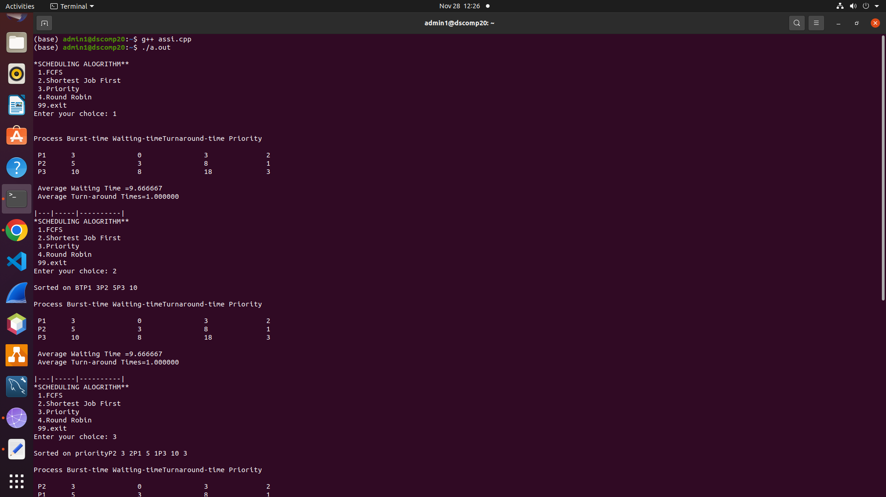
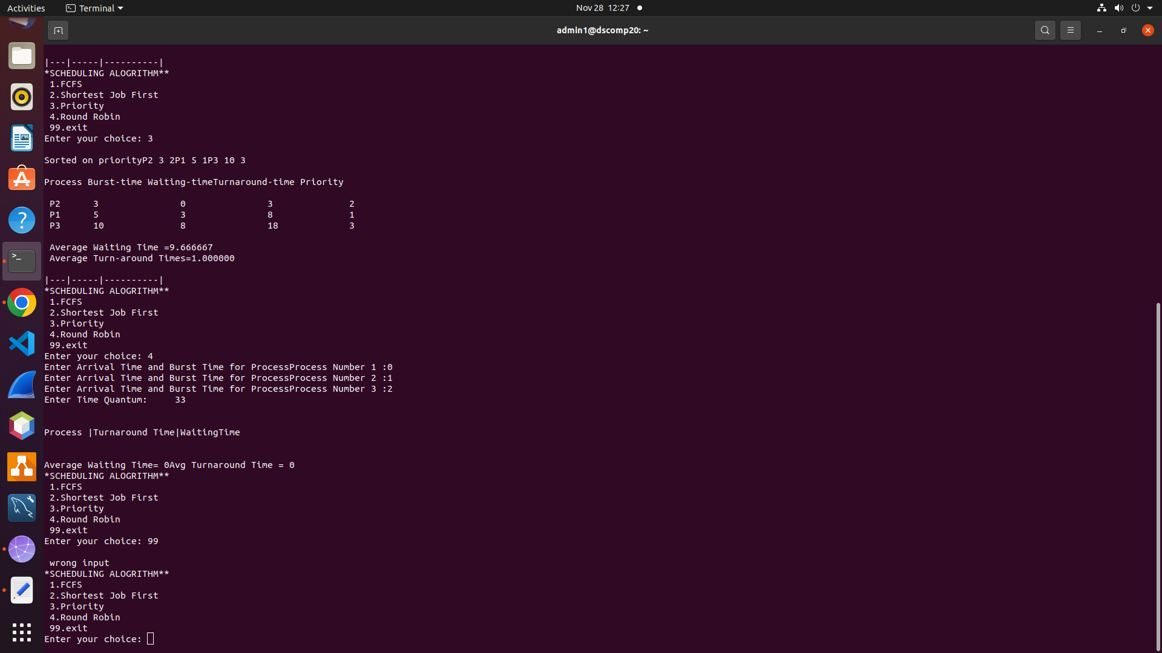
************Program Output****************

