Field Work
On
Digital Payment in System (UPI)
Submitted to
KCES’s Institute of Management and Research, Jalgaon



Submitted by
Name: Gayatri Devidas kakade
Email id: gayatrikakade2007@gmail.com
Under the Guidance of
Name: Dr. Deepali Kirange
In Partial Fulfillment of
Master of Computer Application(Integrated)
Kavayitri Bahinabai Chaudhari North Maharashtra University, Jalgaon

INDEX
SR.NO. | TOPIC | PAGE NO
1 | Introduction | 03-06
2 | Objectives | 07
3 | Proposed System (DFD, ERD, Database Design) | 08-11
4 | Methodology | 12-14
5 | Implementation(Code) | 15-24
6 | Testing and Results | 25-40
7 | Conclusion and Future Scope | 41-42

- Introduction
  - Digital Payment:-Digital payment is a modern method of transferring money electronically without using cash. It allows individuals and businesses to make payments through digital platforms such as mobile apps, internet banking, and payment cards. With the rise of technology and smartphones, digital payments have become an essential part of daily life.They make transactions faster, safer, and more convenient. Instead of carrying cash, people can use UPI apps like Google Pay, PhonePe, or Paytm to pay bills, shop online, or send money instantly. Digital payments also help promote a cashless economy and improve transparency in financial transactions.
The following figure represents the concept of a digital payment system used for electronic money transactions.
1.1.1 Unified Payments Interface (UPI)


Fig. 1.1.1
The following figure shows the Unified Payments Interface (UPI), which enables instant digital payments and money transfers.
UPI (Unified Payments Interface) is a digital payment system developed by NPCI that allows users to transfer money instantly between bank accounts using a mobile phone. Users can send or receive money using a UPI ID, mobile number, or QR code, without sharing bank account details. UPI is fast, secure, convenient, and available 24×7.

1.1.2 PhonePe



Fig. 1.1.2
The following figure 1.1.2 shows PhonePe, a UPI-based digital payment application used for money transfers and other payment services.
PhonePe is a popular UPI-based digital payment application. It allows users to send and receive money, recharge mobile phones, pay bills, shop online, and access financial services through one application.

1.1.3 Google Pay



Fig. 1.1.3
The following figure 1.1.3 shows Google Pay, a UPI-based digital payment application used for online payments and money transfers.
Google Pay is a digital payment application based on UPI. It allows users to transfer money directly between bank accounts, make payments, and pay bills using a smartphone.

1.1.4 Paytm

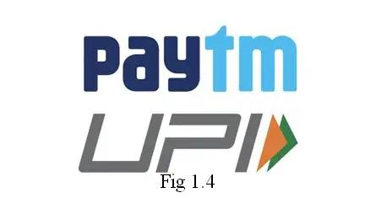

Fig. 1.1.4
The following figure 1.1.4 shows Paytm, a digital payment platform that provides various online payment and financial services.
Paytm is a digital payment platform that provides services such as money transfer, mobile recharge, bill payments, online shopping, banking, investments, and insurance.

1.1.5 BHIM App



Fig. 1.1.5
The following figure shows the BHIM application, a UPI-based digital payment application used for sending and receiving money.
BHIM (Bharat Interface for Money) is a UPI-based payment application developed by NPCI. It allows users to send and receive money instantly using UPI IDs, mobile numbers, and QR codes and promotes digital payments.

1.2 How UPI Works
- Install a UPI application such as PhonePe, Google Pay, Paytm, or BHIM.
- Link your bank account with the application.
- Create a secure UPI PIN.
- Send or receive money using a UPI ID, mobile number, or QR code.
1.3 Smartpay:- SmartPay is a web-based digital payment and financial services application developed using Python Flask, MySQL, HTML, CSS and JavaScript. The main purpose of SmartPay is to provide multiple payment and financial services through a single platform.
SmartPay allows users to register and login, manage their wallet balance, send money using UPI ID, generate QR codes, pay bills, view transaction history and manage their profile. It also includes financial-service modules such as Insurance, Mutual Funds and Deposits.
The system stores user and transaction information in a MySQL database and uses Flask for backend processing and validation. SmartPay is developed as an academic project to demonstrate how a digital payment application can be designed and implemented using modern web technologies.

- Objectives
- To develop a user-friendly digital payment platform for managing online payment-related services.
- To allow users to register, login and manage their profile securely.
- To provide a facility for sending money using UPI ID.
- To provide QR code generation and scanning-based payment functionality.
- To enable users to pay different types of bills through a single platform.
- To maintain and display transaction history for better tracking of payments.
- To provide additional financial services such as Insurance, Mutual Funds and Deposits.
- To store and manage user and transaction data using a MySQL database.
- To demonstrate the practical implementation of a digital payment system using Flask, HTML, CSS, JavaScript and MySQL.
- To provide a simple and convenient platform where multiple digital payment and financial services are available in one place.

Proposed System
The proposed system is SmartPay, a web-based digital payment and financial services website developed to provide multiple financial activities through a single platform. The main purpose of SmartPay is to provide users with a simple, organized and convenient interface for managing digital payments and other financial services.
3.1 System Design (DFD, ERD, Database Design):-
The System Design of SmartPay explains how the different modules of the website interact with users, application processes and the database. It consists of the Data Flow Diagram (DFD), Entity Relationship Diagram (ERD), and Database Design.

3.1.1 Data Flow Diagram :-
The DFD represents the flow of data between the user, SmartPay application modules and database.
The following figure 3.1.1 shows the Level 0 Data Flow Diagram (DFD) of the SmartPay system.

Level 0:-

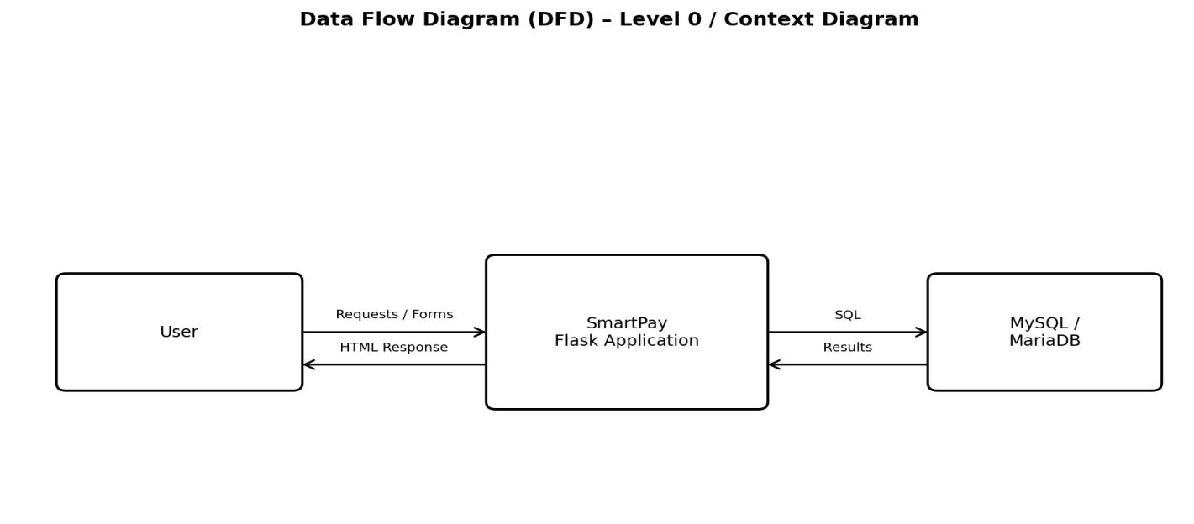
Fig 3.1.1 (Level 0)

Level 1:-
Level 1 separates the main processing areas into Authentication, Payments, Bill Payment and Financial Services. These modules use user/wallet data, transaction data and financial-service records.
The following figure 3.1.1 shows the Level 1 Data Flow Diagram (DFD) representing the detailed flow of data between different modules of the SmartPay system.
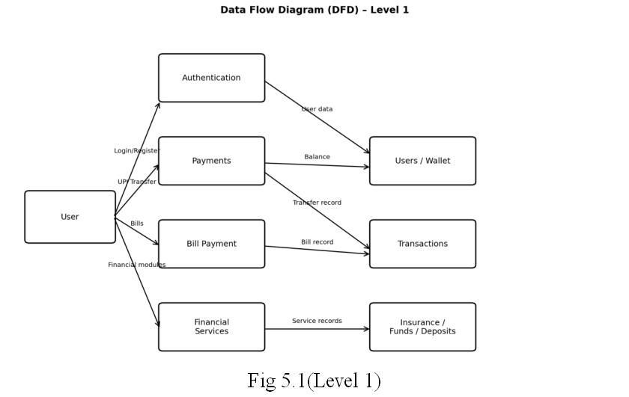
Fig 3.1.1 (Level 1)

3.2 Entity Relationship Diagram (ERD):-
The ERD represents the relationship between the main entities used in SmartPay.
The main entity is the Users table. A user can have multiple records in different modules such as transactions, bill payments, insurance, mutual funds, deposits and notifications.
The following figure 3.2 shows the Entity Relationship Diagram (ERD) of the SmartPay system and the relationships between different entities.

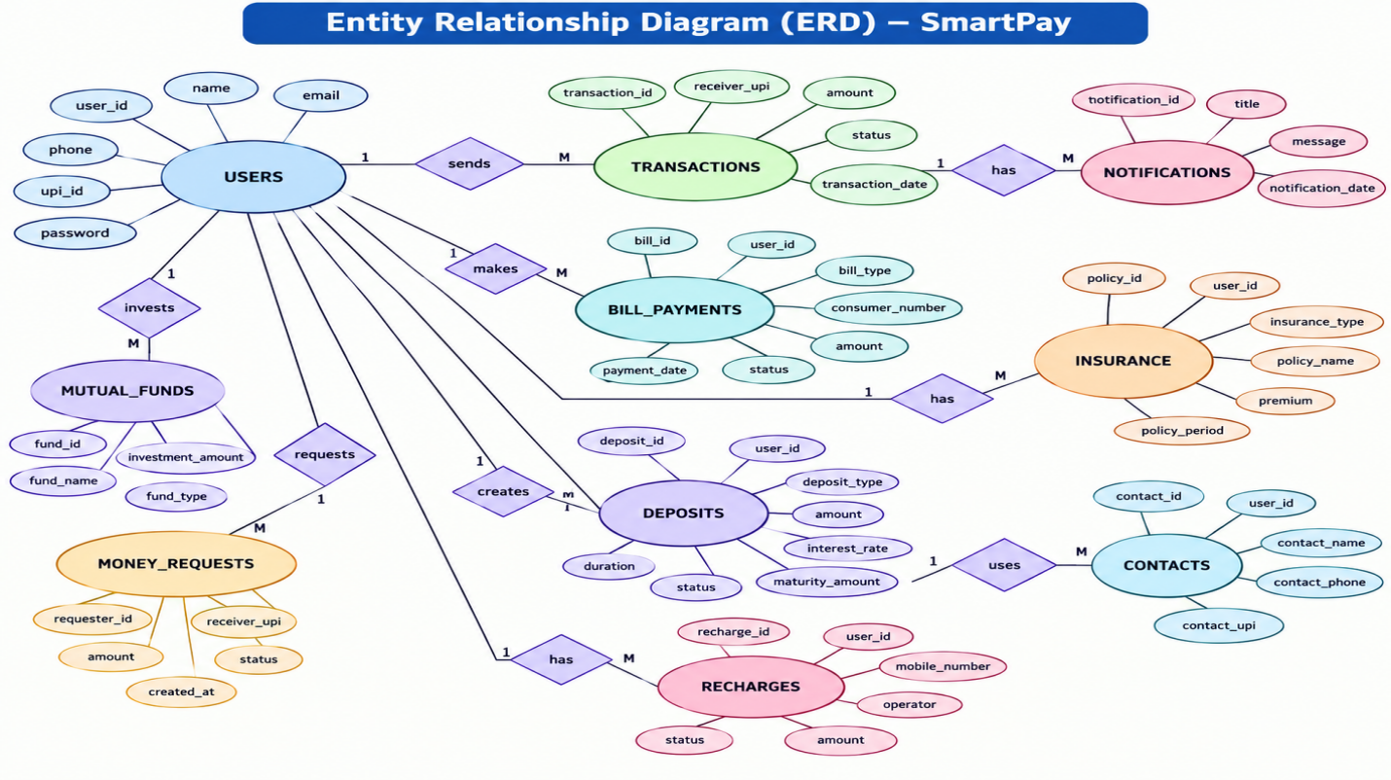
Fig 3.2

3.3. Database Design:-
SmartPay uses MySQL/MariaDB for storing and managing application data. The database is designed to keep user information, payment records and financial-service information in separate tables.
The following figure 3.3 shows the database design of the SmartPay system, including the major tables used to store and manage application data.

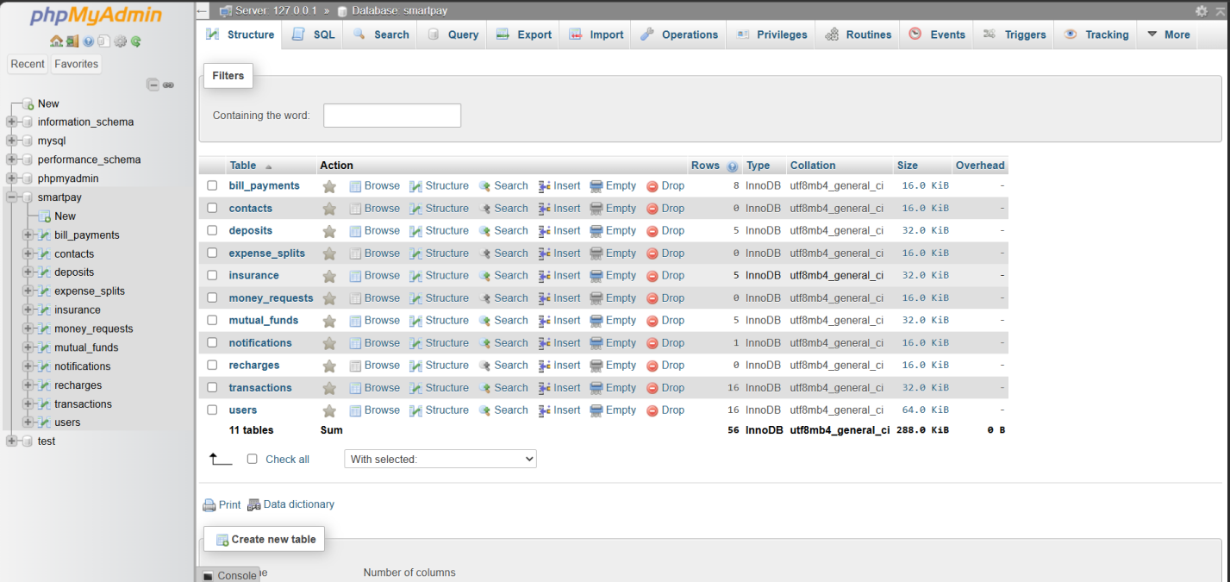Fig 3.3

- Methodology
The SmartPay website is developed using a systematic software development methodology. The development process is divided into different stages to ensure that the website is functional, user-friendly and properly connected with the database.

4.1 Requirement Analysis
In the first stage, the requirements of the SmartPay system are identified. The main requirements include user registration and login, dashboard, money transfer, QR code generation, bill payment, transaction history, insurance, mutual funds, deposits, notifications and profile management.

4.2 System Design
The overall structure of the SmartPay website is designed before implementation. The system architecture, database structure, user flow and relationships between different modules are planned. The database contains tables for users, transactions, bill payments, insurance, mutual funds, deposits, notifications and other required information.

4.3 Frontend Development
The user interface of SmartPay is developed using HTML, CSS and JavaScript. Separate web pages are created for different services such as Login, Registration, Dashboard, Send Money, QR Code, Bill Payment, Transactions, Insurance, Mutual Funds, Deposits, Notifications and Profile.The frontend is designed to provide simple navigation and an easy-to-use interface for users.

4.4 Backend Development
The backend is developed using Python Flask. Flask handles user requests, form submissions, login authentication, payment processing, database operations and page navigation. For example, when a user sends money, the backend verifies the receiver's UPI ID and available balance, processes the transaction and stores the transaction details in the database.

4.5 Database Implementation
MySQL/MariaDB is used as the database for SmartPay. The database stores and manages user information and service-related records.
Important tables include:
- users
- transactions
- bill_payments
- insurance
- mutual_funds
- deposits
- notifications
- contacts
- money_requests
- recharges
- expense_splits

4.6 Module Implementation
The different SmartPay modules are implemented independently and then connected with the main dashboard.
The major modules include:
- User Module → Registration, Login, Profile and Logout
2. Payment Module → Send Money, UPI ID and QR Code
3. Bill Payment Module → Different bill categories and consumer number
4. Transaction Module → Transaction history and status
5. Insurance Module → Life, Health, Vehicle and Travel Insurance
6. Investment Module → Mutual Funds and Deposits
7. Notification Module → User notifications and updates

4.7 Validation and Error Handling
Input validation is implemented to ensure that users enter valid information. The system checks required fields, UPI ID, email, phone number, amount and other necessary details. If an error occurs during an operation, an appropriate message is displayed to the user instead of allowing invalid data to be stored.

4.8 Testing
After implementation, each module is tested individually and then tested as part of the complete system. Functional testing is performed for registration, login, money transfer, bill payment, QR code, transactions, insurance, mutual funds and deposits.

4.9 Final Integration
Finally, all modules are integrated with the Flask backend and MySQL database. The complete SmartPay website is tested to verify that the frontend, backend and database work together correctly.

Implementation(Code)
The SmartPay system is implemented using Python Flask, MySQL/MariaDB, HTML, CSS, and JavaScript. The Flask framework is used for backend processing, routing, validation, and database operations, while HTML, CSS, and JavaScript are used to design the user interface.
The following figure 5 shows the project structure and implementation files used in the SmartPay application.

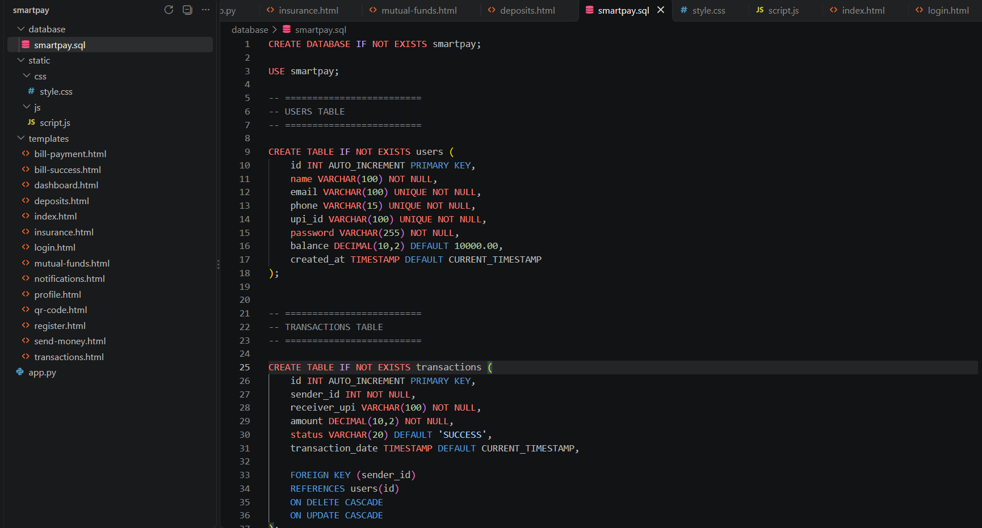

Fig. 5

Main Implementation Modules:-
Smartpay.sql:-
CREATE DATABASE IF NOT EXISTS smartpay;
USE smartpay;
-- =========================
-- USERS TABLE
-- =========================
CREATE TABLE IF NOT EXISTS users (
id INT AUTO_INCREMENT PRIMARY KEY,
name VARCHAR(100) NOT NULL,
email VARCHAR(100) UNIQUE NOT NULL,
phone VARCHAR(15) UNIQUE NOT NULL,
upi_id VARCHAR(100) UNIQUE NOT NULL,
password VARCHAR(255) NOT NULL,
balance DECIMAL(10,2) DEFAULT 10000.00,
created_at TIMESTAMP DEFAULT CURRENT_TIMESTAMP
);
-- =========================
-- TRANSACTIONS TABLE
-- =========================
CREATE TABLE IF NOT EXISTS transactions (
id INT AUTO_INCREMENT PRIMARY KEY,
sender_id INT NOT NULL,
receiver_upi VARCHAR(100) NOT NULL,
amount DECIMAL(10,2) NOT NULL,
status VARCHAR(20) DEFAULT 'SUCCESS',
transaction_date TIMESTAMP DEFAULT CURRENT_TIMESTAMP,
FOREIGN KEY (sender_id)
REFERENCES users(id)
ON DELETE CASCADE
ON UPDATE CASCADE
);
-- =========================
-- NOTIFICATIONS TABLE
-- =========================
CREATE TABLE IF NOT EXISTS notifications (
id INT AUTO_INCREMENT PRIMARY KEY,
user_id INT NOT NULL,
title VARCHAR(150) NOT NULL,
message TEXT NOT NULL,
notification_date TIMESTAMP DEFAULT CURRENT_TIMESTAMP,
FOREIGN KEY (user_id)
REFERENCES users(id)
ON DELETE CASCADE
ON UPDATE CASCADE
);
Index.html:-
<!DOCTYPE html>
<html lang="en">
<head>
<meta charset="UTF-8">
<meta name="viewport"
content="width=device-width, initial-scale=1.0">
<title>SmartPay - Smart Payments</title>
<link rel="stylesheet"
href="{{ url_for('static', filename='css/style.css') }}">
</head>
<body class="home-page">
<!-- ================= NAVBAR ================= -->
<nav>
<a href="/" class="logo">
<span class="logo-icon">
₹
</span>
SmartPay
</a>
<div>
<a href="/">
Home
</a>
<a href="{{ url_for('login') }}">
Login
</a>
<a
href="{{ url_for('register') }}"
class="nav-register">
Register
</a>
</div>
</nav>
<!-- ================= HERO ================= -->
<section class="hero">
<!-- LEFT -->
<div class="hero-left">
<div class="badge">
⚡ &nbsp; Fast &amp; Secure Payments
</div>
<h1>
Smart Payments.
<br>
<span>
Simple Life.
</span>
</h1>
<p>
Send money, manage transactions and make
digital payments easily with SmartPay.
</p>
<div>
<a
href="{{ url_for('register') }}"
class="btn btn-primary">
Get Started
</a>
<a
href="{{ url_for('login') }}"
class="btn btn-secondary">
Login
</a>
</div>
</div>
<!-- RIGHT WALLET -->
<div class="hero-right">
<div class="wallet-card">
<div class="wallet-top">
<span>
SmartPay Wallet
</span>
<span>
•••
</span>
</div>
<div class="wallet-label">
Available Balance
</div>
<div class="wallet-balance">
₹25,000.00
</div>
<div class="wallet-number">
**** &nbsp; **** &nbsp; **** &nbsp; 4582
</div>
<div class="wallet-bottom">
<span>
SMARTPAY
</span>
<span>
💳
</span>
</div>
</div>
</div>
</section>
<!-- ================= FEATURES ================= -->
<section class="features">
<div class="feature">
<div class="feature-icon">
🔒
</div>
<div>
<h3>
Secure
</h3>
<p>
Your payments are protected
</p>
</div>
</div>
<div class="feature">
<div class="feature-icon">
⚡
</div>
<div>
<h3>
Fast
</h3>
<p>
Quick and easy transactions
</p>
</div>
</div>
<div class="feature">
<div class="feature-icon">
💳
</div>
<div>
<h3>
Simple
</h3>
<p>
Easy digital payments
</p>
</div>
</div>
</section>
<!-- ================= FOOTER ================= -->
<footer>
© 2026 SmartPay. All rights reserved.
</footer>

</body>
</html>

Testing and Results
Testing is an important phase of the SmartPay project. The main purpose of testing is to verify that all modules of the website work correctly, invalid inputs are handled properly, and financial operations update the database and wallet balance correctly.
Testing of SmartPay was performed for normal operations, invalid inputs, authentication, payment operations and financial conditions. The major modules tested were Registration, Login, Dashboard, Send Money, QR Code, Bill Payment, Transactions, Insurance, Mutual Funds, Deposits and Logout.

6.1 Testing Objectives:-
The main objectives of testing are:
- To verify that all SmartPay modules work as expected.
- To check whether valid user information is accepted.
- To verify that invalid inputs are rejected.
- To check user authentication and session management.
- To verify money transfer and wallet balance updates.
- To verify that transaction records are stored correctly.
- To check bill payment functionality.
- To verify QR code generation.
- To test Insurance, Mutual Funds and Deposits modules.
- To verify that insufficient balance and self-payment are rejected.
- To ensure that important data is correctly stored in MySQL/MariaDB.

6.2 Functional Testing:-

6.2.1 Registration Testing
The registration module was tested using valid and duplicate user details. Valid details create a new user account, while duplicate email, phone number or UPI ID registration is rejected.

6.2.2 Login Testing
The login functionality was tested with correct and incorrect credentials. Valid credentials allow the user to access the dashboard, while incorrect credentials are rejected.

6.2.3 Send Money Testing
The Send Money module was tested using a valid receiver UPI ID and sufficient wallet balance. The system updates the sender and receiver balances and stores a successful transaction. Self-payment and insufficient-balance conditions are rejected.

6.2.4 Bill Payment Testing
Bill payment was tested with valid bill details and sufficient balance. The system deducts the required amount and stores the bill payment record in the database.

6.2.5 QR Code Testing
The QR Code module was tested using the logged-in user's UPI ID. The system generates a UPI payment QR code containing the required payment information.

6.2.6 Insurance Testing

The Insurance module was tested with valid policy information. The system validates the policy details, checks the wallet balance where required, stores the policy information and displays the result.

6.2.7 Mutual Funds Testing
Different SmartPay mutual fund options were tested with valid investment amounts. The investment amount is deducted from the user's balance and the investment record is stored.

6.2.8 Deposits Testing
The Deposits module was tested with different deposit types, amounts and durations. The system calculates the maturity amount using the project's defined interest calculation and stores the deposit information.

6.2.9 Logout Testing
The logout functionality was tested to verify that the active Flask session is cleared after logout.

6.3 Negative Testing:-
Negative testing was performed to ensure that invalid financial operations are not processed.
The following conditions were tested:
- Incorrect login credentials
- Duplicate registration
- Invalid UPI ID
- Self-payment
- Insufficient wallet balance
- Non-positive payment amount
- Invalid bill information
- Invalid financial-service values
- Missing required information
The SmartPay application includes validation for important inputs and rejects invalid financial operations such as self-payment and insufficient balance.

6.4 Database Testing:-
Database testing was performed to verify that the information submitted through the website is correctly stored in MySQL/MariaDB.
The following records were checked:
- User registration details
- Wallet balance
- Money transfer transactions
- Bill payment records
- Insurance records
- Mutual fund investments
- Deposit records
- Notifications
- Profile information
Successful financial operations are committed to the database, while invalid operations are rejected. Monetary calculations use Decimal for safer financial calculations

6.5 Result :-

The SmartPay system provides a user registration and login system through which users can create an account and securely access their dashboard. After login, users can view their available balance and access different services provided by the website.
The following figure 6.5 shows the SmartPay system interface after successful implementation.

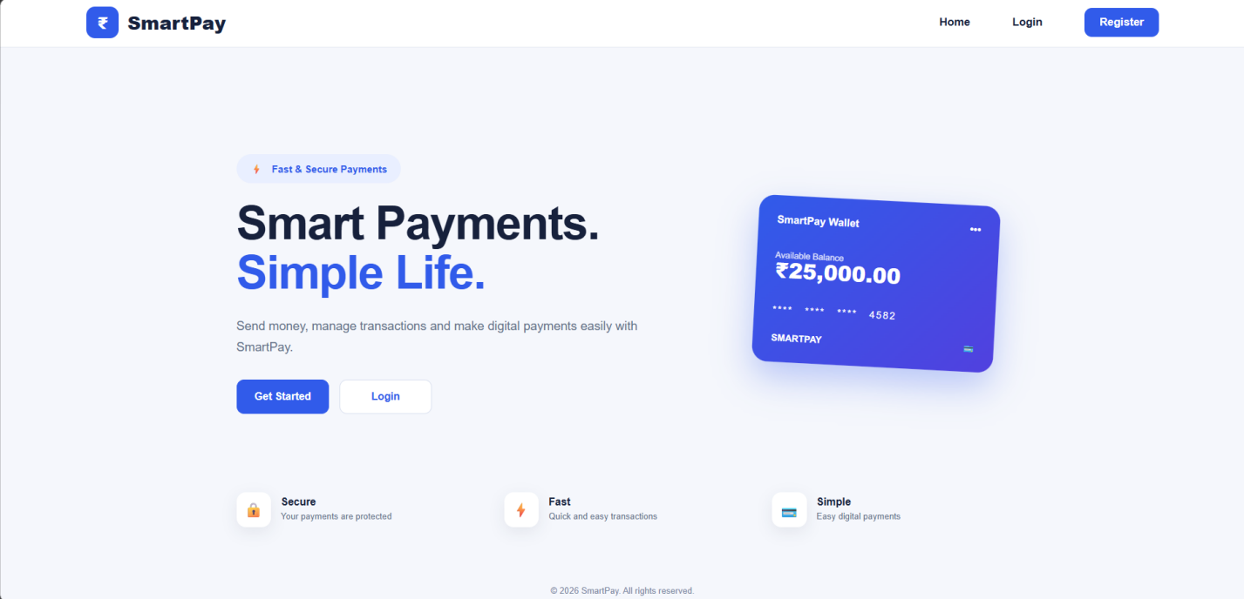
Fig. 6.5

6.5.1 User Registration and Login
SmartPay provides a registration module where new users can create an account by entering details such as name, email, phone number, UPI ID and password. Registered users can log in using their credentials and access the SmartPay dashboard.
The following figure a) 6.5.1 shows the User Registration page of the SmartPay application.

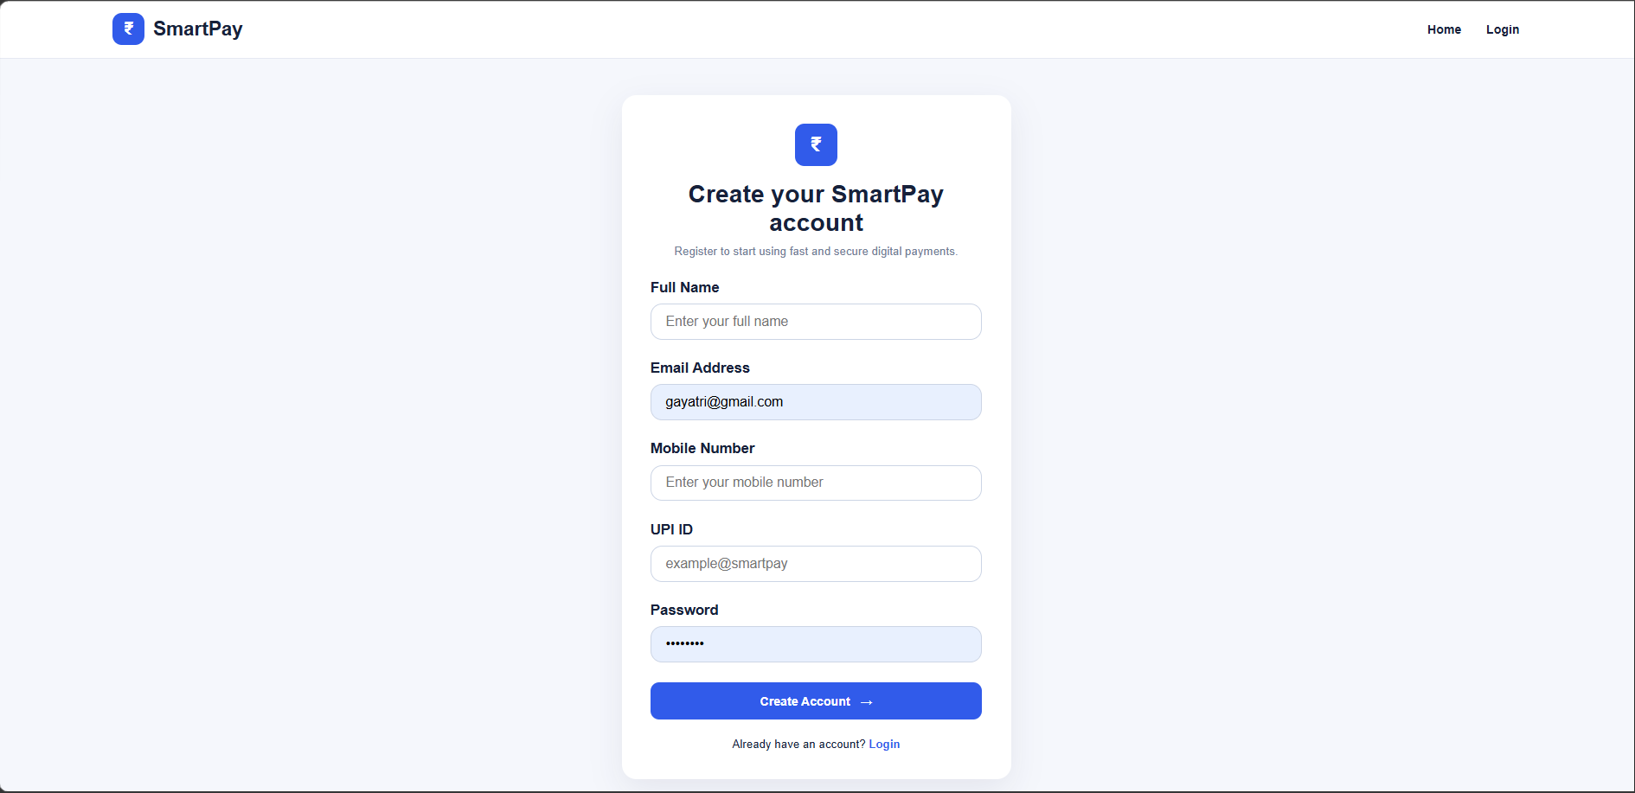
Fig. a) 6.5.1
The following figure b)6.5.1 shows the Login page through which registered users can access the SmartPay application.

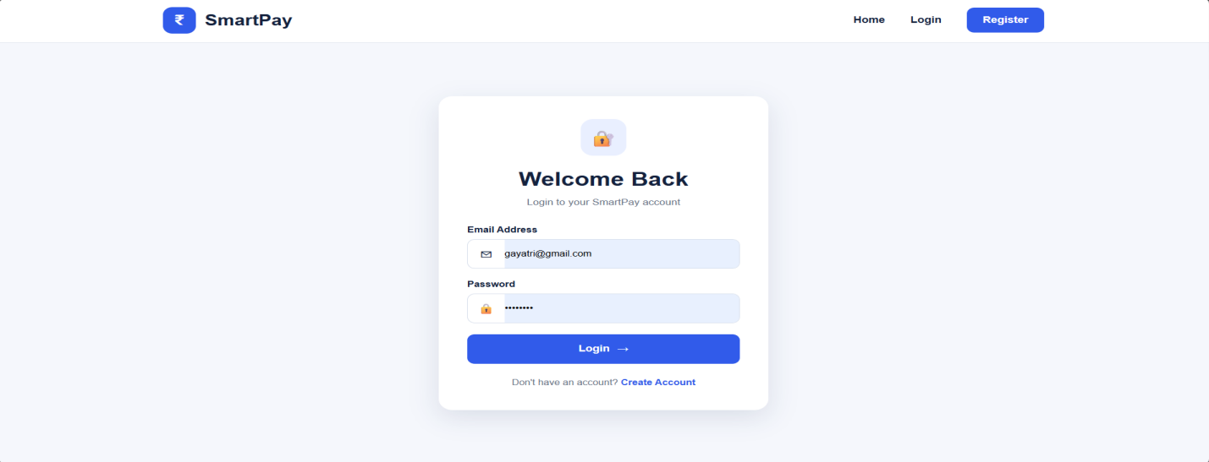
Fig. b) 6.5.1

6.5.2 Dashboard
The dashboard acts as the main interface of the SmartPay website. It provides access to important services such as Send Money, QR Code, Bill Payment, Transactions, Insurance, Mutual Funds, Deposits, Notifications and Profile.
The following figure 6.5.2 shows the SmartPay Dashboard, which provides access to the major payment and financial services.
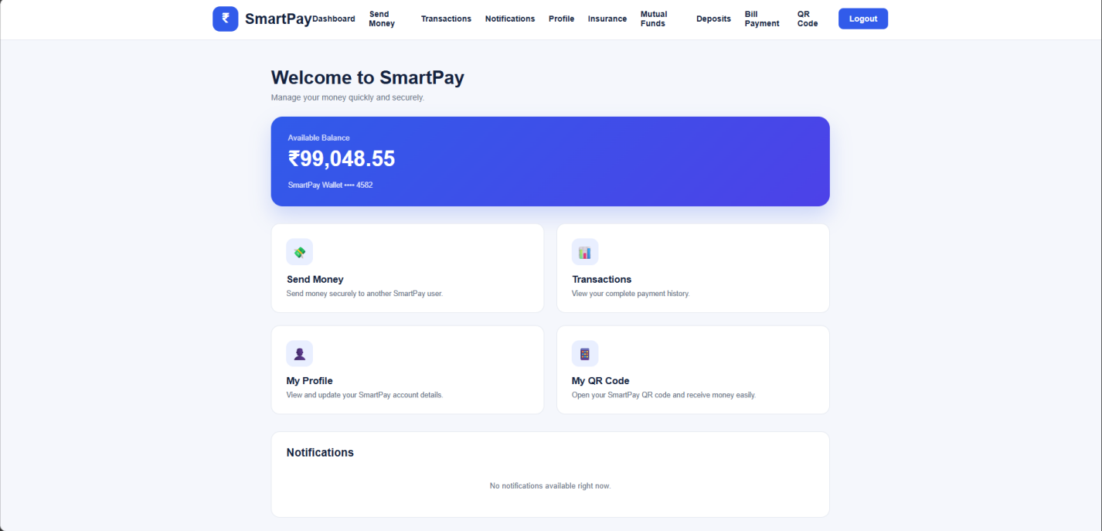
Fig. 6.5.2

6.5.3 Send Money
The Send Money module allows users to transfer money to another user using their UPI ID. The system checks the sender's balance and receiver details before processing the transaction. After a successful transaction, the sender's balance is reduced and the transaction details are stored in the database.
The following figure 6.5.3 shows the Send Money module used to transfer money to another user using a UPI ID.
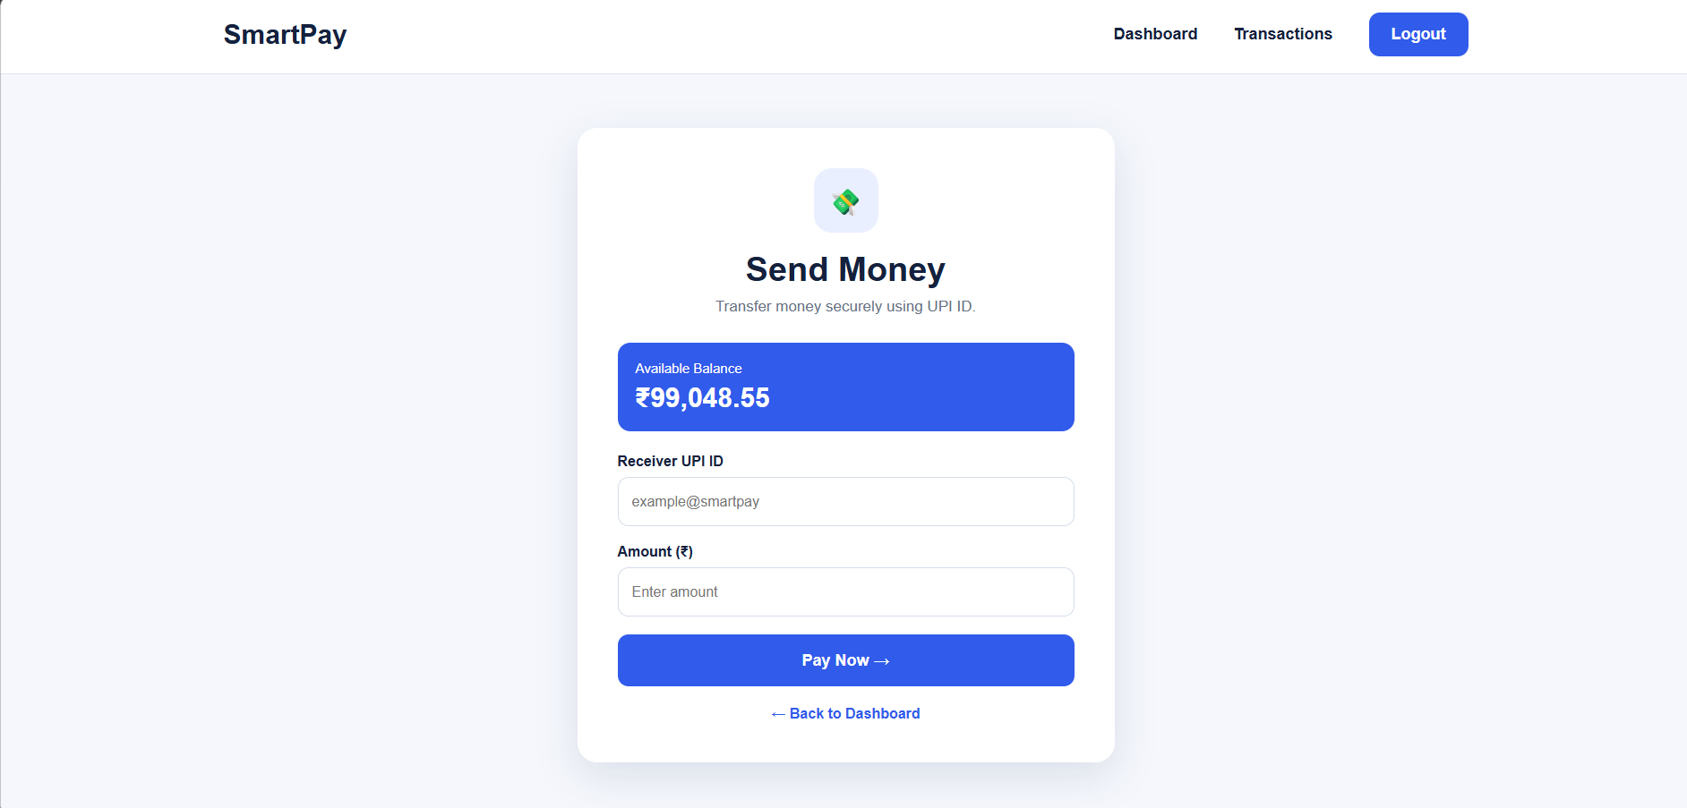
Fig. 6.5.3

6.5.4 Transaction History
The Transactions module maintains a record of users' payment activities. Users can view details such as transaction amount, receiver UPI ID, transaction status and transaction date. This helps users track their previous transactions.
The following figure 6.5.4 shows the Transaction History page displaying the user's previous payment transactions.

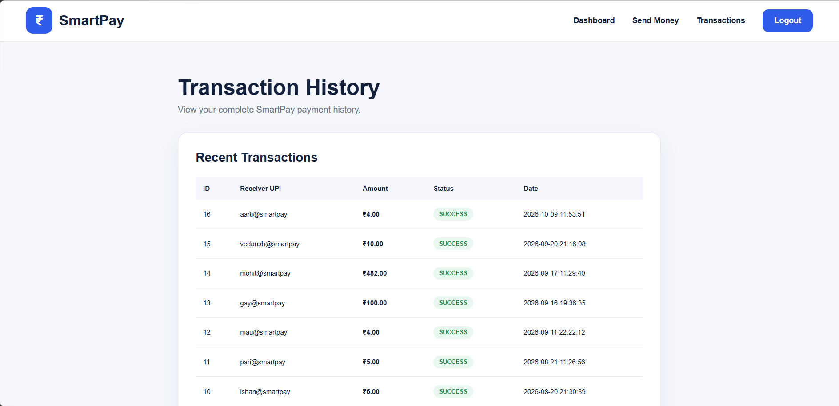Fig. 6.5.4

6.5.5 Notifications
The Notifications module is used to display important messages and updates related to the user's activities on the SmartPay platform.
The following figure 6.5.5 shows the Notifications page used to display important messages and updates to the user.

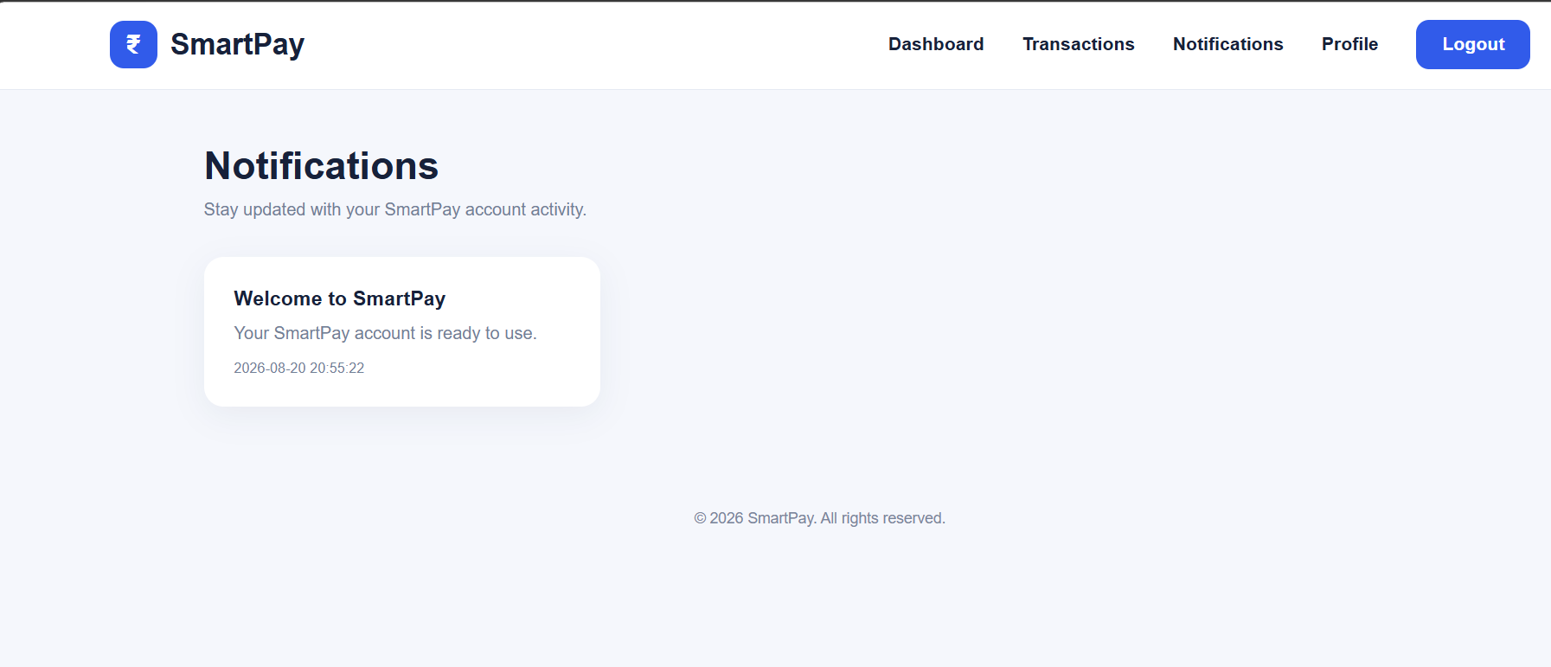
Fig. 6.5.5

6.5.6 Profile Management
The Profile module allows users to view and manage their personal information such as name, email, phone number and UPI ID.
The following figure 6.5.6 shows the Profile Management page where users can view and manage their SmartPay account information.
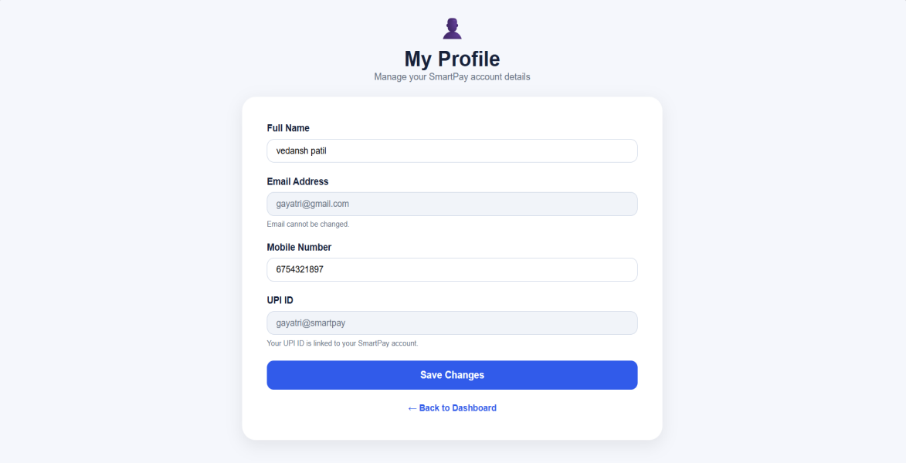
Fig. 6.5.6

6.5.7 Insurance Services
SmartPay also provides an Insurance section where users can select different insurance services. The available policy options include Smart Life Secure, Smart Health Plus, Smart Vehicle Protect and Smart Travel Secure. Users can select a policy and enter the required premium and policy-related details.
The following figure 6.5.7 shows the Insurance Services page containing the available insurance policy options in SmartPay.
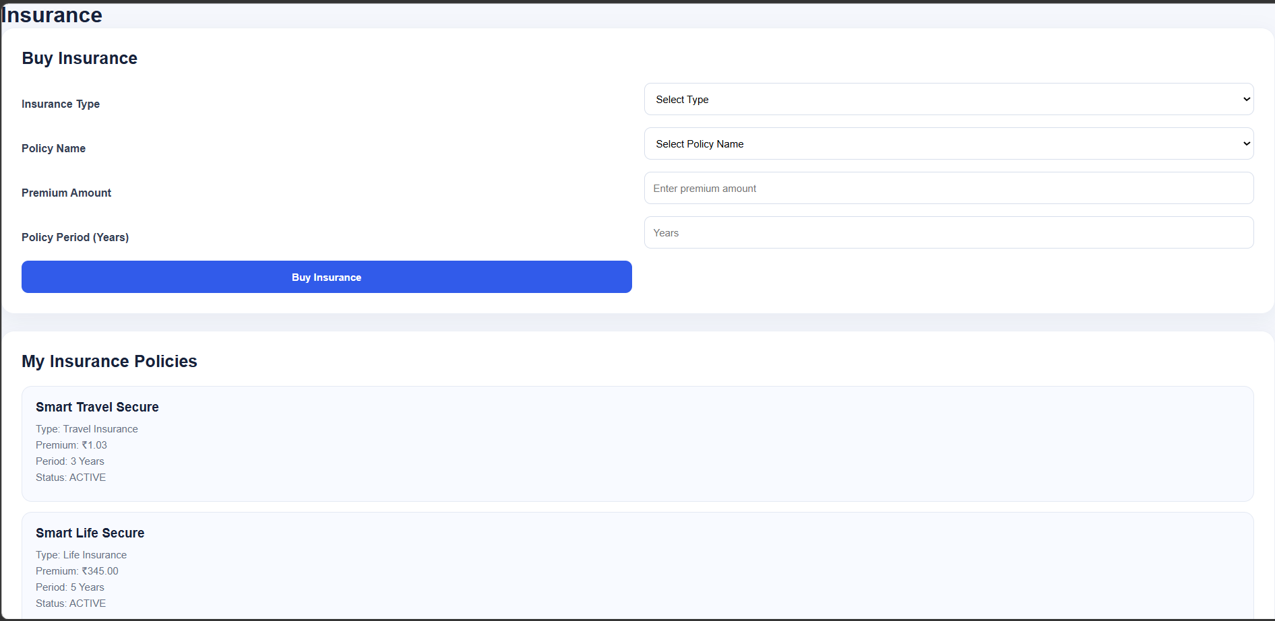
Fig. 6.5.7

6.5.8 Mutual Funds
The Mutual Funds module provides different investment options such as SmartPay Growth Fund, SmartPay Balanced Fund, SmartPay Equity Fund and SmartPay Tax Saver Fund. Users can select a fund and enter the investment amount.
The following figure 6.5.8 shows the Mutual Funds page containing different investment options available in SmartPay.

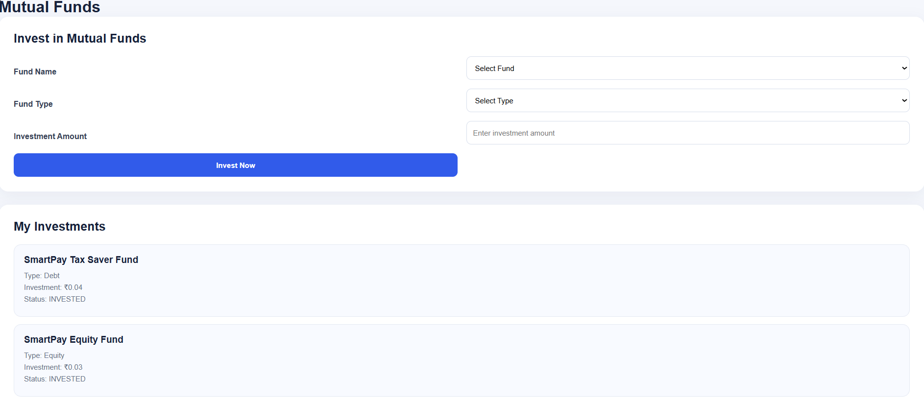
Fig. 6.5.8

6.5.9 Deposits
The Deposits module allows users to select different deposit types such as Fixed Deposit, Recurring Deposit and Savings Deposit. The system calculates the maturity amount based on the investment amount, interest rate and duration.
The following figure 6.5.9 shows the Deposits page where users can select different deposit types and enter deposit details.

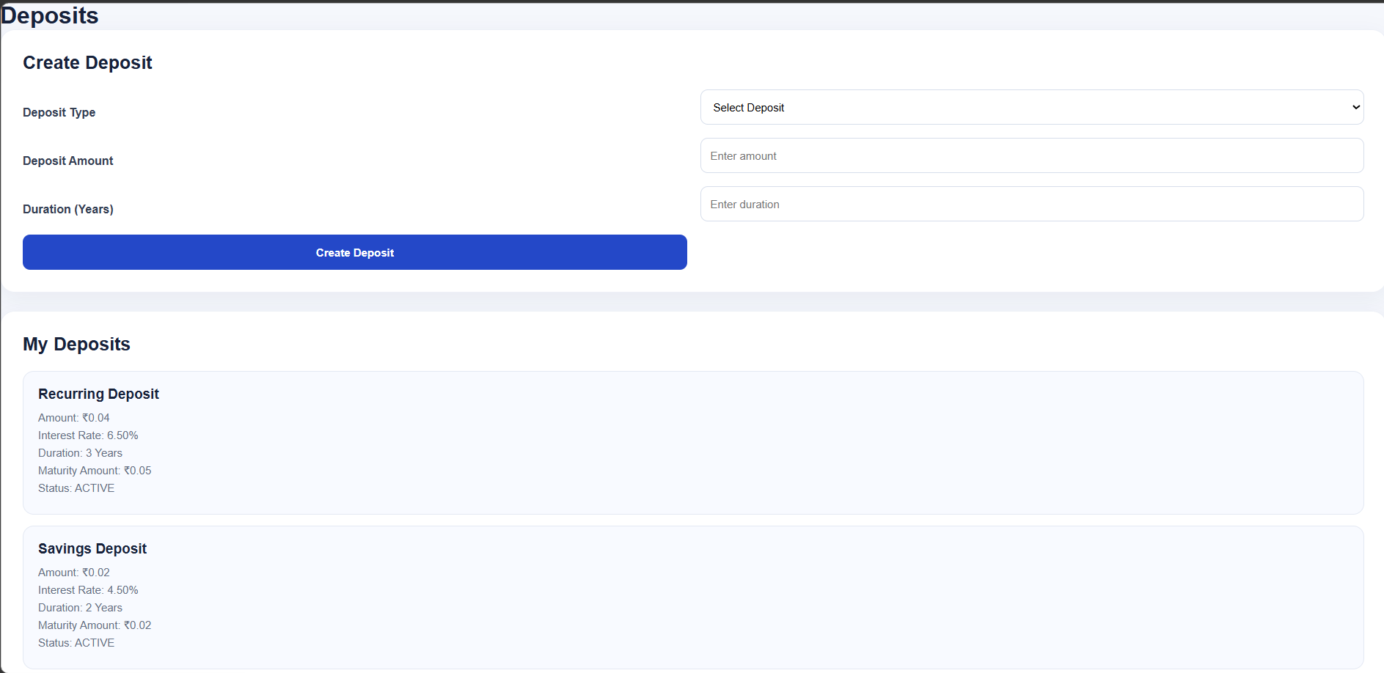
Fig. 6.5.9

6.5.10 Bill Payment
The Bill Payment module allows users to make payments for different bill categories. Users can select the bill type, enter the required consumer number and amount, and submit the payment. The payment information is stored in the database for future reference.
The following figure 6.5.10 shows the Bill Payment page used to make payments for different bill categories.

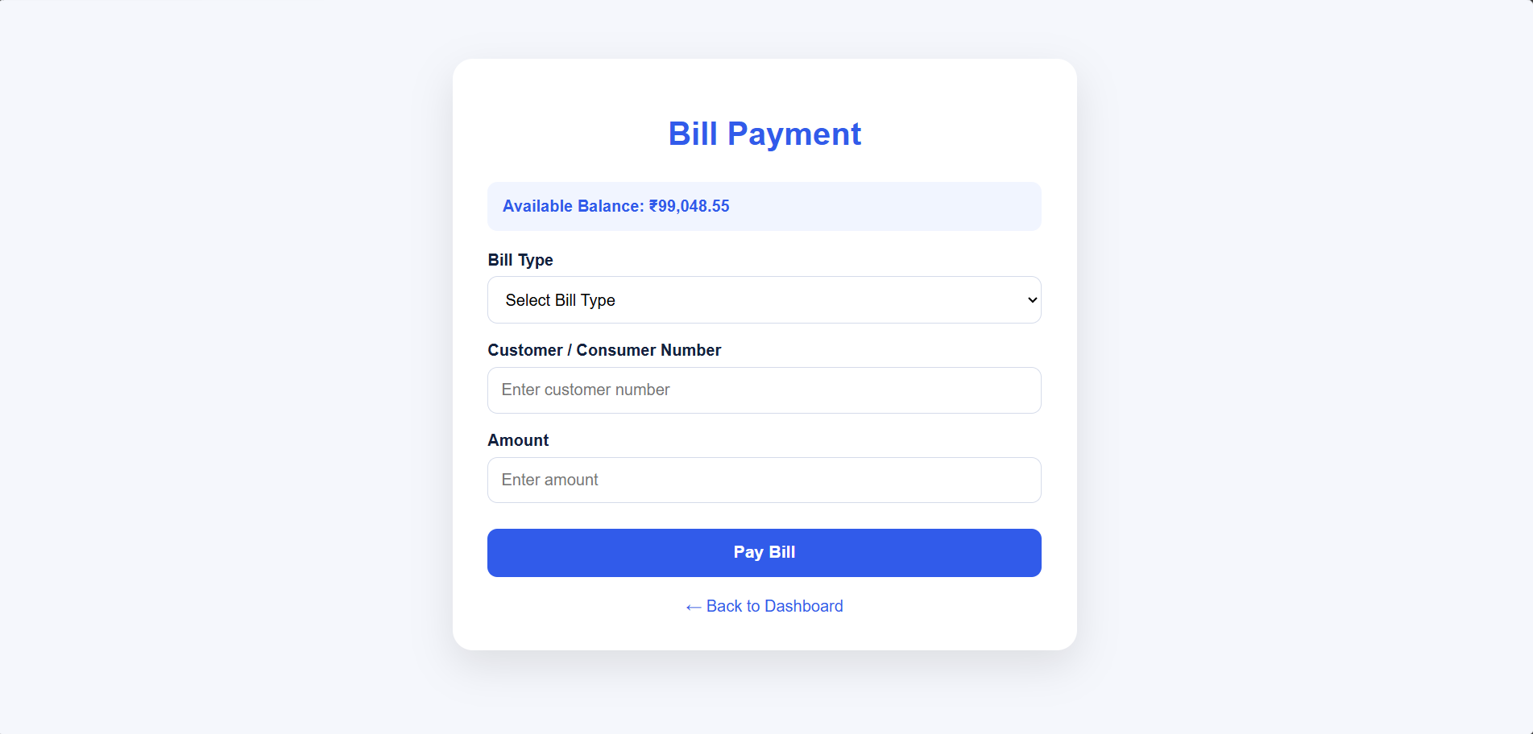
Fig. 6.5.10

6.5.11 QR Code Payment
SmartPay provides a QR Code feature that allows a user's UPI information to be represented through a QR code. The system generates a UPI payment URL using the user's UPI ID and displays it as a QR code.
The following figure 6.5.11 shows the QR Code Payment page that generates a payment QR code using the user's UPI information.

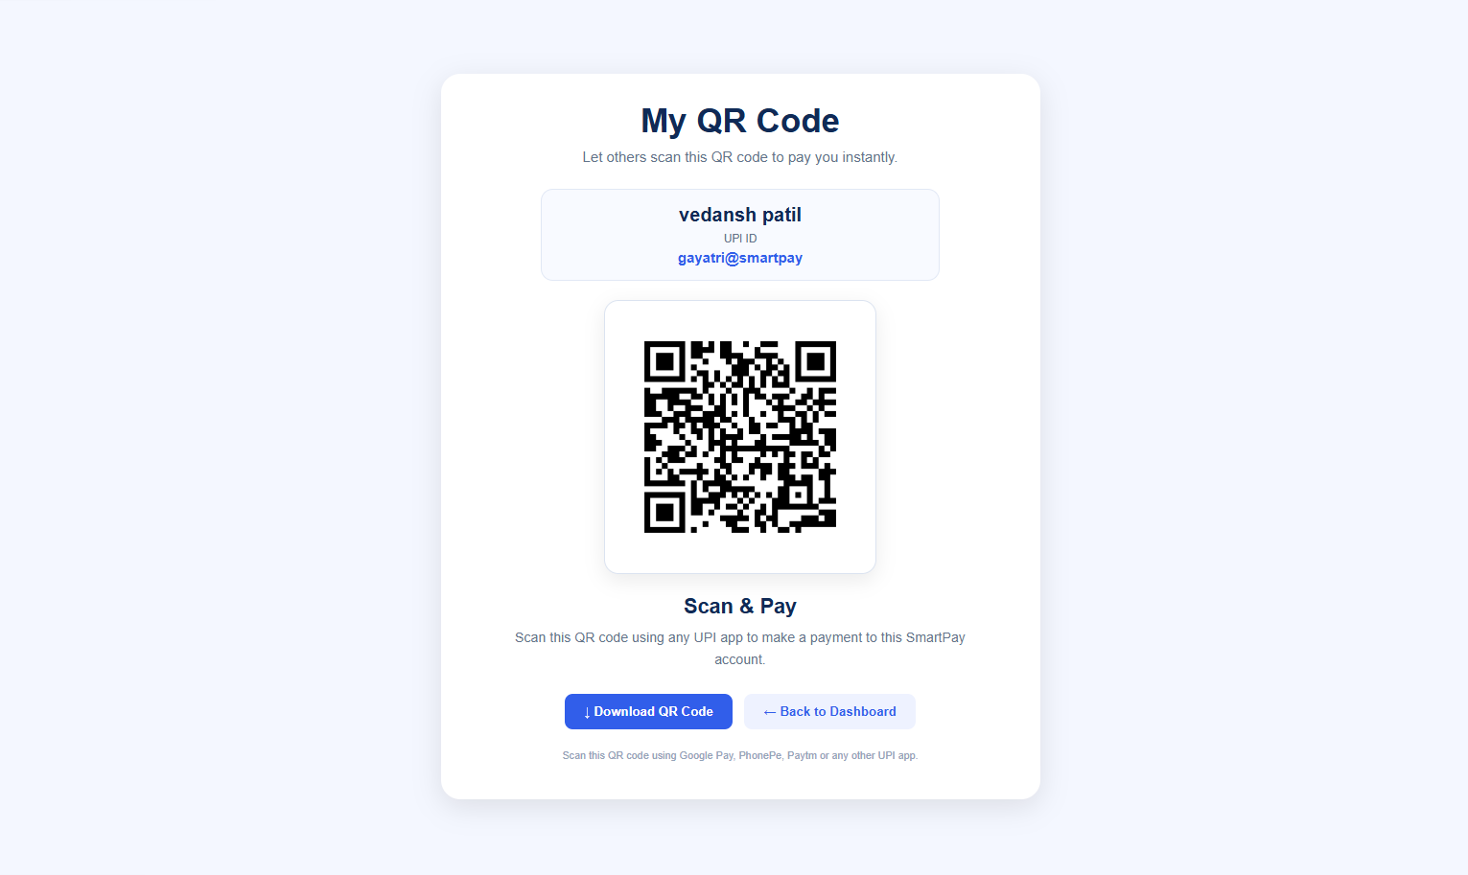
Fig. 6.5.11

6.5.12 Database Management

SmartPay uses MySQL/MariaDB to store and manage application data. User details, transactions, bill payments, insurance records, mutual fund investments, deposits and notifications are stored in the database. This helps the system maintain organized and structured records.
The following figure 6.5.12 shows the SmartPay database in MySQL/MariaDB containing the tables used to store and manage application data.

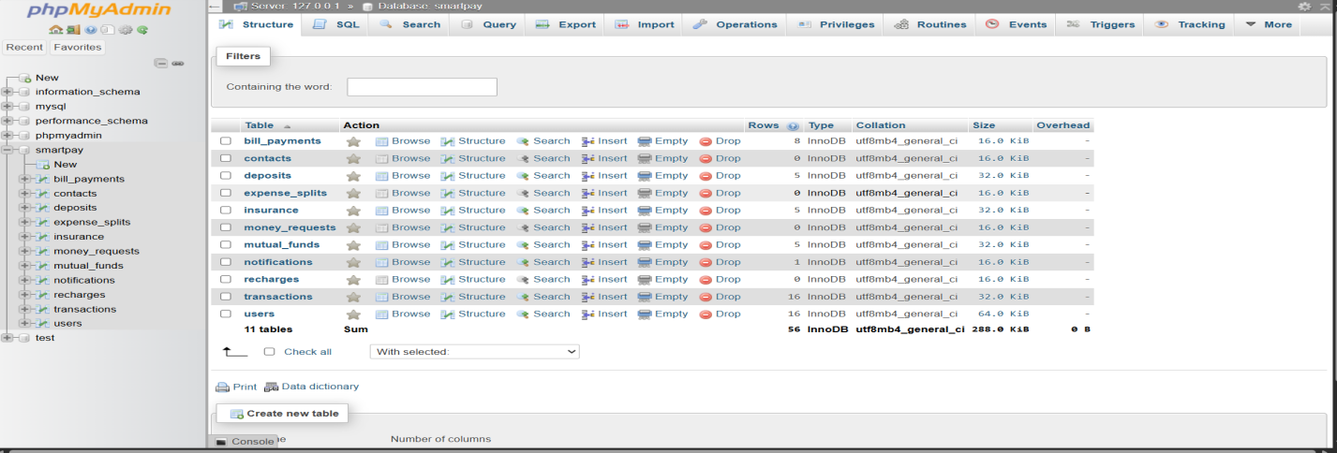
Fig. 6.5.12

7.Conclusion and Future Scope

7.1 Conclusion:-
The SmartPay project successfully demonstrates a web-based digital payment and financial services application. The system provides multiple features such as user registration and login, wallet balance management, UPI-based money transfer, QR code generation, bill payment, transaction history, notifications and profile management.
The project also includes additional financial services such as Insurance, Mutual Funds and Deposits. The application uses Python Flask for backend processing, HTML, CSS and JavaScript for the user interface, and MySQL/MariaDB for storing and managing data.
7.2 Future Scope:-
In the future, the SmartPay system can be enhanced with several smart and user-friendly features:
1 Smart Expense Analyzer – Analyze transaction history and show monthly and category-wise spending.
2 AI-Based Financial Suggestions – Provide personalized saving and investment suggestions based on the user's spending patterns.
3 Smart Bill Reminder – Notify users about upcoming bill due dates to avoid late payments.
4 Personalized Dashboard – Display customized payment, spending, and financial information according to user activity.
5 Goal-Based Savings – Allow users to set financial goals and track their savings progress.
6 Smart Payment Risk Alerts – Detect unusual or high-value transactions and provide security alerts to users.
7 Family Expense Management – Allow users to manage and track shared or family expenses from one platform.
8 Rewards and Cashback System – Introduce reward points, cashback, and offers for eligible transactions.
9 Voice-Based SmartPay – Enable users to access balance, transaction history, and other services using voice commands.
10 Advanced Financial Dashboard – Provide graphical reports and analytics for better understanding of expenses, savings, and investments.

