**Q1 . Write a program in php to use foreach loop.**

<?php

$colors = array("red","green","blue","yellow");

foreach($colors as $value)

{

echo "$value <br>";

}

?>

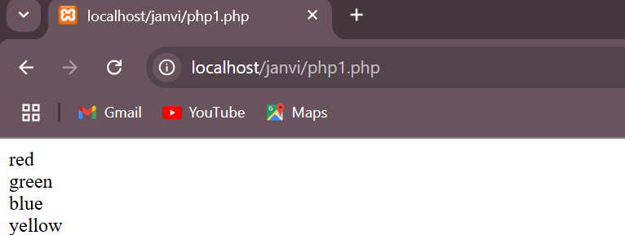

**Q2. Write a program using switch case.**

<?php

$car = "Hyundai";

switch ($car) {

case "Honda":

echo "Your favorite car is Honda!";

break;

case "BMW":

echo "Your favorite car is BMW!";

break;

case "Hyundai":

echo "Your favorite car is Hyundai!";

break;

default:

echo "Your favorite car is neither Honda, BMW, nor Hyundai!";

}

?>

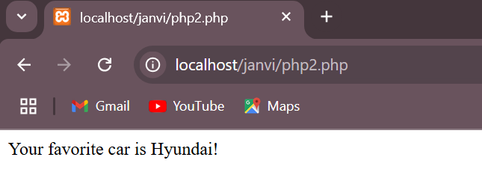

**Q3. Write a program in php to use by value in function by passing parameter.**

<?php

function makecoffee($type = "cappuccino")

{

return "Making a cup of $type.\n";

}

echo makecoffee();

echo makecoffee(null);

echo makecoffee("espresso");

?>

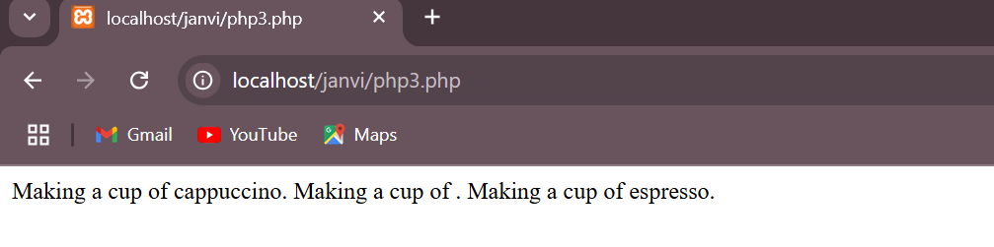

**Q4. Write a program in php to use Create anonymous & nested function.**

<?php

$greet = function($name)

{

printf("Hello %s\r\n", $name);

};

$greet('World');

$greet('PHP'); function MyFunc() {

// The Nested Functions function DoThis()

{ return 'Yeah!';

}

function DoThat() { return 'Nah!';

}

MyFunc(); echo DoThis();}

?>

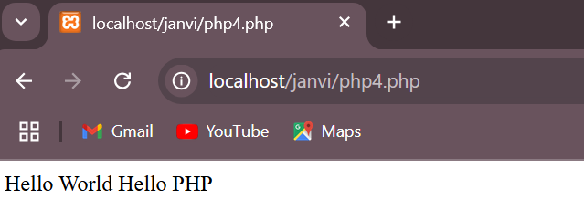

**Q5.Write a program in php to Create Asssociate Array.**

<?php

$age = array("Peter"=>"35", "Ben"=>"37", "Joe"=>"43");

echo "Peter is " . $age['Peter'] . " years old.";

?>

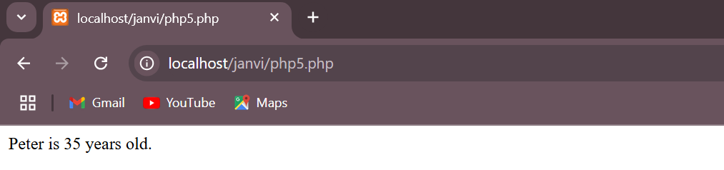

**Q6. Write a program in php to Sorting an array.**

<?php

$numbers = array(4, 6, 2, 22, 11);

sort($numbers);

$arrlength = count($numbers);

for($x = 0; $x < $arrlength; $x++) {

echo $numbers[$x];

echo "<br>";

}

?>

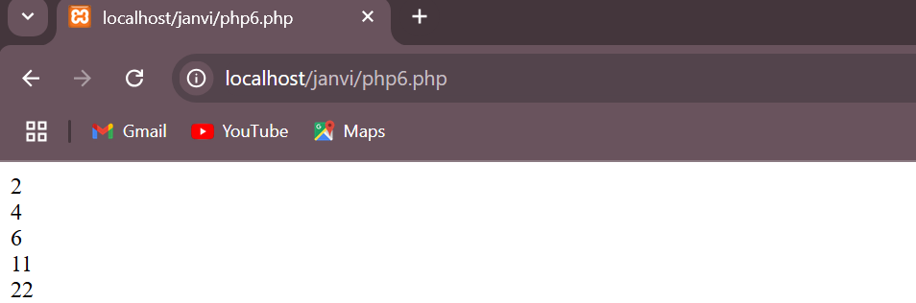

**Q7. Write a PHP program to demonstrate the class and object.**

<?php

class Sample

{

private $num1;

private $num2;

public function setdata($n1, $n2)

{

$this->num1=$n1;

$this->num2=$n2;

}

public function showdata()

{

echo "Num1: ".$this->num1."<br>";

echo "Num2: ".$this->num2."<br>";

}

}

$obj = new Sample();

$obj->setdata(20,30);

$obj->showdata();

?>

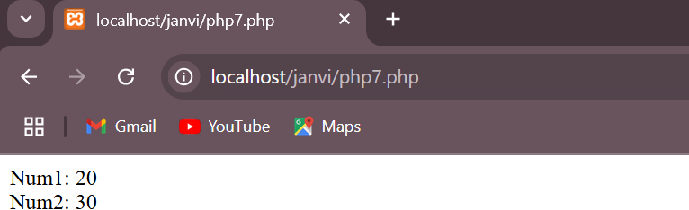

**Q8. Write a program in php by using Get Method.**

<?php

if( $_GET["name"] || $_GET["age"] ) {

echo "Welcome ". $_GET['name']. "<br />";

echo "You are ". $_GET['age']. " years old.";

exit();}

?>

<html>

<body>

<form action = "<?php $_PHP_SELF ?>" method = "GET">

Name: <input type = "text" name = "name" />

Age: <input type = "text" name = "age" />

<input type = "submit" />

</form>

</body>

</html>

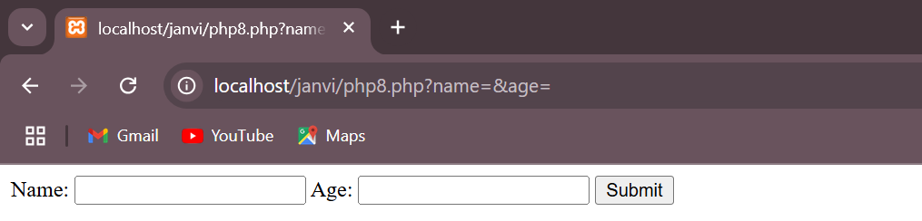

**Q9. Write a program using Post method.**

<!DOCTYPE html>

<html>

<body>

<form method="post" action="login.php">

User Id: <input type="text" name="userid"><br>

Password: <input type="password" name="password"><br>

<input type="submit" value="Login">

</form>

</body>

</html>

<!DOCTYPE html>

<?php

$uid = $_POST['userid'];

$pw = $_POST['password'];

if($uid == 'ben' and $pw == 'ben23')

{

session_start();

$_SESSION['sid']=session_id();

echo "Logged in successfully";

}

?>

<!DOCTYPE html>

<html>

<body>

<?php

echo "Logged out successfully";

session_start();

session_destroy();?>

</body>

</html>

**Q10. Write a PHP program to demonstrate the Hit Counter using session.**

<html>

<head>

<title>Hit Counter Program</title>

</head><body> <body>

<?php

session_start();

if(!isset($_SESSION["count"])){

$_SESSION["count"]=0; }

else{

$_SESSION["count"]++; }

echo "This is Hit Counter "."<br>";

echo "Your are ".$_SESSION["count"]; ?>

time Seen before .

</body>

</html>

**Q11. Write a PHP program to create table in database.**

<?php

$conn = mysqli_connect("localhost","root","","test")or die("Some error has ocour".mysqli_error($conn));

//create database company $query4="create database company";

$query="create table employee(id int,name varchar(50),address varchar(100))";

$result=mysqli_query($conn,$query);

if($result)

{

echo "Employee Table create successfully";

}

else

{

echo "Some problem Occure";

}

mysqli_close($conn);

?>

**Q12. Write a PHP program to insert data into database tables.**

<?php

$con=mysqli_connect("localhost","root","","test")or die("Some error has ocour".mysqli_errno($con));

//$query4="create database company";

$query="insert into employee values(1,'ashok','wardha')";

$result=mysqli_query($con,$query);

if($result)

{

echo "Data inserted into employee table successfully";

}

else

{

echo "Some problem Occure";

}

mysqli_close($con);

?>

**Q13. Write php program to get the factorial value of a given number**

<html>

<head>

<title>Factorial Program using loop in PHP</title>

</head><body>

<form method="post">

Enter the Number:<br>

<input type="number" name="number" id="number">

<input type="submit" name="submit" value="Submit" />

</form><?php

if($_POST){

$fact = 1; //getting value from input text box 'number'

$number = $_POST['number'];

echo "Factorial of $number:<br><br>";//start loop

for ($i = 1; $i <= $number; $i++){

$fact = $fact * $i; } echo $fact . "<br>"; }?>

</body>

</html>

**Q14. Write a PHP program to demonstrate the Cookies.**

**Program :-**

<?php

setcookie("user","Hello Cookiee is Set ",time()+60*60*24);

echo $_COOKIE["user"];

?>

**Q15. Write a program in php to create image by using gd library.**

**Program:-**

<?php

$image =imagecreate(400,400);

$colorRed = imagecolorallocate($image,255,0,0);

$colorYellow = imagecolorallocate($image,255,255,0);

imageFilledRectangle($image, 50, 50, 250, 150, $colorYellow);

header("content-type:image/jpeg");

imagejpeg($image);

?>