VPN

First we have to create the VPN ,before we have to create the delicated subnet (purpose vnet gateways).
- Step by step process is given below :
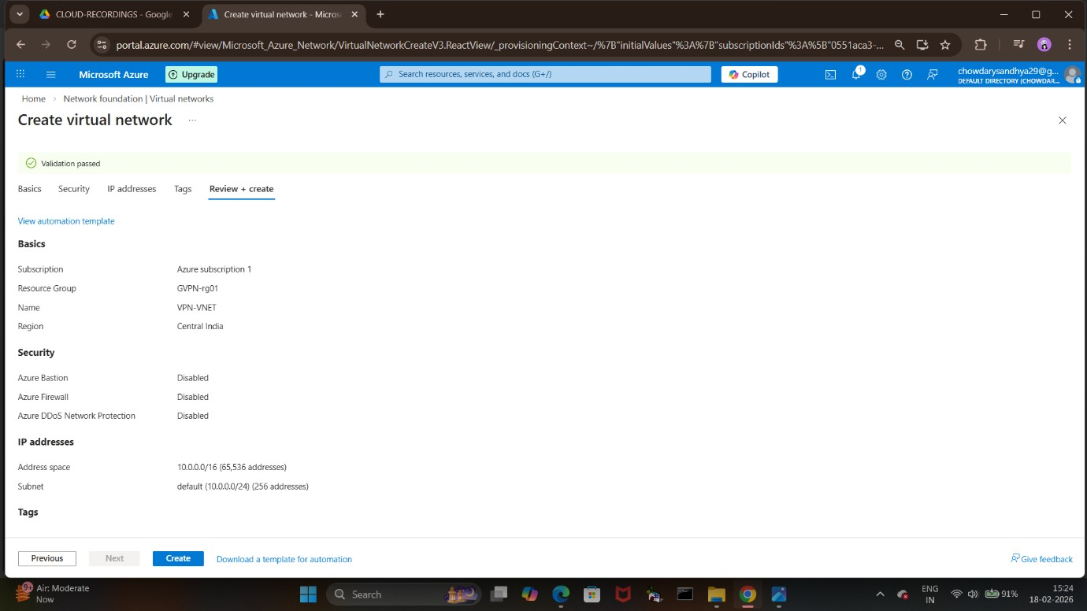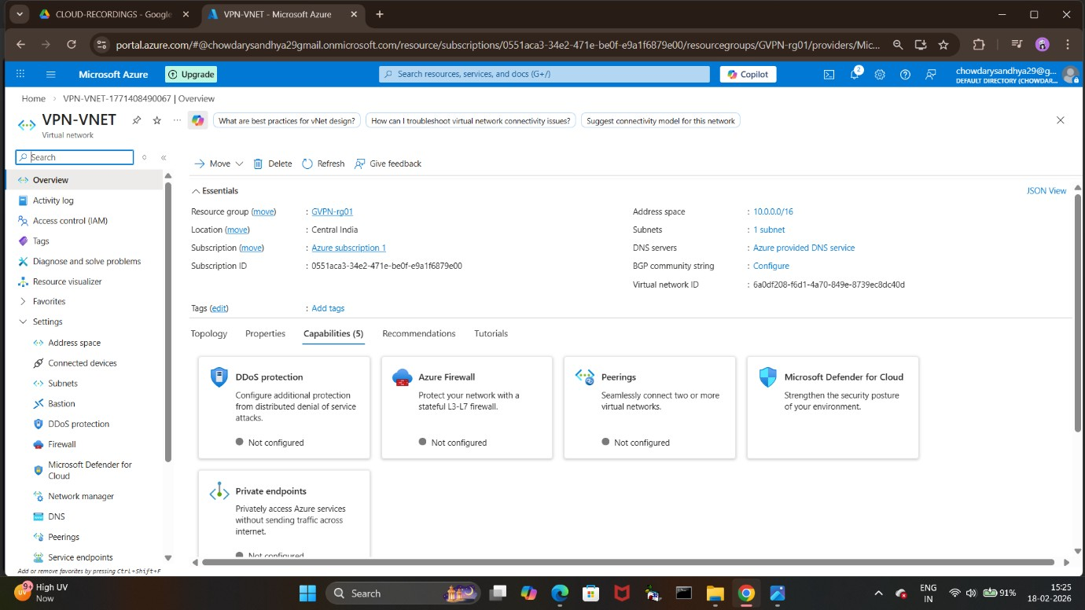

Here -delicated subnet

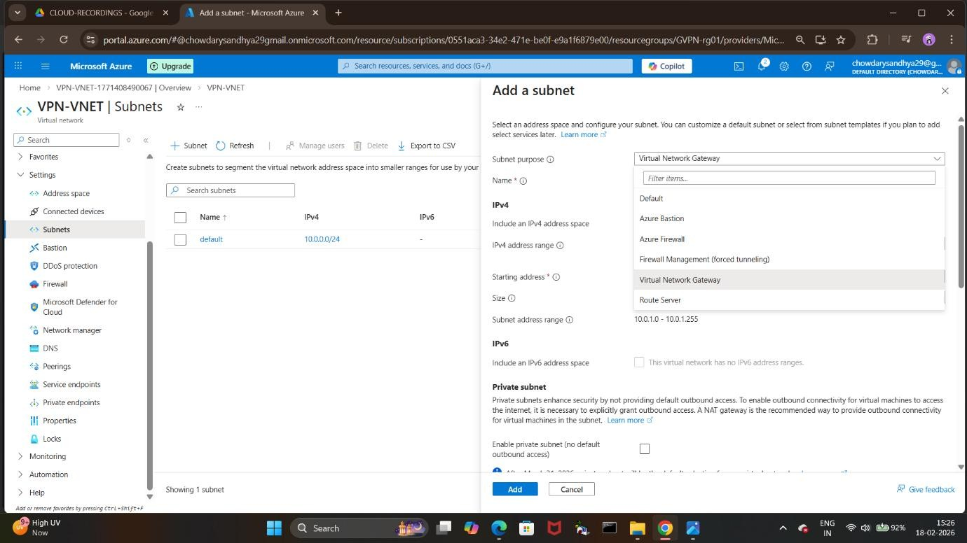
- Then after we have to create a virtual network gateways
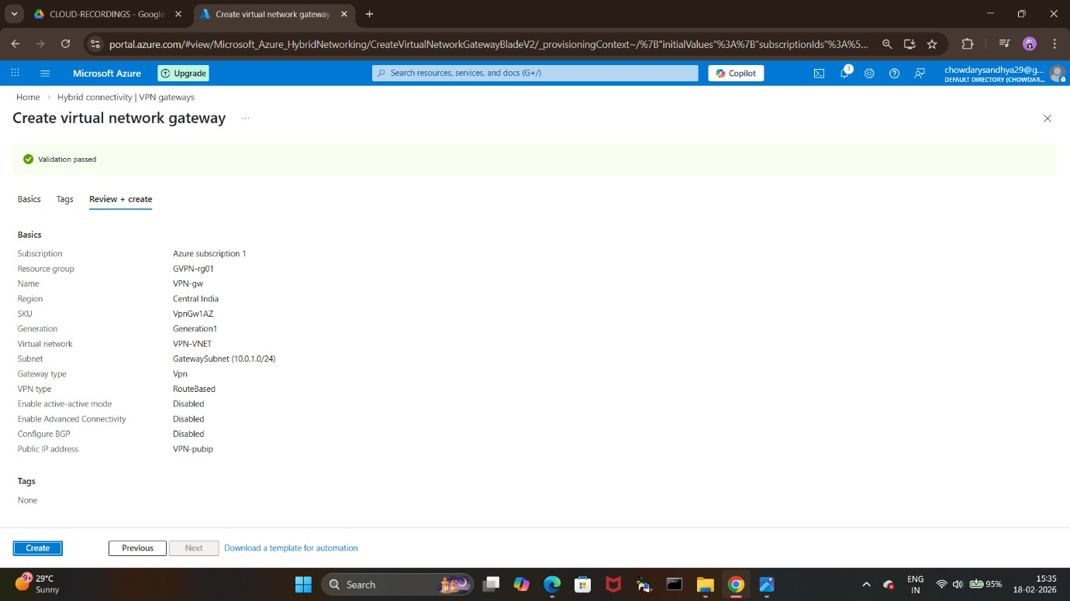

NOTE : It can take to deployment the minimum 30 min

➢ VPN can works in different ways they are :
  - Site to site
  - Point to site
  - Express route
1.site to site

- By default can create the tunnel between one branch to another
- Traffic moving via tunnel itself [over the internet traffic will flow]
- The traffic will travel internally ( private communication will done )
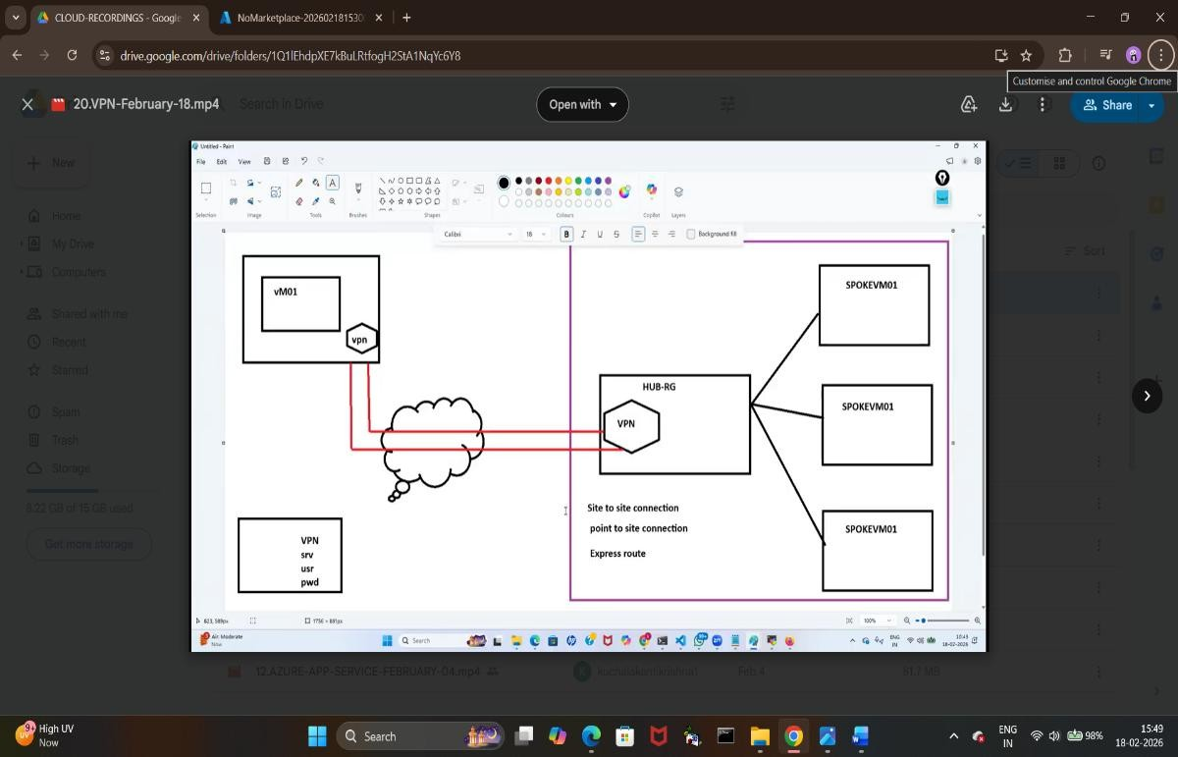

2.Point to site
- On demand connection

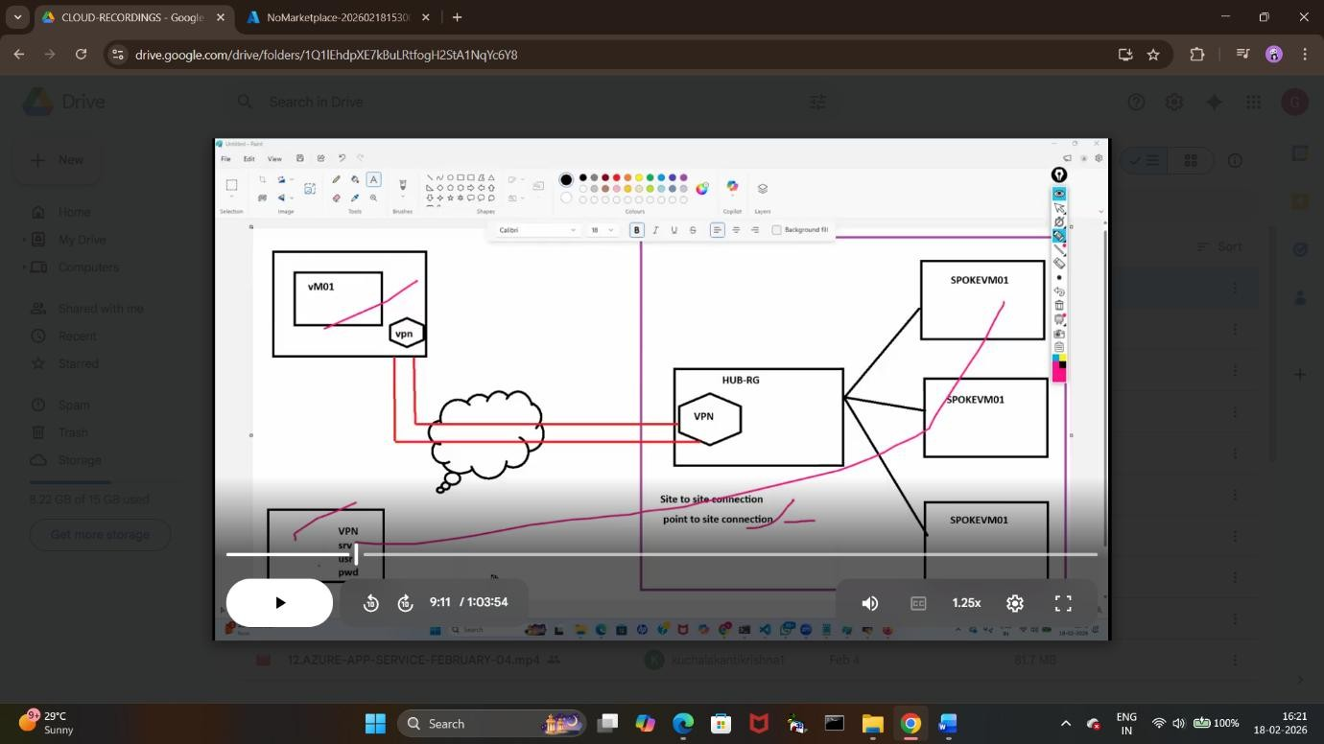
- When we have to use then only we have to connect and remains we have disconnect it.
- Mostly we have to use work from home
- Ex: our pc and the server will connect privately
- Over the network connection will pass with in the tunnel 3.Express Route
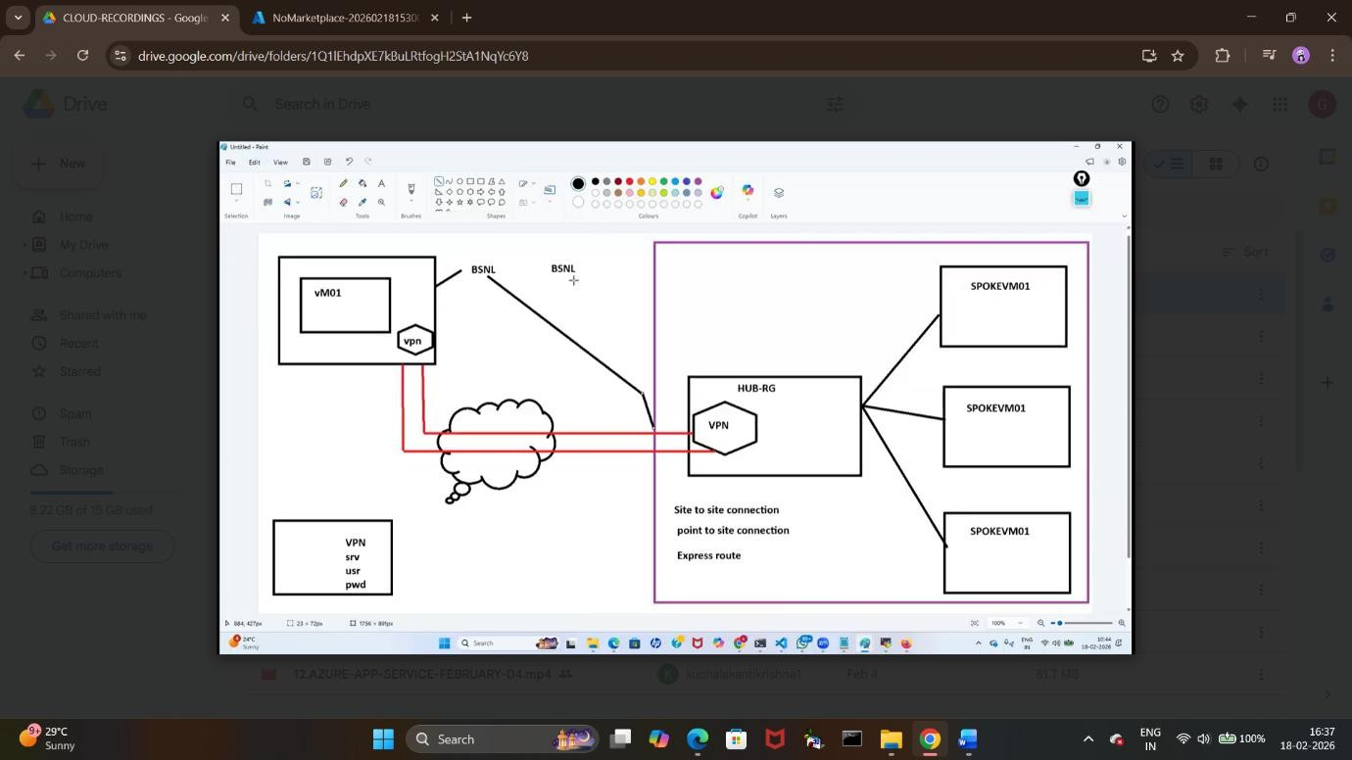
- Here it has the physical cable connection
- Ex: office – our pc or account communicate via physical cable (BSNL)
- They have to configure the near by offices like * one place to
Hyderabad BSNL to Chennai BSNL *
- Huge data can transfer vis express route LAB
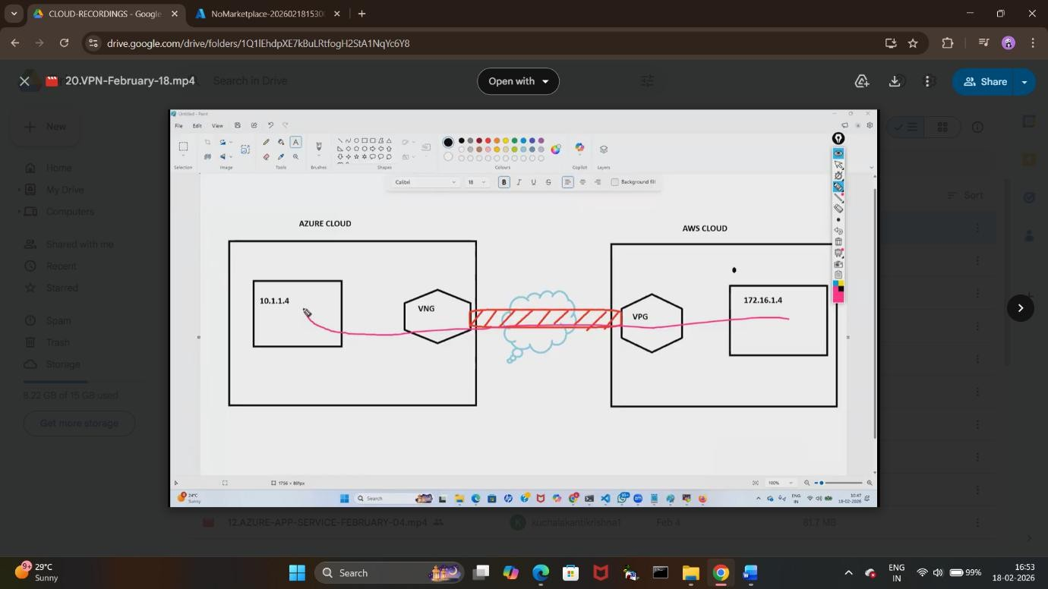
- The azure cloud can communicate or even aws cloud can communicate via tunnel with private Ip’s only

Then we have to configure the AWS

- First we have to create VPC

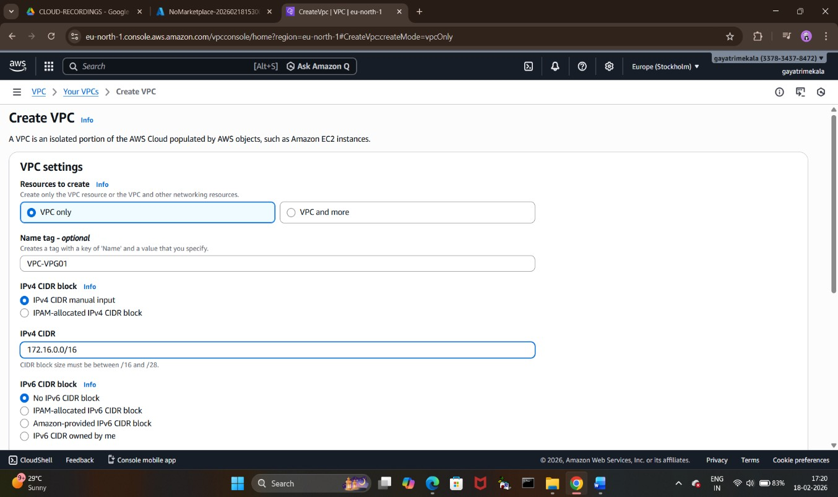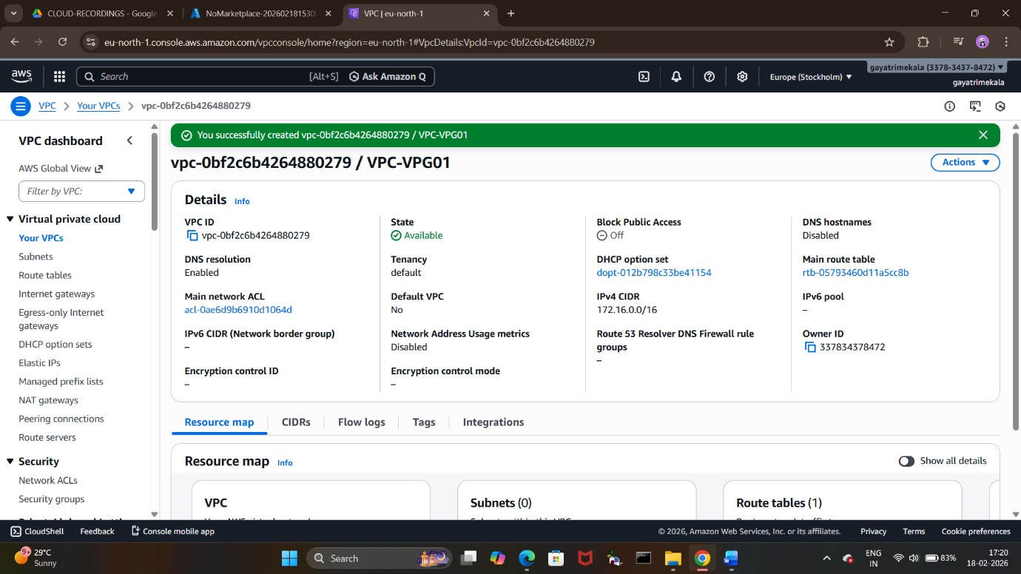

- Then we have to create the subnet
- With in the VPC code we have to create the subnet

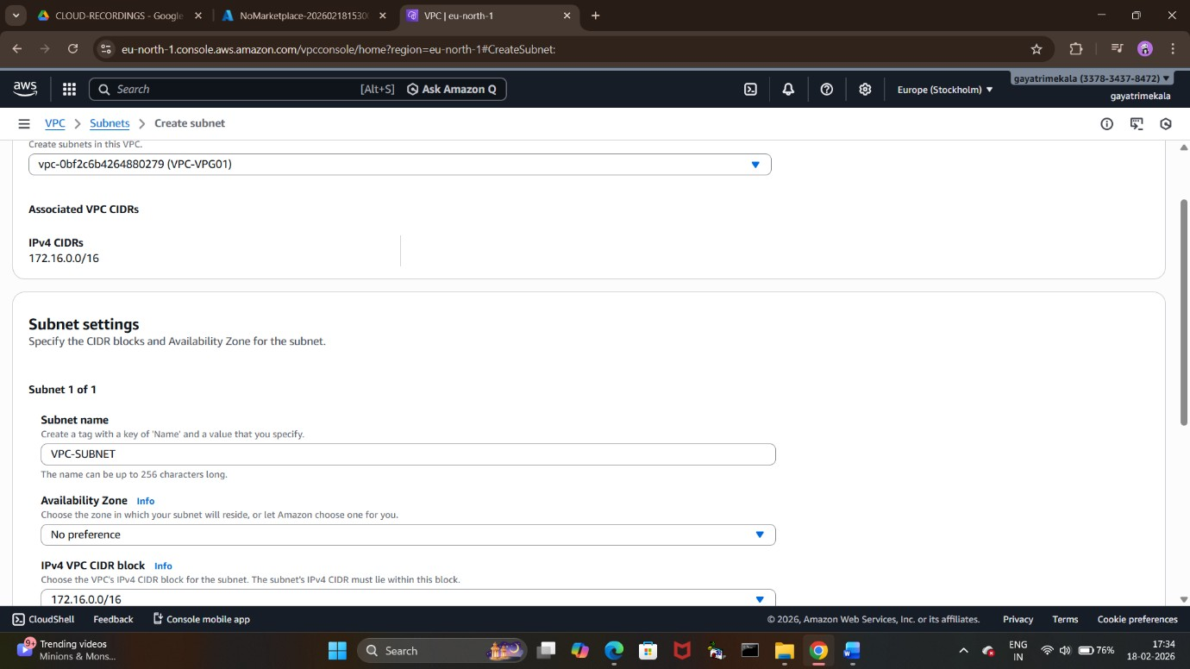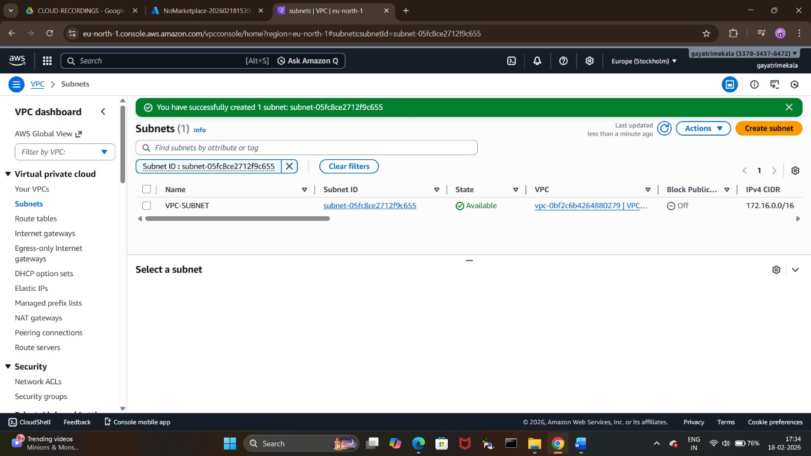

Next , we have to create internet gateway

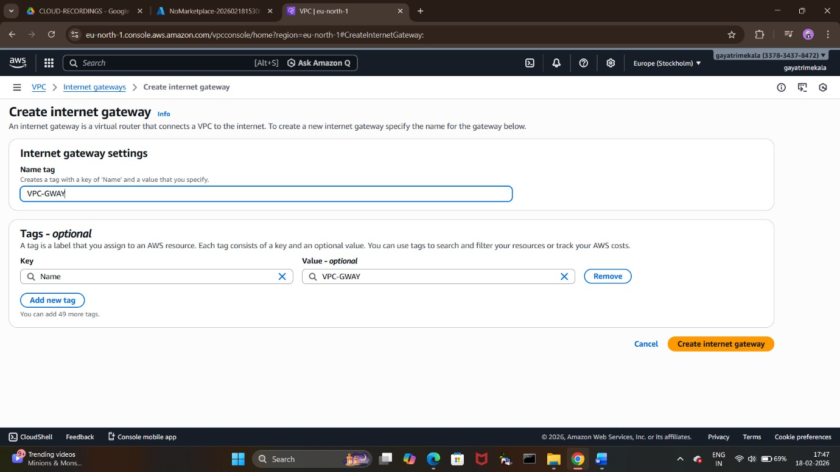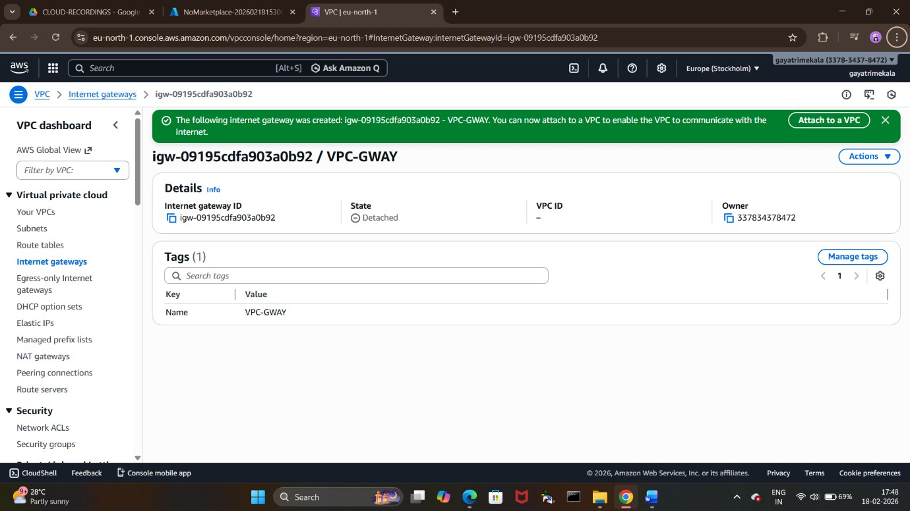
- Connect to the internet -we need to have a internet in aws

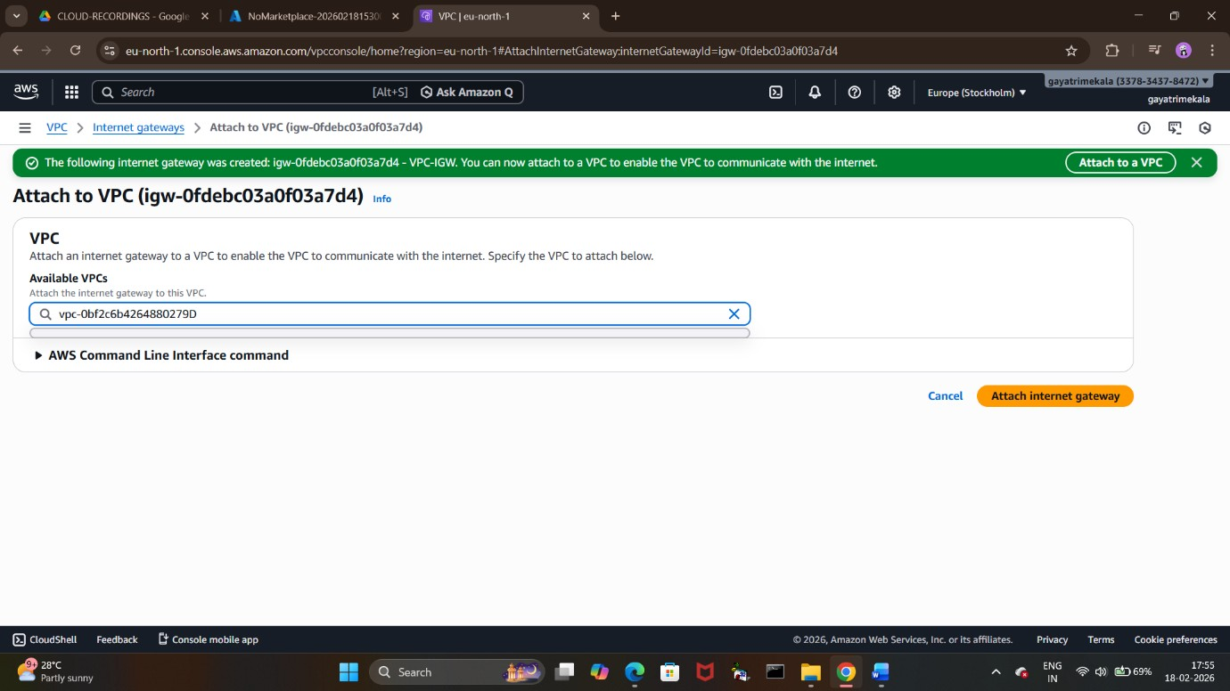

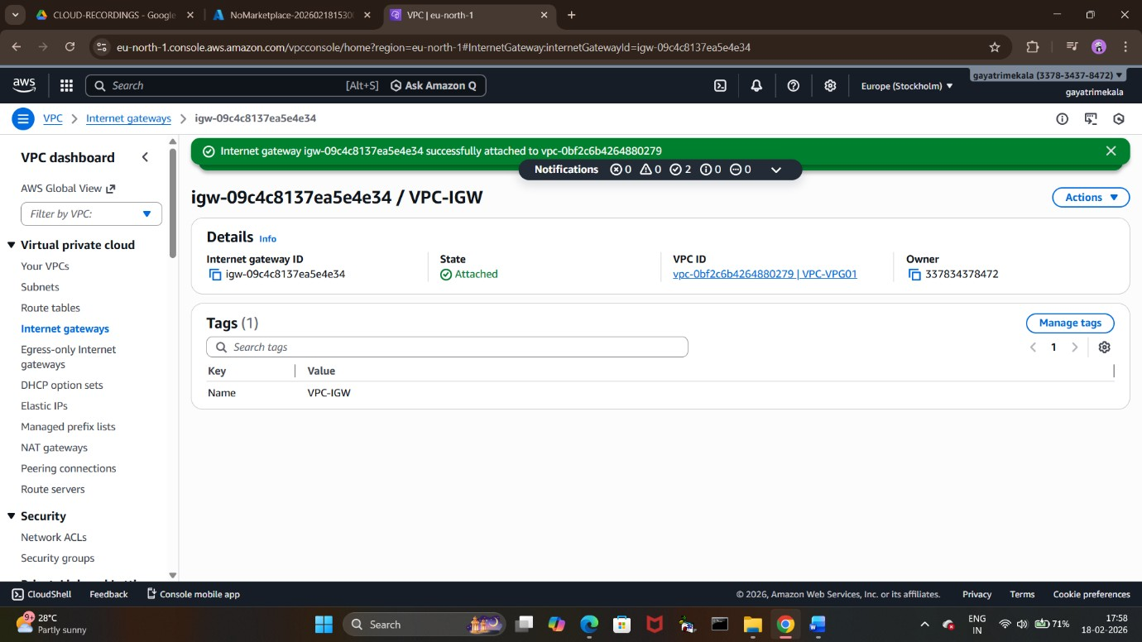

then we have to create the route tables

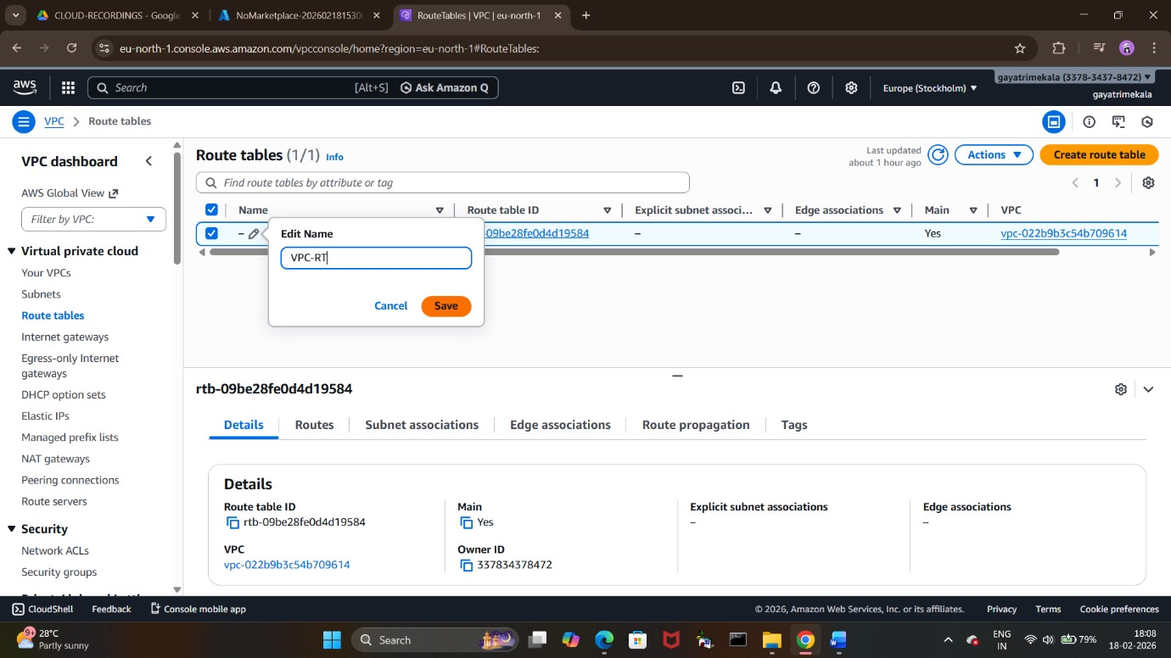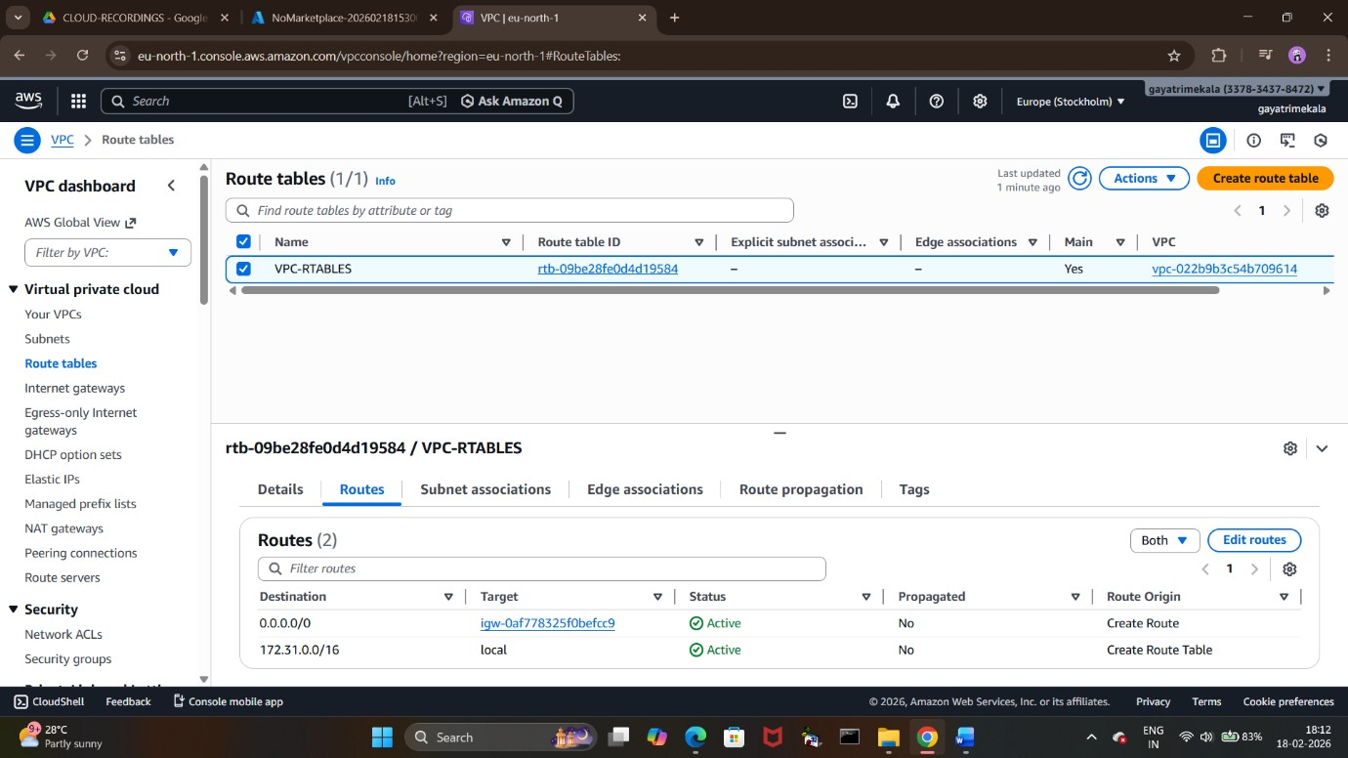
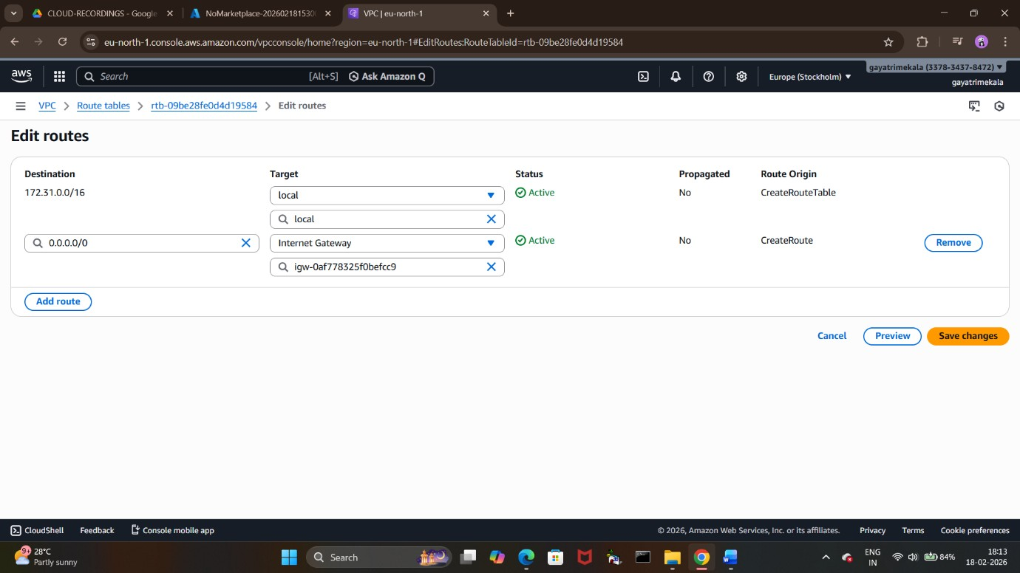
❖ We have to write the route table if any traffic it should use internet gateway to connect outside

- Then we have to create the security group
- VPC must access the internet
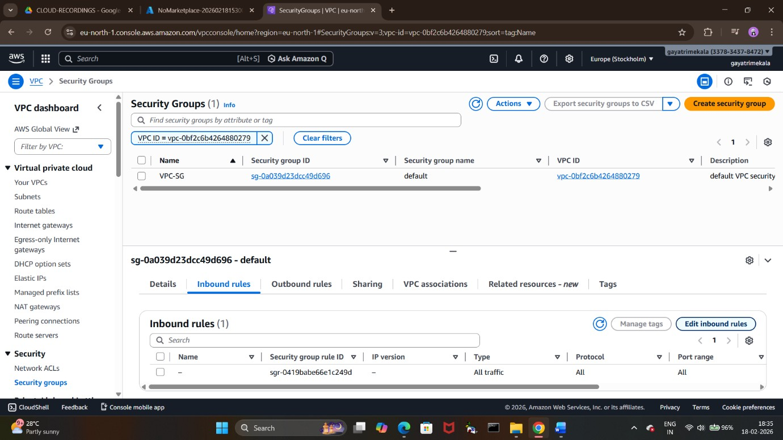
- Edit inbound rules
- Add rules


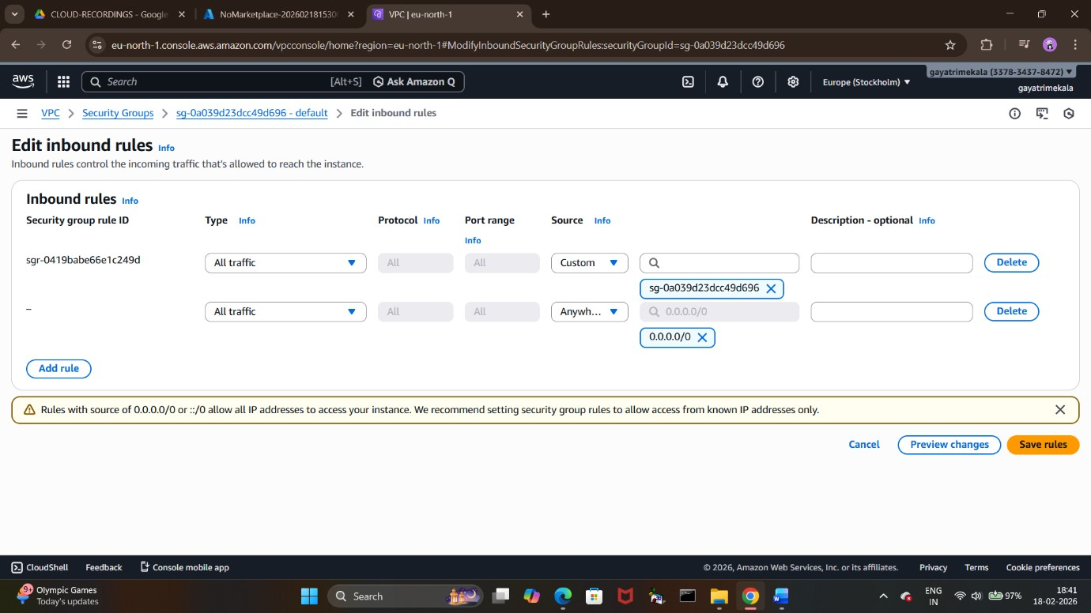


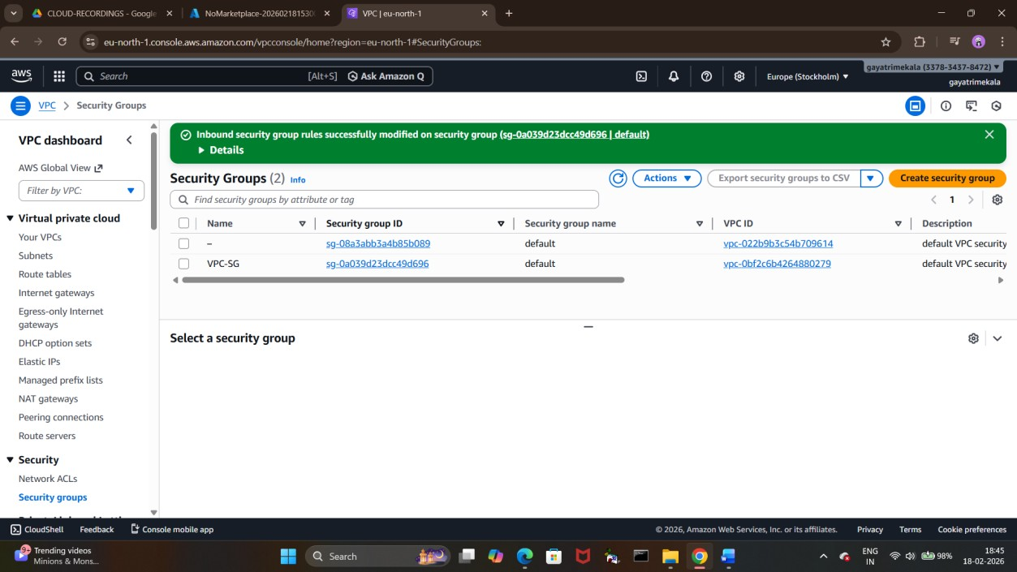
- We have to allow all traffic to my machine
Now we create the virtual machine in the AWS the virtual machine is EC2

First we have to select the EC2-it is same like a virtual machine
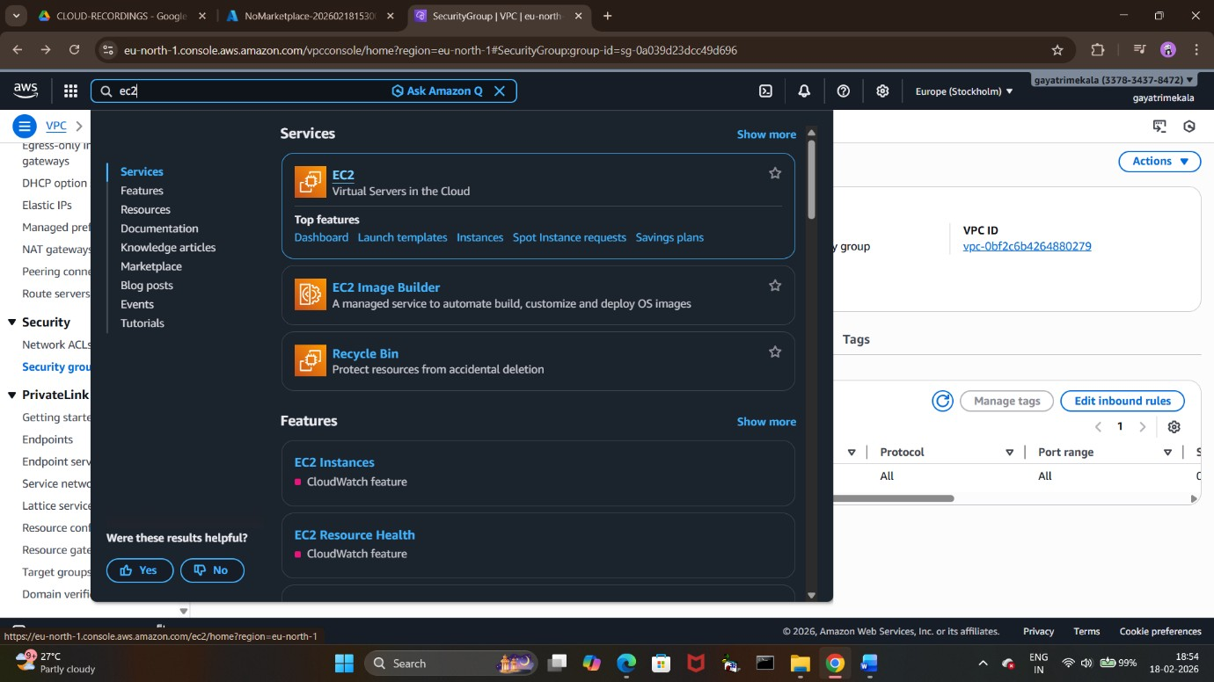
- Next, we have to fill the name
- The server we have to give the ubuntu
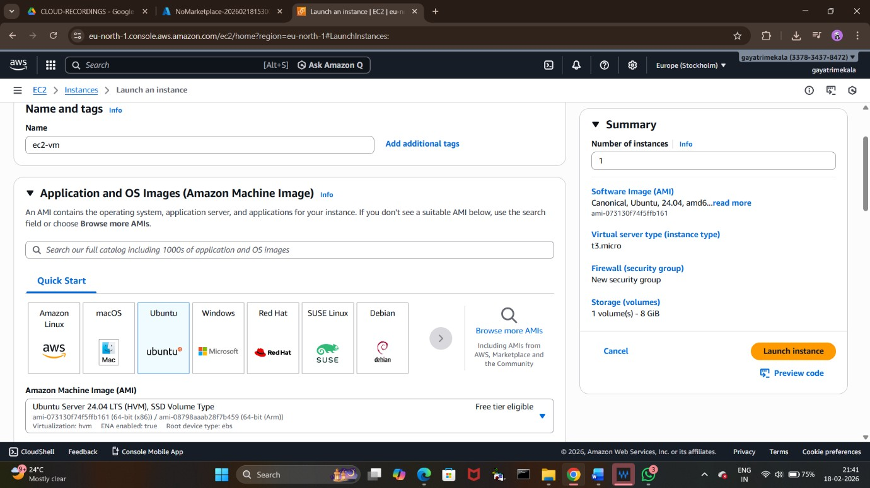
- And we have to give the image in the (free tier) because we are using the free tier account
- We are login with in the key
❖ Now, create new pair of key

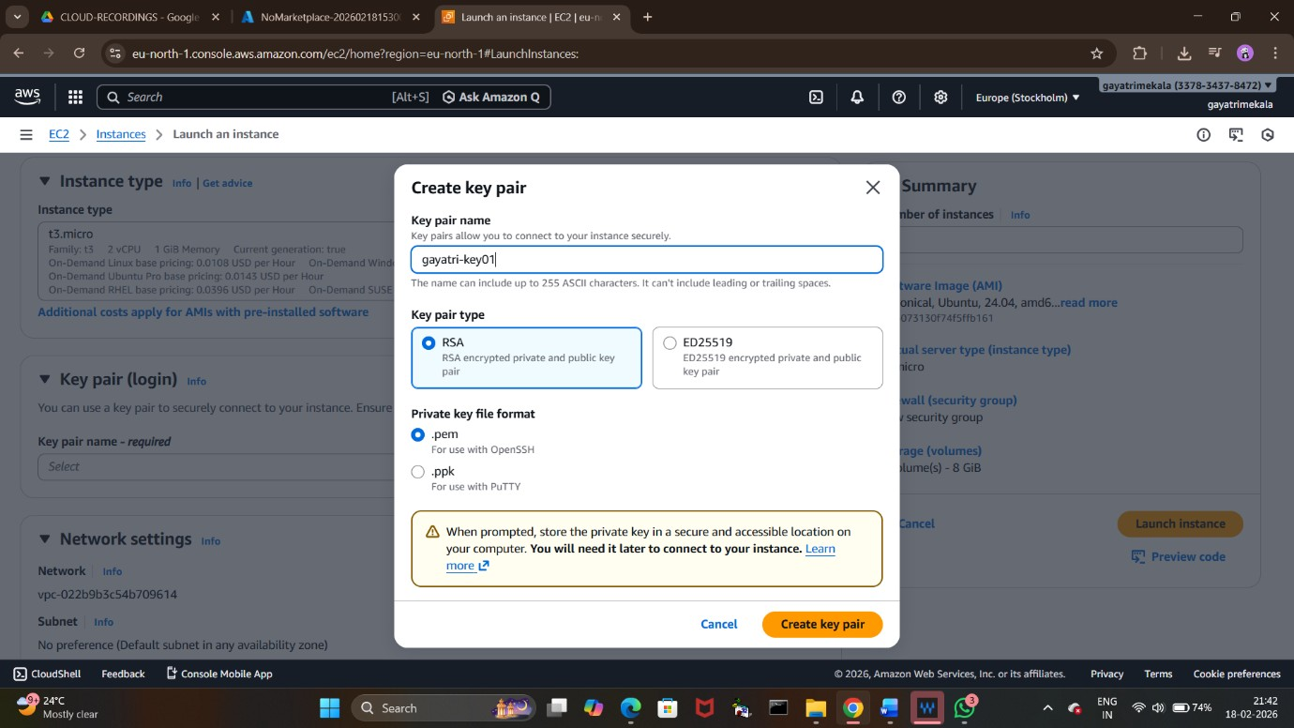
Network settings:
- VPC -already we have created
- Now , enable the IP—because login into the machine
- We have to selected the existing security group –we have to access the already created sg rules and all.
- Sg-default
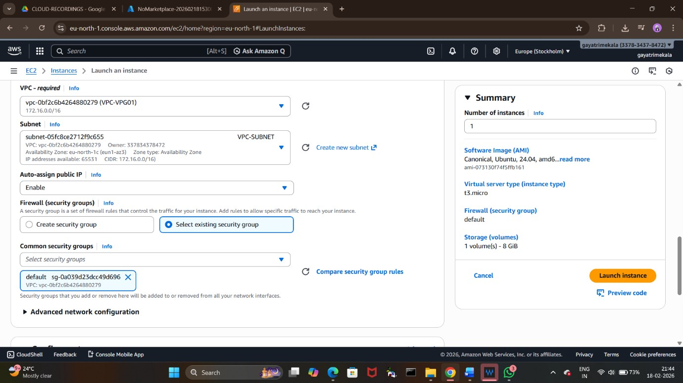

Completion of all access now we have to launch it.
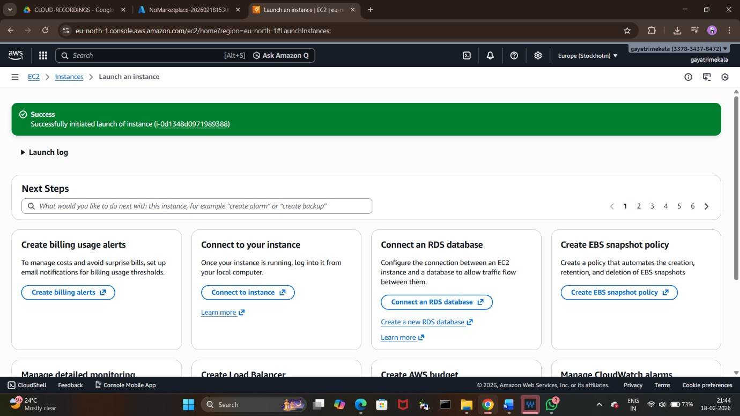
  - Now we have create the create VPN [virtual private network]

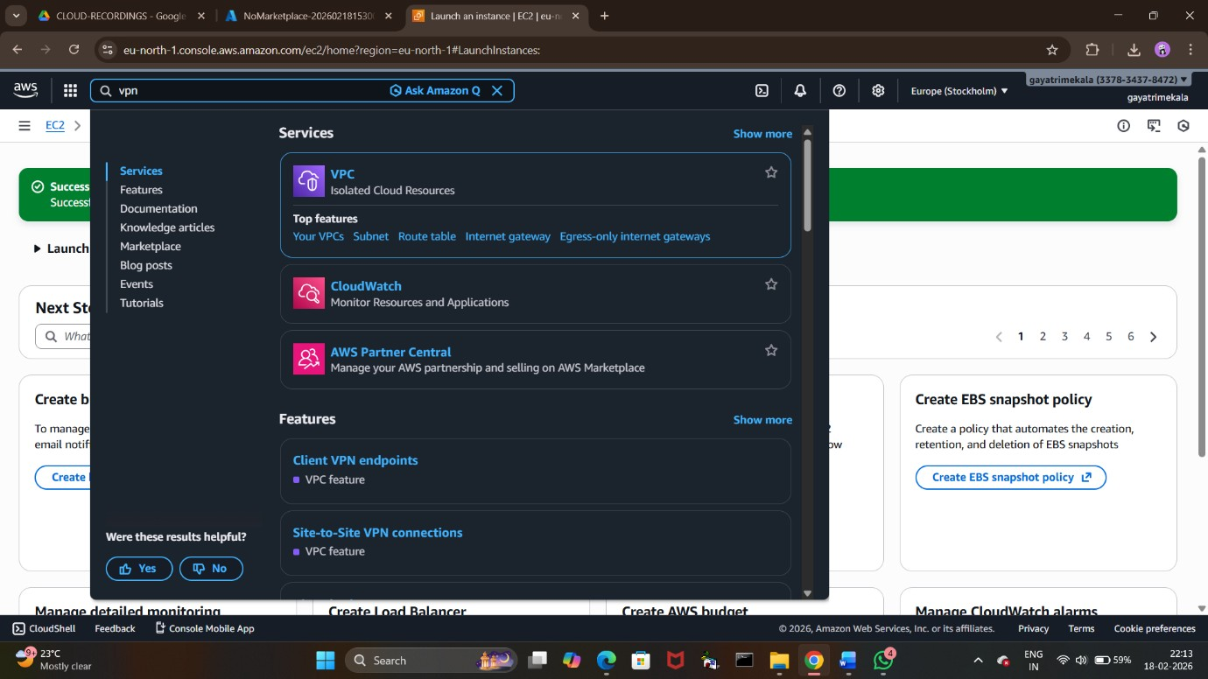
  - In the dashboards -option we have to see virtual private gateway
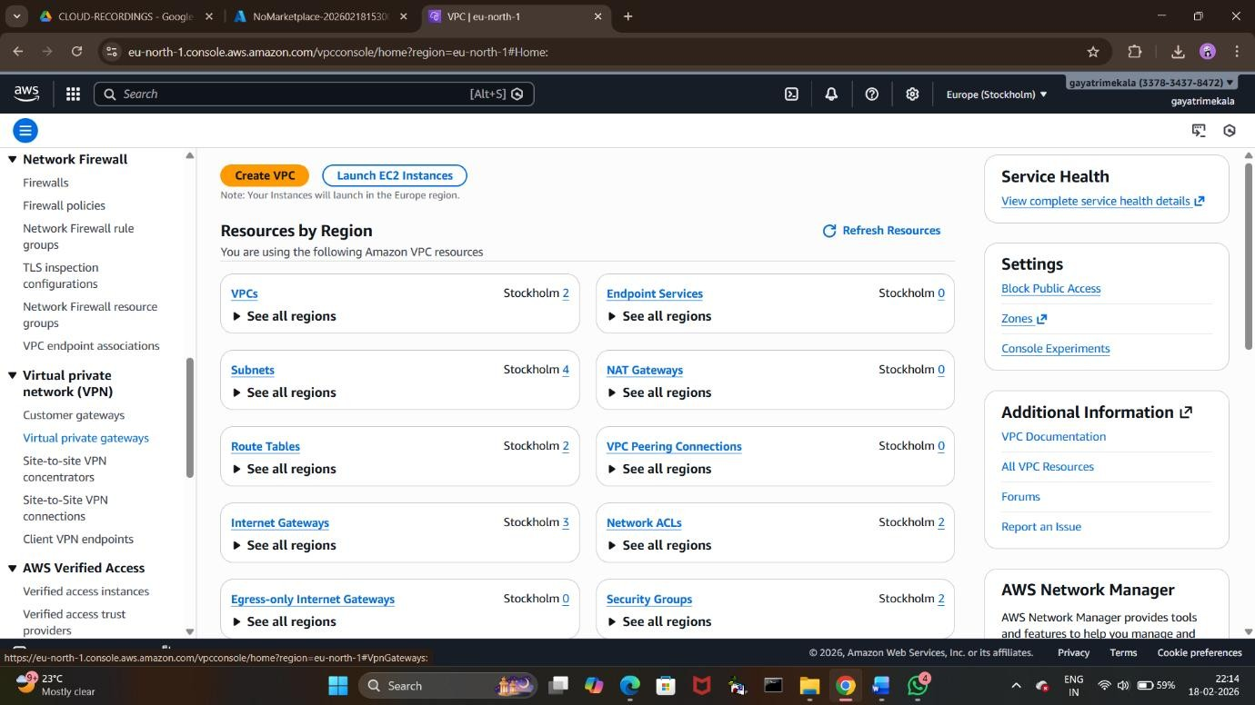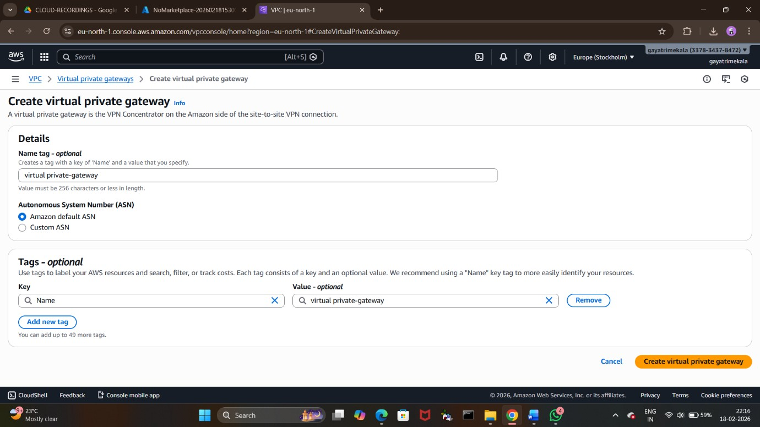
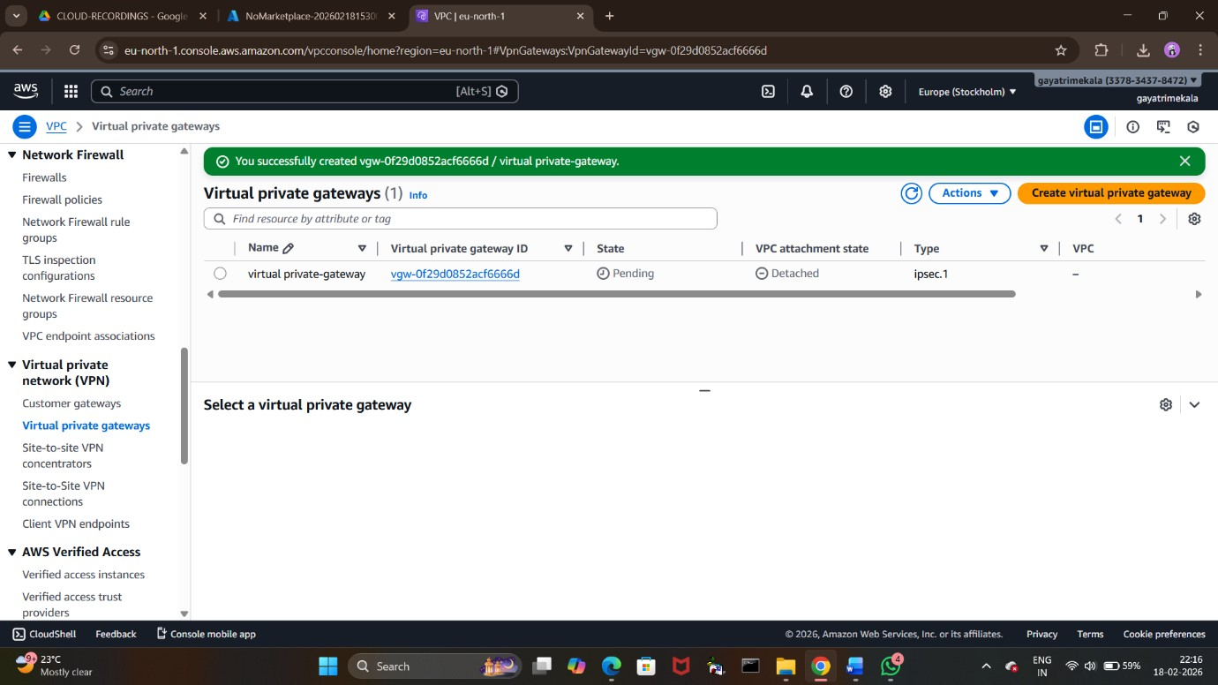
  - Once we have to create the VPN then attach to the VPC
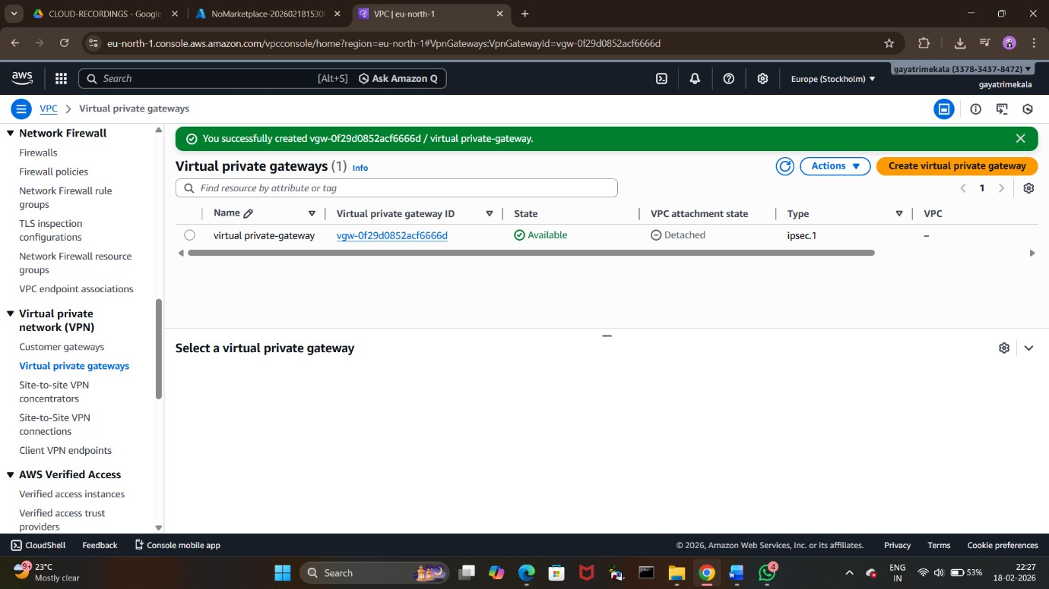

- now we are attach to the VPC
- then it should be attached
-

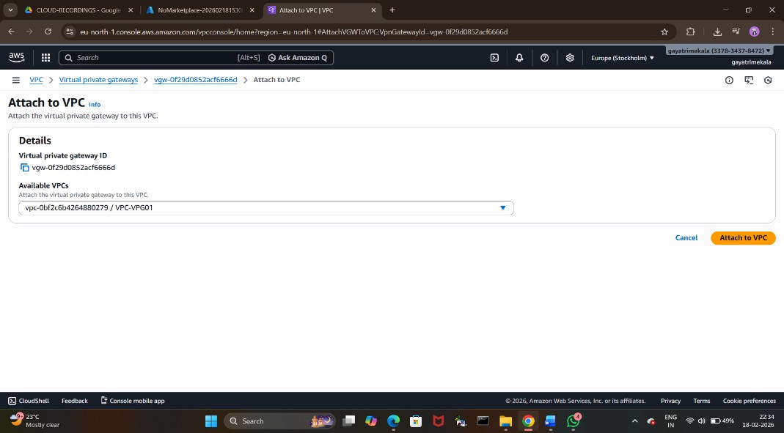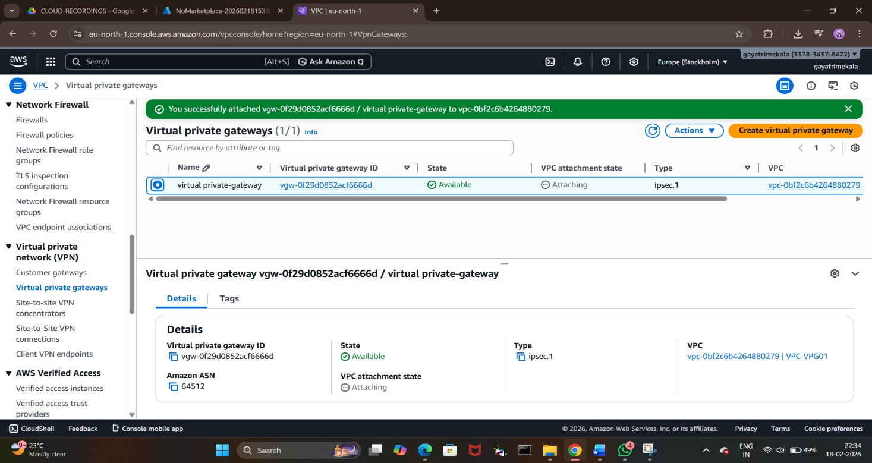

- Now , we have to create a machine (azure)
- Subnet (default)
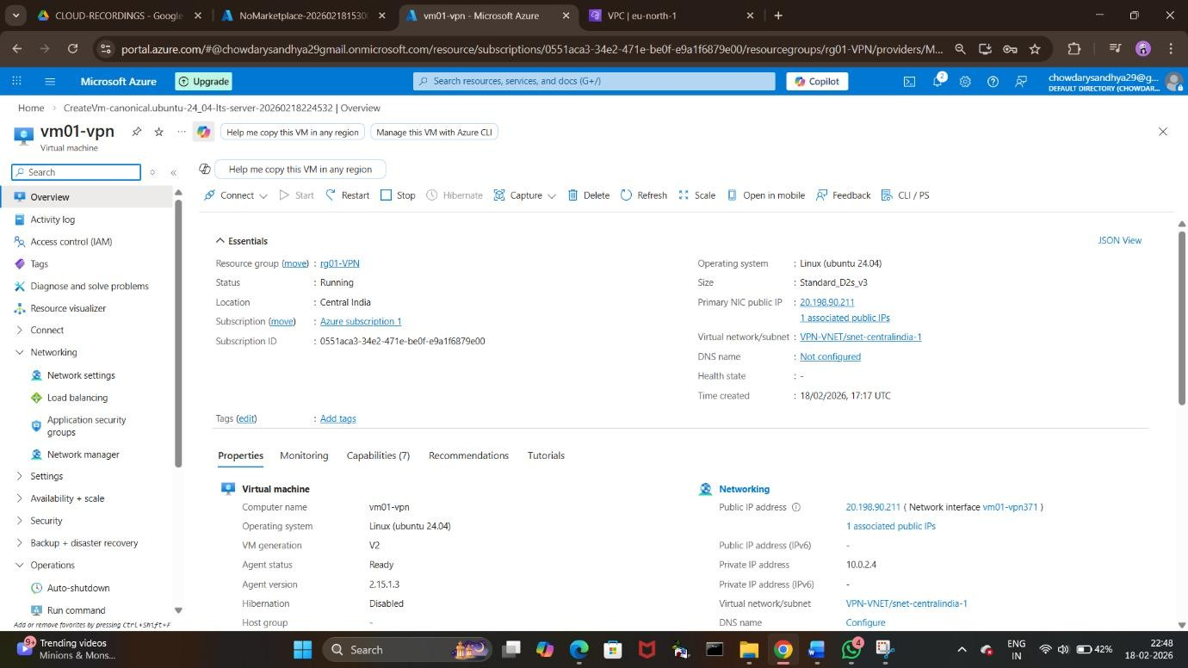

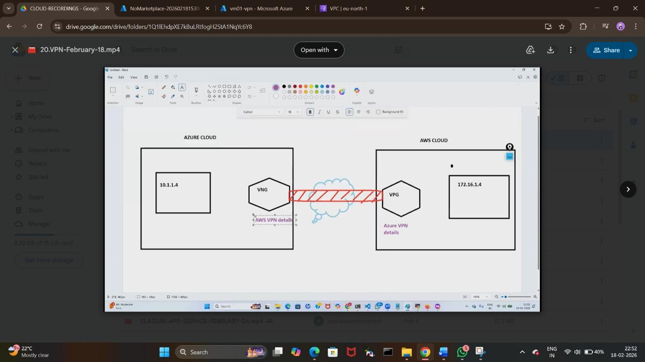
- Now , we have to configure the both two machines
- Exchange both VPN’S to access it

- Now we have connect directly with EC2 via web console
- As well in azure we have to connect web directly by using BASHION

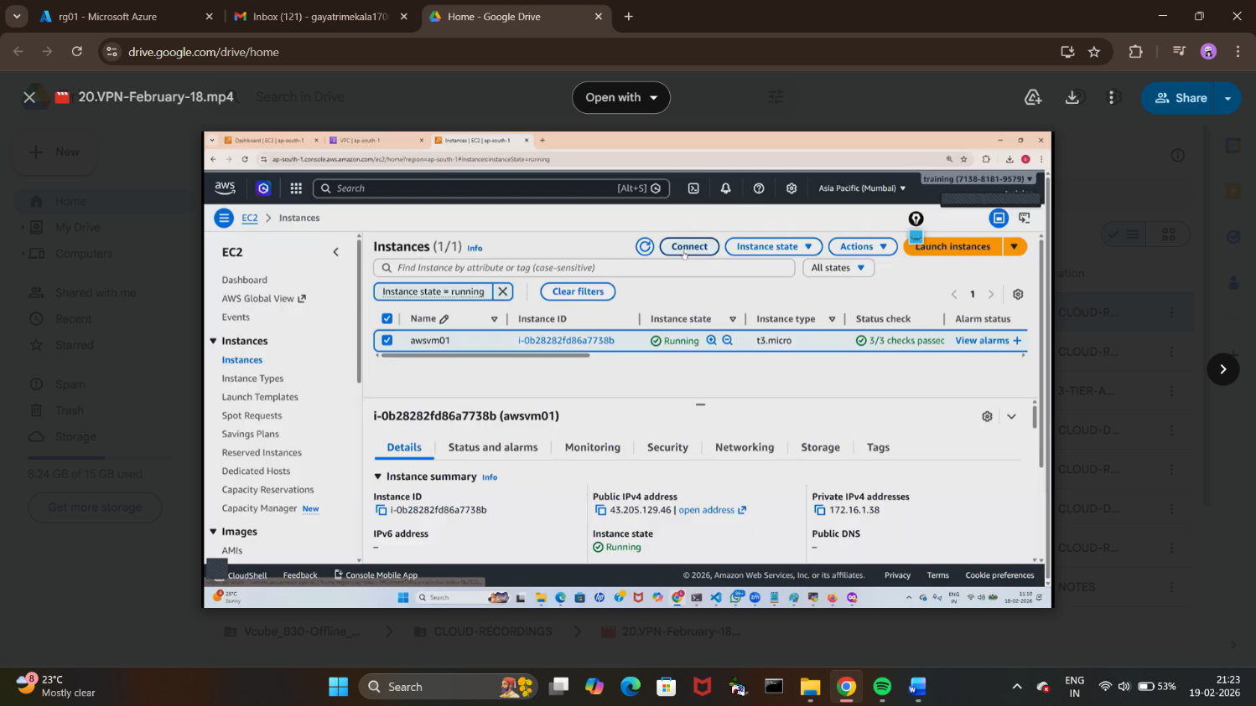

- By using Ping we have configure it.
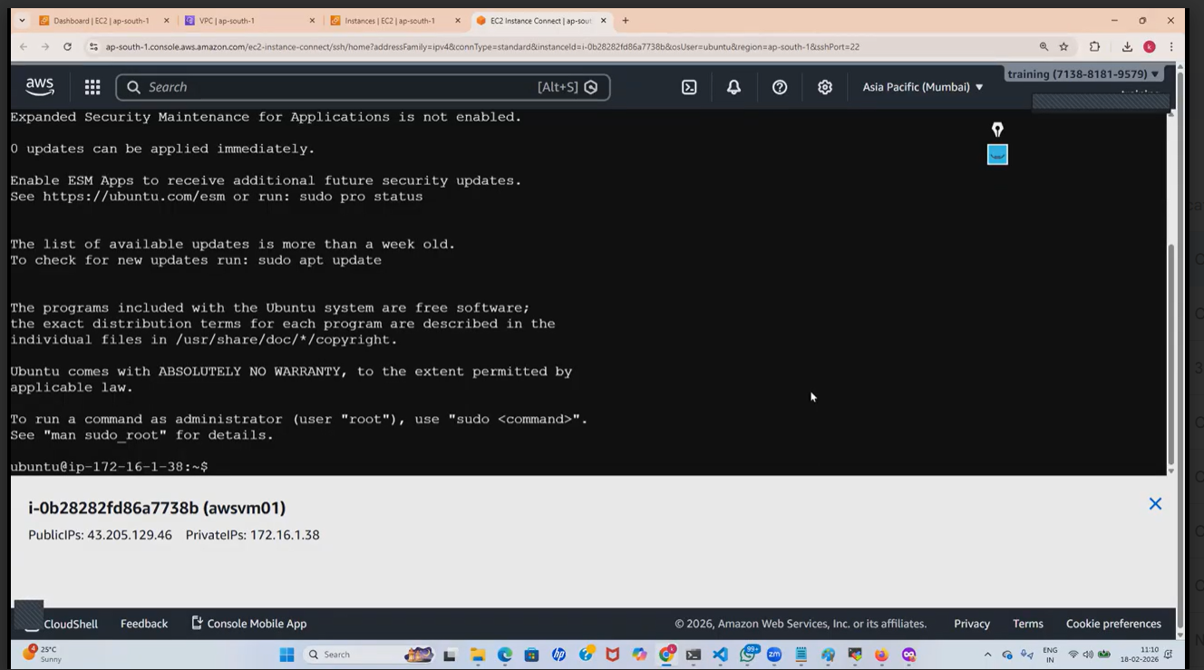

- Now we have to create the customer gateway
- IP address –in azure VPN public IP we have to mention here

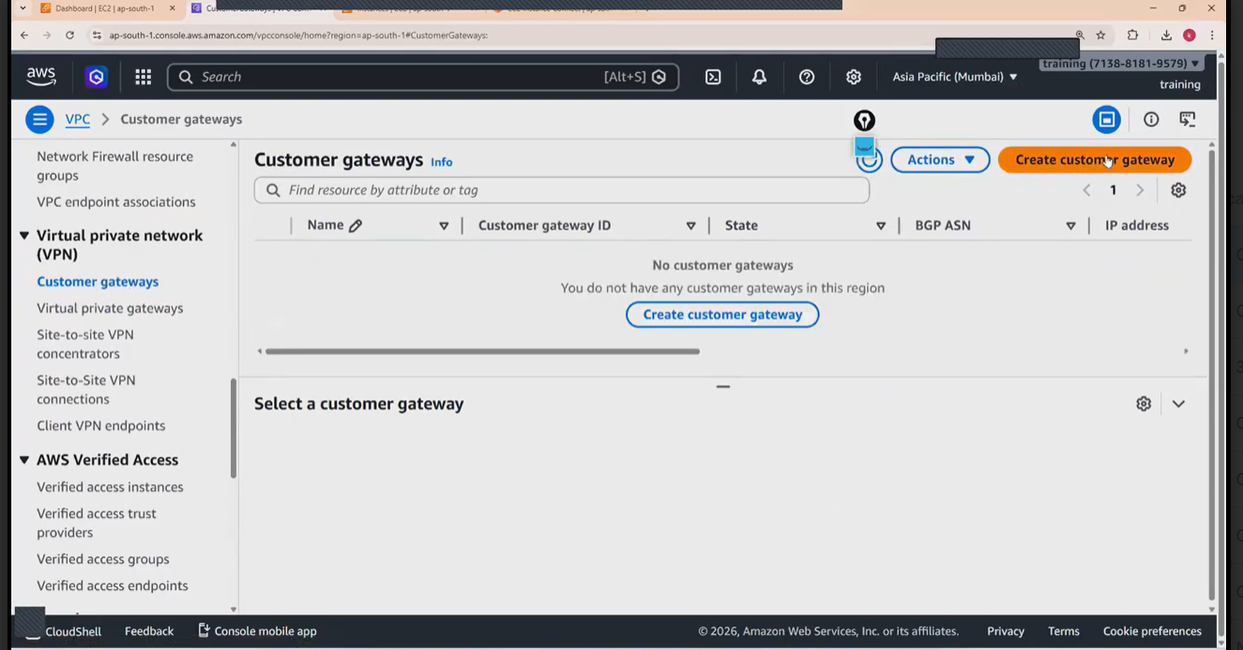
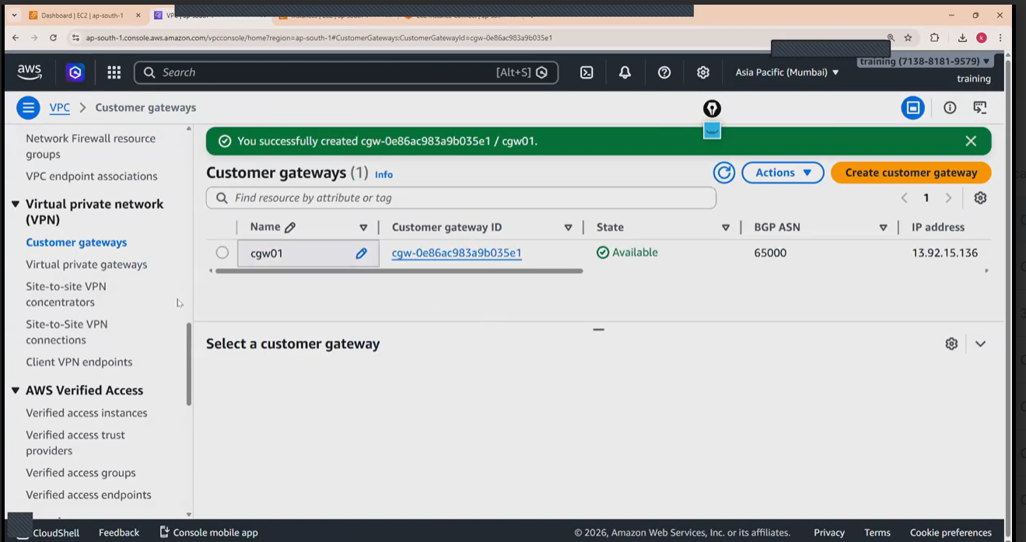

- Now we have to configure SITE TO SITE connection
- Static –we have to give VNET Ip address range
- VPN connection [ create ]
- Copy VPC IP -route table edit routes [10.0.0.0/16-in 10 series virtual private gateway ]
- Private IP of virtual network



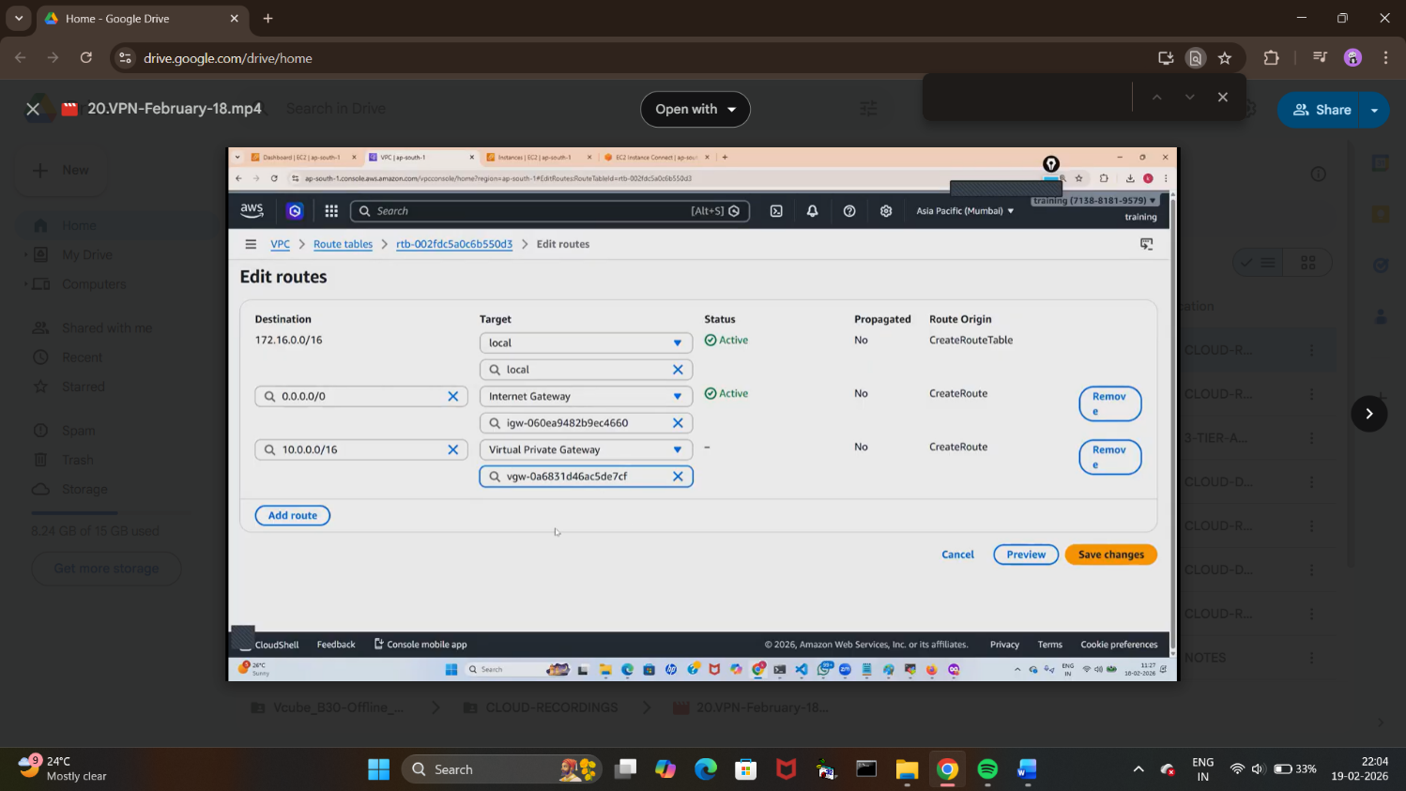
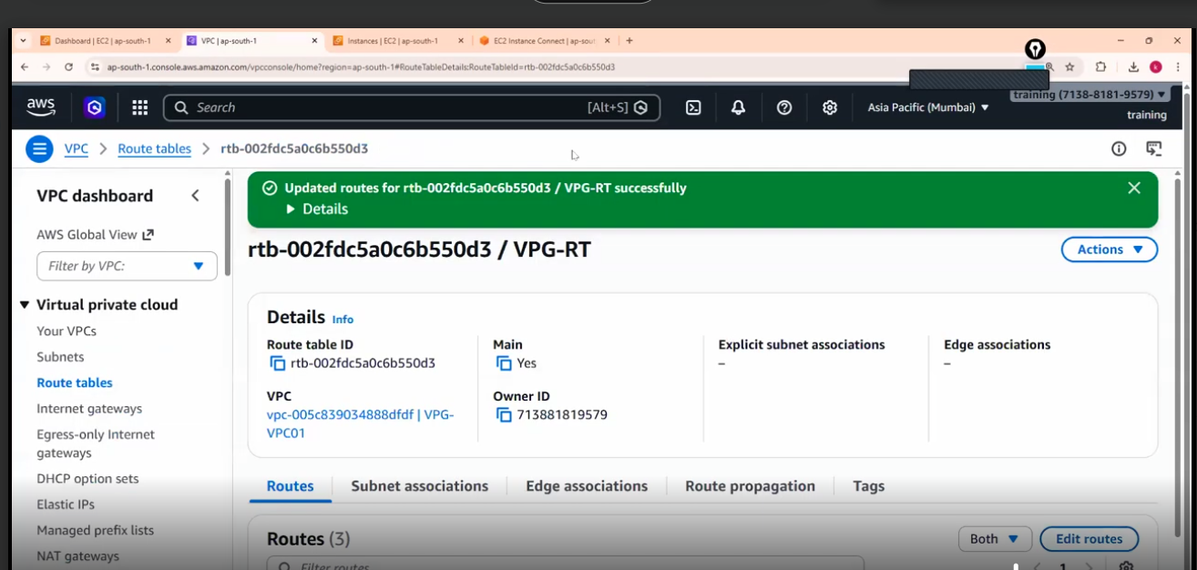

- Now we have to configure by PING

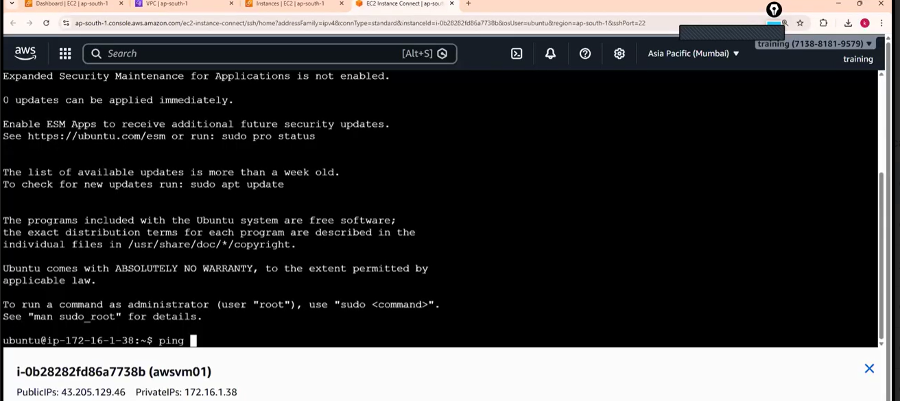

- By using the private IP [ virtual network ]
- Now we have to download the configure
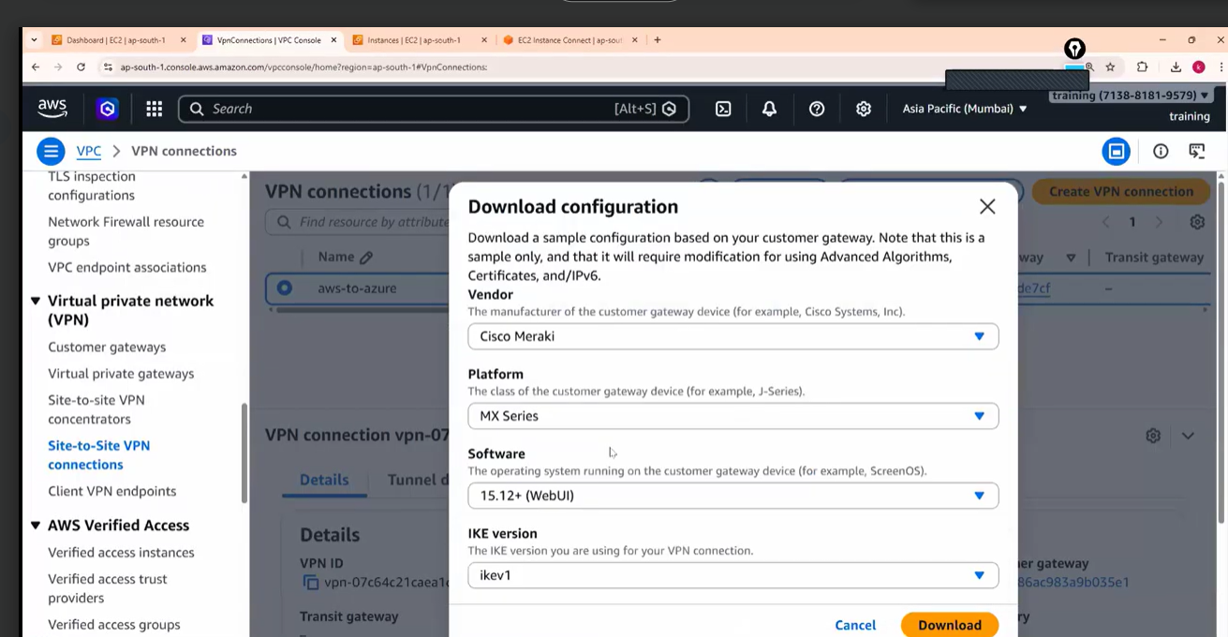

Now, generated the key and paste it

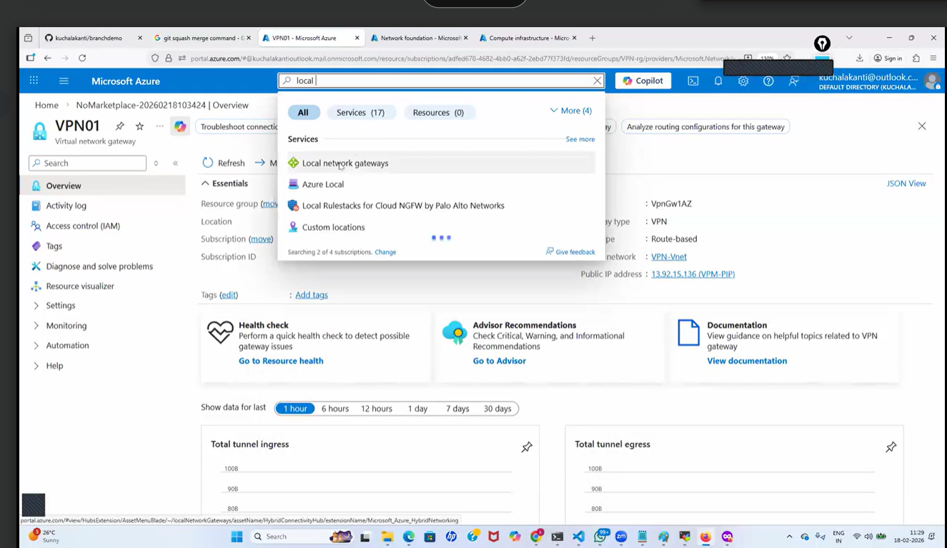
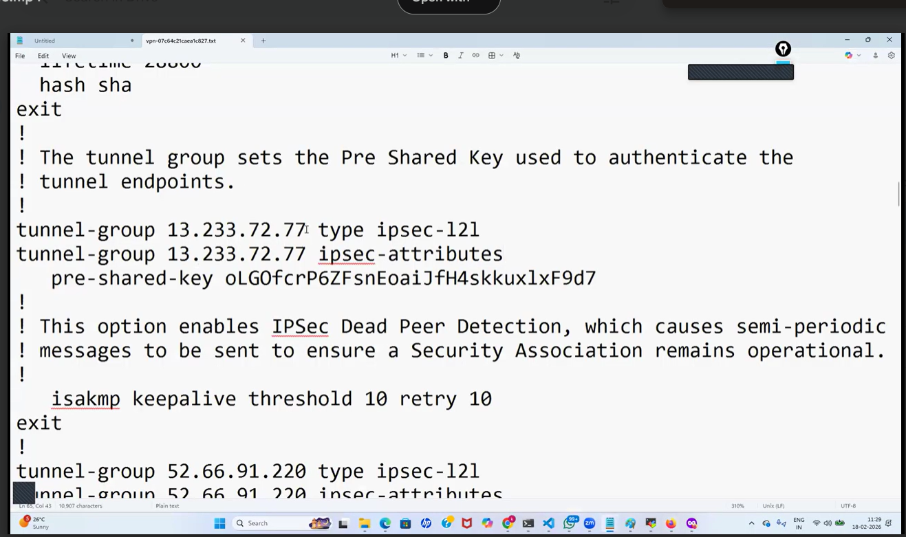

- Copy the public-IP
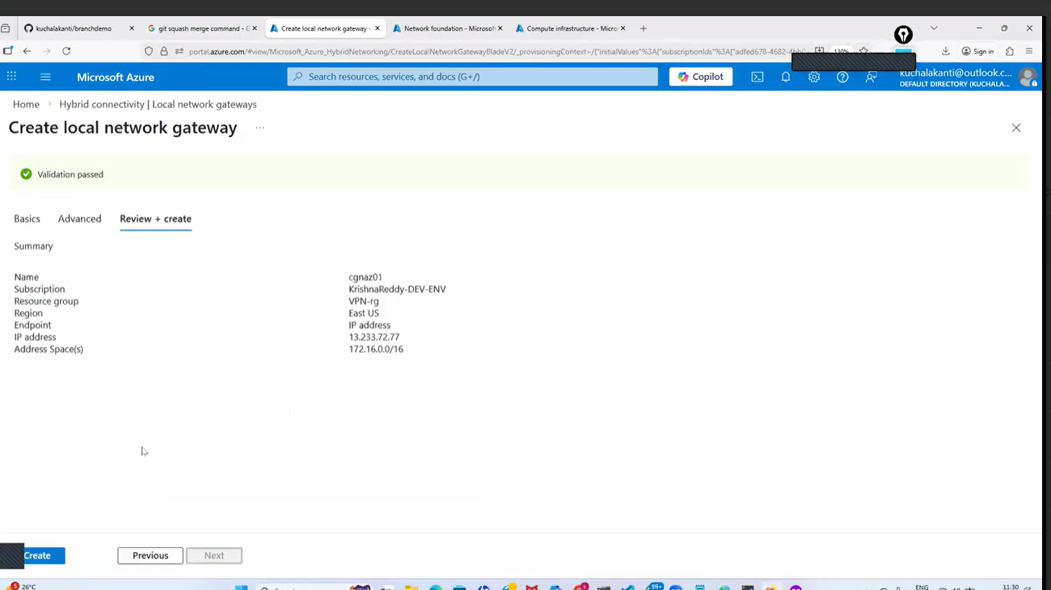
Now we have to configure the site to site connection
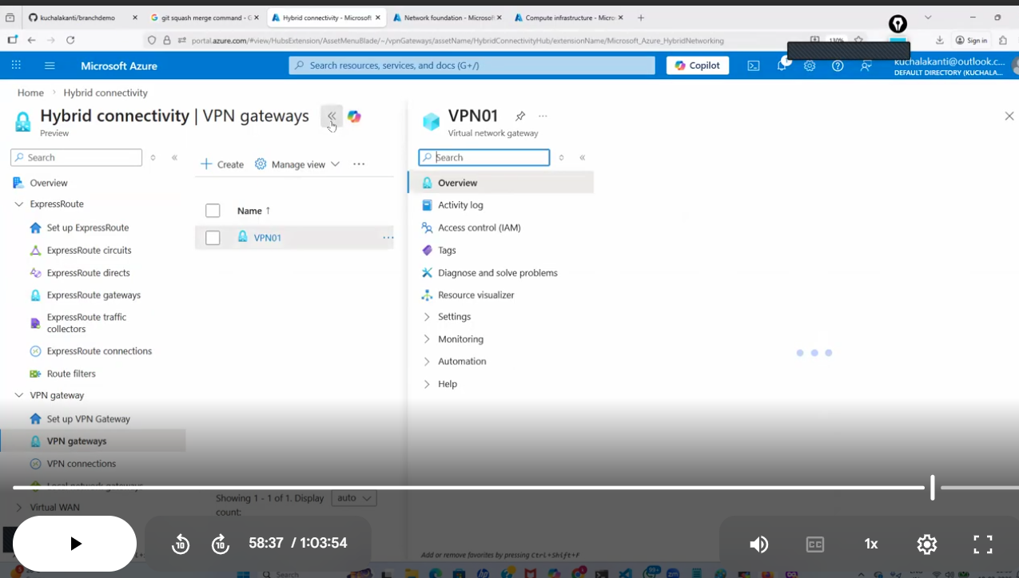
Now go to settings and click site connections { site-to-site } connection
- Now **in settings we have to give which we are created in azure
- Authentication method-shared key we have to use
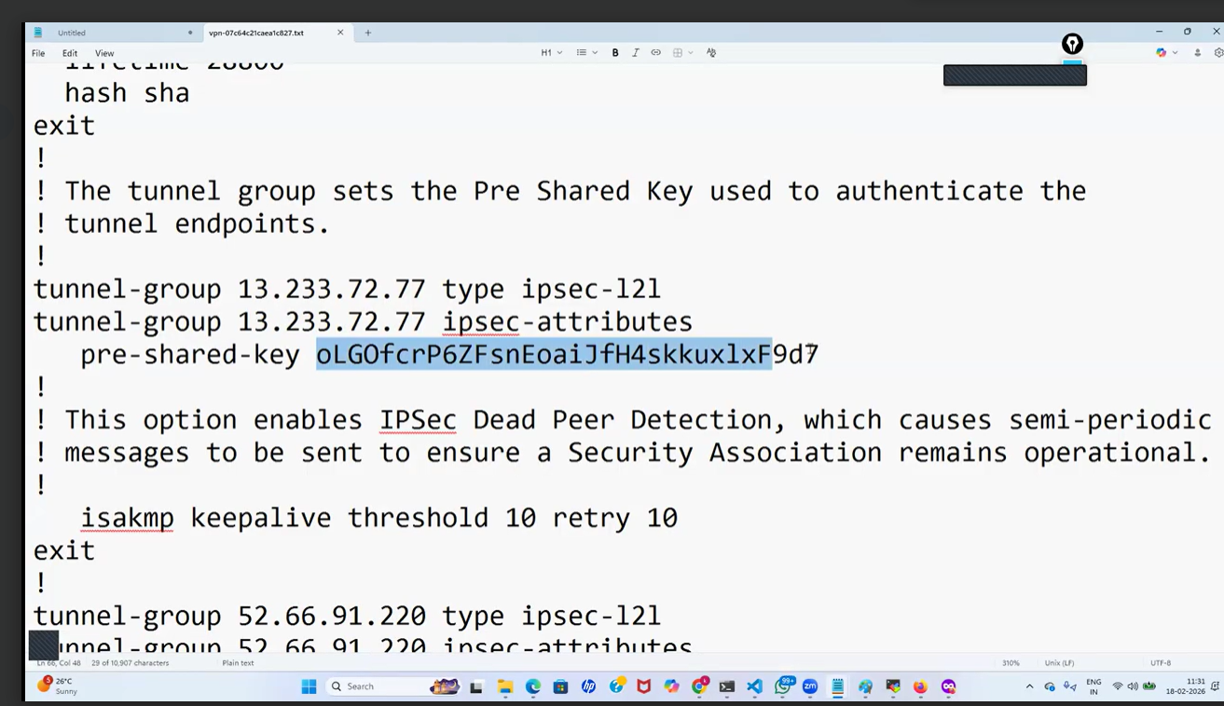
Now create and deploy that .
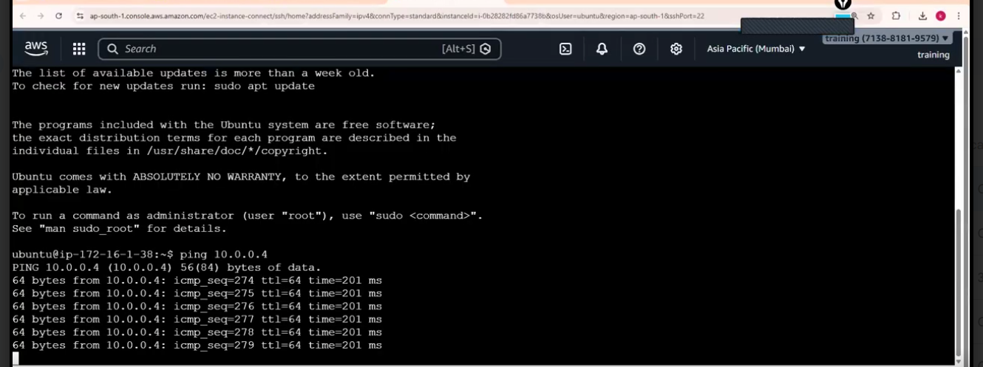
In AWS application server and in AZURE database server should be communicate privately.

