Lisa Tillery

Cedar Hill, Texas 75104

504-452-8396

[ltill65@hotmail.com](mailto:ltill65@hotmail.com)

March 2019

Greetings:

This letter is to express my interest in becoming a part of your organization. Please accept my resume which will give you detail information about my educational background and work experience.

I am a professional Registered Nurse with 20+ years of experience. As you will see in my resume, I hold a Master Degree in Business Administration with emphasis in Healthcare Management.

As an experienced and professional Registered Nurse, I have held various positions in departments throughout acute care hospitals. Some positions include the following: Chart review, Clinical Nurse Coordinator/Acute Case Management/Admission Coordinator/Utilization Review/Utilization Management - Medical Nurse Auditor -One Day Surgery -Pre-Assessment Evaluation/Pre-Op Center -Operating Room Circulator –PACU Phase II -Medical/Surgery RN -Orthopedic RN- Home Health Aide Supervisor.

The combination of my knowledge, experience and expertise in many areas of nursing will add value to your operations. Please feel free to contact me at the phone number and/or email address on my resume. I am very excited about the opportunity to interview and become a member of your team. Thank you for your time and consideration.

Kind Regards,

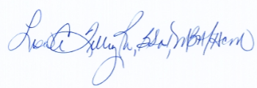

Lisa Tillery, BSN, RN, MBA/Healthcare Management