Felicia L. Glaspie, NRCMA

500 Rolling Hills Place

Apartment #1310

Lancaster, TX 75146

(469) 412-7370

[Fhanks4@gmail.com](mailto:Fhanks4@gmail.com)

**PROFESSIONAL SUMMARY**

Dependable Medical Assistant capable of working well in a fast-paced environment and learning quickly in order to provide excellent service to patients and work hard for a doctor to expedite patient visits while maintaining a friendly and caring demeanor.

**HIGHLIGHTS OF QUALIFICATIONS and SKILLS**

Phlebotomy

Vital Signs

ICD and CPT Code

Keyboard (35 wpm)

Medical Terminology

Casting

Taking EKGs

Injections

Chief Complaints

Specimen Collections

Urinalysis

Customer Service

MS Word

**EDUCATION and CERTIFICATIONS**

Concorde Career College – Grand Prairie, TX Graduate

Accredited Medical Assistant Program

* **NRCMA Certification #160651**
* CPR Certified 5/2017
* HIPAA Certified

Externship:

Raj Shiwach, MD 11/2017 – 2/2018

Insite Clinical Research

Medical Assistant – Externship (Completed 216 Hours)

* Greeted patients
* Checked patients in and out
* Scheduled patient appointments and follow up calls for reminder appointments
* Roomed patients
* Chief complaints
* Vitals – recorded and scanned
* Specimen collections
* Urinalysis
* Cleaned and restocked all exam rooms between patient visits

PROFESSIONAL EXPERIENCE

Head Start of Greater Dallas – Dallas, TX 8/2018 – Present

**Health Assistant**

* Enrolled Students into Head Start
* Vitals
* Hemocrit
* Capillary sticks
* Testing for lead
* Scanned all immunization and physical documentation and dental

**Substitute Teacher** – Dallas, TX 9/2011 – 8/2018

* Assist Teachers with Pre K and education needs
* Set up classroom for daily activities for education learning
* Ensure children are safe and in a supportive environment
* Take care of children spanning in the ages from 3 to 5 years

GE Capital – Bedford, TX 1/2008 – 7/2009

**Account Collector II**

* Responsible for incoming/outgoing calls for past due accounts
* Scheduled payment arrangements for accounts 30-60 days past due
* Contacted Dealerships for customer information for possible repossession

**Digital Badges:**

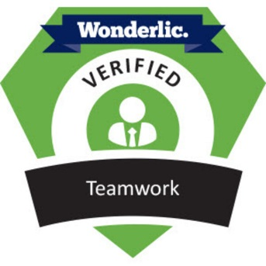 

Please click here to see more badges: <https://wonderlic.credly.com/members/feliciaglaspie>