**Front end case study**

* **Steps to follow in your cmd**

**Step 1: Install Create-React-App**

npm install -g create-react-app

**step 2:create a new React project by running**

npx create-react-app profile-mapping-app

**Step 3: Navigate to Your Project Directory**

cd profile-mapping-app

**Step 4: Install Necessary Packages**

A.React Router (for navigation):npm install react-router-dom

B.Axios (for making HTTP requests):npm install axios

C.Install Leaflet and React-Leaflet:npm install leaflet react-leaflet

**Step 5: Start the Development Server**

npm start

* **Directory structure**

profile-mapping-app/

│

├── src/

│ ├── components/

│ │ ├── AddProfile.js

│ │ ├── AdminPanel.js

│ │ ├── Header.js

│ │ ├── MapComponent.js

│ │ ├── ProfileDetails.js

│ │ ├── ProfileItem.js // If you created this component

│ │ ├── ProfileList.js

│ │ ├── ProfileMap.js

│ │ └── MapComponent.css

│ │

│ ├── App.js

│ ├── Home.js

│ ├── index.js

│ ├── App.css

│ ├── App.test.js

│ └── index.css

│

├── public/

│ ├── index.html

│ └── ... // other public assets

│

├── .env // Environment variables file (if created)

└── Makefile // If you have a Makefile for your project

* **The key functionalities of the application include:**

**1.Profile Display: I have inserted 2 haedcoded profiles for references.**

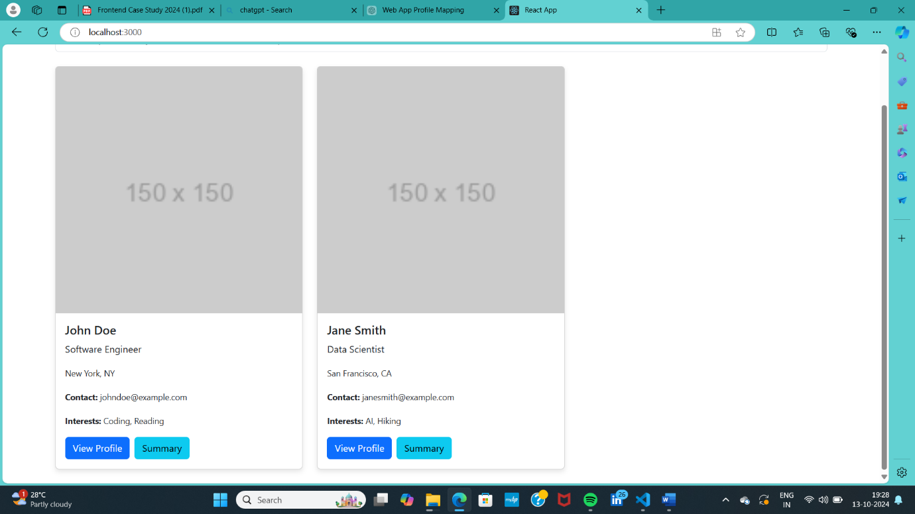

**2.nteractive Mapping:** Added the interactive map**.**

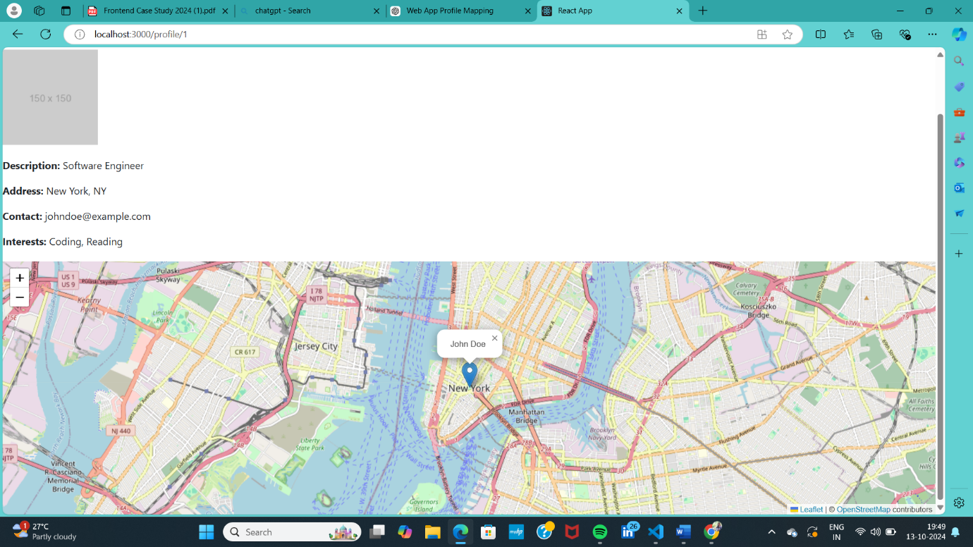

**3.Summary Integration**: After clicking on the summary button It will show you the map of that respective profile.

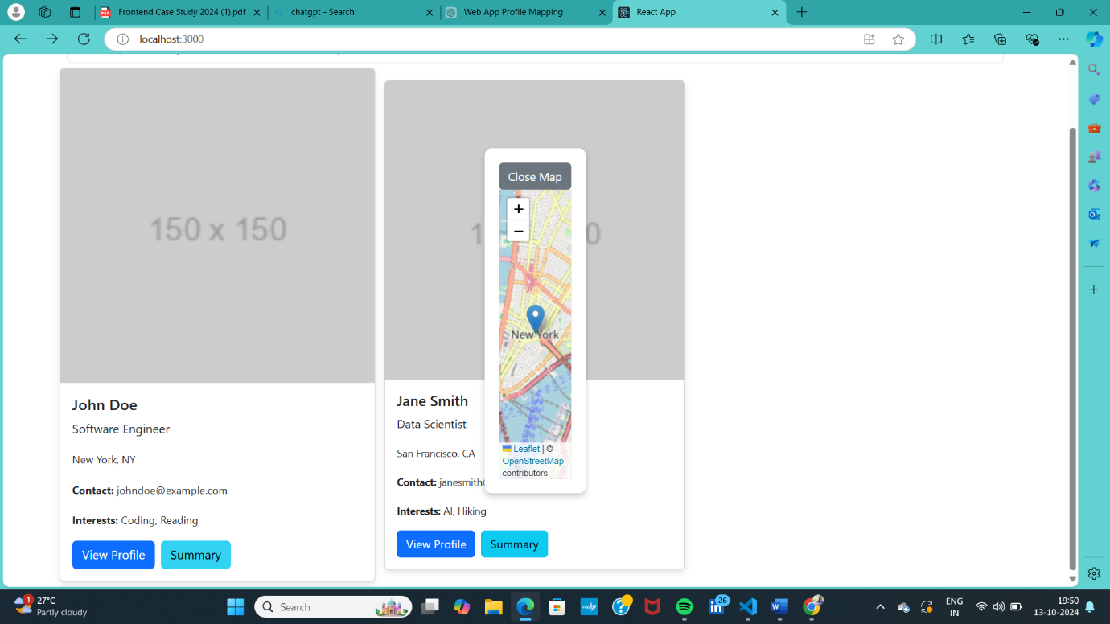

**4.Map Services Integration:** Used [Install Leaflet and React-Leaflet:npm install leaflet react-leaflet] foe map .

**5.User-Friendly Experience:** The UI I have used I super easy to use and user friendly.

**6.Profile Data Management** : As you see admin can add , edit, delete the profiles.

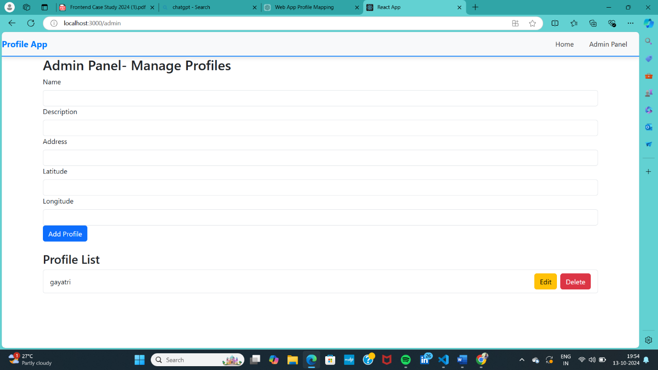

**7.This will require an admin panel or dashboard to manage the profile data efficiently:** I have created a admin panel as well.

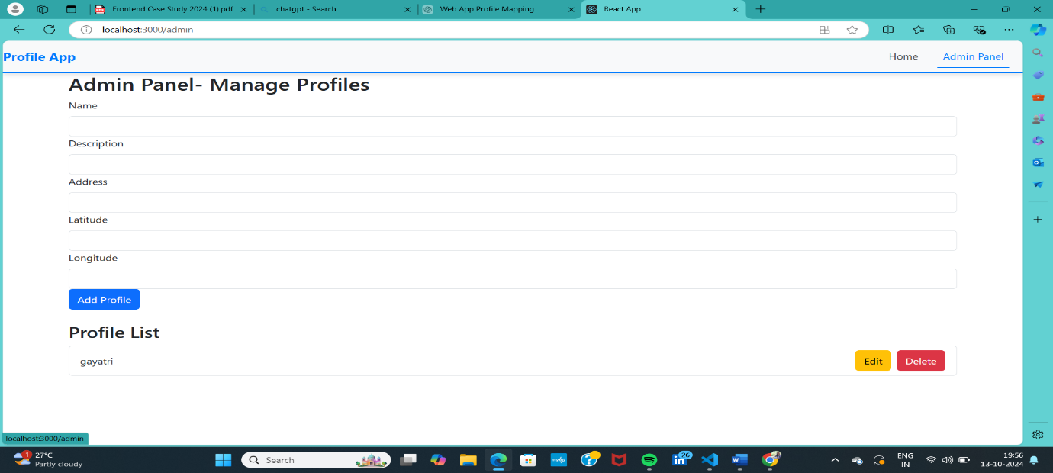

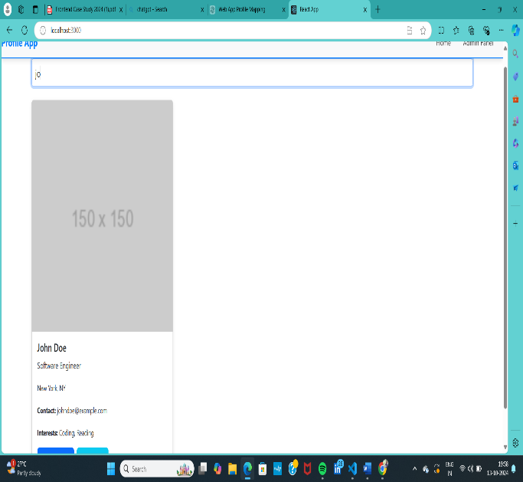**8.Search and Filter Functionality :** Successfully added the search and filter functionality

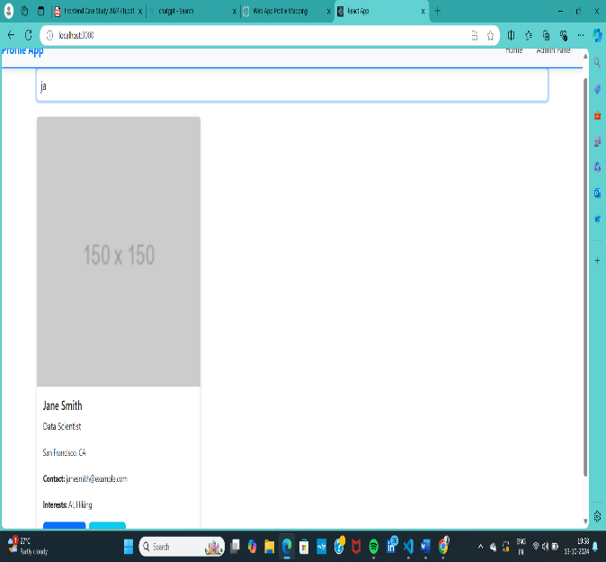

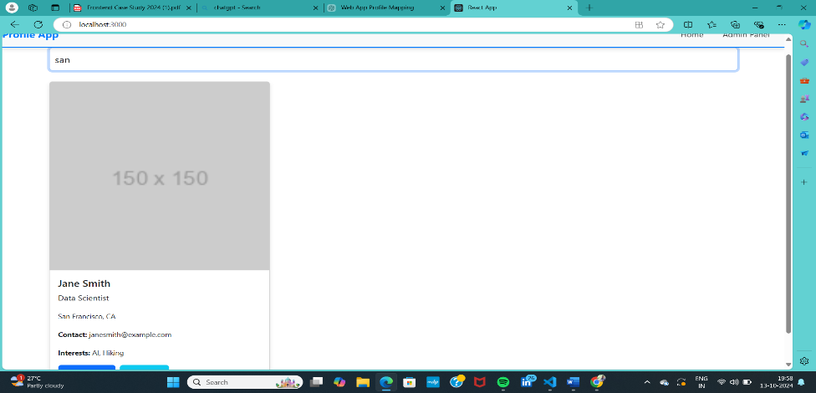

**9.Responsive Design :**Definitely it provides a responsive design .

**10.validation mechanisms :** There are validation are given to each field of the add profile section.

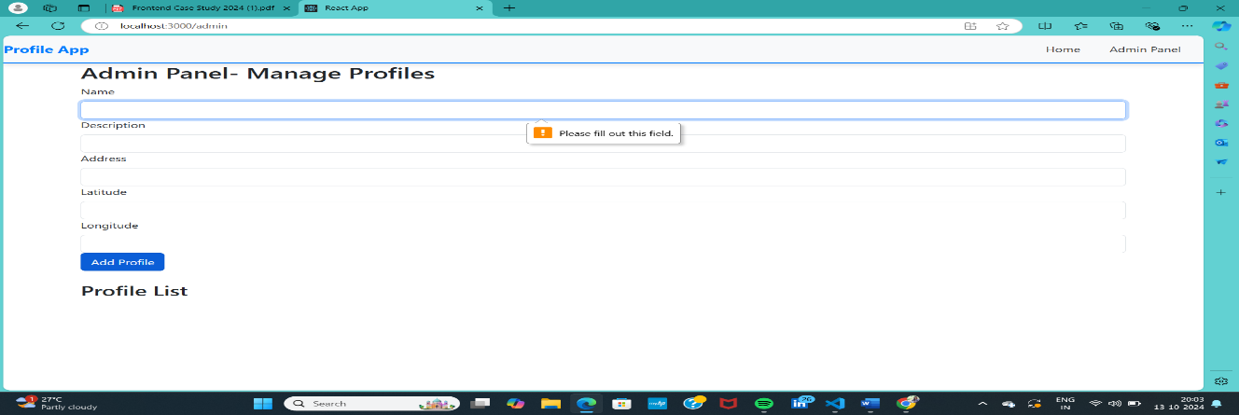

**11.Loading Indicators :** added the loading indicators as well

**12.Profile Details**: There is a separate foe the entire profile information.

