***Magento Mobile App***

**MAGENTO MOBILE APP SRS**

[www.magentomobileshop.com](http://www.magentomobileshop.com) **i**s the most preferred online web application. MAGENTO MOBILE is an application through which we can make our own websites for any product, applications and can add to PLAY STORE with many features 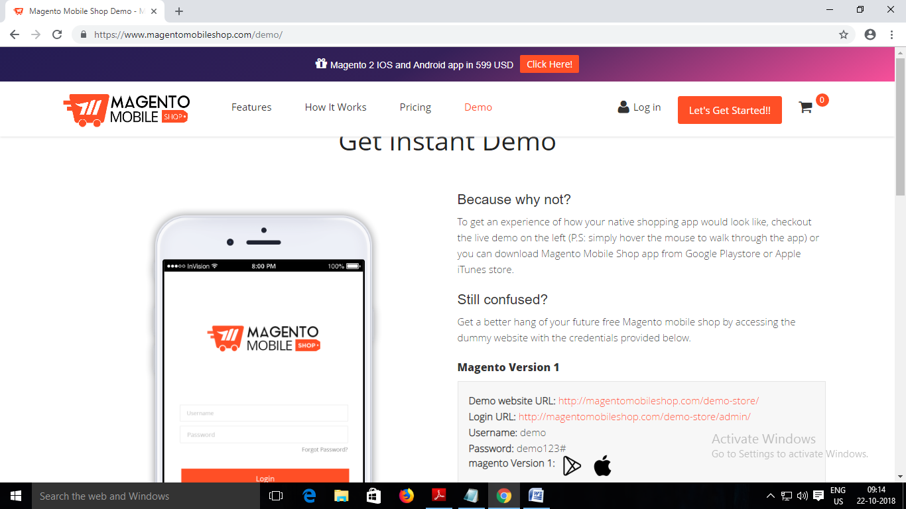through which we can add those options to our websites or applications.

**Steps to follow to post an Ad:-**

1)By clicking The LOGO It should redirects to the HOME PAGE Of Magento Mobile Apps.

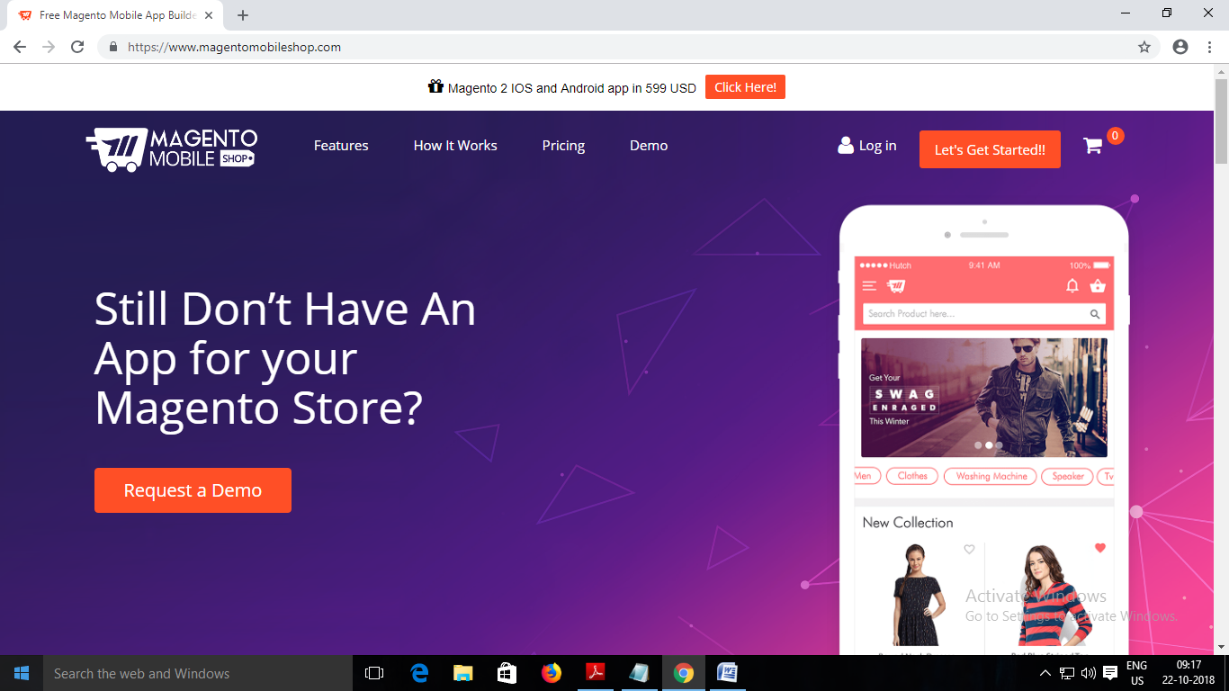

2) In Home Page There are lots of menu present such as: Features, How it Works, Pricing, Demo,Login,Let’s Get Started. 

3) There is a button “Request a Demo” Which redirects to the Demo Page of this application.

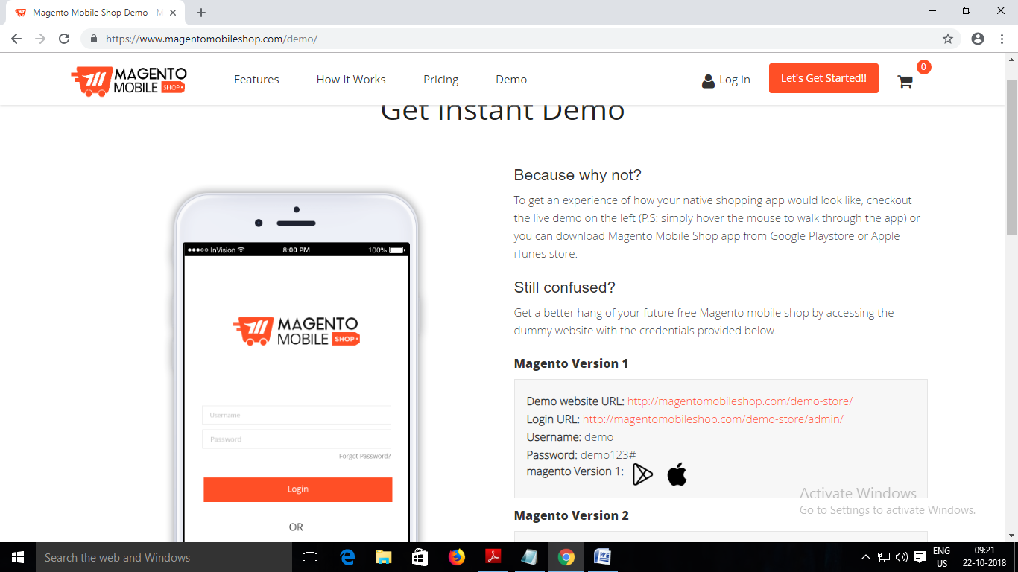

4) There is a dummy Mobile present in the Demo Page Which Displays About the uses of Application.Where The Login Page and Shopping Websites Pages are displaying.

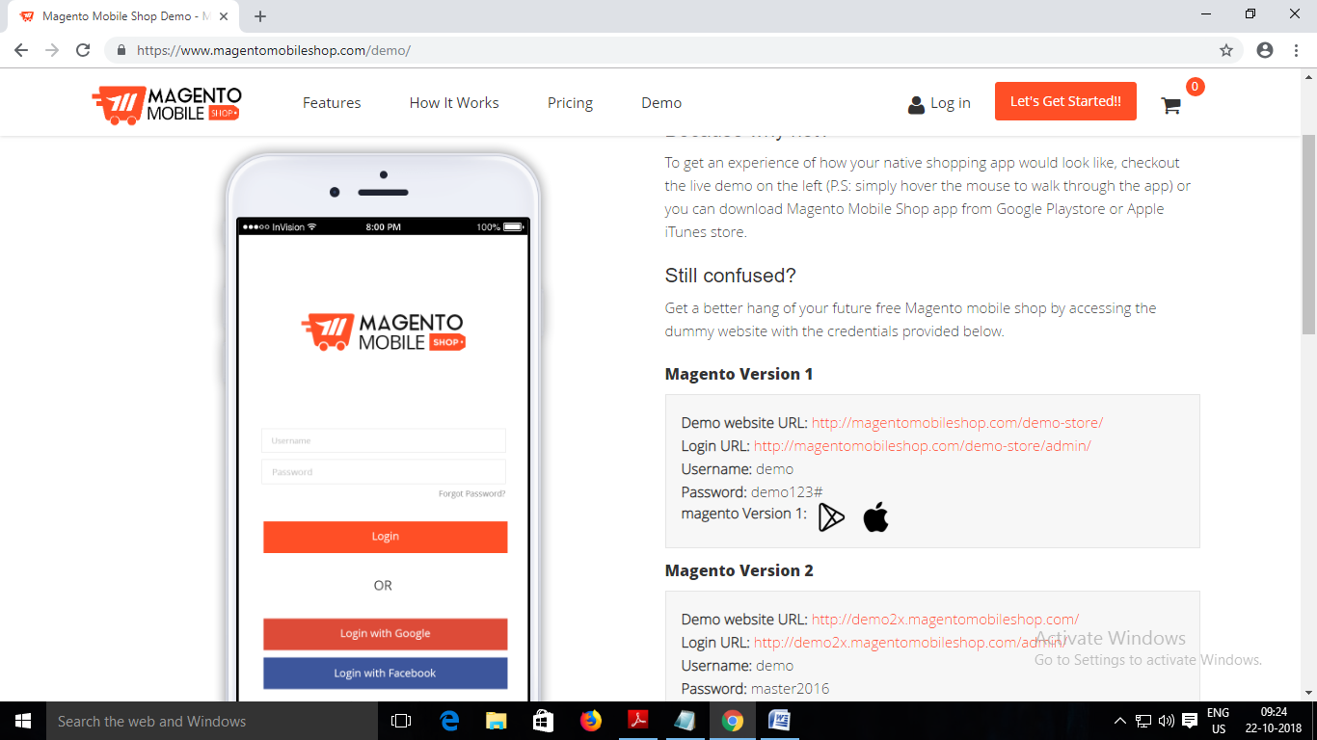5)Demo Page also describes about the Magento Versions under which some links are also given to Redirect Login Page and Shopping Websites.

6) <http://magentomobileshop.com/demo-store/> Clicking on this link The Page should redirects to the new window Shopping Page.

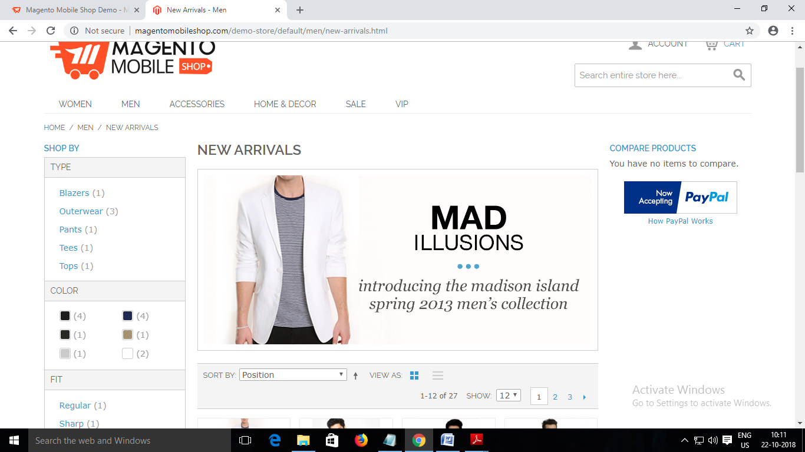

* Here There are Options to Shop Products. By Clicking WOMEN menu it should redirect to the WOMEN Shoping Page to buy.Like This the options are MEN,ACCESSORIES,HOME & DECOR,SALE VIP.

**MARKET PLACE :**

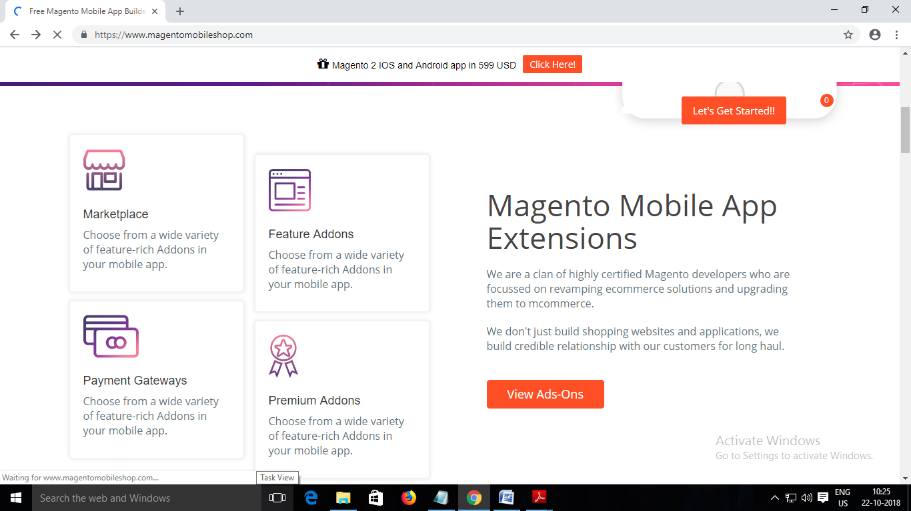

7) Customer clicks on “Market Place” should redirects to the Market Place Page where there are some domains like “Amazon, Ebay ,Etsy” which customer can buy and add to cart.

8) Customer can search The added domains by clicking the SEARCH Field.

**FEATURE ADDONS :**

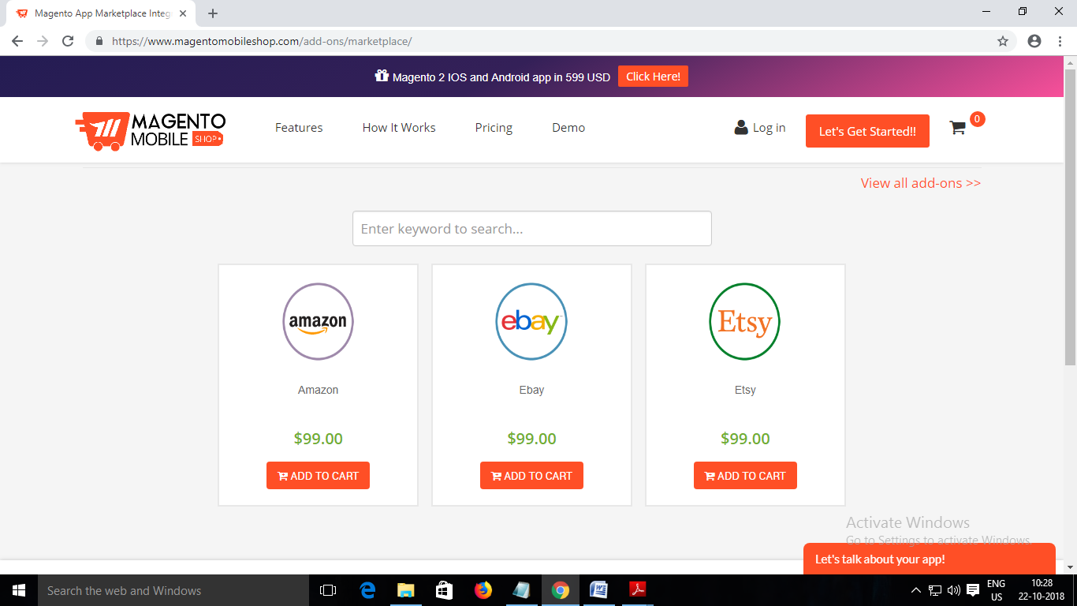

7) Customer clicks on “Feature Addons” should redirects to the Feature Addons Page where there are some Feature options like “Add to Wishlist, App store optimization ,Product star rating ”etc. which customer can buy and add to cart.

8) Customer can search The added domains by clicking the SEARCH Field.

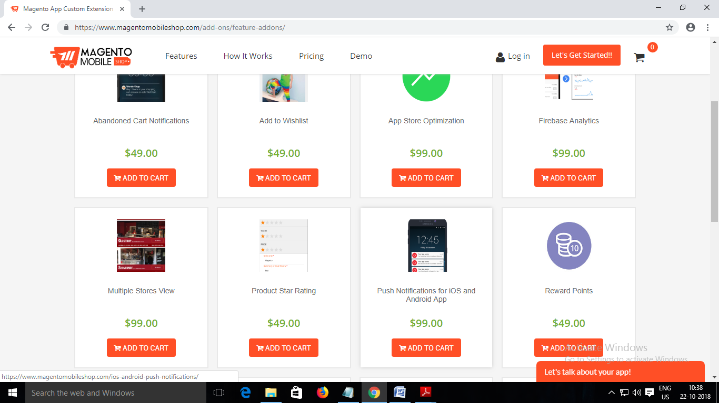

11) Customer clicks on “Payment Gateways” should redirects to the Payment Gateways Page where there are some Payment options like “Mobikwik,Paytm ”etc. which customer can buy and add to cart.

12) Customer can search The added Payment Options by clicking the SEARCH Field.

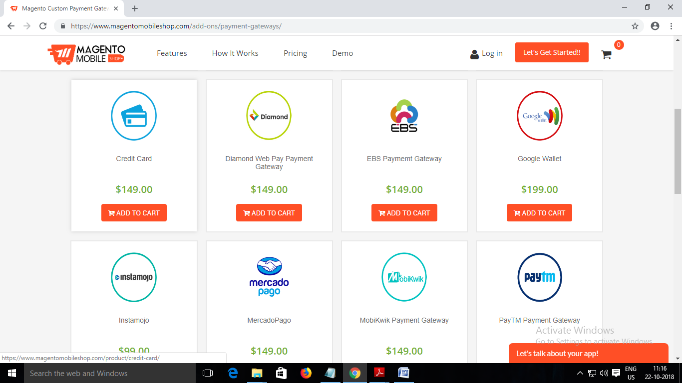

**PRICING :**

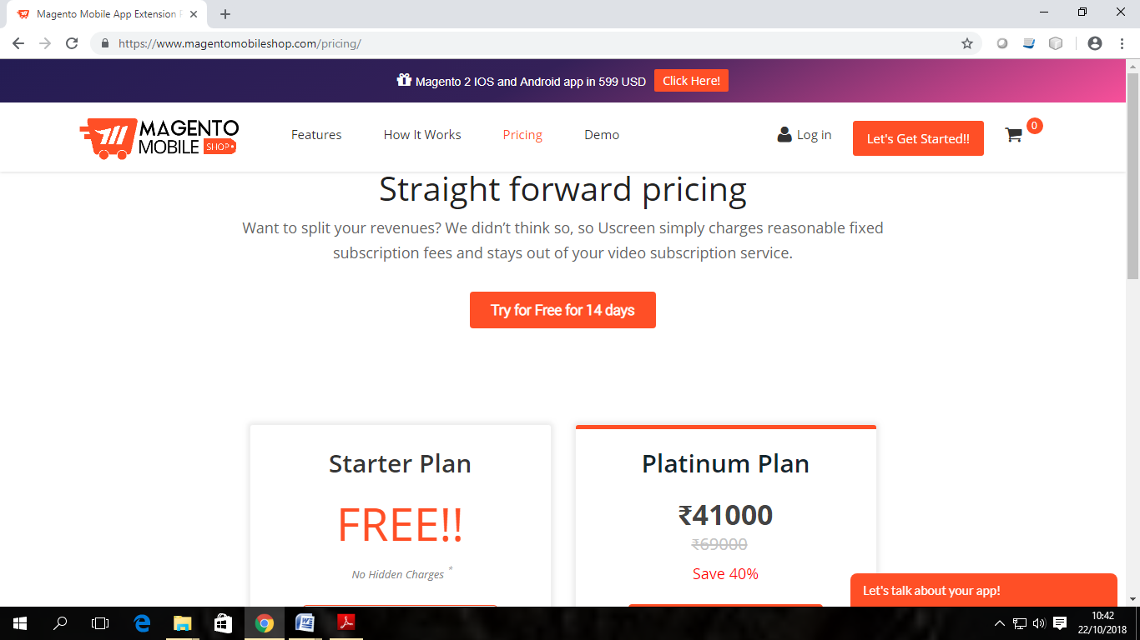

* After clicking on price,this page is bifurcated to,
* On this page there are two options , one is for free trial and another one is paying trial.

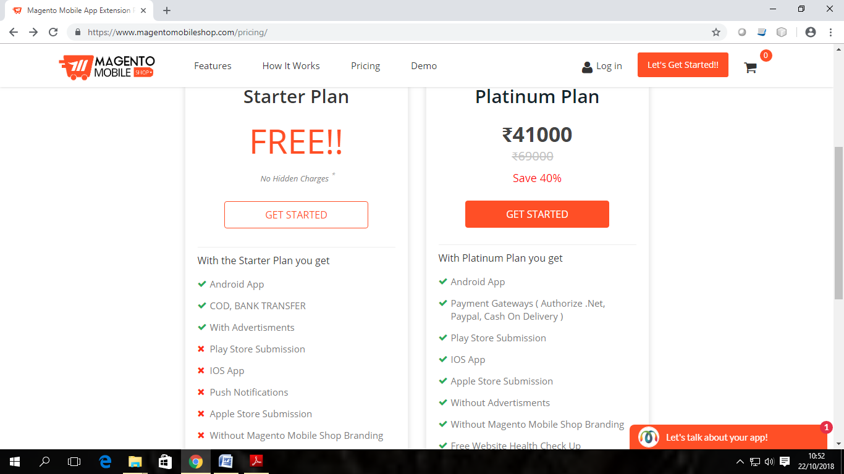

* In this Starter plan no chargers are applied.
* User can try this application for 14 days for free.
* In this plan there is brief explanation of Starter plan.



* This one is for paid paying plan.
* This plan is named as Platinum plan, where 40% discount is on,for 41000 rs.
* There is also brief explanation about this plan.

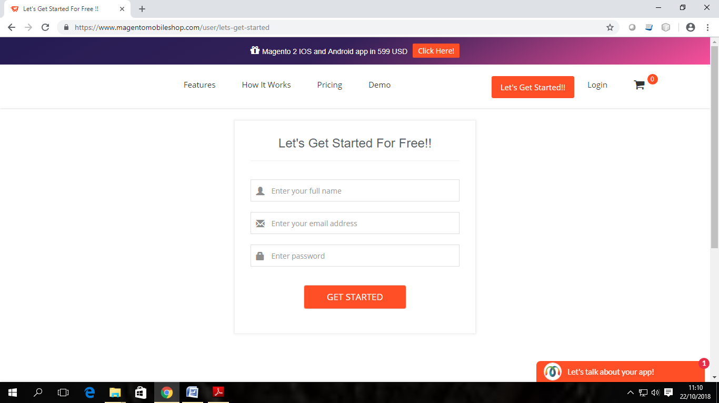

* After clicking on ‘Get Started’ option in Platinum Plan ,this page displays.
* Where user have to enter full name, email Address and password.

**Login Module :**

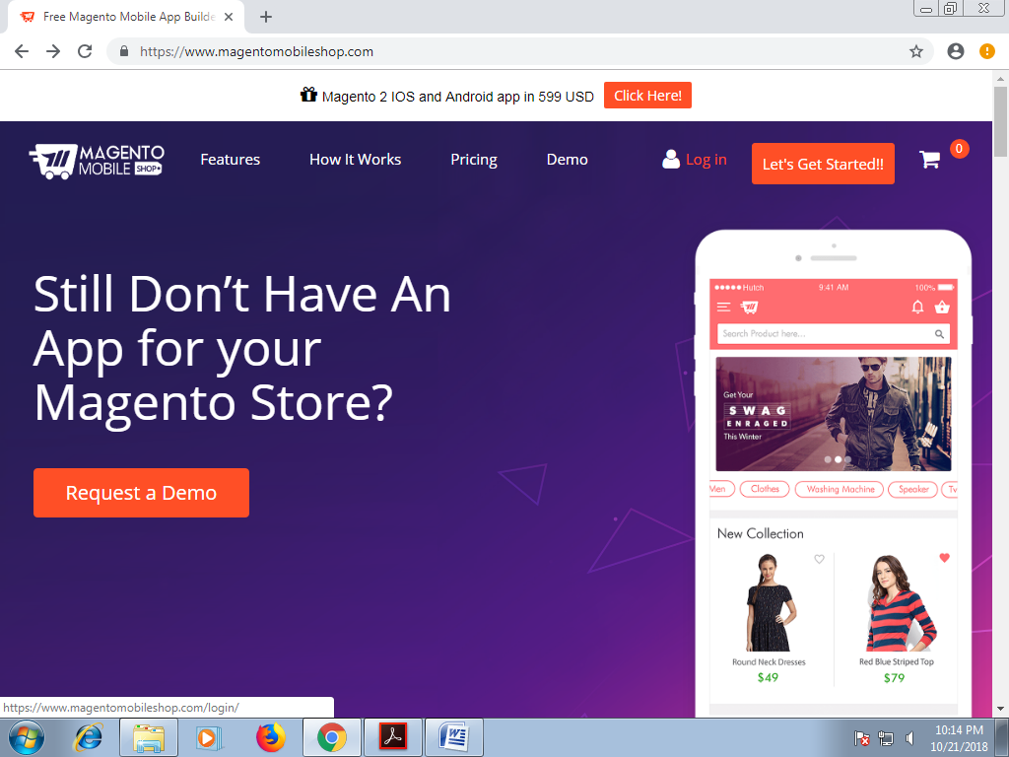

* By clicking on Login button user will be redirected to the login page where only registered users can login to the application.
* There is a checkbox “Remember me”, on getting checkbox checked application remembers the user credentials

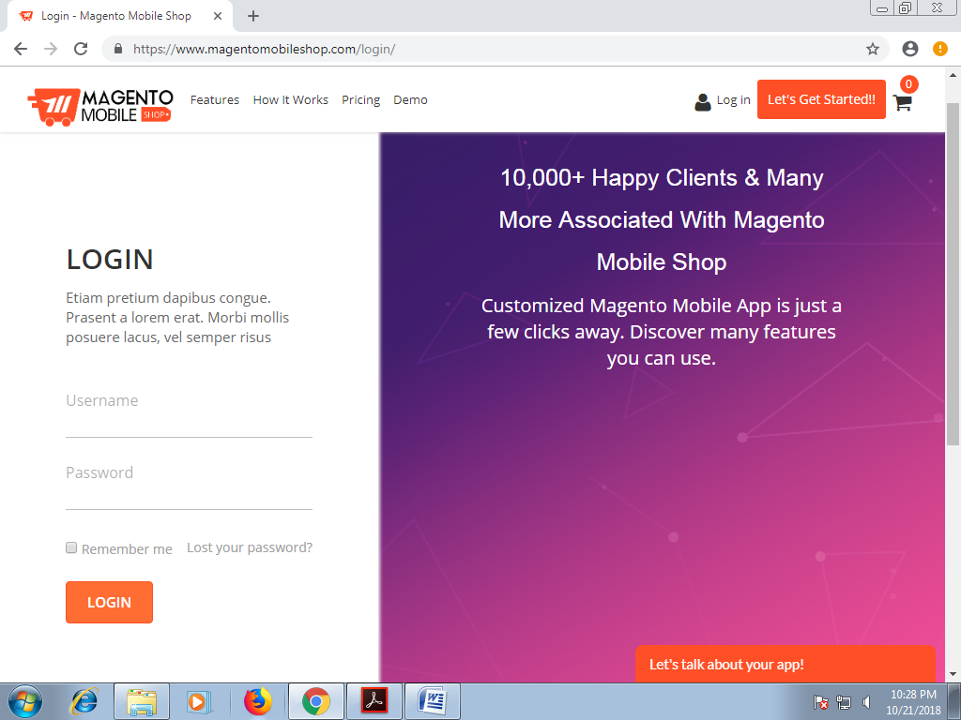

* There is link provided in the login module “Lost your password?” which redirects the user to the page where user can recover their password using email-id.

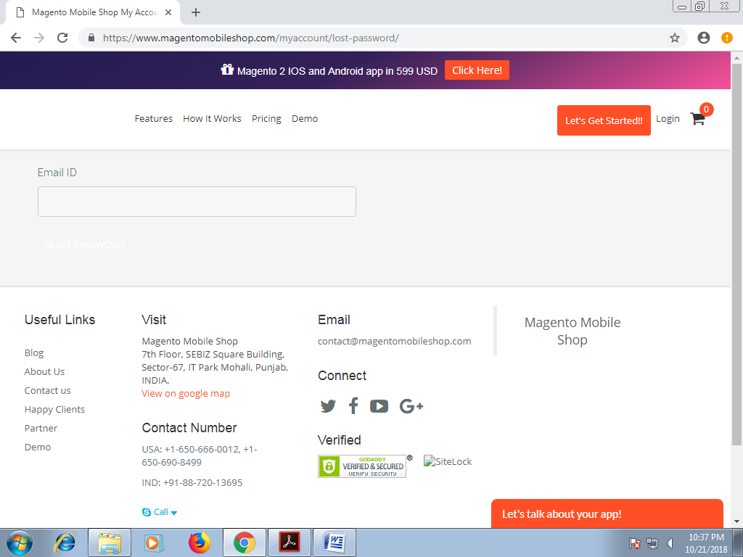

* There is a tab provided to chat i.e. “Let’s talk about your app!” which provides the functionality to talk about your app.
* After clicking on the tab the application interface looks like as given below

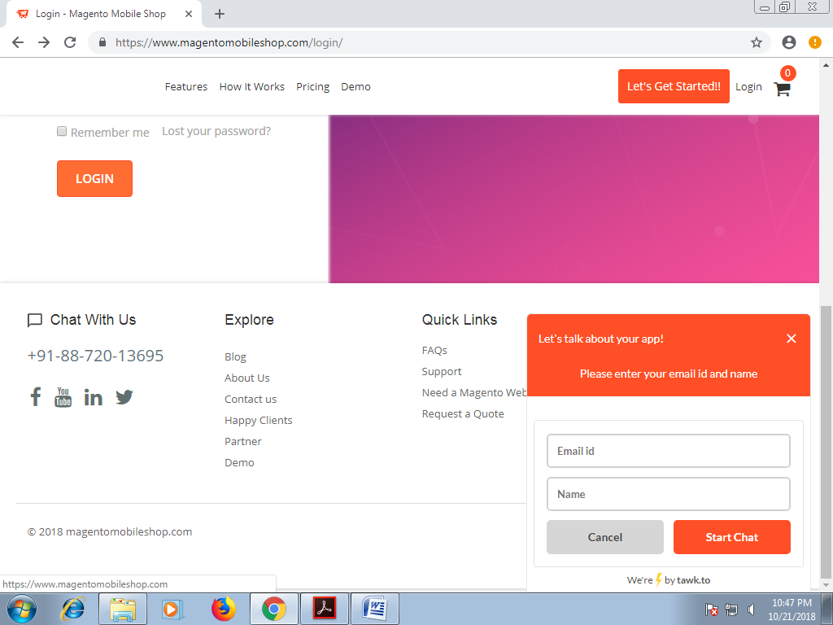

* In this window user have to enter email-id and name.
* After entering all details user can chat about this app to another user.