**NATIONAL INSTITUTE OF TECHNOLOGY, ROURKELA**



Project Report

Biomedical Instrumentation

**Glucose Monitoring System Utilizing**

**Infrared Technology**

**Group 5**

Submitted By: -

Shradha Raj (122BM0498)

Bibhansu Ballhava Prusty (122BM0497)

Prathibha Gaytri Patnala (122BM0496)

Bibhusundar Mohapatra(122BM0495)

Tushar Kanta Mishra (122BM0494)

**Introduction**

The prevalence of diabetes is increasing globally, making regular blood glucose monitoring essential for millions of people. Traditional methods involve pricking a finger to draw blood, which is invasive, uncomfortable, and carries risks of infection. Consequently, there is a growing demand for non-invasive glucose monitoring solutions. This project addresses this demand by developing a device that utilizes infrared (IR) light, allowing users to monitor their glucose levels without puncturing the skin. IR technology is promising because specific wavelengths interact uniquely with glucose, making it a viable choice for a non-invasive approach.

**Prescribed Solution & Problem Statement**

Diabetes management requires precise, frequent monitoring of blood glucose. The common, finger-prick methods, while accurate, have downsides: they can cause pain, involve a constant cost of test strips, and increase the risk of skin infections. The primary problem is to find a method that reduces the physical and financial burden on patients while maintaining reliable accuracy.

This project proposes a non-invasive solution utilizing IR technology. The device uses an IR LED light to shine through the skin. Phototransistors then measure the light intensity after it passes through the skin, which correlates with the glucose concentration. The light absorption properties of glucose allow this indirect measurement. It is based on the principle of Beer Lambert's. The Arduino microcontroller calculates glucose levels using a polynomial regression algorithm, which establishes a mathematical relationship between light intensity and glucose concentration, providing users with a pain-free monitoring experience.

**Uniqueness of the Project**

What sets this project apart is the use of infrared light, a method relatively new in glucose monitoring. Unlike many devices currently on the market, this approach offers a non-invasive, needle-free experience by measuring light absorption specific to glucose. While many non-invasive methods are still in early stages, the IR technology leverages glucose’s unique absorption peaks at wavelengths such as 940 nm and 1450 nm, allowing the device to target and monitor glucose levels accurately without interference from other bodily components like water or red blood cells. This unique wavelength targeting makes the device suitable for continuous or frequent monitoring, presenting a much-needed alternative for users who prefer a non-invasive solution.

**Components Required**

1. LCD
2. Arduino UNO
3. Potentiometer
4. Jumper wires 1 set
5. Vero board
6. Breadboard
7. Resistor
8. IR LED
9. Photodiode

**System or Concept-Level Block Diagram**

The glucose monitoring device consists of several key components:

1. **IR LED**: This light source emits infrared light at a specific wavelength optimal for glucose detection. When placed against the skin, the IR light interacts with the blood in underlying tissues.

2.**Photodiode**: These diodes detect the intensity of light that has passed through the tissue. Since glucose absorbs light differently at specific wavelengths, the phototransistors measure the drop in light intensity, which is then correlated to glucose levels.

3. **Arduino Microcontroller**: The microcontroller reads signals from the phototransistors and applies a polynomial regression algorithm to convert the data into glucose concentration values. The results can be displayed on an LCD screen or transmitted to a mobile device for real-time monitoring.

4. **Display or Output Module**: The calculated glucose level is displayed on an onboard screen, allowing users to view and monitor their glucose levels conveniently.

**Hardware, Software, Tools**

• **Hardware Components**:

• **IR LED**: A light-emitting diode that operates in the infrared spectrum, with wavelengths ideal for glucose absorption.

• **Photodiode**: Used as photodetectors, they measure the intensity of light passing through the tissue.

• **Arduino UNO Microcontroller**: Serves as the primary processing unit to handle data from sensors and execute the glucose concentration algorithm.

• **Display Screen** : Shows the glucose concentration values on an LCD screen for user access.

• **Software**:

• **Arduino IDE**: Used to program the microcontroller with the necessary algorithms and data processing instructions.

• **MATLAB:** Used for data analysis and calibration.

• **Tools and Equipment**:

* Power supply for hardware components
* Breadboard and jumper wires for prototyping
* Calibration equipment to ensure accurate measurements
* A transparent container to hold glucose solution

**Project Circuit**

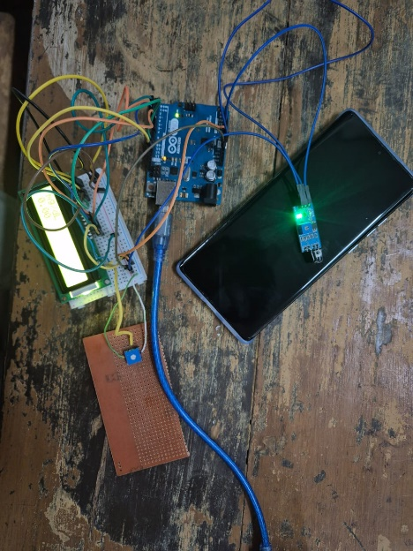 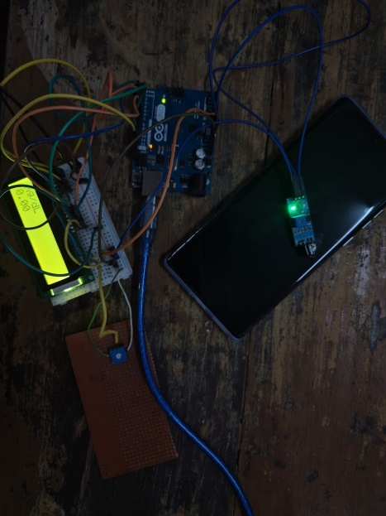

1. Circuit (b) Circuit with the reading displayed on LCD

**Algorithm**

* Analog output of the photodiode is read.
* The calibration formula to convert the analog value to glucose concentration: 𝑦=(3×10^−5)⋅analogValue^2+0.2903⋅analogValue−4.798
* Calculated concentration is displayed on LCD.

**Experimental Readings**

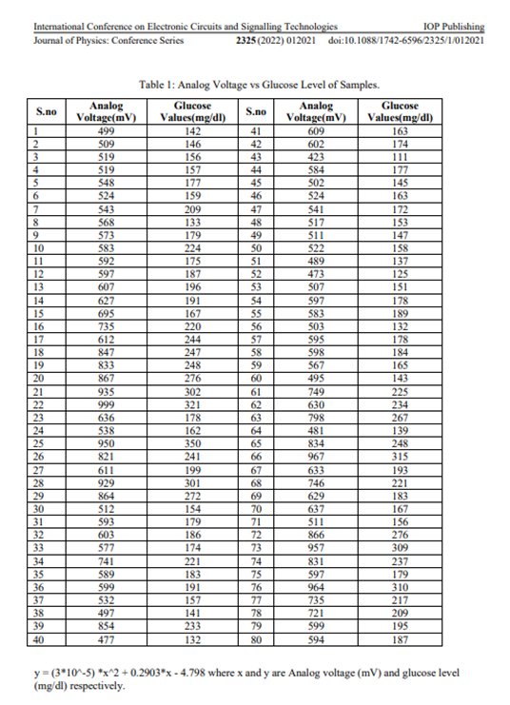

Journal of Physics: Conference Series 2325 (2022) 012021 doi:10.1088/1742-6596/2325/1/012021

**Aurdino Code**

const int PT1_PIN = A0; // phototransistor 1 pin

const int led = 3; // led pin

#include <LiquidCrystal.h>

LiquidCrystal lcd(12, 11, 5, 4, 3, 2);

double y;

double analogToGlucose(double analogValue) {

y = (3*pow(10,-5)) *pow(analogValue,2) + 0.2903*analogValue - 4.798;

return y;

}

void setup() {

lcd.begin(16, 2);

pinMode(led, OUTPUT);

Serial.begin(9600);

}

void loop() {

digitalWrite(led,HIGH);

int pt1Value = 1030 - analogRead(PT1_PIN);

double averageValue = pt1Value ;

// calculate glucose concentration from voltage

double glucoseConcentration = 0.34 * analogToGlucose(averageValue);

// display glucose concentration

Serial.println(" mg/dL");

lcd.clear();

lcd.setCursor(0, 0);

lcd.print("mg/dL");

lcd.setCursor(0, 1);

lcd.print(glucoseConcentration);

// delay before taking the next measurement

delay(1000);

}

**MATLAB Code**

glucose_concentration = [50, 100, 150, 200, 250]; % Known concentrations (mg/dL)

sensor_readings = [200, 400, 600, 800, 1000]; % Phototransistor analog values

coefficients = polyfit(sensor_readings, glucose_concentration, 2);

disp('The quadratic equation is:');

fprintf('y = (%.5f)x^2 + (%.5f)x + (%.5f)\n', coefficients(1), coefficients(2), coefficients(3));

x_fit = linspace(min(sensor_readings), max(sensor_readings), 100); % Sensor readings for plotting

y_fit = polyval(coefficients, x_fit); % Evaluate quadratic model

% Plot the data and the fitted curve

figure;

plot(sensor_readings, glucose_concentration, 'ro', 'MarkerSize', 8, 'LineWidth', 1.5); % Original data

hold on;

plot(x_fit, y_fit, 'b-', 'LineWidth', 1.5); % Fitted curve

xlabel('Sensor Reading (Analog Value)');

ylabel('Glucose Concentration (mg/dL)');

title('Quadratic Fit for Glucose Concentration');

legend('Calibration Data', 'Fitted Curve');

grid on;

hold off;

**Future Perspective**

The potential for expanding and improving this project is considerable. In the future, the system can be enhanced by:

• **Refining sensor sensitivity**: Developing sensors with better sensitivity to glucose absorption at specific IR wavelengths could improve accuracy.

• **Integration with mobile apps**: Adding a Bluetooth or Wi-Fi module would enable real-time data transmission to a smartphone app, where users could track and analyze trends in glucose levels.

• **Personalized calibration**: Developing personalized calibration algorithms to account for individual differences in skin thickness, tissue composition, and glucose absorption could make readings even more accurate.

• **Wearable technology**: Converting the device into a wearable, such as a wristband, could allow continuous glucose monitoring, providing users and healthcare providers with invaluable data.

• **Incorporating AI for prediction**: Using machine learning algorithms to predict glucose trends based on historical data could enable preventive alerts for individuals with diabetes, ultimately supporting proactive diabetes management.

**Limitations of the Project**

The project, while innovative, does face some limitations:

• **Environmental Light Interference**: The sensitivity of the phototransistors could be affected by ambient light, requiring shielding or calibration to maintain accuracy.

• **Interference from Other Compounds**: Other substances in the blood, like hemoglobin and lipids, may partially absorb IR light, potentially affecting the readings.

• **Sensitivity to Skin Variability**: Differences in skin pigmentation, thickness, and moisture levels among individuals may impact the device’s ability to accurately measure glucose levels, necessitating a personalized calibration feature.

• **Cost of IR Components**: The cost of high-quality IR LEDs and photodetectors may impact the affordability of the device, particularly if scaled for commercial production.

**Result**

Normal glucose levels are being shown around 79 to 99 mg/dL and abnormalities are deviated from this range.

**Conclusion**

A non invasive glucose monitoring system is designed using IR technology and the desirable results are observed however more work needs to be done and accuracy is to be further tested.

**References**

1. Darwich, Mhd Ayham, Anas Shahen, Abbas Daoud, Abdullah Lahia, Jomana Diab, and Ebrahim Ismaiel. 2023. "Non-Invasive IR-Based Measurement of Human Blood Glucose" *Engineering Proceedings* 35, no. 1: 27. <https://doi.org/10.3390/IECB2023-14593>
2. V. Dooslin Mercy Bai, Krithina P D, Manimaran P, Elavarasan S, Sowbarnicka M. Non-Invasive glucose monitoring device. Int J Health Sci Res. 2023; 13(10):69-73. DOI: <https://doi.org/10.52403/ijhsr.20231009>
3. Hina, A. and Saadeh, W. Noninvasive Blood Glucose Monitoring Systems Using Near-InfraredTechnology—A Review. Sensors, [online] 22, (13). Available at: Sensors | Free Full-Text | Noninvasive Blood Glucose Monitoring Systems Using Near-Infrared Technology &mdash;A Review (mdpi.com)
4. Althobaiti M, Al-Naib I. 2021. Optimization of dual-channel near-infrared non-invasive glucose level measurement sensors based on monte-carlo simulations. IEEE Photonics J. [13(open in a new window)](https://doi.org/10.1109/JPHOT.2021.3079408)([3(open in a new window)](https://doi.org/10.1109/JPHOT.2021.3079408)):1–10. doi: 10.1109/JPHOT.2021.3079408.
5. Saleh G, Alkaabi F, Al-Hajhouj N, Al-Towailib F, Al-Hamza S. 2018. Design of non-invasive glucose meter using near-infrared technique. J Med Eng Technol. [42(open in a new window)](https://doi.org/10.1080/03091902.2018.1439114)([2(open in a new window)](https://doi.org/10.1080/03091902.2018.1439114)):140–147. doi: 10.1080/03091902.2018.1439114.