Game Design Document

Fill up the following document

1. Write the title of your project.

Marathon

1. What is the goal of the game?

Boy makes it to the finish line.

1. Write a brief story of your game.

There is a marathon . The boy gets bullied all the time . During the marathon vegetables and fruits are thrown at him.Depending on the number of vegetables and fruits that are avoided the boy changes into a magician , then a wizard , then at last into a king. If the characters touch the fruits or vegetables the game is over but a second try is given.

1. Which are the playing characters of this game?

* Playing characters are the ones who respond to the user based on the input from the user.
* Cars, monkeys, dinos, wizards, etc., are the playing characters in the game.

|  |  |  |
| --- | --- | --- |
| Number | Character Name | What can this character do? |
| 1 | Alex | Run and duck . |
| 2 | Magician | Run and duck. |
| 3 | Wizard | Run and duck |
| 4 | King | Run and duck. |
| 5 |  |  |
| 6 |  |  |
| 7 |  |  |
| 8 |  |  |

1. Which are the Non-Playing Characters of this game?

* Non-Playing characters are the ones that don't have an action or behavior when the user interacts with the game.
* Hurdles, stones, bananas, coins, etc., are non-playing characters in the game.

|  |  |  |
| --- | --- | --- |
| Number | Character Name | What can this character do? |
| 1 | Banana | Move from right to left. |
| 2 | Tomato | Left to right. |
| 3 | Onion | Move from right to left. |
| 4 | Corn | Left to right. |
| 5 | Potato | Move from right to left. |
| 6 | Boy1 | Run . |
| 7 | Boy2 | Run. |
| 8 |  |  |

Draw your imagination of this game. What does this game look like?

* Draw the game either on your computer or on paper.
* Add images of the game scenes to show each of the playing and non-playing characters at least once.

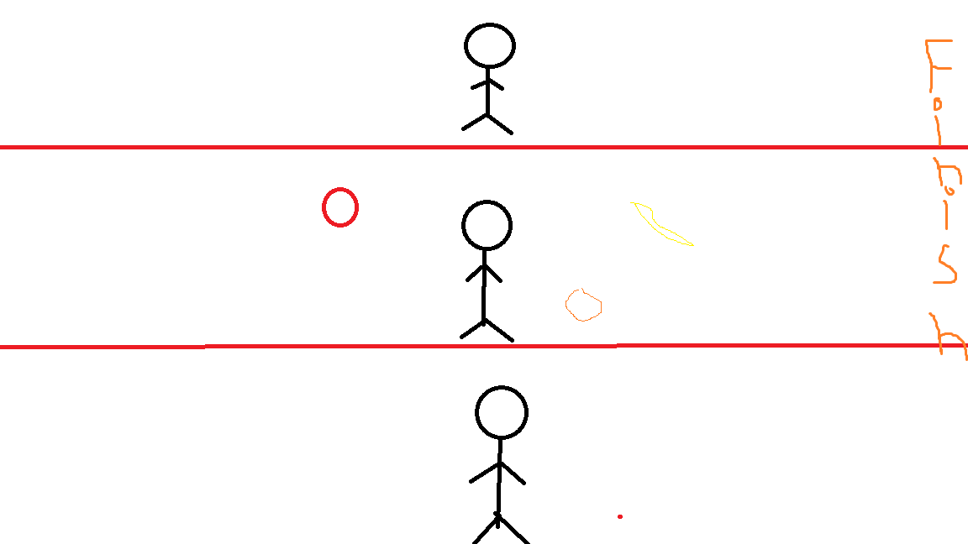

How do you plan to make your game engaging?

By giving feedback when the character avoids the fruits and vegetables , when the player gets to the finish line.