Zomato Restaurant Analysis Dashboard
Power BI Project Documentation and Mentor Submission
Prepared by: Gayathri
Tool Used: Microsoft Power BI Desktop
Dataset: Zomato Restaurant Data and Country Mapping Data
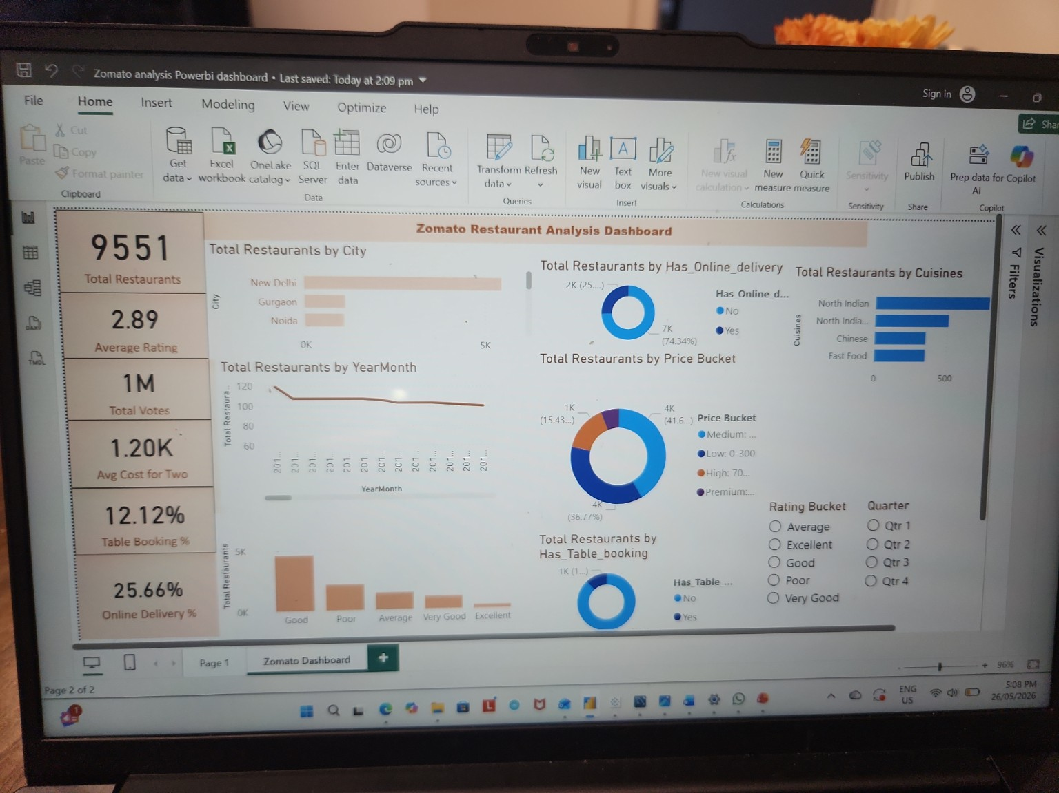
Final dashboard screenshot created in Power BI

1. Project Objective
The objective of this project is to create an interactive Power BI dashboard for Zomato restaurant data. The dashboard helps users understand restaurant distribution, ratings, price buckets, table booking availability, online delivery availability, cuisines, city-wise trends and restaurant openings over time.
Source | Purpose
Zomata Excel File | Main restaurant dataset containing RestaurantID, RestaurantName, CountryCode, City, Cuisines, Ratings, Votes, Average Cost for Two, table booking, online delivery and Datekey_Opening.
CountryName Excel File / Country Mapping | Country lookup data used to map CountryCode to Country Name.
Zomato Questionnaires | Mentor requirement document with questions/tasks to be completed in Power BI.
- Imported the Excel data into Power BI using Home > Get Data > Excel Workbook.
- Loaded the restaurant table and country mapping table.
- Open Power Query Editor and check column names, data types and null values.
- Converted Datekey_Opening into a proper date format by replacing underscore (_) with hyphen (-), then changing the data type to Date.
- Created Country Map table and Calendar table.
- Created relationships between fact table, country map table and calendar table.
- Created calculated columns and DAX measures required for KPIs and charts.
- Designed dashboard visuals, slicers and KPI cards.
- Formatted the dashboard with proper titles, labels, colours and alignment.
- Validated totals and percentages against the dataset before submission.

2. Data Model and Relationships
Table |  | Key Column |  | Purpose
Restaurant Table |  | RestaurantID |  | Main fact table. One row represents one restaurant record.
Country Map Table |  | CountryCode / CountryID |  | Lookup table used to show Country Name instead of only Country Code.
Calendar Table |  | Date |  | Date dimension table created from Datekey_Opening for year, month, quarter and financial period analysis.
From | To |  | Relationship |  | Reason
Restaurant[CountryCode] | CountryMap[CountryID] |  | Many-to-One |  | Allows city and country level restaurant analysis.
Restaurant[OpeningDate] | Calendar[Date] |  | Many-to-One |  | Allows restaurant openings by Year, Quarter and Month.

3. Important DAX Measures and Columns Used

3.1 Date Cleaning Column
OpeningDate = DATEVALUE(SUBSTITUTE('Zomato'[Datekey_Opening], "_", "-"))

3.2 Calendar Table
Calendar = CALENDAR(MIN('Zomato'[OpeningDate]), MAX('Zomato'[OpeningDate]))
Year = YEAR('Calendar'[Date])
Monthno = MONTH('Calendar'[Date])
Monthfullname = FORMAT('Calendar'[Date], "MMMM")
Quarter = "Qtr " & FORMAT('Calendar'[Date], "Q")
YearMonth = FORMAT('Calendar'[Date], "YYYY-MMM")
Weekdayno = WEEKDAY('Calendar'[Date], 2)
Weekdayname = FORMAT('Calendar'[Date], "dddd")
FinancialMonth = "FM" & IF(MONTH('Calendar'[Date]) >= 4, MONTH('Calendar'[Date]) - 3, MONTH('Calendar'[Date]) + 9)
FinancialQuarter = SWITCH(TRUE(), MONTH('Calendar'[Date]) IN {4,5,6}, "FQ1", MONTH('Calendar'[Date]) IN {7,8,9}, "FQ2", MONTH('Calendar'[Date]) IN {10,11,12}, "FQ3", "FQ4")

3.3 KPI Measures
Total Restaurants = DISTINCTCOUNT('Zomato'[RestaurantID])
Average Rating = AVERAGE('Zomato'[Rating])
Total Votes = SUM('Zomato'[Votes])
Avg Cost for Two = AVERAGE('Zomato'[Average_Cost_for_two])
Table Booking % = DIVIDE(CALCULATE([Total Restaurants], 'Zomato'[Has_Table_booking] = "Yes"), [Total Restaurants])
Online Delivery % = DIVIDE(CALCULATE([Total Restaurants], 'Zomato'[Has_Online_delivery] = "Yes"), [Total Restaurants])

3.4 Rating Bucket Column
Rating Bucket = SWITCH(TRUE(), 'Zomato'[Rating] >= 4.5, "Excellent", 'Zomato'[Rating] >= 4.0, "Very Good", 'Zomato'[Rating] >= 3.0, "Good", 'Zomato'[Rating] >= 2.0, "Average", "Poor")

3.5 Price Bucket Column
Price Bucket = SWITCH(TRUE(), 'Zomato'[Average_Cost_for_two] <= 300, "Low: 0-300", 'Zomato'[Average_Cost_for_two] <= 700, "Medium: 301-700", 'Zomato'[Average_Cost_for_two] <= 1500, "High: 701-1500", "Premium: 1500+")

4. Mentor Questions and Answers
Question | Answer / Work Done
1. Build a Country Map Table. | I imported the country mapping file and created a Country Map table. I used CountryCode/CountryID as the key and Country Name as the descriptive column. Then I created a relationship between the restaurant table and the country map table.
2. Build a Calendar Table using Datekey_Opening. | I cleaned the Datekey_Opening column by replacing underscores with hyphens and converting it into Date format. Then I created a Calendar table using the minimum and maximum opening dates and added Year, Monthno, Monthfullname, Quarter, YearMonth, Weekdayno, Weekdayname, FinancialMonth and FinancialQuarter columns.
3. Find the number of restaurants based on City and Country. | I used the Total Restaurants measure and created bar charts/table visuals with City and Country fields. This shows the count of restaurants for each city and country.
4. Find the number of restaurants opening based on Year, Quarter and Month. | I used the Calendar table fields Year, Quarter and YearMonth with the Total Restaurants measure. This shows the opening trend of restaurants over time.
5. Count restaurants based on Average Ratings. | I created a Rating Bucket column with Poor, Average, Good, Very Good and Excellent groups. Then I used a column chart to count restaurants in each rating bucket.
6. Create average price buckets and count restaurants in each bucket. | I created a Price Bucket column using Average_Cost_for_two ranges. Then I used a donut chart to show how many restaurants fall into Low, Medium, High and Premium price buckets.
7. Show percentage of restaurants based on Has_Table_booking. | I created Table Booking % using a DAX DIVIDE formula. A donut chart shows Yes vs No table booking availability.
8. Show percentage of restaurants based on Has_Online_delivery. | I created Online Delivery % using a DAX DIVIDE formula. A donut chart shows Yes vs No online delivery availability.
9. Develop charts based on Cuisines, City and Ratings. | I created bar charts for cuisines and city, a rating bucket chart, date trend chart, KPI cards and slicers for Quarter and Rating Bucket to make the dashboard interactive.

5. Dashboard Visuals Created
Visual | Purpose
KPI Cards | Total Restaurants, Average Rating, Total Votes, Avg Cost for Two, Table Booking %, Online Delivery %.
Bar Chart - City | Shows total restaurants by city. New Delhi has the highest number of restaurants in the dataset.
Line Chart - YearMonth | Shows restaurant openings by month/year.
Donut Chart - Online Delivery | Shows percentage split of restaurants with and without online delivery.
Donut Chart - Price Bucket | Shows restaurant count by cost bucket.
Donut Chart - Table Booking | Shows percentage split of restaurants with and without table booking.
Bar Chart - Cuisines | Shows the most common cuisines in the dataset.
Column Chart - Rating Bucket | Shows restaurant count by rating category.
Slicers | Rating Bucket and Quarter slicers allow interactive filtering.

6. Dashboard Output Summary
KPI | Value from Dashboard/Data
Total Restaurants | 9,551
Average Rating | 2.89
Total Votes | 1.50M
Average Cost for Two | 1.20K
Table Booking % | 12.12%
Online Delivery % | 25.66%

7. Validation Checklist
- Total restaurant count matches the distinct count of RestaurantID.
- Average rating is formatted to two decimals.
- Total votes are formatted in millions for easy reading.
- Average cost for two is formatted in thousands.
- Table booking and online delivery percentages add up correctly between Yes and No.
- City, cuisine, rating and price bucket charts respond to slicers.
- Relationships are active and filter direction is working correctly.
- Dashboard title and visual titles are clear for mentor review.

8. Short Explanation about Power Bi Dashboard:
I created a Zomato Restaurant Analysis Dashboard in Power BI using restaurant data and country mapping data. First, I imported the Excel files, cleaned the Datekey_Opening column, and created a Calendar table for time-based analysis. I also created a Country Map table and built relationships with the main restaurant table. Then I created DAX measures for Total Restaurants, Average Rating, Total Votes, Average Cost for Two, Table Booking % and Online Delivery %. I created rating buckets and price buckets to make the analysis easier to understand. Finally, I designed an interactive dashboard with KPI cards, city and cuisine charts, year/month trend, table booking and online delivery donut charts, price bucket chart, rating bucket chart and slicers. This dashboard helps identify restaurant distribution, popular cities, cuisine patterns, rating categories and service availability.

9. Submission Notes
- Submitted the Power BI .pbix file along with this documentation.

