Google Data Analytics Professional Certificate Capstone Project

Fitbit Fitness Tracker
Data Analysis & Business Insights Report
A 30-day wearable activity, sleep and engagement analysis

Daily activity records | Sleep records after cleaning | Hourly step records | Activity participants
940 | 410 | 22,099 | 33

Prepared By : Gayatri Rawat

Date : July 2026
Tools Used : Python, Pandas, NumPy, Matplotlib, Seaborn, Kaggle Notebook
Prepared from the uploaded Kaggle capstone notebook
1. Executive Summary
This project analyses Fitbit wearable data to understand how daily activity, sedentary time, sleep, calorie expenditure, and time-of-day behaviour interact. The analysis uses daily activity, daily sleep, and hourly step data from a 30-day period. The notebook applies data-quality checks, date standardization, duplicate removal, feature engineering, an activity–sleep merge, descriptive summaries, regression visualizations, weekday analysis, an hourly activity heatmap, and correlation analysis.
The results show a clear positive association between daily steps and calorie expenditure, while sedentary minutes move in the opposite direction to daily steps. Sleep is comparatively less directly related to steps: Total Steps and Sleep Hours correlate at -0.19, while Sedentary Minutes and Sleep Hours correlate at -0.60.
Average sleep is 7.0 hours and average sleep efficiency is 91.6%. Tuesday and Saturday have the highest average steps in the daily activity data, while Sunday is lowest. The hourly heatmap indicates that activity is concentrated during daytime hours.

Key takeaways
- 7,405 steps and 2,134 calories are the notebook's reference medians.
- Sedentary behaviour is inversely associated with daily steps (-0.33).
- Low-activity days average 1,045.2 sedentary minutes versus 888.7 for high-activity days.
- Average sleep is 7.0 hours, median is 7.2 hours.
- Sedentary Minutes has a stronger negative association with Sleep Hours (-0.60) than Total Steps does (-0.19).
2. Business Task & Analytical Questions
Business task: use wearable-user behaviour data to identify actionable patterns in physical activity, sedentary behaviour, sleep, and calorie expenditure. The goal is to translate observed patterns into practical opportunities for engagement-oriented content, reminders, and user-facing insights.
Questions addressed in the notebook
Business area | Analytical question
Activity and energy | Does physical activity translate into higher calorie expenditure?
Sleep and activity | Are users who get more sleep also more physically active?
Sedentary behaviour | Are highly sedentary users also taking fewer steps?
Activity composition | How do users at different activity levels divide their time among very active, fairly active, light, and sedentary behaviour?
Weekly behaviour | Which days are users most and least active?
Sleep efficiency | How much time are users spending in bed without sleeping?
Weekday sleep | Do users sleep differently on different days?
Time of day | When are users most active?
Relationships | Which activity and sleep measures move together?

Decision-useful perspective
The analysis combines movement volume, activity intensity, sedentary time, sleep duration, sleep efficiency, and hourly patterns rather than relying on a single metric. This supports personalized, explainable user feedback.
3. Data Sources
The notebook reads three datasets from the Fitabase Fitbit export for 4/12/2016–5/12/2016. Although the Kaggle directory contains many files, these three are used in the analysis.
Dataset | Rows | Columns | Purpose
dailyActivity_merged.csv | 940 | 15 | Daily steps, distance, activity minutes, sedentary minutes, calories
sleepDay_merged.csv | 413 | 5 | Sleep records, minutes asleep, and time in bed
hourlySteps_merged.csv | 22,099 | 3 | Hourly step totals used for time-of-day analysis

Participant coverage
Daily activity and hourly steps contain 33 unique participants. Sleep contains 24. After removing three duplicate sleep rows, 410 sleep records remain. The inner activity–sleep merge produces 410 matched records across 24 participants.

Scope
The data cover approximately one month in April–May 2016. Findings are descriptive patterns within this historical wearable sample and should not be treated as population-level estimates.
4. Data Cleaning & Manipulation
The notebook creates working copies before transformation and documents each major preparation step.
Quality checks: Missing-value counts were zero for all three datasets. Duplicate checks found 0 duplicates in daily activity, 3 in sleep, and 0 in hourly steps.
Date standardization: ActivityDate and SleepDay were converted to datetime values. Sleep timestamps were normalized to the date, and ActivityHour was converted to datetime.
Duplicate removal: The three exact duplicate sleep records were removed, reducing the sleep dataset from 413 to 410 rows.
Column alignment: ActivityDate and SleepDay were renamed to a common Date field to support the activity–sleep merge.
Feature engineering: TotalActiveMinutes, DayOfWeek, SleepHours, TimeInBedHours, and SleepEfficiency were created.
Activity segmentation: Daily activity was categorized from TotalSteps: 0–5,000 Low Activity, 5,000–10,000 Moderate Activity, and above 10,000 High Activity.
Data integration: Cleaned activity and sleep records were inner-joined on Id and Date, with one-to-one validation.
Hourly preparation: DayOfWeek and Hour were extracted from ActivityHour for the heatmap.
Derived metrics
- TotalActiveMinutes = VeryActiveMinutes + FairlyActiveMinutes + LightlyActiveMinutes.
- SleepHours = TotalMinutesAsleep ÷ 60.
- TimeInBedHours = TotalTimeInBed ÷ 60.
- SleepEfficiency = TotalMinutesAsleep ÷ TotalTimeInBed × 100.
5. Descriptive Analysis & Dataset Profile

Activity-level summary
Activity level | Very active | Fairly active | Lightly active | Sedentary
Low Activity | 3.0 | 2.6 | 118.3 | 1,045.2
Moderate Activity | 13.4 | 11.6 | 246.9 | 956.1
High Activity | 48.5 | 27.4 | 237.8 | 888.7
Average minutes by activity category, categories are defined from daily TotalSteps.

Sleep summary
Measure | Mean | Median | Minimum | Maximum
Sleep hours | 7.0 | 7.2 | 1.0 | 13.3
Time in bed (hours) | 7.6 | 7.7 | 1.0 | 16.0
Sleep efficiency (%) | 91.6 | 94.3 | 49.8 | 100.0

Interpretation
High-activity days contain much more very-active and fairly-active time and fewer sedentary minutes than low-activity days. Sleep averages around seven hours, but individual observations vary substantially.
6. Activity & Calorie Expenditure
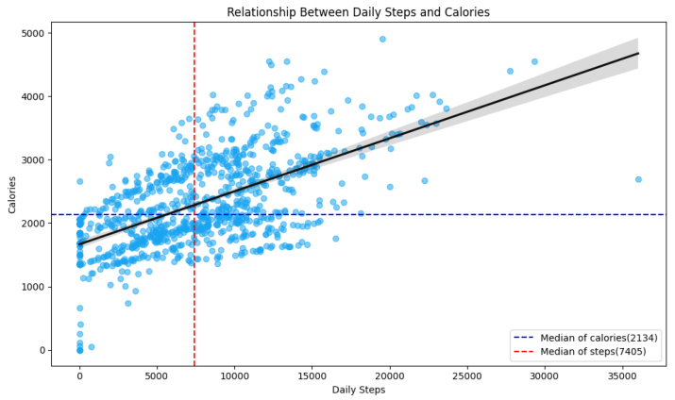
Figure 1. Relationship between daily steps and calories.
The regression plot shows a positive relationship between TotalSteps and Calories. The notebook uses medians of 7,405 steps and 2,134 calories as reference lines. The scatter is wide, so steps do not determine calorie expenditure on their own.
Key Findings :
- TotalSteps and Calories burned have a positive correlation of 0.59.
- VeryActiveMinutes and Calories correlate at 0.62, FairlyActiveMinutes at 0.30, LightlyActiveMinutes at 0.29.
- TotalDistance and TotalSteps correlate at 0.99.
Business implication: A fitness application could provide users with a combined view of daily steps, activity intensity, distance, and estimated calories instead of relying on a single metric. This would help users understand different dimensions of their activity.
Recommendation: Develop activity summaries that show daily step progress alongside active minutes and estimated calories. Use personalized messages to recognize progress and encourage achievable improvements in activity, rather than promising a fixed number of calories for a particular step count.
7. Sedentary Behaviour & Activity Composition
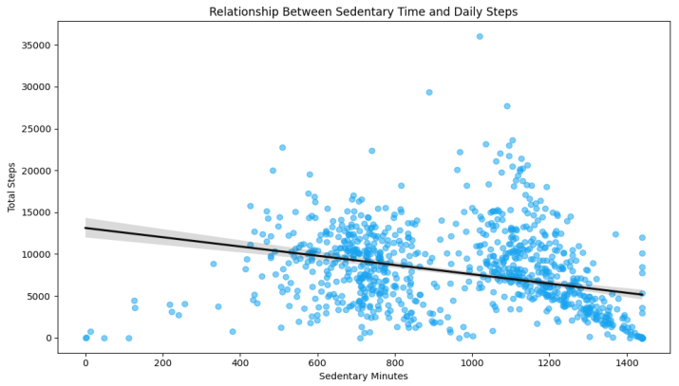
Figure 2. Relationship between sedentary minutes and daily steps.

Key Findings: The regression line slopes downward, Sedentary minutes and daily steps have a negative correlation of −0.33. Low-activity days average 1,045.2 sedentary minutes, compared with 888.7 minutes on high-activity days.
Interpretation: Records with more sedentary time tend to have fewer steps. High-activity days also contain substantially more very-active minutes.
Business implication: Fitness products could support users who have long periods of inactivity by making small movement goals easier to achieve.
Recommendation: Test personalized movement reminders and gradual step goals to encourage users to take breaks from prolonged inactivity.
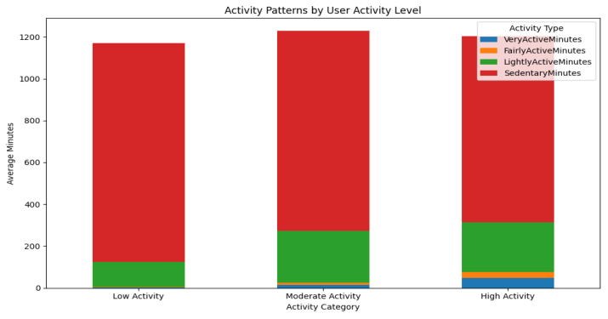
Figure 3. Average activity composition by step-based activity level.
Key Findings: Low-activity days average 1,045.2 sedentary minutes versus 888.7 for high-activity days and 956.1 in the moderate-activity days. Very-active time rises from 3.0 to 48.5 minutes across these groups.
Interpretation: The high-activity group recorded more very-active time and fewer sedentary minutes than the low-activity group. This highlights the importance of activity intensity and sedentary behaviour in understanding daily movement patterns.
Business implication: People with lower baseline activity may benefit from smaller, attainable goals, while more active users may respond better to challenges that help maintain consistency.
Recommendation: Set personalized activity goals based on users’ activity levels, encouraging short walks for less-active users and consistency streaks or intensity challenges for more-active users.
8. Sleep & Activity Findings
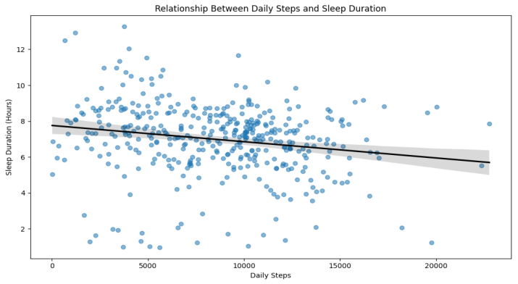
Figure 4. Relationship between daily steps and sleep duration.
Key Findings: TotalSteps and SleepHours have a -0.19 correlation, indicating a weak negative association. This is much weaker than several activity-to-activity relationships. Average sleep duration is 7.0 hours, and median sleep duration is 7.2 hours and ranges from 1.0 to 13.3 hours.
Interpretation: Daily steps and sleep duration show a weak negative correlation (-0.19), suggesting no strong relationship. Sleep duration varies considerably across records.
Business Implication: Activity levels should not be used to predict sleep duration, both are distinct aspects of wellness.
Recommendation: Provide separate activity and sleep summaries with an optional weekly view to help users track personal trends.

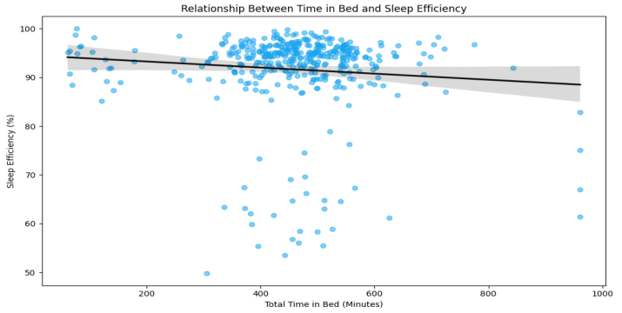
Figure 5. Relationship between time in bed and sleep efficiency.
Key Findings: Average sleep efficiency is 91.6% and the median is 94.3%. Average time in bed is 7.6 hours, with a median of 7.7 hours. The plot's slight downward trend suggests that more time in bed does not automatically imply higher efficiency.
Interpretation: Participants spend more time in bed than asleep, and longer time in bed does not always mean higher sleep efficiency.
Business Implication: Showing sleep duration and sleep efficiency together provides a clearer picture of sleep patterns.
Recommendation: Provide weekly sleep summaries with both metrics, helping users track trends without making medical claims.
9. Weekly & Hourly Activity Patterns
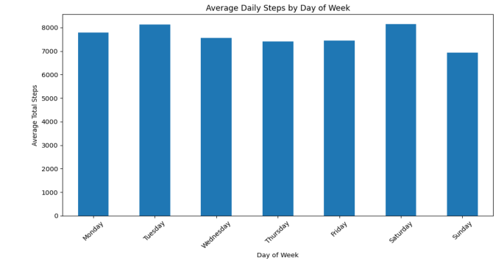
Figure 6. Average daily steps by day of week.
Key Findings: Average steps are highest on Saturday (8,153.0) and Tuesday (8,125.0), while Sunday is lowest (6,933.2). The difference between Saturday and Sunday is approximately 1,220 steps per day.
Interpretation: Average step counts vary by day, with Saturday and Tuesday showing relatively high activity. These patterns do not explain why activity levels differ.
Business Implication: Weekly activity trends can help guide personalized challenges and reminders.
Recommendation: Test day-specific goals and prompts based on users’ individual activity patterns rather than assuming everyone follows the same routine.

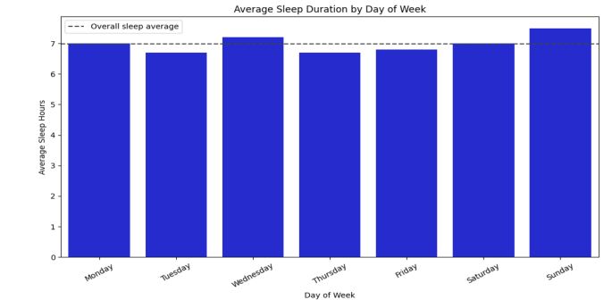
Figure 7. Average sleep duration by day of week.
Key Findings: Average sleep duration is 7.0 hours and ranges from about 6.7 hours on Tuesday and Thursday to 7.5 hours on Sunday. Sunday combines the lowest average steps with the highest average sleep duration in the merged data.
Interpretation: Sunday shows the highest average sleep duration and lowest average steps in this sample. However, this does not imply a causal relationship.
Business Implication: Weekly activity and sleep summaries can reveal differences between weekday and weekend patterns.
Recommendation: Display steps and sleep duration side by side in a weekly overview, helping users track personal trends.

10. Time-of-Day activity Patterns
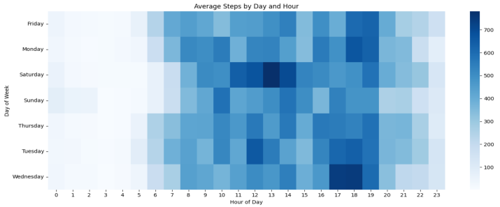
Figure 8. Average steps by day and hour.

Key Findings: Activity is very low overnight and higher during daytime periods, with stronger cells around late morning, afternoon, and early evening. The exact pattern varies by weekday.
Interpretation: Activity varies by hour, suggesting potential opportunities for context-aware reminders.
Business Implication: Personalized notification timing may improve relevance compared to generic reminders.
Recommendation: Use users’ hourly activity patterns to suggest reminders, while respecting their preferences and quiet hours.
11. Activity and Calorie Variables

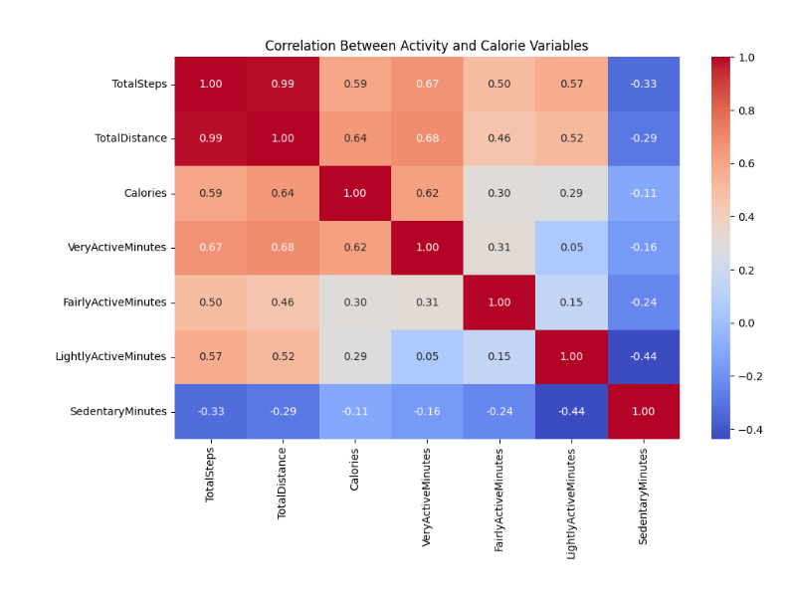
Key Findings
Total Steps and Total Distance have a very strong correlation (0.99). Calories correlate moderately with Total Distance (0.64) and Very Active Minutes (0.62), while Sedentary Minutes correlate negatively with Lightly Active Minutes (-0.44).
Interpretation
Higher activity levels are generally associated with greater calorie expenditure, while sedentary time tends to decrease as some activity measures increase. However, correlation does not imply causation.
Business Implication
Combining steps, calories, activity intensity, and sedentary time can help users better understand their daily movement patterns and activity levels.
Recommendation
Develop personalized dashboards to track steps, calories, and active minutes. Provide gentle reminders to encourage movement and reduce prolonged sedentary time.
12. Activity and Calorie Variables
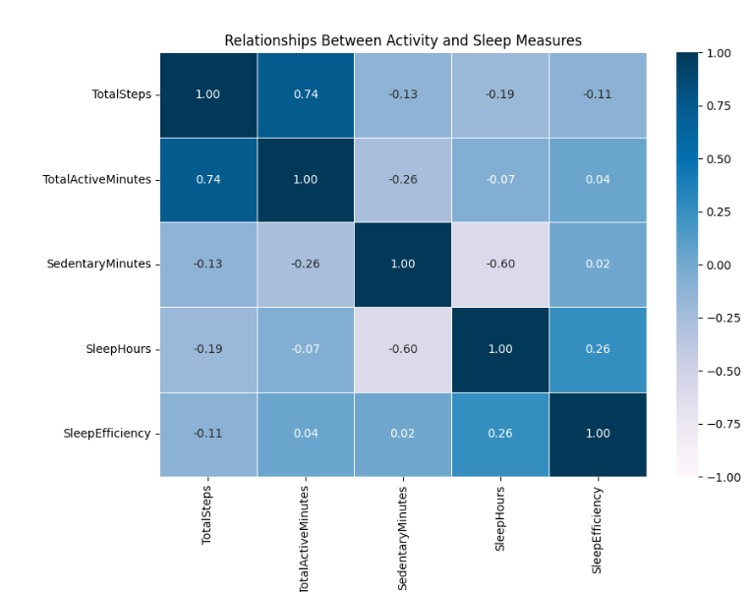

Key Finding: In the merged activity–sleep dataset, sedentary minutes and sleep duration have a correlation of −0.60, while total steps and total active minutes correlate at 0.74.
Interpretation: Sedentary time is more strongly associated with sleep duration than daily steps are in this sample. Activity measures also tend to move together.
Recommendation: Provide explainable weekly insights combining movement, sedentary time, and sleep metrics. Evaluate proposed reminders and content using changes in steps, sedentary minutes, and user engagement.
13. Conclusion
This analysis demonstrates how Fitbit activity, sleep, and hourly step datasets can be combined to produce practical behavioural insights. The notebook moves from raw records through quality checks, cleaning, feature engineering, integration, visualization, and correlation analysis.
Main findings
- Daily steps are positively associated with calories (0.59).
- Sedentary minutes are negatively associated with daily steps (-0.33) and sleep duration (-0.60).
- Higher step-based activity categories show substantially more very-active minutes and fewer sedentary minutes.
- Average sleep is 7.0 hours, with 91.6% average sleep efficiency.
- Tuesday and Saturday have the highest average daily steps, Sunday is lowest.
- Hourly activity is concentrated in daytime periods, supporting time-aware engagement.
Limitations
- The observation period is roughly one month in 2016.
- Only 24 of 33 activity participants have sleep records.
- The analysis is descriptive and correlation-based, it does not establish causation.
- The sample may not represent all wearable users.
- The step-based activity categories are analytical groupings, not clinical classifications.
Final recommendation
1. Encourage Regular Movement: Introduce personalized reminders and achievable step goals to reduce sedentary time and promote daily activity.
2. Personalize Activity Insights: Present daily steps, activity intensity, and estimated calories burned together to help users track their progress.
3. Use Time-Based Engagement: Offer movement reminders and activity challenges based on observed weekday and hourly activity patterns.
4. Promote Better Sleep Awareness: Display sleep duration and sleep efficiency together to help users understand their sleep patterns.
5. Provide Data-Driven Feedback: Combine activity, sedentary behaviour, and sleep metrics in clear weekly summaries to support informed decisions.
6. Evaluate Recommendations: Test the effectiveness of reminders and personalized challenges using changes in activity levels, sedentary time, and user engagement.

