- Install NPM
- node -v
- npm -v
- install VS code
- install VITE: install react , node vue js
- npm create vite
- it will ask project name, put it as React-Blog(Create new project)
- when you create next/second project: use npm create vite TestProjectName
- while installing ask some question
- SWC - Speedy Web Compiler, this helps in significant performance improvements
- Open Project in VS code
- Traverse to project directory in CMD
- For first installation it will ask npm install
- npm run dev
- open in browse http://localhost:5173/
- VITE: fast development and build tool, Minimize file in buid
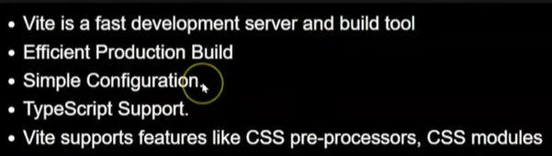
Work Flow:
- Index.html
- <body>
- <div id="root"></div>
- <script type="module" src="/src/main.jsx"></script>
- </body>
2. main.jsx
import App from './App.jsx'

createRoot(document.getElementById('root')).render(
<StrictMode>
<App />
</StrictMode>,
)
3.App.jsx
import './App.css'

function FirstModule() {
const [count, setCount] = useState(0)
return (
<>
<h1>
First Module Page
</h1>
</>
)
}
export default FirstModule

JSX: javaScript Extention

React is JavaScript libray: we can decide its flow
For framework : it has its fixed type

Without React install: on VITE website

Folder Structure:
- package.json
dependencies: are those libraries on which our project is running. devDependencies: development dependancies.because of which we can do development.
node_module:
-all mentioned dependancies w r t their version, that code in exist in node_module folder
-keep record which files are used in project

- package-lock.json
-here we will exact version details of our libraries
-also it stores the nested details of all libraries, like one library may depend upon another library

- READ.md
Can write some instruction or information about project and its documentation

- vite.confige,s
-Used in configuration of vite
-can be used to change host, port, build directory, input directory

- eslint.config.js
-decide which files we can build
-can make rules , like maxLength of a function
-which ecmaVersion version is getting used

- .gitignore
Node_modules we wont push

- Index.html
-only 1 html which execute on program
-its an entry file of project

- Rest basic work flow will be same as “Work Flow”

- SRC folder
-all actual development done src folder only
-write project files .outside of src can also work but not recommended

- Public folder:
-Can be same as assets folder in src folder
-only diff is, any image, files fonts which we want shoe publically can only be put in public folder

- Node_module folder
-all the libraries and nested library are shown here
-we wont push it on git because,
-its too heavy, sometimes in GB
-when new developer want to install he need to execute
npm install

Components:
- One small part will be called as a component
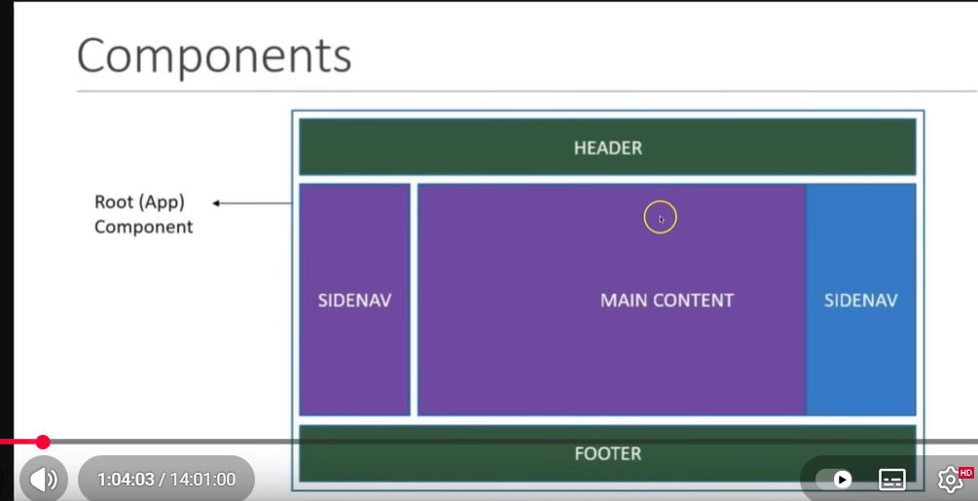
2.Everything is component in React when building UI
3. Component is piece of UI which has its own appearance, logic and behavior
3. note: diff between function and Component
Function can have its name with small letter
function app (){}
Component need to have its name with Capital letter
function App (){}
-component can contatin HTML code, JavaScript or JSX code as well.
-function will contain only javaScript code

Types of component
1.Class based component(which was used earlier)
2. Now we use Functional Component
3.High Order Component
4.controlled / uncontrolled component

Importing and exporting Components:
There are 3 types of export
- Default export
- Named export
- Multiple export
We can export variable and constants as well(Not just function)
JSX:
- On google we find full form as Java Script XML
- On React official site it is JavaScript extension
- React is more popular because of JSX, which gives facility to use HTML and JavaScript together

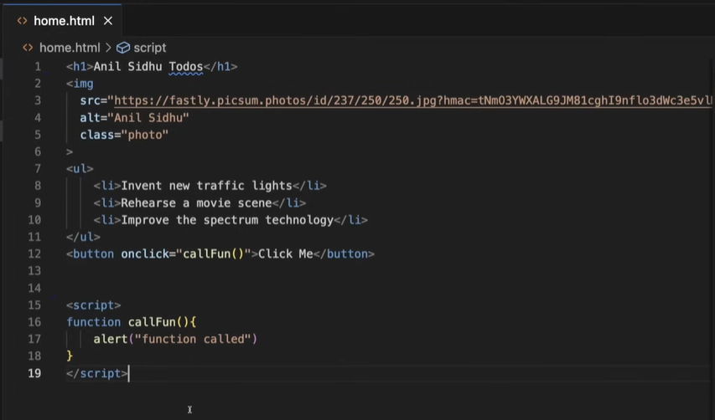

JSX inside Curly Braces:
Whatever we write we can use it on JSX page using curly braces.
We write 1.variable,
- condition,
- Use function,
- Operation inside JSX,
- Object and array inside jsx
- HTML tags property with jsx

