NPM ASSIGNMENT

- Update Command.
sudo apt update.
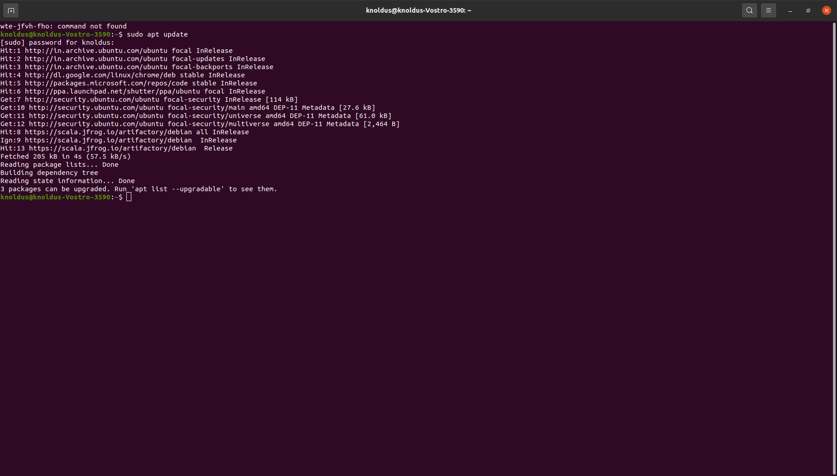

- Nodejs Command
sudo apt install nodejs

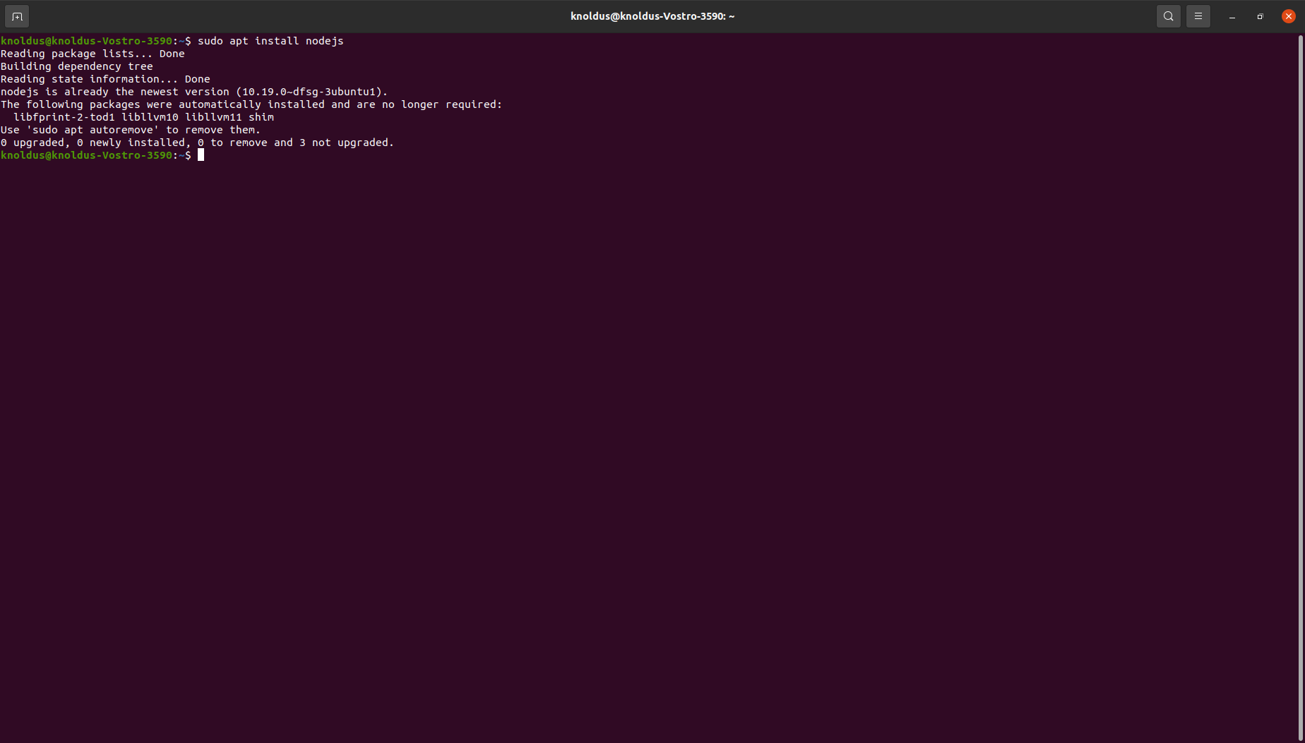
node -v

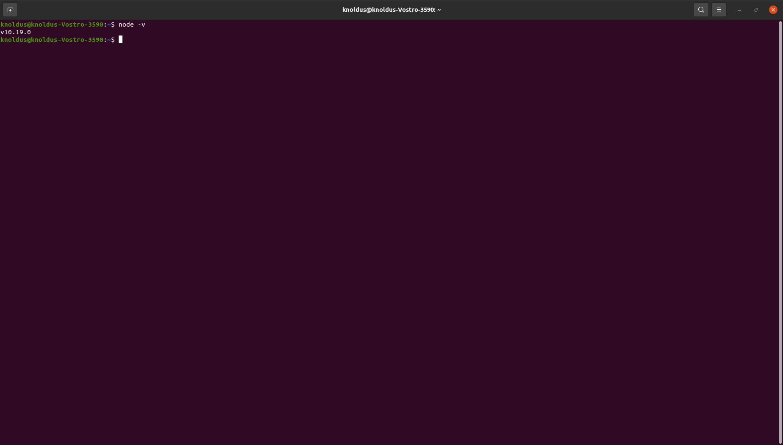

- NPM Command
sudo apt install npm

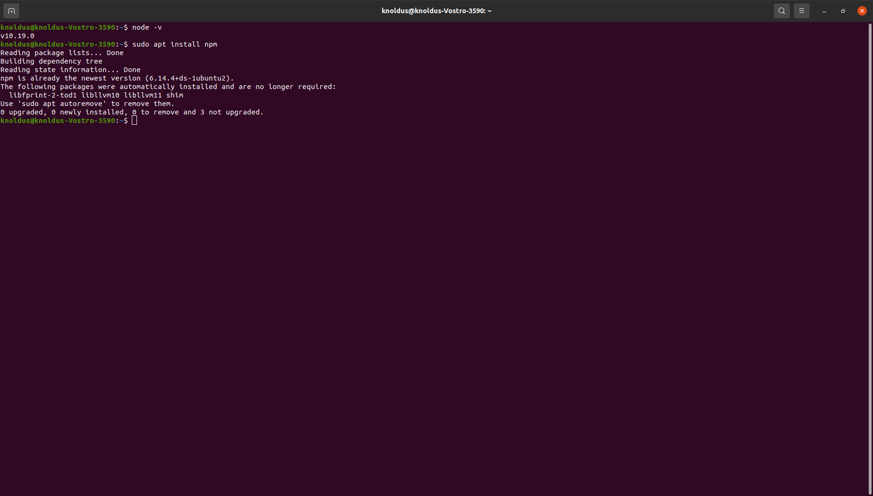

- Angular Command.
sudo npm install -g @angular/cli.

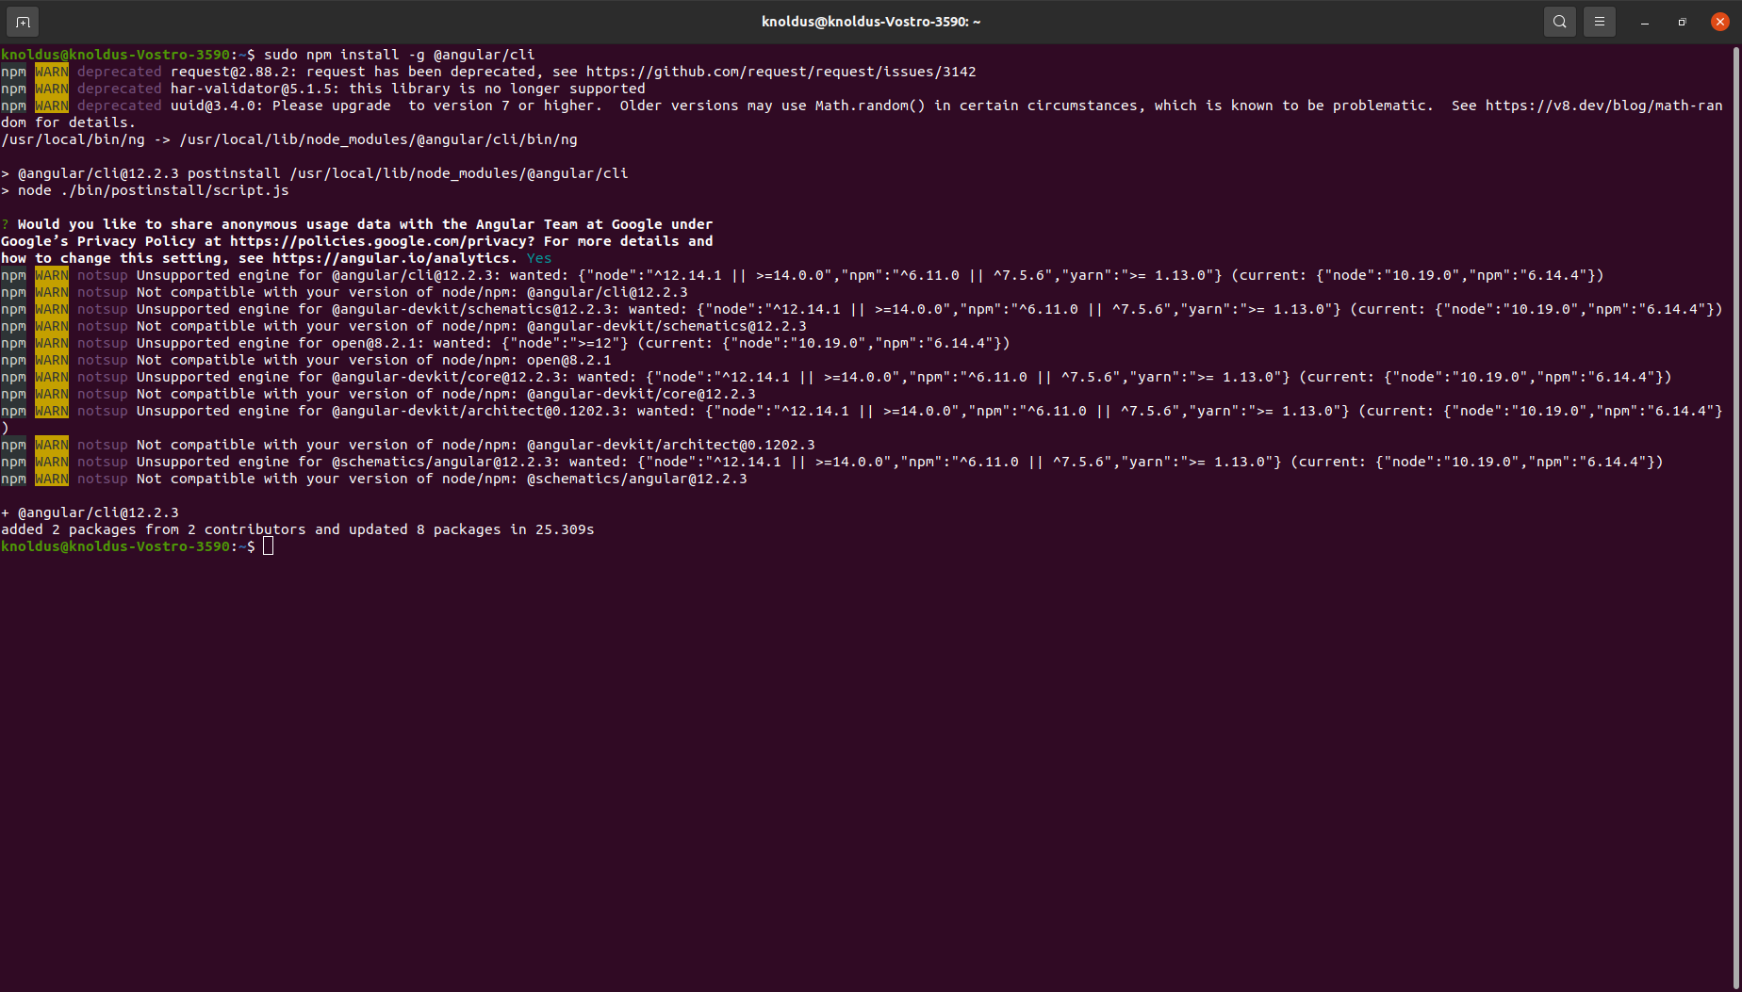

ng --version.

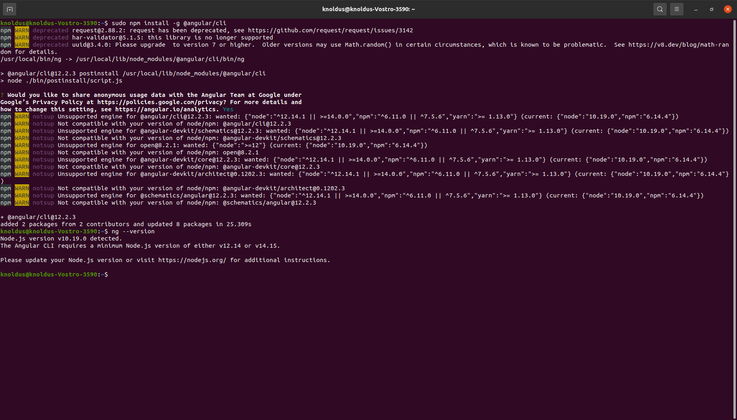

- Ionic Command
sudo npm i -g @vue/cli.

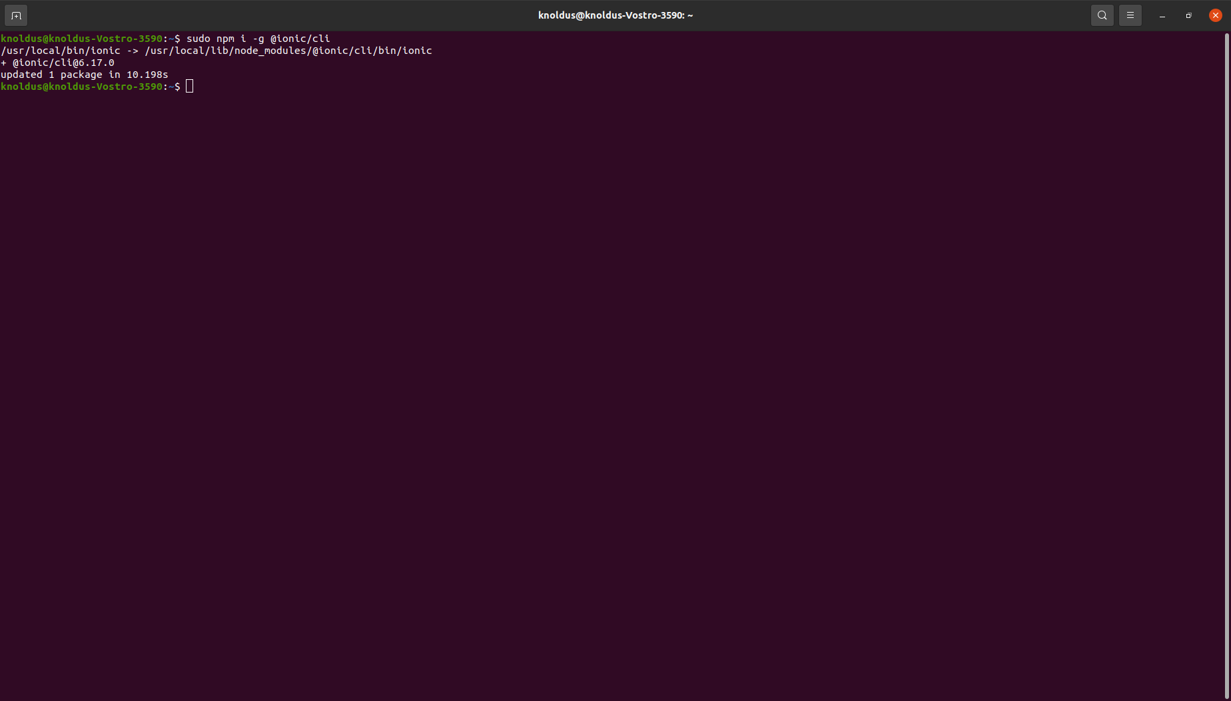

Ionic -v

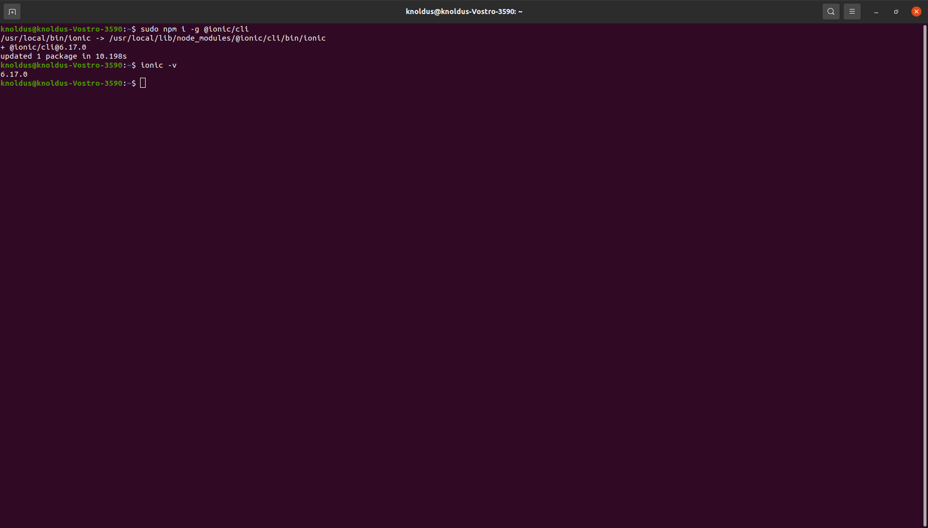

- VUE Command
sudo npm install -g @vue/cli.

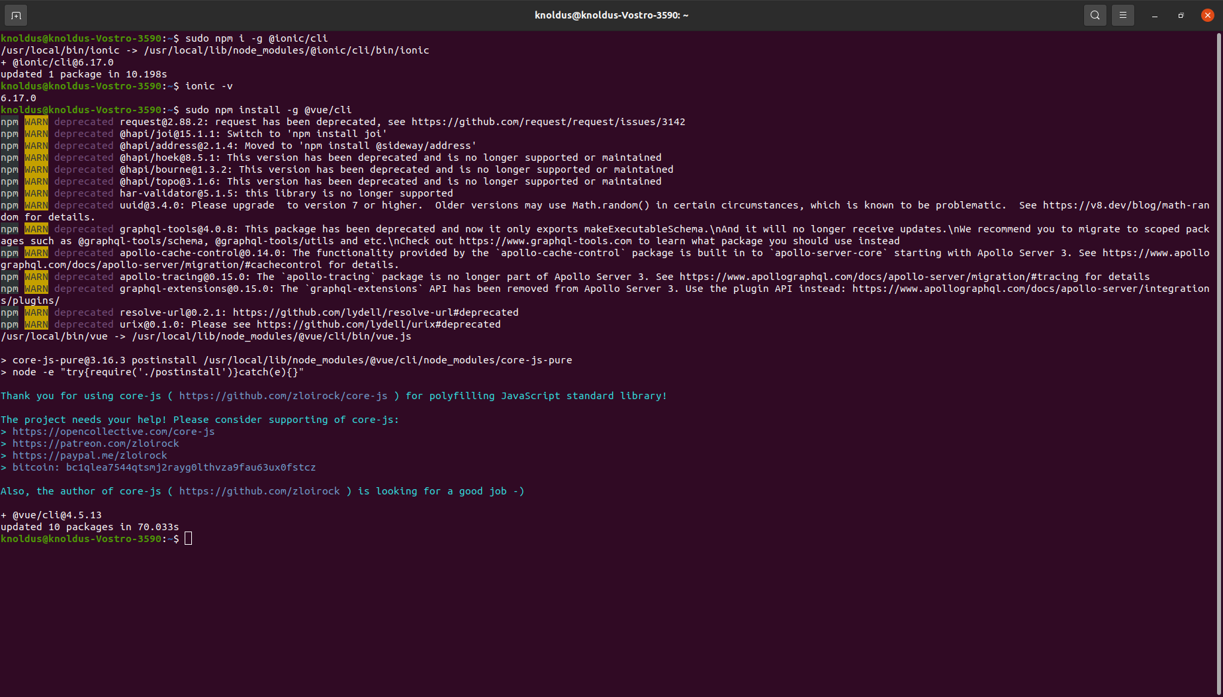

Vue --version

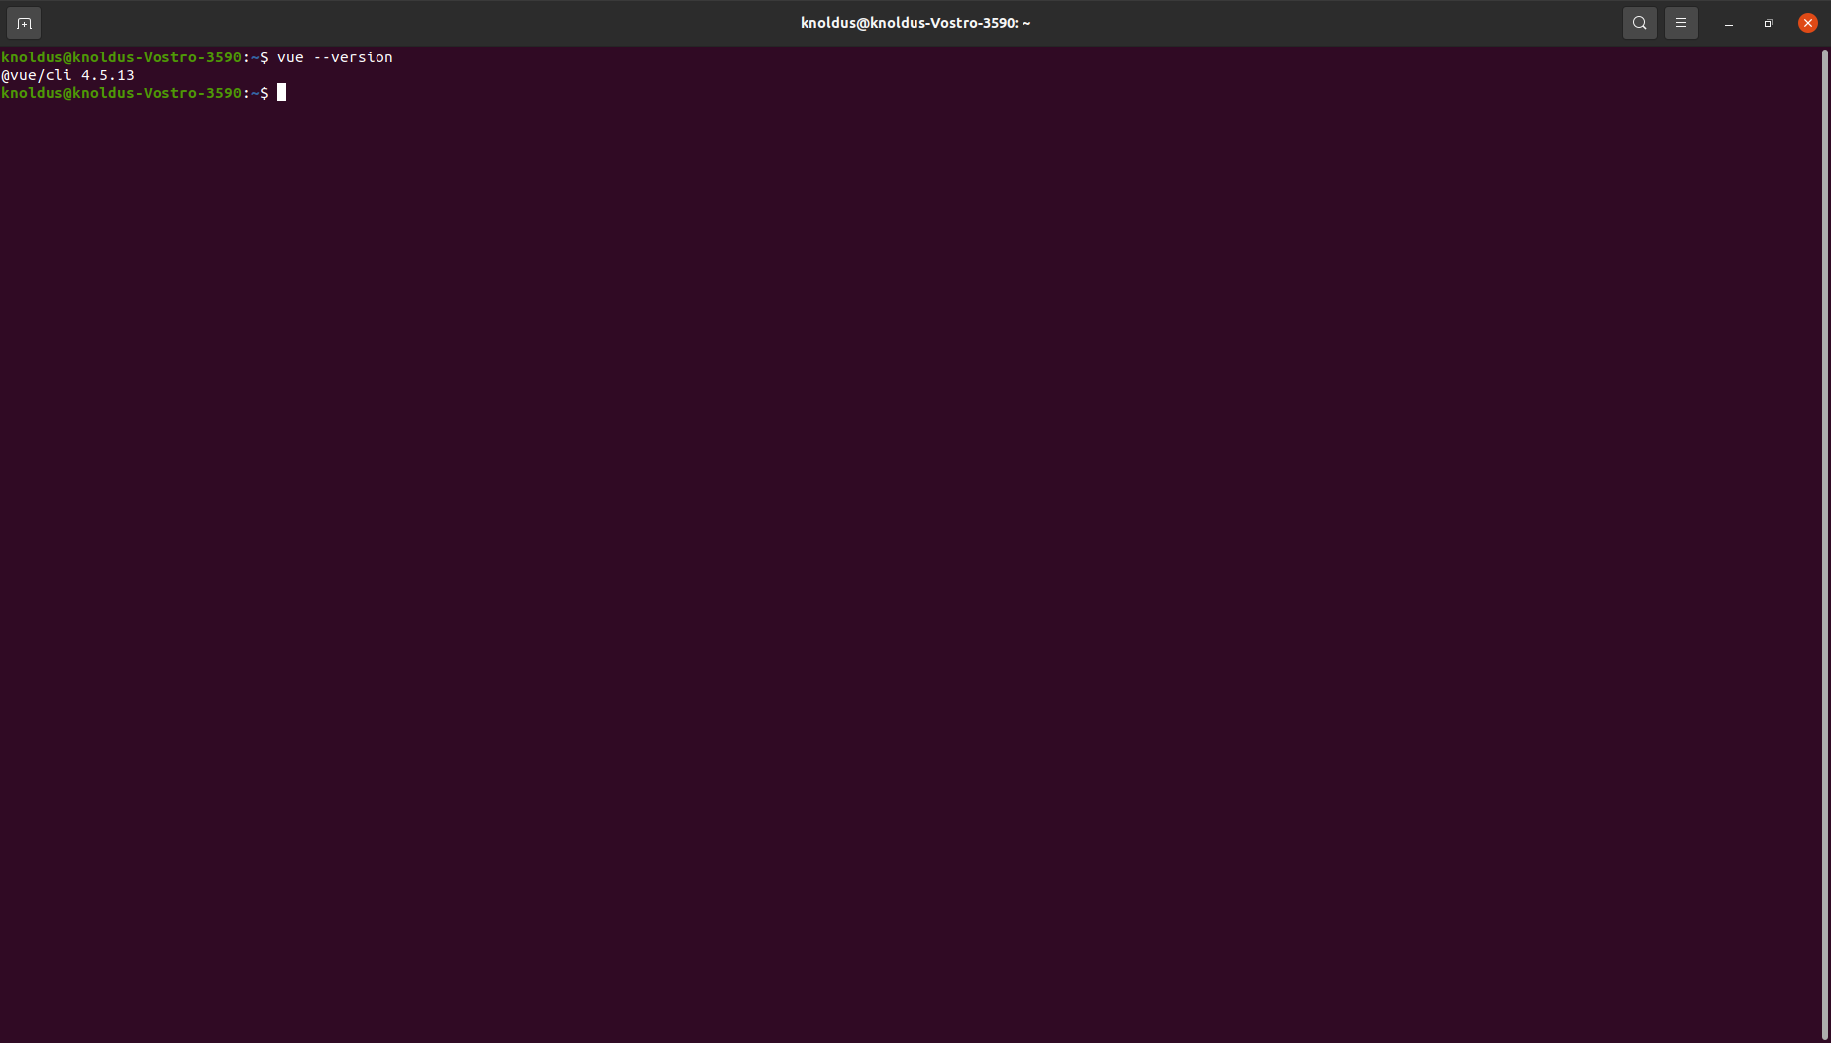

- Create-React-Command
sudo npm -g install create-react-app.

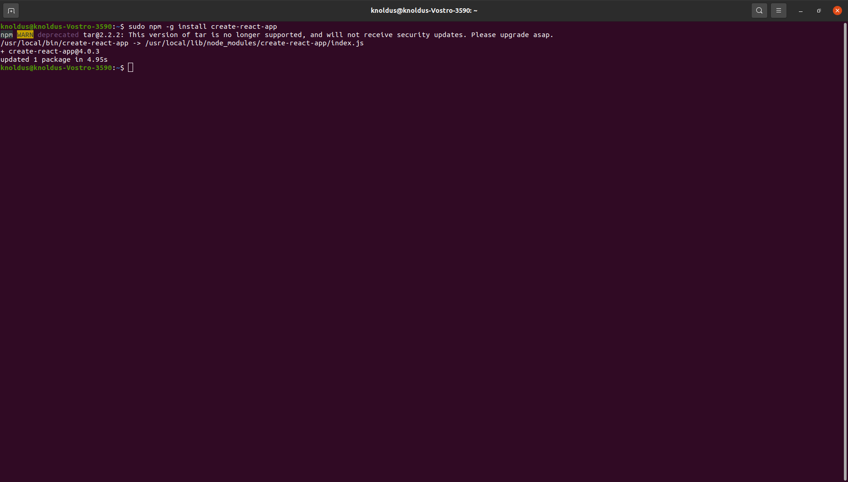

Create-react-app --version.

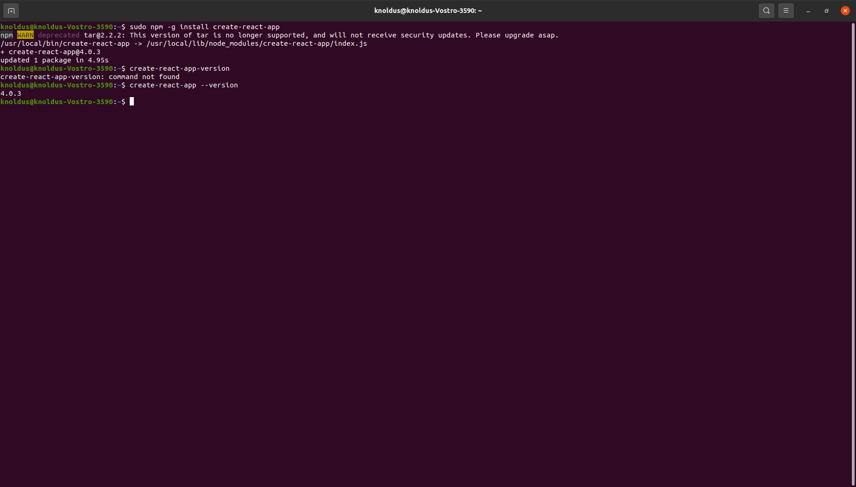

- Command for Angular cli Latest version.
Sudo npm cache clean -f
Sudo npm install -g n
Sudo n latest

