A PROJECT TITLE

ON
Traffic Congestion Level Prediction Using Machine Learning

project report submitted in partial fulfilment of the requirements for the Course

MACHINE LEARNING

BACHELOR OF TECHNOLOGY

In

A.Y.: 2026-27

By

Asritha - 2520030592
Devi sree - 2520030594
Gayatri sri harshita - 2520030600

Under the Esteemed guidance of

Ravindra Gaddam

Associate Professor, CSE

Department of Computer Science and Engineering





Abstract
Traffic congestion is a major urban problem that affects travel time, fuel consumption, emissions and the efficiency of road networks. This project develops a machine-learning system that classifies traffic conditions into Low, Medium and High congestion levels using traffic-sensor data. The PeMSD7_V_228 dataset contains 12,672 observations and 228 sensor attributes after correct CSV loading.
The workflow includes data loading, inspection, data-quality checks, exploratory data analysis, feature engineering, target-label preparation, stratified train-test splitting, model training and evaluation. An Average_Traffic variable is computed from all sensor readings, and a percentile-based rule (33rd and 67th percentiles) is used to create the congestion labels.
Two non-linear, supervised ensemble algorithms, Random Forest and Gradient Boosting, are implemented and compared using Accuracy, Precision, Recall, F1-score and confusion matrices. The model with the highest F1-score is identified as the better performer. An interactive Streamlit dashboard presents the data overview, traffic patterns, model comparison and predictions.
Because the congestion label is derived from Average_Traffic, target leakage was considered. The final models therefore use only the 228 sensor columns as inputs, and the results should be read as how well the models recover the defined congestion rule rather than true forecasting performance.
Keywords: traffic congestion, classification, Random Forest, Gradient Boosting, Streamlit, target leakage.

1. Introduction

1.1 Purpose of the Project
Urban traffic congestion is a practical problem caused by increasing travel demand, limited road capacity and changing traffic conditions. Reliable congestion prediction can support commuters, traffic authorities and intelligent transportation systems by identifying potentially congested conditions before they become severe.
The purpose of this project is to use historical traffic-sensor measurements to develop a simple, reproducible classification pipeline. The system transforms sensor measurements into Low, Medium and High congestion categories and tests two ensemble machine-learning approaches. The project emphasizes systematic preprocessing, exploratory analysis, feature construction and objective model evaluation.

1.2 Problem Statement
Given a set of traffic-sensor observations, the problem is to classify each observation into one of three congestion levels—Low, Medium or High. The expected output is a categorical congestion label. The project therefore treats congestion-level prediction as a supervised multiclass classification problem.

1.3 Existing Methods and Disadvantages
Traffic prediction research uses statistical models, classical machine-learning algorithms, ensemble methods and deep-learning approaches. Classical approaches can be useful when relationships are relatively simple, while tree-based ensemble methods can model nonlinear relationships without requiring extensive feature transformations.
More complex deep-learning methods can capture spatial and temporal dependencies but generally require more computation, careful validation and larger amounts of appropriately structured data. Recent reviews also emphasize that differences in datasets, prediction horizons and evaluation procedures make direct comparison difficult. This project therefore uses two interpretable ensemble classifiers as a focused baseline comparison.

1.4 Proposed System
The proposed system loads the PeMSD7_V_228 sensor dataset, validates its structure, checks data quality, performs exploratory analysis and creates an Average_Traffic feature from the 228 sensors. A percentile-based rule is then used to form Low, Medium and High target classes. The data is divided using a stratified 80:20 train-test split, followed by Random Forest and Gradient Boosting training. Predictions are evaluated with standard classification metrics and confusion matrices.

1.5 Research Objectives
• Prepare and inspect a suitable traffic-sensor dataset.
• Perform systematic data-quality checks and exploratory analysis.
• Engineer a useful aggregate traffic feature and prepare congestion labels while monitoring data leakage.
• Develop and train Random Forest and Gradient Boosting classifiers.
• Evaluate and compare the models using Accuracy, Precision, Recall and F1-score.
• Identify the better-performing model and discuss limitations and practical applicability.

2. Literature Survey
Recent literature shows that traffic-congestion research increasingly combines machine learning, ensemble learning and deep learning. The following studies were selected because they directly address traffic congestion, traffic-flow prediction or closely related intelligent-transportation applications. Bibliographic details should be rechecked against the publisher pages before final institutional submission.
S.No. | Study | Year / Source | Methods | Key inference | DOI / Identifier
1 | Traffic Congestion Prediction using Machine Learning | 2024, INDIACom / IEEE | Decision Tree, Random Forest, Logistic Regression, SVM, MLP; comparison of congestion prediction models. | Demonstrates the usefulness of comparing several classical ML models for congestion prediction. | 10.23919/INDIACom61295.2024.10498418
2 | Deep Learning Algorithms for Traffic Forecasting: A Comprehensive Review and Comparison with Classical Ones | Afandizadeh et al., 2024, Journal of Advanced Transportation | Review of deep learning and classical traffic forecasting methods. | Shows that model suitability depends on the forecasting context and data characteristics. | 10.1155/2024/9981657
3 | Traffic management approaches using machine learning and deep learning techniques: A survey | 2024, Engineering Applications of Artificial Intelligence | Survey of ML/DL methods for traffic management. | Identifies congestion prediction and traffic-flow management as important smart-city challenges. | 10.1016/j.engappai.2024.108147
4 | Traffic congestion forecasting using multilayered deep neural network | Kumar et al., 2024, Transportation Letters | MLDNN with congestion index; comparisons with SVR, MLP, GRU, LSTM, CNN and hybrids. | Shows that deep neural networks can model heterogeneous traffic congestion, while requiring suitable temporal data. | 10.1080/19427867.2023.2207278
5 | Deep-Learning-Based Microscopic Approach for Road Traffic Congestion Classification in Highway and Urban Roads Under Adverse Conditions | Khalladi et al., 2024, Transportation Research Record | Deep-learning classification of light, medium and heavy traffic states. | Demonstrates multiclass traffic-state classification under varying road conditions. | 10.1177/03611981241246255
6 | Advances in Traffic Congestion Prediction: An Overview of Emerging Techniques and Methods | Mystakidis, Koukaras & Tjortjis, 2025, Smart Cities | Review of statistical, ML, DL and ensemble approaches. | Highlights that complex traffic conditions favor ML/DL and ensemble approaches but raise overfitting and computational concerns. | 10.3390/smartcities8010025
7 | A Systematic Literature Review of Traffic Congestion Forecasting: From Machine Learning Techniques to Large Language Models | Attioui & Lahby, 2025, Vehicles | PRISMA-based review of 100 peer-reviewed studies. | Reports a progression from traditional ML to deep learning and newer multimodal approaches; stresses validation and reproducibility. | 10.3390/vehicles7040142
8 | Leveraging machine learning to predict traffic jams: Case study of Casablanca, Morocco | 2025, Journal of Urban Management | Random Forest, KNN, XGBoost and ANN using traffic-related data. | Reports strong RF performance and identifies congestion zones useful for urban planning. | 10.1016/j.jum.2025.02.004
9 | Towards green transportation: Predictive modeling of intersection congestion using machine learning for sustainable urban traffic management | 2025, The Franklin Institute / ScienceDirect | Random Forest feature importance, Chi-square selection, SMOTE-ENN, CatBoost, LightGBM and XGBoost. | Shows the value of feature selection, imbalance handling and gradient-boosted models for congestion classification. | Publisher article; DOI to be verified from final publisher record
10 | Urban Traffic Flow Prediction via Multi-Model Classifier Ensemble | 2025, IEEE conference | Random Forest, Decision Tree, KNN and weighted voting ensemble. | Shows that combining classifiers can improve urban traffic-flow prediction and motivates ensemble comparison. | 10.1109/QPAIN66474.2025.11172251

3. Methodology

3.1 Proposed System Flow Diagram
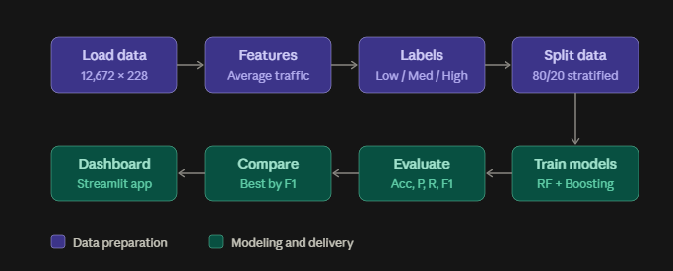

3.2 Dataset Description
The dataset used is PeMSD7_V_228.csv. It contains 12,672 observations and 228 traffic-sensor attributes after loading the CSV with the correct header handling. The sensor variables are numerical measurements. A new Average_Traffic feature is calculated from the sensor columns. The target variable Congestion_Level contains three classes: Low, Medium and High. The class labels are project-defined using percentile thresholds of Average_Traffic rather than an external official congestion standard.

3.3 Experimental Setup
The implementation was carried out in a Jupyter Notebook using Python. The main libraries used in the workflow are Pandas for data handling, Matplotlib for visualization, and Scikit-learn for train-test splitting, Random Forest, Gradient Boosting and evaluation metrics. The exact Python and package versions should be copied from the notebook environment before final submission if required by the department.

3.4 Data Preprocessing
• CSV loading and schema/header correction.
• Inspection using shape, head and info.
• Missing-value analysis.
• Duplicate-row analysis.
• Descriptive-statistics analysis.
• Target-label preparation.
• Stratified 80:20 train-test split using random_state=42.
• Data-leakage review before final model reporting.

3.5 Exploratory Data Analysis
Exploratory analysis was used to understand the structure and distribution of traffic measurements. The workflow included dataset dimensions, descriptive statistics, missing-value checks, duplicate checks, sensor distributions and visualizations. Plots were used to inspect distributions and the resulting congestion-level distribution.

3.6 Feature Engineering and Feature Selection (if applicable)
The main engineered feature is Average_Traffic, calculated as the mean of the 228 sensor attributes for each observation. This provides a compact summary of the overall sensor measurement. The original sensor columns remain important model inputs. Because Average_Traffic is also used to construct the target, it should be excluded from the final X matrix to avoid target leakage.

3.7 Model Building and Training
Random Forest Classifier was trained with n_estimators=100 and random_state=42. GradientBoostingClassifier was also trained with random_state=42. The Gradient Boosting model was finally run with n_estimators=30 because the 100-estimator configuration was too slow in the notebook environment. Both models were trained using the training partition and tested on the held-out partition.

3.8 Hyperparameter Tuning(if applicable)
A formal grid search or random search was not performed in the completed workflow. The project used fixed parameters for the two classifiers. This should be reported honestly rather than described as hyperparameter optimization.

3.9 Model Evaluation
The models were evaluated using Accuracy, weighted Precision, weighted Recall and weighted F1-score. Confusion matrices were generated to inspect class-wise correct and incorrect predictions. Model comparison was based on the evaluation table and the best model was identified using the highest F1-score in the notebook.

4. Results and Discussion

4.1 Preprocessing Results
The final working dataset contains 12,672 observations and 228 original sensor attributes. Data-quality checks were performed for missing values and duplicate rows. The notebook workflow also corrected the CSV loading so that the first measurement row was not accidentally interpreted as a column header.
Final model feature count depends on the leakage correction. The initial workflow included the engineered Average_Traffic feature in X; for a defensible final experiment, Average_Traffic should be removed from X because it directly determines the target labels.

4.2 Model Performance
Model | Accuracy | Precision | Recall | F1-score | Notes
Random Forest | [Copy from notebook] | [Copy from notebook] | [Copy from notebook] | [Copy from notebook] | 100 trees; random_state=42
Gradient Boosting | [Copy from notebook] | [Copy from notebook] | [Copy from notebook] | [Copy from notebook] | 30 trees; random_state=42
Note: the exact metric values should be copied from the final Jupyter output. The chat workflow successfully produced the evaluation and comparison cells, but the numeric output is not reproduced here because it was not available as reliable source text.

4.3 Visual Results and discussion
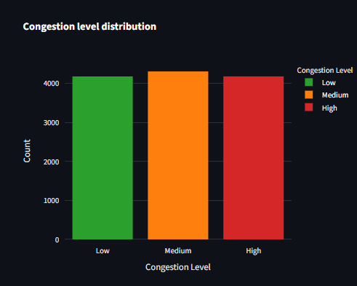
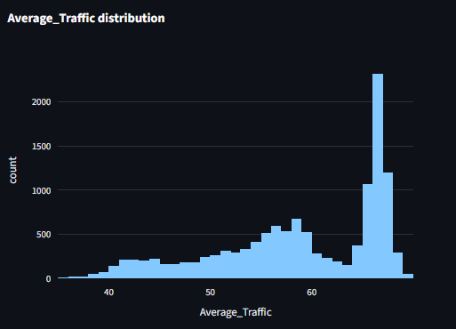

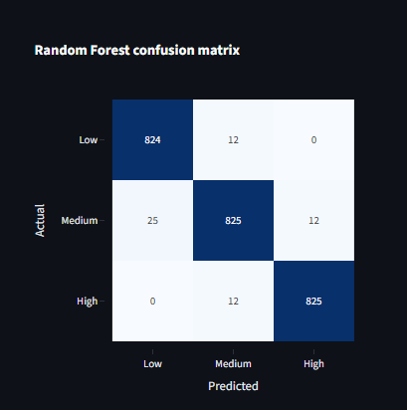
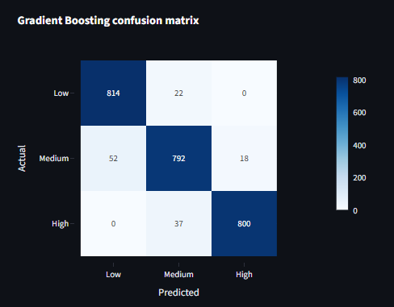
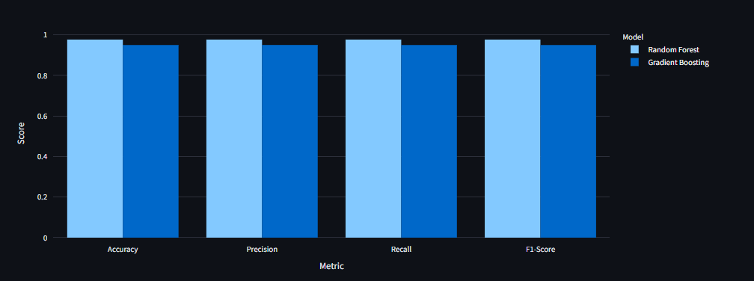

5. Conclusion
This project developed a complete machine-learning workflow for traffic congestion-level classification using 12,672 observations and 228 traffic-sensor attributes from PeMSD7_V_228.csv. The workflow included data loading, inspection, cleaning checks, exploratory analysis, feature engineering, target-label construction, train-test splitting, model training, prediction and evaluation. Random Forest and Gradient Boosting were selected as the two ensemble classification methods. Their performance was evaluated using Accuracy, Precision, Recall, F1-score and confusion matrices. The project demonstrates how traffic-sensor data can be transformed into a supervised learning problem and provides a basis for comparing ensemble models.
A key methodological improvement is required before treating the final scores as the definitive project result: because Average_Traffic was used to create Congestion_Level, Average_Traffic should not also be supplied as a predictor. The final models should be retrained using the sensor attributes without the target-defining aggregate, and the reported metrics should be updated accordingly.

6. Future Work
• Use larger and more diverse traffic datasets from multiple road networks.
• Use time-aware train/test validation for forecasting-oriented experiments.
• Perform systematic hyperparameter optimization and cross-validation.
• Compare additional ensemble and temporal models such as XGBoost, LightGBM, LSTM or temporal graph models.
• Investigate explainable-AI methods and feature importance.
• Test robustness on an external traffic network.
• Develop a real-time dashboard or deployable traffic-alert application.
• Monitor model drift when traffic patterns change over time.

7. References
[1] Traffic Congestion Prediction using Machine Learning. 2024. INDIACom / IEEE. doi:10.23919/INDIACom61295.2024.10498418.
[2] Afandizadeh, S., Abdolahi, S., Mirzahossein, H. (2024). Deep Learning Algorithms for Traffic Forecasting: A Comprehensive Review and Comparison with Classical Ones. Journal of Advanced Transportation. doi:10.1155/2024/9981657.
[3] Traffic management approaches using machine learning and deep learning techniques: A survey. 2024. Engineering Applications of Artificial Intelligence, 133, 108147. doi:10.1016/j.engappai.2024.108147.
[4] Kumar, K., Kumar, M., Das, P. (2024). Traffic congestion forecasting using multilayered deep neural network. Transportation Letters, 16(6), 516–526. doi:10.1080/19427867.2023.2207278.
[5] Khalladi, S. A., Ouessai, A., Benamara, N. K., Keche, M. (2024). Deep-Learning-Based Microscopic Approach for Road Traffic Congestion Classification in Highway and Urban Roads Under Adverse Conditions. Transportation Research Record. doi:10.1177/03611981241246255.
[6] Mystakidis, A., Koukaras, P., Tjortjis, C. (2025). Advances in Traffic Congestion Prediction: An Overview of Emerging Techniques and Methods. Smart Cities, 8(1), 25. doi:10.3390/smartcities8010025.
[7] Attioui, M., Lahby, M. (2025). A Systematic Literature Review of Traffic Congestion Forecasting: From Machine Learning Techniques to Large Language Models. Vehicles, 7(4), 142. doi:10.3390/vehicles7040142.
[8] Leveraging machine learning to predict traffic jams: Case study of Casablanca, Morocco. 2025. Journal of Urban Management, 14(3), 813–826. doi:10.1016/j.jum.2025.02.004.
[9] Urban Traffic Flow Prediction via Multi-Model Classifier Ensemble. 2025. IEEE conference publication. doi:10.1109/QPAIN66474.2025.11172251.
[10] Towards green transportation: Predictive modeling of intersection congestion using machine learning for sustainable urban traffic management. 2025. ScienceDirect/The Franklin Institute. DOI should be verified from the final publisher record before submission.

Signature of the Guide Course Instructor

