Digital Banking CRM - Step-by-Step Guide

# Step 1: Create Custom Objects

1. Go to Setup → Object Manager → Create → Custom Object.  
   2. Enter Object Label (e.g., Bank Account), API Name will auto-populate.  
   3. Optional: check 'Allow Reports' and 'Allow Activities'.  
   4. Save.  
     
   Repeat this for:  
   - Transaction  
   - Loan  
   - Card  
   - Service Request  
     
   Note: Standard Object 'Contact' is already available, no need to create.

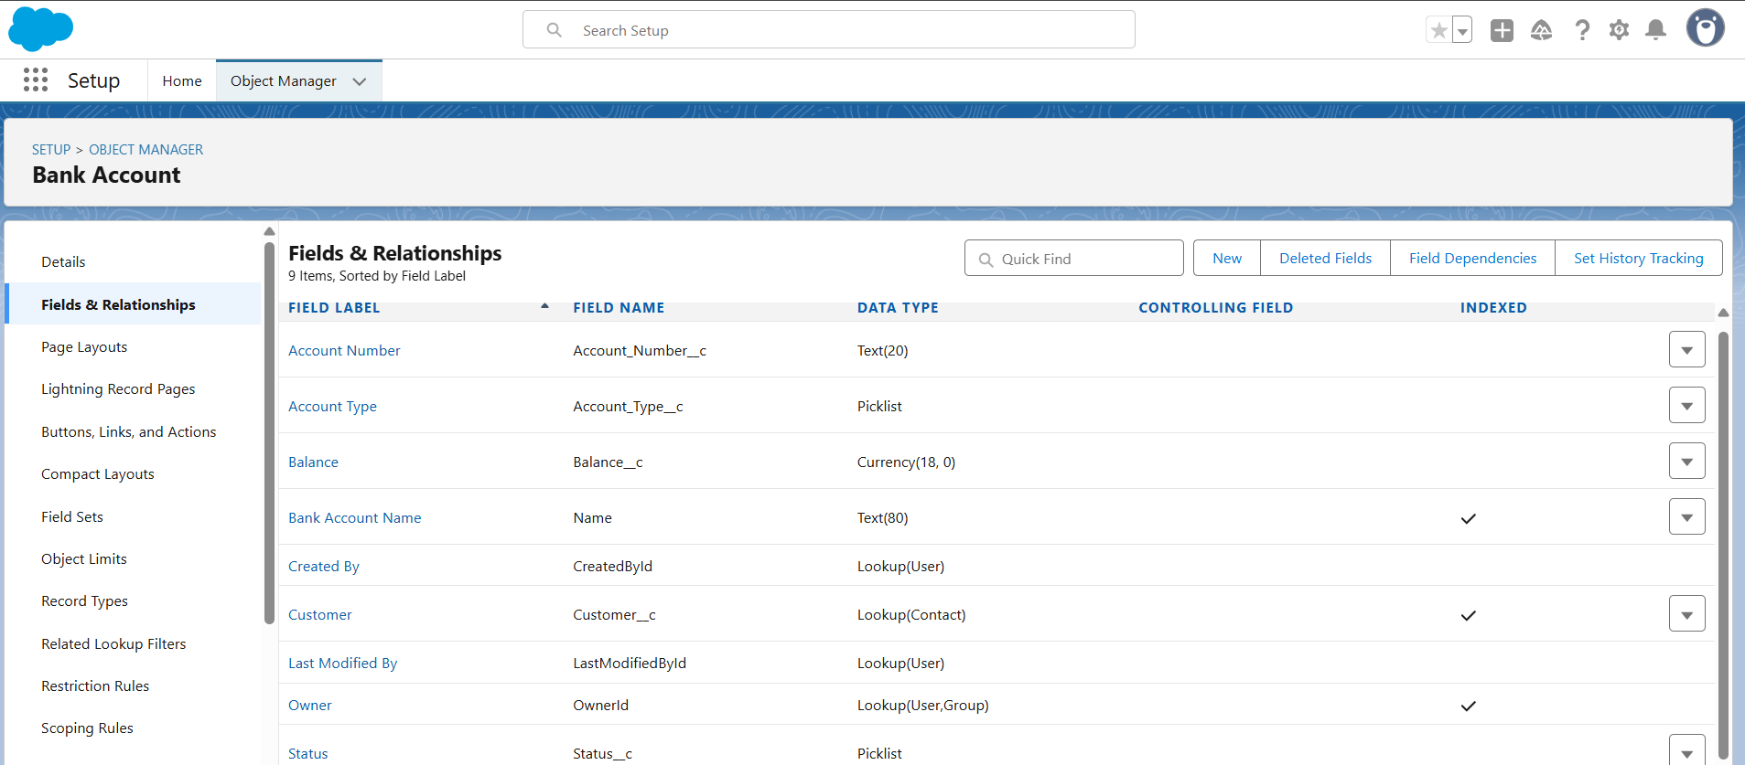

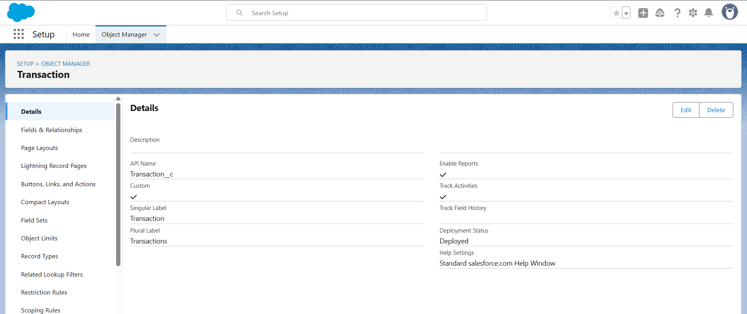

# Step 2: Add Fields to Each Object

## Bank Account

- Account Number → Text  
- Account Type → Picklist (Savings, Current)  
- Balance → Currency  
- Status → Picklist (Active, Closed)  
- Customer → Lookup(Contact)



## Transaction

- Transaction Date → Date/Time  
- Amount → Currency  
- Type → Picklist (Credit, Debit)  
- Status → Picklist (Completed, Failed)  
- Related Account → Lookup(Bank Account)

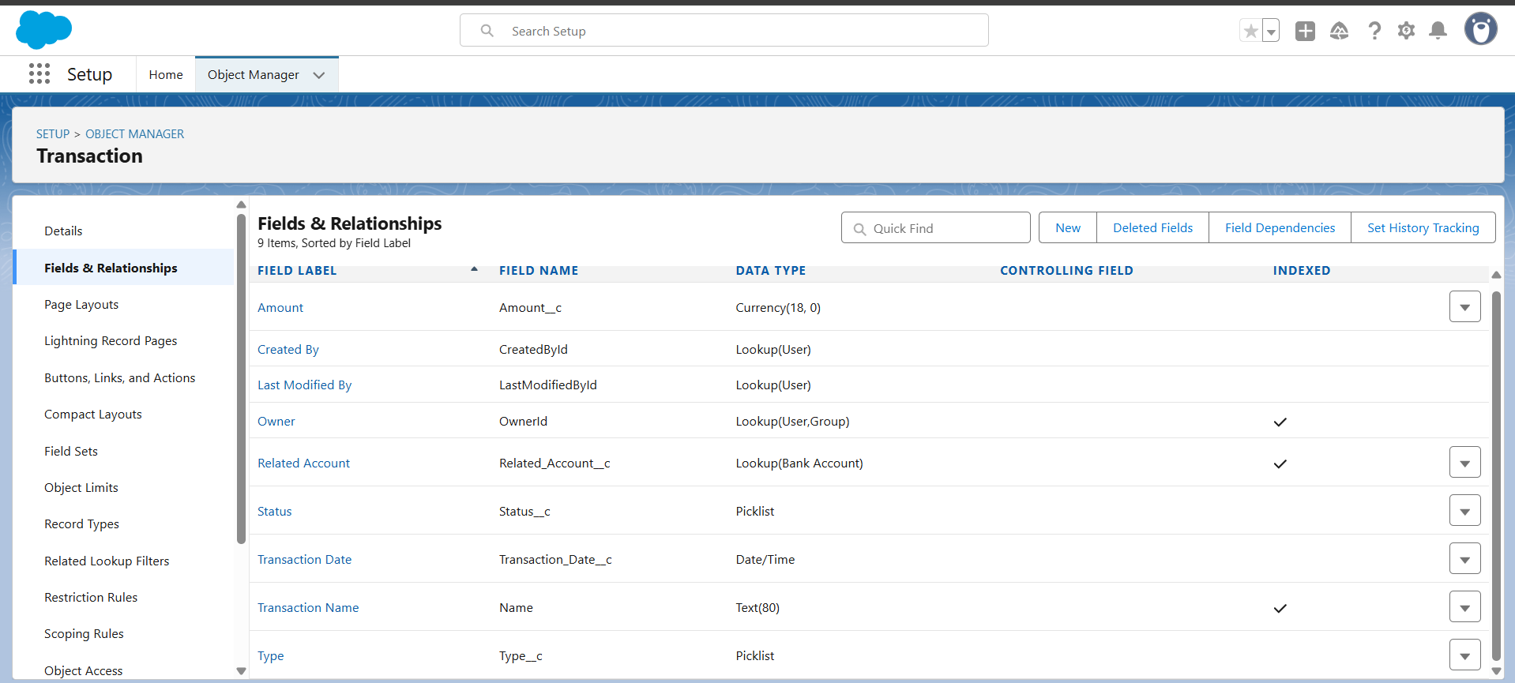

## Loan

- Loan Number → Text  
- Loan Type → Picklist (Personal, Home, Auto)  
- Amount → Currency  
- Status → Picklist (Applied, Approved, Closed)  
- Customer → Lookup(Contact)

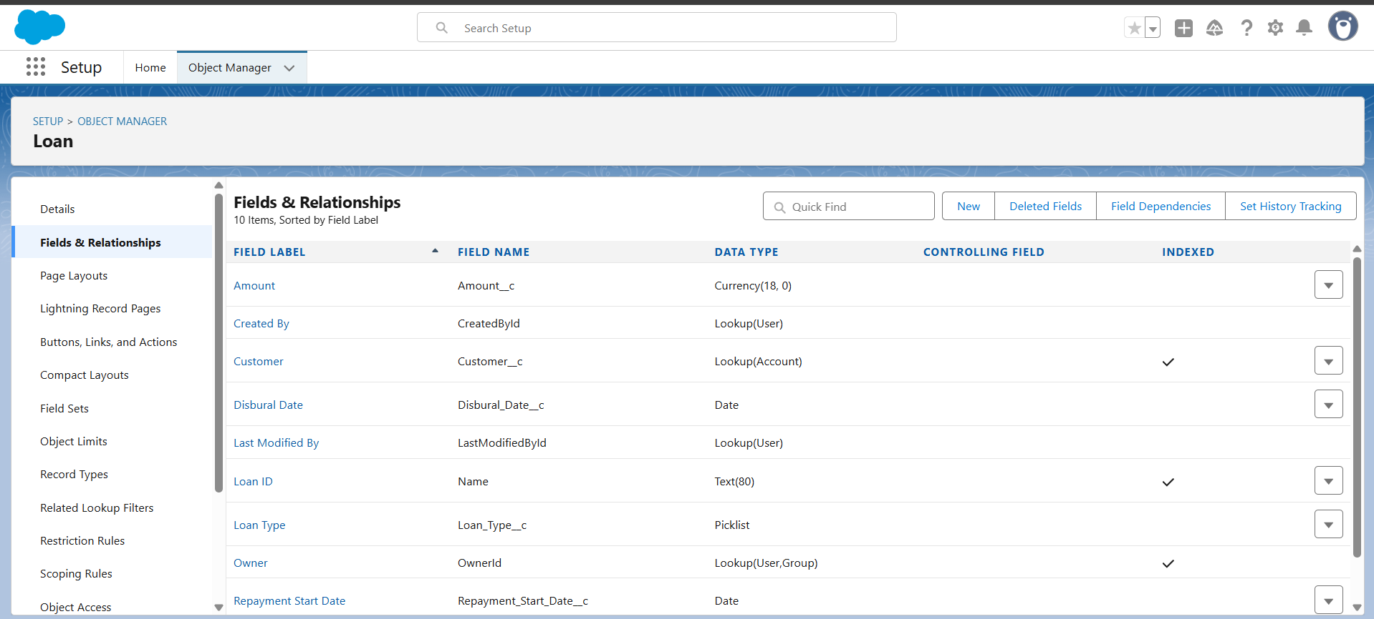

## Card

- Card Type → Picklist (Debit, Credit)  
- Last 4 Digits → Text  
- Status → Picklist (Active, Blocked)  
- Linked Account → Lookup(Bank Account)

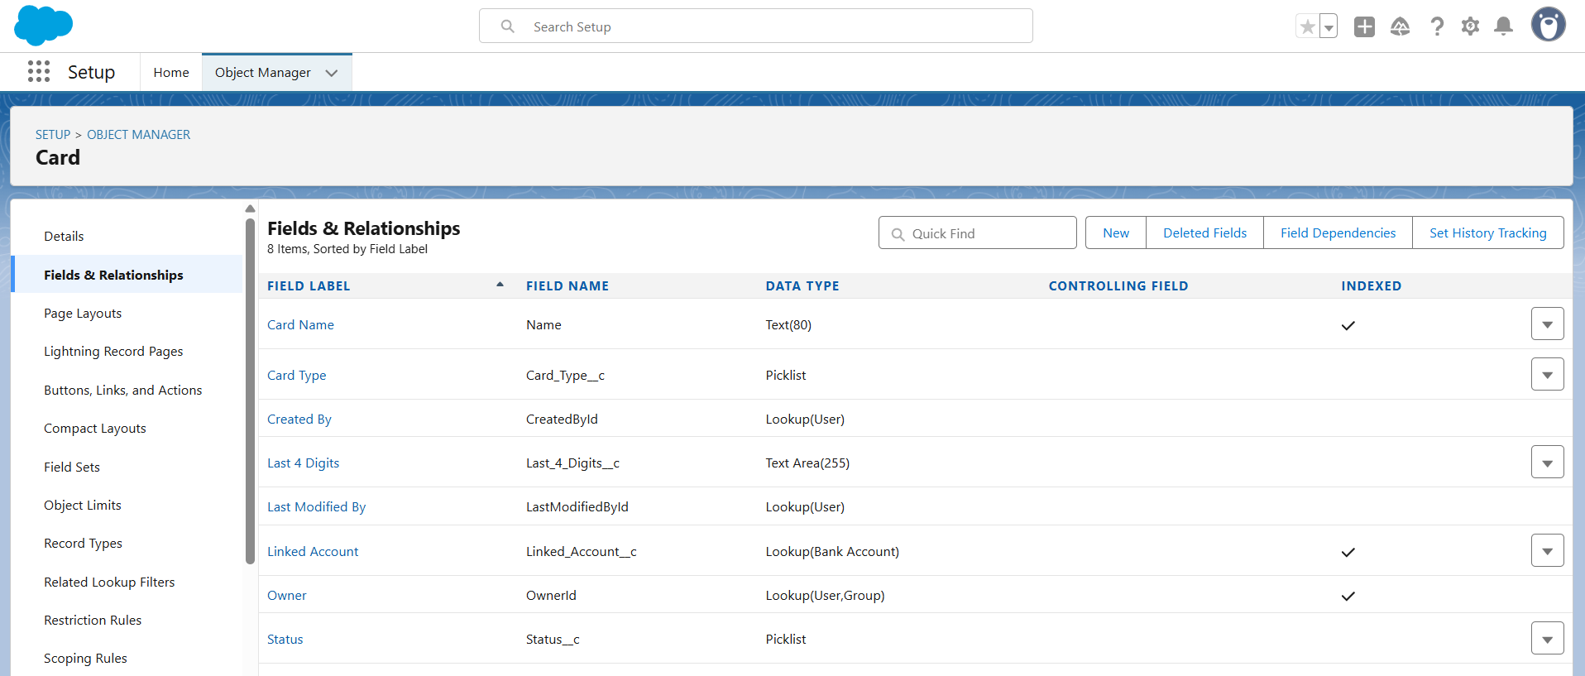

## Service Request

- Subject → Text  
- Type → Picklist (Account Issue, Card Issue, Loan Enquiry)  
- Status → Picklist (New, In Progress, Closed)  
- Customer → Lookup(Contact)

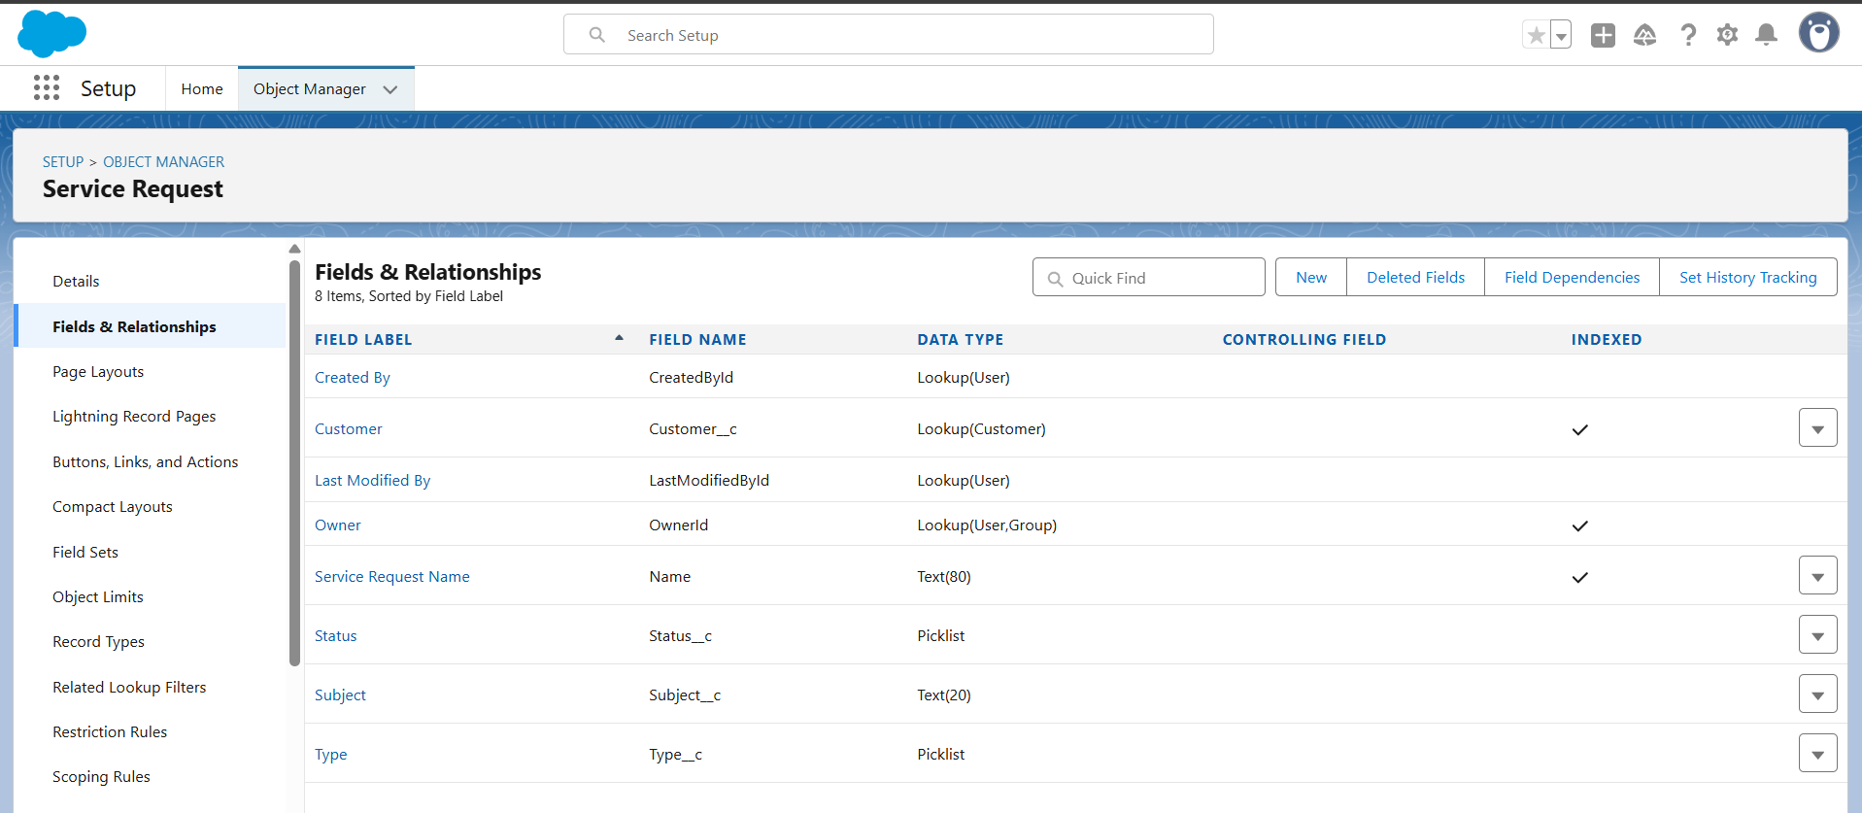  
  
To create fields: Go to Object → Fields & Relationships → New and select the type (Text, Picklist, Lookup, Currency, etc.)

# Step 3: Define Relationships

1. Lookup Fields: Already defined above.  
  
 - Bank Account → Customer (Contact)  
 - Transaction → Related Account (Bank Account)  
 - Loan → Customer (Contact)  
 - Card → Linked Account (Bank Account)  
 - Service Request → Customer (Contact)  
  
2. Optional: You can also use Master-Detail instead of Lookup if you want cascading delete/reporting benefits.

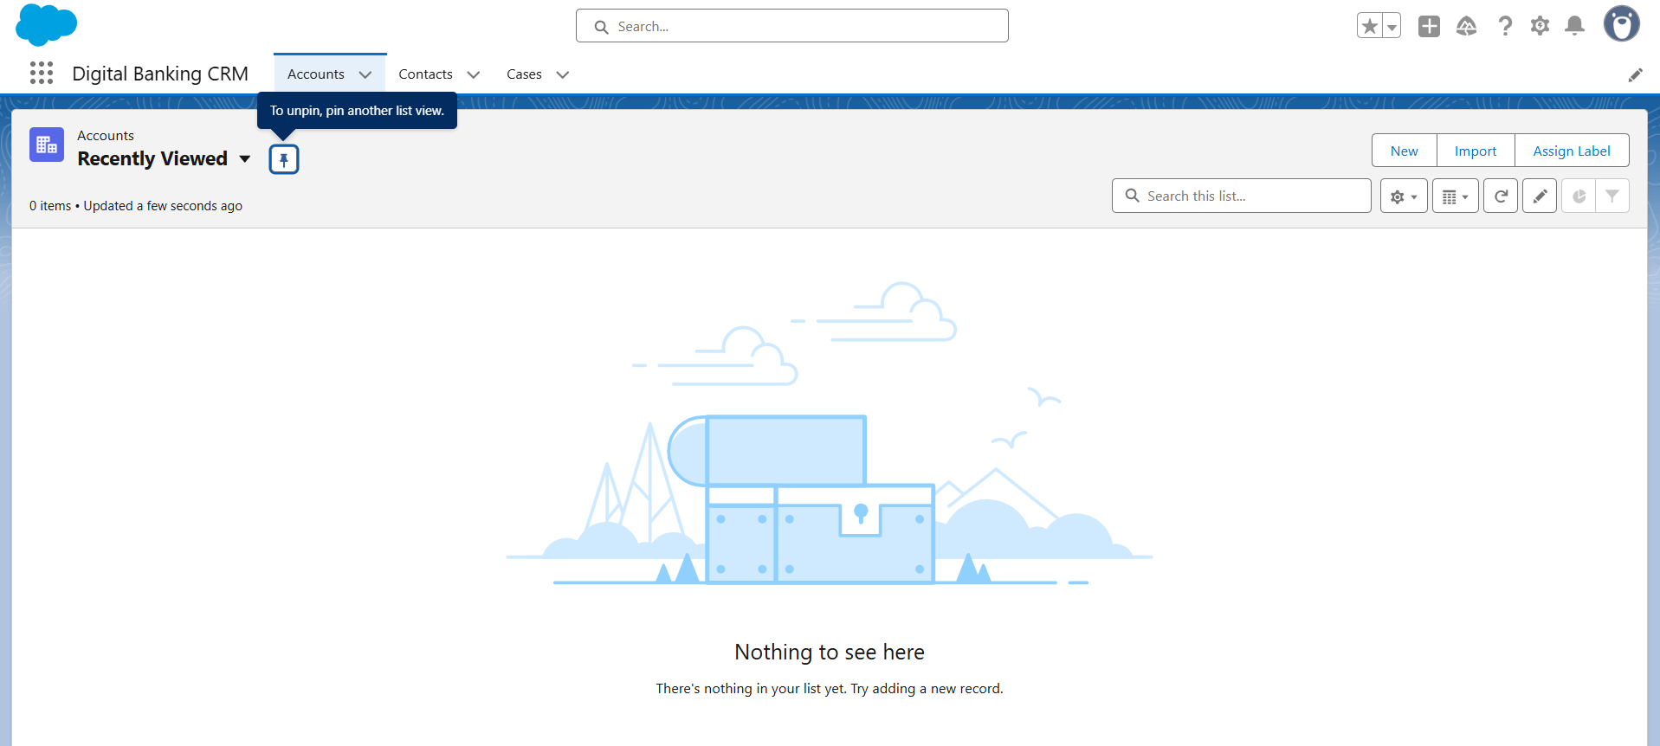

# Step 4: Page Layouts & List Views (Optional but Recommended)

1. Customize Page Layouts for each object to show only relevant fields.  
2. Create List Views for quick access:  
 - Active Bank Accounts  
 - Pending Transactions  
 - Open Service Requests

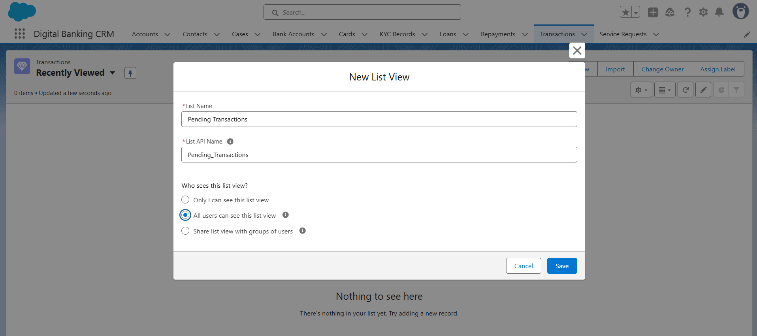

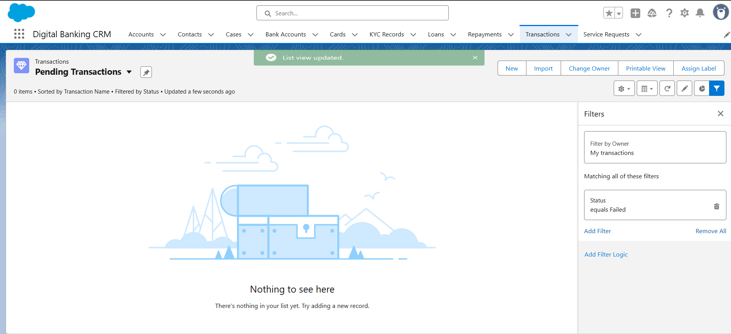

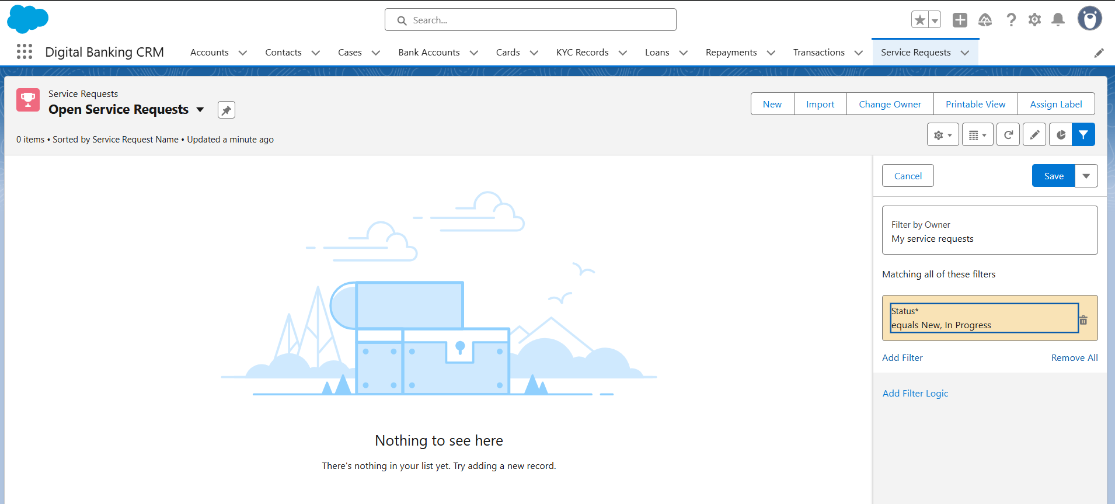

# Step 5: Mini Schema Diagram (ERD)

Simple ERD:  
  
Contact  
 │  
 ├──< Bank Account  
 │ │  
 │ ├──< Transaction  
 │ └──< Card  
 │  
 ├──< Loan  
 │  
 └──< Service Request  
  
'<' represents a Lookup relationship from child to parent.  
Only key objects and relationships are shown for simplicity.