WEEK 4 REPORT
Predictive Modeling and Optimization in Logistics Systems
Gayatri Krishna Zende
Computer Science And Engineering

1. Introduction
This project focuses on predictive modeling and optimization in a logistics environment. The aim is to forecast actual delivery time using shipment and operational variables and then use the model insights to suggest practical improvements. A hypothetical logistics dataset was created to represent realistic shipment conditions such as distance, shipment volume, transportation cost, traffic, weather risk, promised delivery time and actual delivery time.

2. Problem Definition
The prediction problem is to estimate Actual_Delivery_Days from measurable logistics features. Accurate delivery-time estimation can help logistics teams identify potentially delayed shipments, plan resources, improve route decisions and communicate more realistic delivery expectations.

3. Dataset Description
The dataset contains 250 simulated shipment records. Key variables include Distance_km, Shipment_Volume, Transportation_Cost, Traffic_Index, Weather_Risk, Promised_Delivery_Days and Actual_Delivery_Days. The target variable is Actual_Delivery_Days.

4. Data Preparation
- Checked the structure and numerical variables of the dataset.
- Separated predictor variables from the target variable.
- Split the data into 80% training and 20% testing sets.
- Standardized features using only training-set mean and standard deviation to avoid data leakage.

5. Model Selection and Implementation
Linear Regression was selected as a transparent baseline model because the target is continuous and the model provides an interpretable relationship between operational features and delivery time. The implementation uses Python, NumPy and Pandas. The training process estimates regression coefficients from the training data and then predicts delivery time for unseen test records.

6. Python Code
df = pd.read_csv("Week_4_Logistics_Dataset.csv")
features = [
"Distance_km", "Shipment_Volume", "Transportation_Cost",
"Traffic_Index", "Weather_Risk", "Promised_Delivery_Days"
]
X = df[features].values
y = df["Actual_Delivery_Days"].values
# 80% training and 20% testing
# Standardize training features
# Fit Linear Regression
# Predict on test data
MAE = np.mean(np.abs(y_test - pred))
RMSE = np.sqrt(np.mean((y_test - pred) ** 2))
R2 = 1 - np.sum((y_test - pred) ** 2) / np.sum((y_test - y_test.mean()) ** 2)

7. Model Evaluation
Metric | Test Result
MAE | 0.516 days
RMSE | 0.616 days
R² | 0.885
MAE represents the average absolute prediction error. RMSE gives greater weight to larger errors, while R² indicates the proportion of variation in the target explained by the model. These metrics should be interpreted together rather than relying on a single measure.

8. Visualization and Interpretation
The Actual vs Predicted chart compares model predictions with observed delivery times. Points closer to the reference diagonal indicate smaller prediction errors. The distance chart helps examine the relationship between shipment distance and delivery time. The delay distribution shows how delivery delays are spread across the simulated shipments.
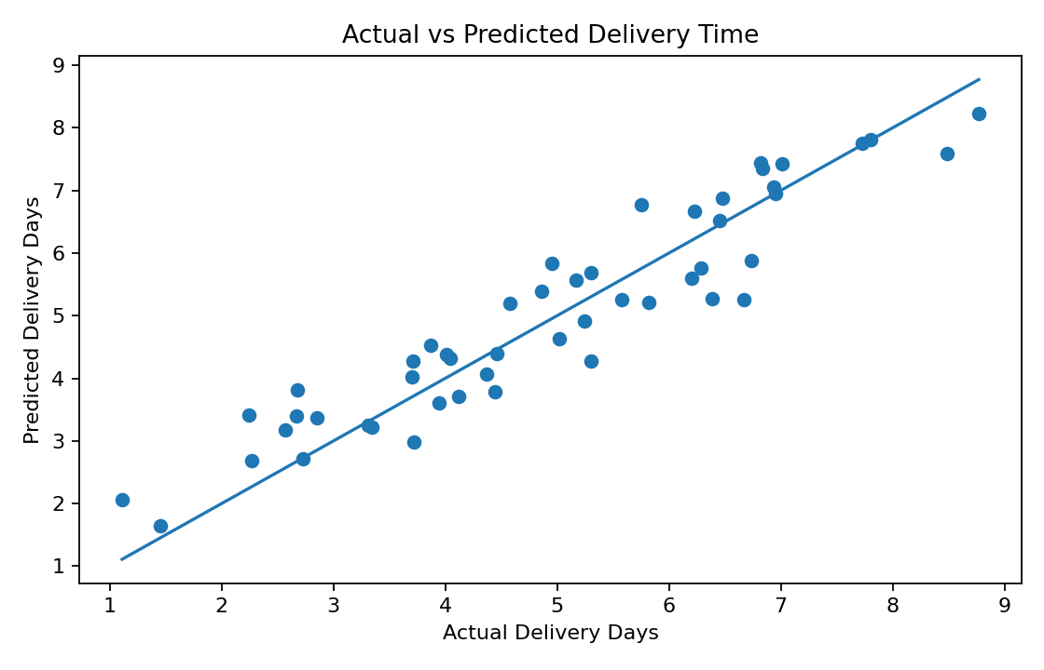
Figure 1: Actual vs Predicted Delivery Time
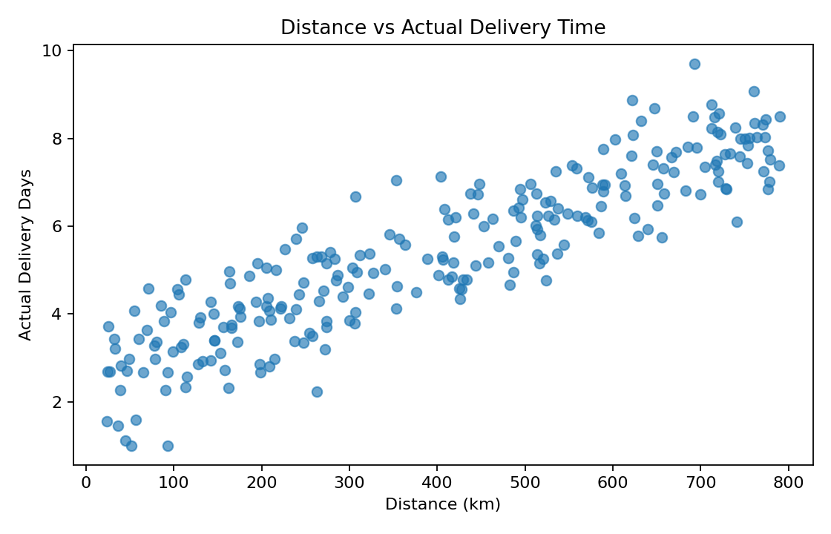
Figure 2: Distance vs Actual Delivery Time
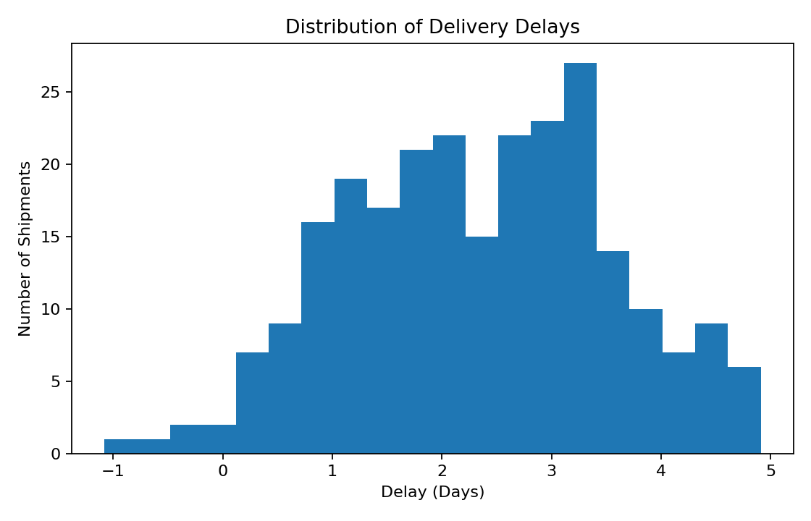
Figure 3: Distribution of Delivery Delays

9. Optimization Strategies
- Use predicted delivery time to flag shipments that may miss promised delivery dates.
- Prioritize route planning for long-distance and high-traffic shipments.
- Allocate additional vehicles or delivery capacity during periods with higher traffic risk.
- Create contingency routes or schedules for shipments with higher weather risk.
- Compare transportation cost with distance and shipment volume to identify inefficient shipment patterns.
- Use periodic model retraining as new operational data becomes available.

10. Key Insights
Delivery time is influenced by multiple operational factors rather than a single variable. Distance, shipment volume, traffic, weather conditions, transportation cost and promised delivery time can jointly support delivery-time prediction. Predictive insights can therefore be used as an early-warning mechanism for possible delays and as an input to operational planning.

11. Recommendations
Logistics teams should combine predictive estimates with real-time operational information before making final decisions. High-risk shipments can be reviewed earlier, routes can be adjusted where practical, and resources can be allocated according to predicted workload and delay risk. Future work can compare Linear Regression with Decision Tree or ensemble models and use cross-validation and hyperparameter tuning.

12. Conclusion
This project demonstrates a complete predictive analytics workflow for a logistics problem: defining the prediction target, preparing data, training a regression model, evaluating predictions and converting model insights into optimization recommendations. The approach provides a foundation for data-driven logistics planning and can be extended with larger real-world datasets and more advanced models.

13. Technologies Used
Python | Pandas | NumPy | Predictive Modeling | Regression | Data Analysis | Visualization
#Logistics #DataScience #Python #PredictiveModeling #DataAnalysis #MachineLearning #Optimization #YuvaIntern

