Using Temporal Vector-Space Models and Historical Content Extraction to Analyze Political Misinformation

Jesse Waite, *jessewaite86@gmail.com*

M.S. Computer Science, Washington State University

*The limits of my language mean the limits of my world*

*-Wittgenstein*

Abstract

This work introduces methods to evaluate misinformation and political bias patterns using temporal vector-space sentiment models and historical content extraction. Methods for quantifying political bias and misinformation were defined and applied to 2016 United States presidential election news and social media content of several foreign and domestic news organizations. A long term partisan analysis was also performed for news content disseminated by Google News (US), a news aggregator, from June 2011 through June 2017. The results demonstrate that consistent political misinformation and bias patterns are ascertainable using temporal vector-space sentiment analyses. The results were replicated for a second known 2016 election news dataset from (Faris et al., 2017) and demonstrate substantial partisan and candidate bias. This work demonstrates that historical content extraction methods and quantitative language models effectively identify strategic information patterns for which qualitative analyses are unreliable and unreproducible. The definitive patterns presented in this work invite similar computational analyses of misinformation, influence campaigns, political bias, and overall information dynamics with applications in political science, network science, signals intelligence and counter-misinformation. Empirical methods for quantifying political misinformation and bias over time using large scale, historical content extraction methods are surprisingly absent from the literature, despite their presumable utility. Likewise, no previous work has incorporated historical web content extraction methods and temporal sentiment models to empirically describe bias and misinformation, nor to evaluate their temporal dynamics.

Introduction

Rapid political and technological change, increasingly sophisticated misinformation operations (Lin & Kerr, 2017), abundant examples of major media misreporting and partisan bias, electoral polarization (Pew, 2014), and decreasing public institutional trust (Twenge, 2014) call for robust and reproducible methods of analyzing the strategic communication patterns of online organizations. The information monopoly of online social and news media platforms, with their unwieldy potential to both empower and undermine democratic discourse, animates the need to research information dynamics using reproducible quantitative methods. Such organizations extensively monitor their audiences and deploy algorithmic methods to fit their information distributions to consumers, warranting historical analysis of these distributions. Fortunately, the growth of these platforms has also generated plentiful content for analysis.

Tightly coupled with this platform growth are the social and cognitive biases that accompany them. Sustained information bias commits social groups to in-group reasoning patterns and cognitive biases: confirmation bias, attentional bias, the availability heuristic, and many others examined in (Baron, 2009). Additional structural properties, like network homophily, systematically reinforce information homogeneity whereby online audiences are attended by services and community structures more likely to provide information and sources correlated with their prior biases and preferences (Bessi, 2016). The web provides abundant examples of confirmation bias, allowing users to select information sources consistent with their prior beliefs. In corresponding fashion, algorithms present users with homophilic content to maximize site interaction and to propagate ideas and products. This model is a contemporary automated extension of (Gentzkow & Shapiro, 2006), which provided a game theoretic model in which sources slant their content toward the prior beliefs of their customers to improve their reputation for quality. Strategic bias patterns are thus a form of misinformation by exploiting social flaws that supplant objective discourse, eliding information that contradicts prevailing narratives and beliefs.

Media bias is thus closely wedded to cognitive and social biases and assumes several consistent and measurable forms. Coverage volume and propagation bias reinforce the availability heuristic, focusing attentional emphasis on certain topics by disproportionately maximizing their exposure and suppressing contrary topics and views, making it easier to contextualize these topics versus their less prominent counterparts. Tonal coverage bias is identified by differences in the embedded language sentiment distribution between topics of objectively equal merit. This bias feeds a moral license effect as audiences’ prior beliefs are consistently reaffirmed by the mistreatment or negative representation of scapegoat groups, decreasing audience introspection. Likewise, as social pressures toward reputation increase, organizations have fewer incentives to report objective information that might contradict audiences’ views, and greater incentives to avoid the inference of negative behavior, placing these institutions in a position of licensing a bias toward “correctness” to avoid negative inferences associated with reporting controversial information (Morris, 2001). Fuller treatment of models of media bias can be found in (Gentzkow, Shapiro & Stone 2015), and likewise cognitive biases in (Baron, 2000) and (Heuer, 1999).

The connections between media bias and social cognition highlight digital society’s susceptibility to misinformation, and hence its ease of exploitation via strategically-oriented information distributions. By estimating these distributions, empirical models of bias and misinformation can be generated. This work’s accomplishment is to demonstrate that bias, political influence campaigns, and malicious misinformation activity affect these temporal distributions in reproducible ways, and thus can be detected using large-scale textual analyses of extracted historical content. This is because strategically disseminating polarizing information entails skewing a topic’s propagation as well as the embedded distribution of negative/positive and subjective/objective language in its context. An organization cannot promote specific perceptions of a topic without coincidingly positive/negative language, nor without other content-dissemination biases, given by the linking and citation patterns between information sources, social media pages, user shares, and other engagement statistics. By evaluating these distributions over time, reproducible characteristics of bias and misinformation can be ascertained across topics, time, cultures, and languages.

Historical Content Analysis Architecture

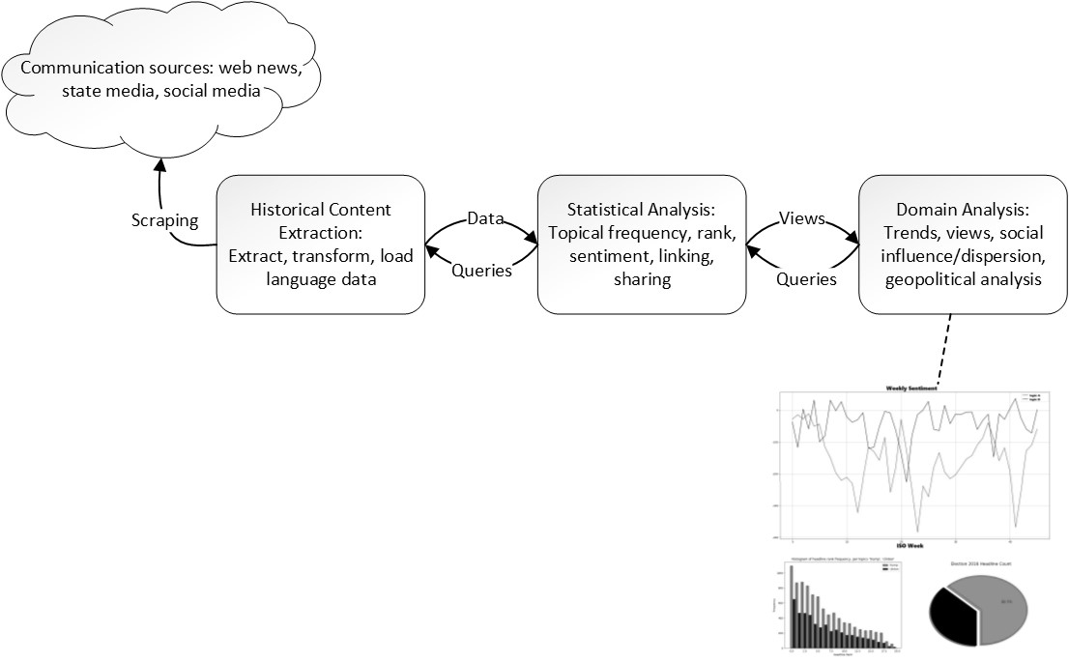

Figure 1: Historical content analysis architecture.

Figure 1 details the basic architecture of historical content analysis. Statistical analysis embodies low-level analyses suiting domain objectives. Domain analysis refers to the high-level objectives guided by research interests or theoretical objectives. Historical content analysis supports a wide range of research objectives, and more interestingly, unsupervised pattern discovery without the steering assumptions of prior research objectives.

Data Collection

Large scale distributional language analyses are accommodated by historical web archives such as Common Crawl (Elbaz), historical protocols such as MEMENTO (Van de Sompel et al., 2009), and tools such as MEMEX (DARPA, 2014). These resources enable the derivation of comprehensive historical content datasets for content sources with significant online presence. The data can also be augmented with corresponding social media metadata such as share counts, link structure, comments, and other audience response data using available social media programmatic interfaces (APIs), to perform other forms of social modeling. Accurate analyses require data models accommodating the requirements of the analytical objectives, and moreover, dense data. Previous work by Leetaru suggested the capability of textual analysis of similar massive text archives for forecasting major regional conflagrations in the Balkans, Egypt, and Tunisia (2011).

In this work, landing page site snapshots were gathered for several organizations, including Google News-U.S., Yahoo News, MSN, Russia Today (RT), Sputnik News, Fox News, Politico, CNN, BBC, NPR, and the Washington Post, for the 2016 U.S. presidential election. All prominent organizations are available on request. This set comprises top-rated mainstream American organizations, three top-rated online news aggregators, beltway sources, as well as the American audience branches of three foreign news organizations, two of which, RT and Sputnik News, are formally accused of strategic misinformation activity by American intelligence agencies (ODNI, 2017). Additionally, to analyze long term partisan trends, extended snapshots were extracted for Google News from June 2011 through June 2017.

Deterministic HTML parsers were written to extract all visible headlines from historical snapshots of each organization’s primary news page, which is assumed to approximate the distribution of information disseminated by that organization. Headlines consisted of each visible headline and textual synopsis, link, and relative ranking on the page when the snapshot was taken. Each headline was also augmented with social metadata including share counts, textual description, and other attributes via its URL using the Facebook Graph API (v2.11). Accordingly, each organizational dataset consisted of a historical collection of front page snapshots (several per day on average), each containing the ordered headlines posted by a source, and with each headline augmented by Facebook metadata. Practitioners should note that sharing statistics (counts, impressions, and so forth) are dynamic and depend on when such figures were queried; the social content metadata in this work was queried in fall 2017, well after such counts would have stabilized for content prior to summer 2017.

This data model provides the comprehensive temporal description of the distribution of information disseminated by these organizations. The data permits queries for two powerful analyses not present in the literature: 1) aggregate historical analyses of overall partisan bias 2) temporal analyses of the distribution of information disseminated over time. The latter provides direct insight into the strategic communication patterns of media organizations beyond mere aggregate metrics, and without the need for subjective evaluation by human analysts, which cannot be reproduced or automated for large-scale analyses. Lastly, the benefit of including several aggregators is that they approximate the expected propagation and popularity of headlines and sources, and present linking patterns by which ‘echo chamber’ patterns may be quantified.

These are the primary objective of this work, with an emphasis on sentiment analysis, but the data model supports numerous research objectives. The combination of language content with Facebook metadata permits estimating the overall tenor and bias of content for an organization or a complete social platform, the behavior of these distributions over time, as well as audience response to various language features. It also allows estimating characteristics of link homophily, audience homophily via sharing distributions, and possibly even malicious coordination by online actors, as examined by (Faris et al., 2017). This combination of structural and language data contrasts with the scarcity of quantitative research of the tonal distributions of information within digital platforms, how they behave over time, recurring organizational bias patterns, analysis of misinformation actors, and similar factors.

Proposed Metrics

The most relevant measures of political bias are topical coverage frequency and embedded coverage sentiment. Demonstrating disparate coverage volume for equivalent topics is insufficient without also analyzing its tenor: a political candidate may receive more coverage than their opponent for instance, but the coverage may be more positive. Therefore, the most immediate way to analyze bias and political activity by news organizations is to separately analyze coverage volume and sentiment, with the latter desirably controlling for disparities in coverage volume. These may then be combined to give a statistical expectation of bias.

Analyzing coverage volume is a matter of applying a topic-term frequency metric and aggregating these frequencies over binned time periods. Metrics for propagation and audience exposure likelihood could be devised but are left to future work. Although coverage volume foregrounds topical frequency, sentiment analysis provides deeper insight into the embedded tonal biases of content purportedly arising from an objective, random process of journalistic discovery. This work incorporates sentiment analysis into long-range content analysis to produce quantitative statements about the bias of news organizations, and further, to discover temporal patterns indicative of politically strategic patterns.

Sentiment analysis research focuses primarily on two approaches: 1) statistical models and 2) learning models using derived representations to determine textual polarity, such as the VADER tool (Hutto & Gilbert, 2014). The former better suit regression tasks but often require more data, whereas the latter attempt to learn the syntactical structure of signaling language, typically for classification tasks, such as in (Recasens & Jurafsky, 2013). Financial researchers have contributed significantly to the advancement of statistical sentiment modeling by demonstrating its effectiveness for deriving financial value functions (Zubair & Cios, 2015) (Mishne & Glance, 2006). A recent survey of sentiment analysis is provided by (Medhat & Korashy, 2014).

The statistical approach using lexical sentiment analysis was justified by access to large amounts of language data, consisting of many thousands of news articles and millions of words. This accommodates the target objective of modelling the sentiment distribution of query topics (e.g. candidates, issues, political parties), where sentiment distributions are evaluated via the associative frequency of topic terms and signaling language. Estimates for topical sentiment are given by analyzing the mathematical distance between topical and signal terms. Using these estimates, both aggregate and temporal estimates of bias can be derived. This approach lends the following basic architecture for lexicon-based signals analysis.

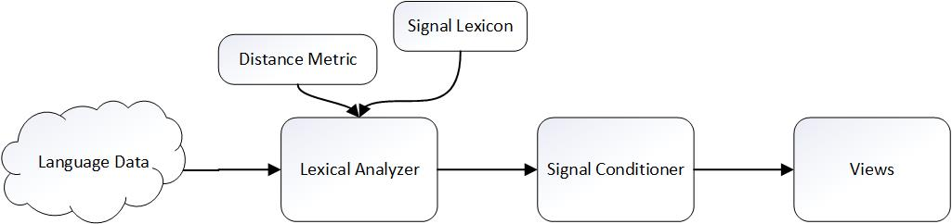

This model generalizes lexical analysis, since sentiment is only one possible lexical query. Others include subjectivity and similar orientation-indicator lexica, such as the various lexica of the Harvard IV-4 General Inquirer (Stone, Dunphy & Smith1966). The signal conditioning component incorporates generic signal processing algorithms to appropriately smooth signal for the chosen query inputs, metrics, and data.

The lexical analyzer takes both a distance metric *dist* and a signal lexicon as input, for greater flexibility. A pointwise measure of associative strength between topic terms and signal lexicon is then:

For sentiment analysis, the signal lexicon divides into positive and negative terms, and net sentiment is calculated as:

See (Liu, 2012) for similar lexicon-based sentiment expressions of semantic orientation. Distance metrics may be rule based, distributional, or co-occurrence based. This work utilizes term co-occurrence metrics which are reviewed by (Medhat & Korashy, 2014) as well as (Manning & Schütze, 1999). The choice input lexicon is an important parameter, which may be pre-built or generated algorithmically from domain data. Pre-built lexica preserve a common baseline, whereas the latter can improve domain precision. For example, the term “scandal” indicates negative sentiment in a political domain yet may not be included in a generic pre-built sentiment lexicon consisting primarily of adjectives. Lexicon generation can flexibly identify such signaling terms for a specific domain. These terms change often, as different topics become artifices of social sentiment in circulation. Another advantage is that lexicon generation accommodates languages for which pre-built signal lexica are unavailable.

Distance Metrics

Many term-based distance metrics exist, most ultimately based on the co-occurrence frequency of signal and query terms within some context. Given consistent language data to estimate these frequencies, semantic associativity can be measured by summing the similarity between subsets of query terms and signal terms. Cosine similarity is perhaps the most powerful, since it encompasses the complete associative vector space of word co-occurrences. Let **F** be the symmetric, triangular term co-occurrence matrix for all terms in some bag of language , for which the row represents the co-occurrence frequency between word and all other words . The cosine similarity of and is given by:

Cosine similarity detects both similarity (closer to 1.0) and dissimilarity (closer to -1.0). Its semantic grasp lies in hyponymy, the detection of indirect similarity via the normalized inner-product of their word co-occurrence vectors (Lyons, 1995). Distance metrics based on immediate co-occurrence frequencies cannot measure similarity between words which never co-occur in the data, such as “red” and “dalmation”. In contrast, cosine similarity captures their semantic relationship via their shared co-occurrences with all other words, hence they might have slightly positive cosine similarity via their mutual association with “fire” and “station”. However, with quality comes greater computation cost, since computing cosine similarity values for a co-occurrence frequency matrix **F** requires calculating inner products between every row and column of **F**. One method of resolving this computational bottleneck is to instead use efficient word-embeddings (Mikolov, Chen, Corrado, and Dean, 2013).

Other common word similarity metrics can be taken directly from Jurafsky or from generic statistical distance methods: pointwise mutual information (PMI) (Fano, 1961), positive-PMI (PPMI) (Church & Hanks, 1989), Dice, Jaccard, Chi-squared, and the t-test (Manning & Schütze, 1999). PPMI was used in this work because it provides the best tradeoff between computational speed and signal quality, and it is a fast and high-quality approximation to cosine similarity. PPMI is simply the positive range of PMI:

PPMI benefits from weighting by term probabilities, mitigating differences in topical coverage volume. These differences can also be controlled by controlled sampling to compare only article sets of equal size for the queried topics. For example, given topics *t1* and *t2*, and their respective articles and for some period, select articles from and , where .

Evaluation of Misinformation and Bias

As described, the datasets consisted of multiple daily snapshots of several large news organizations. For each of these, coverage volume and sentiment per two partisan topic term sets were analyzed: and . These terms were sufficiently unique to prevent false positive hits, and sufficiently inclusive to include most coverage of the leading candidates for U.S. president in 2016. Additionally, to test broader partisan biases beyond the presidential race, a second partisan topic set was also analyzed: and . To identify tonal bias unique to each topic set, the query results for sentiment analysis were cross-filtered of opposing topics, hence any headline containing both “clinton” and “trump” was omitted due to ambiguity. Since multiple snapshots may contain the same headline, only unique daily headlines were retained for analysis, determined via the headline URL. Coverage volume analysis was not filtered in these ways, since its intent is to track these characteristics. The algorithmic outline for two topics is outlined below.

**Algorithm 1: Lexicon-Based Temporal Sentiment Analysis**

**Input** *t1, t2*: Topic term sets (e.g., )

*metric:* Lexical distance metric or method

*extractor:* Historical snapshot/content extractor for a target organization

*grouping:*  A group-by clause for temporal bins (“week”, “month”, et cetera)

*begin:* Begin date for query

*end:* End date for query

**Output**  *plot:* A plot of net sentiment

1. h1 = getTopicalHeadlines(extractor, t1, begin, end) //historical snapshot querying
2. h2 = getTopicalHeadlines(extractor, t2, begin, end)
3. h1 = topicFilter(h1, t2) //topical cross-filtering
4. h2 = topicFilter(h2, t1)
5. headlines = h1 h2
6. headlines = deduplicate(headlines) //duplicate-headline filtering
7. bins = binArticlesBySpan(headlines, bin=“week”)
8. s1Weekly = list()
9. s2Weekly = list()
10. for bin in bins:
11. s1 = netSentiment(t1, S, bin, metric)
12. s1Weekly.add(s1)
13. s2 = netSentiment(t2, S, bin, metric)
14. s2Weekly.add(s2)
15. return plot(s1, s2)

This outline captures the essential elements of temporal sentiment analysis and can be generalized to more than two topic sets. Bin values can be plotted raw, or trend conditioned using additional signal processing, such as basic smoothing techniques. In this work, sentiment was binned by ISO week and averaged over two weeks. Aggregate sentiment for a topic is calculated by summing the values over the time span of interest.

If the distance metric is weighted by term frequency, then the plots are akin to a rate of negative/positive coverage, eliminating potential bias resulting from disproportional topical coverage volume. Multiplying these rates by the topical frequency or share-count at a time-slice thus provides a rudimentary estimate of expected coverage sentiment, combining both the polarity and its propagation. This is done by modifying the lines above, where the operator *‘#’* represents the frequency of a topic within a bin of headlines or headline shares.

**Algorithm 1.1: A modification for expected sentiment**

1. for bin in bins:
2. s1 = netSentiment(t1, S, bin, metric) * #(t1, bin)
3. s1Weekly.add(s1)
4. s2 = netSentiment(t2, S, bin, metric) * #(t2, bin)
5. s2Weekly.add(s2)

The baseline sentiment lexicon used in this work was from (Hu & Liu, 2004), filtered of topical terms (since “trump” is a positive adjective). The lexicon was derived from social media consisting of nearly 7,000 definitive sentiment signaling terms, 2,005 positive terms and 4,783 negative terms. Such compact lexica generate better signal patterns than comprehensive or multi-valued sentiment lexica due to their unambiguity.

To evaluate partisan bias over a period of years, an additional query was performed to analyze long-term bias patterns. The only organization for which such extensive data was collected and analyzed was Google News, for coverage between June 2011 and December 2016, and only partisan queries were analyzed, *t3* and *t4*. The articles pertaining to these topics were analyzed for coverage volume, sentiment via algorithm 1.0. Link histograms were also gathered, to evaluate news-item sources and their change over time for this aggregator and topic sets *t3* and *t4*. Full visual results are listed in the appendices.

**2016 Presidential Election: Coverage of Presidential Candidates**

|  |  |
| --- | --- |
| BBC | CNN |
| Fox News | Google News |
| NBC News | NPR |
| Politico | Russia Today (RT) |
| Sputnik News | Washington Post |

2016 coverage volume statistics show overwhelmingly more coverage of Donald Trump than Hillary Clinton, immediately highlighting the attentional bias of the media overall, and likely contributed to the widespread perception that Clinton was presumed to win. Sum volumes are shown in the plot legends.

|  |  |
| --- | --- |
| BBC | CNN |
| Fox News | Google News |
| NBC News | NPR |
| Politico | Russia Today (RT) |
| Sputnik News | Washington Post |

The sentiment analysis results from algorithm 1.0 reveal that coverage of Trump was overwhelmingly more negative than coverage of Clinton. The reliability of this method is given by observing that a candidate’s large positive and negative spikes precisely correspond to specific news events and the tenor of the associated organizational narratives. These spikes represent news narratives that become artifices for disseminating tonally oriented content which influences perception of a candidate. The latter ISO-weeks 40 and 41 negative spikes for Trump reflect the release of damaging audio recordings, while the positive spikes for Clinton around ISO-week 30 reflect tonally promotional coverage of the Democratic national convention.

Fox News showed the least bias of any organization and was tonally neutral, albeit insignificantly anti-Trump. Likewise, while RT and Sputnik are formally accused of engaging in state-directed misinformation in favor of Donald Trump (ODNI, 2017), this claim is strongly contradicted by empirical data. No similar objective evidence was presented by the ODNI, whose report presented only subjective assessment. Both Russian state-run media outlets exhibited nearly neutral aggregate bias, nor was there a consistent bias in favor of Trump, nor against Clinton, directly contradicting a variety of claims made in (ODNI, 2017) implying strategic bias in favor of Trump. In sum, real data do not support the claim of a cohesive pro-Trump and anti-Clinton information strategy by these organizations. This contrasts with mainstream organizations like BBC, The Washington Post, and CNN, NPR, and Politico, which bore remarkably deterministic anti-conservative and pro-Clinton biases, but reach much larger mainstream American audiences than either RT or Sputnik News, as evidenced by their much higher share counts.

A key observation is that for several organizations, the two plots demonstrate a high degree of auto-correlation emerging in the final 12 weeks of the election, whereby coverage trended negative for one candidate and positive for the other, and vice versa. Notably, the pattern emerges after election primaries completed, in the general head-to-head phase of the election. The patterns imply that immediately, media coverage became oriented by a left-versus-right, anti-conservative and anti-Trump strategic logic in the general election phase. This pattern is worthy of further analysis using distributional approaches to analyze the statistical divergence of topical sentiment distributions. The patterns demonstrate the effectiveness of using temporal sentiment metrics to bear out adversarial patterns of bias.

In that regard, one can remark that strategic reporting patterns by RT and Sputnik are apparent in the final days of the election, with Clinton news trending more negatively and Trump coverage trending more positively. These signatures are more strongly evident in western media organizations, for the opposite anti-Trump/pro-Clinton pattern, exemplified by The Washington Post. This result implies that if the distribution of information of state-run RT and Sputnik represented directed strategic misinformation activity, as alleged by (ODNI, 2017), then far stronger and more deterministic behavior is evident among leading Western media organizations with far greater U.S. propagation, most notably during the most sensitive final weeks of the 2016 election. If the patterns demonstrated by RT and Sputnik represent alleged strategic misinformation, then far worse patterns are strongly evident among major Western news organizations in terms of homogenous aggregate bias, strategic misinformation patterns over time, and social propagation measured through share counts. A second interpretation is that the RT/Sputnik patterns should not be characterized by sustained partisan patterns, which largely cancel over time. This interpretation, a subject for future work, would characterize misinformation activity less by sustained long-term patterns of political preference than by volatile short-term preference toward social discord. Nevertheless, the primary result of this analysis is that in both Russian and Western cases, the sentiment spikes demonstrate how organizations select stories and narratives as artifices of political influence.

2016 Presidential Election: Partisan Coverage

|  |  |
| --- | --- |
| BBC | CNN |
| Fox News | Google News |
| NBC News | NPR |
| Politico | Russia Today (RT) |
| Sputnik News | Washington Post |

The same overall bias patterns emerge for partisan topics, and . Once again, coverage volume bias is very evident in the disproportionate coverage of right-leaning topics.

|  |  |
| --- | --- |
| BBC | CNN |
| Fox News | Google News |
| NBC News | NPR |
| Politico | Russia Today (RT) |
| Sputnik News | Washington Post |

Foremost, aggregate bias for 2016 was strongly negative toward Republican and conservative topics, whereas headlines about Democrats were more positive. Neither party enjoyed aggregate positive coverage, but Democrat topics enjoyed several periods of net positive coverage, which should be regarded as anomalous, since critically objective language tends to be either neutral or negative.

Google News: Long Term Trend Analysis

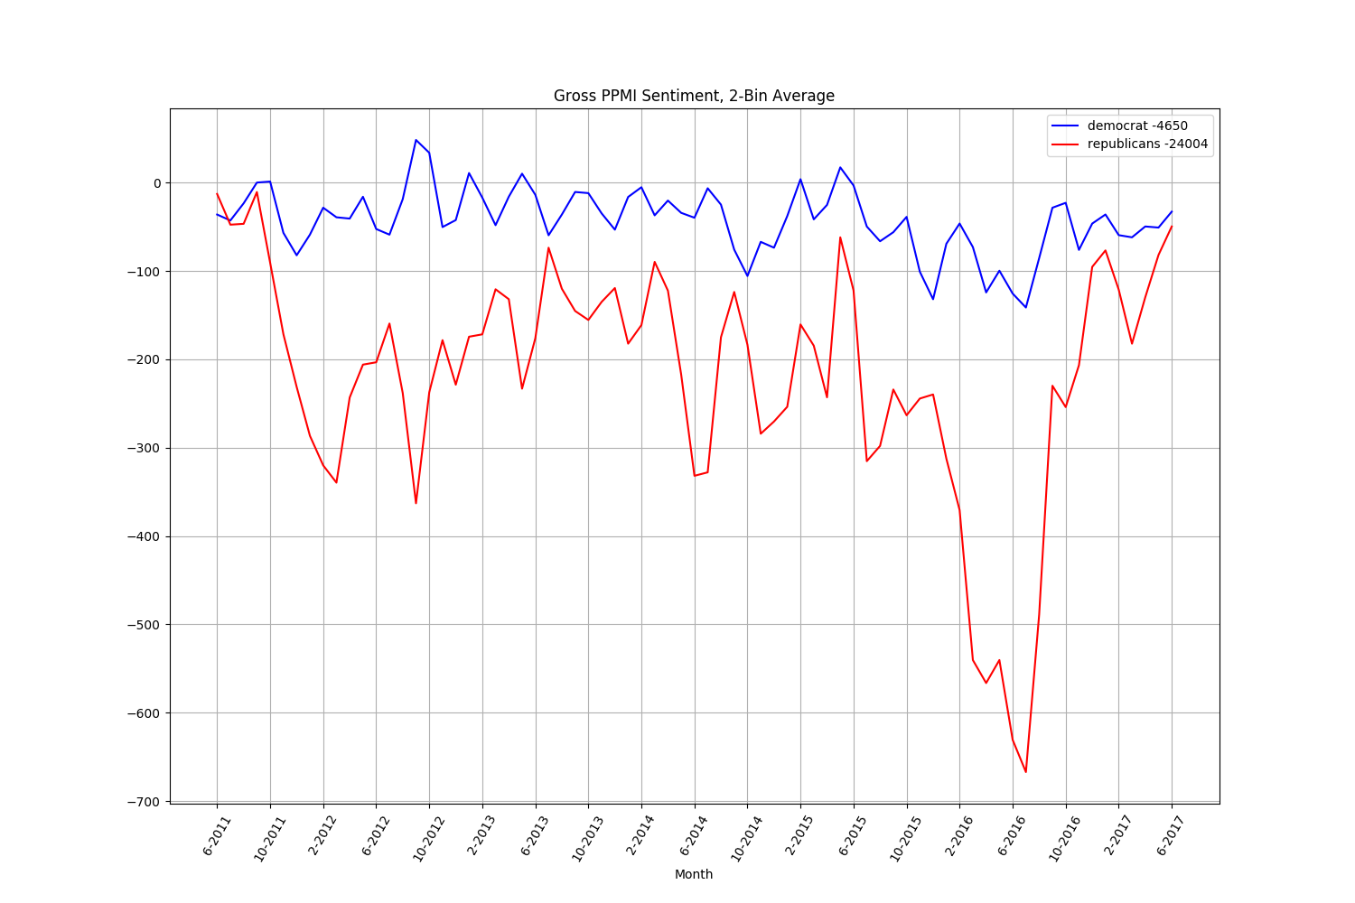

Google News partisan analysis of topic sets *t3* and *t4* show consistently more negative coverage of coverage of conservative topics and more positive coverage of left-leaning topics. The results also show that bias increased significantly during 2015 and 2016.

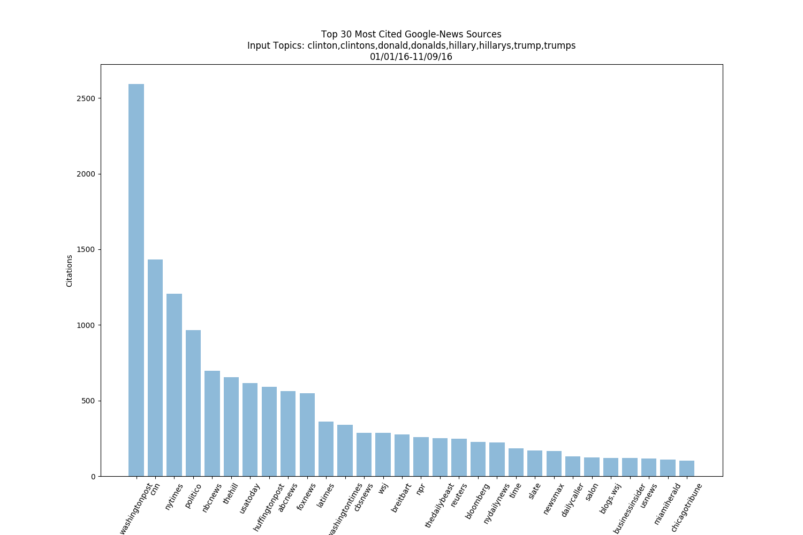

A headline link histogram of 2016 news about topics *t1* and *t2* indicates a highly non-uniform link distribution, with overwhelming linking toward strongly leftwing news organizations: based on the previous sentiment results, the further left-biased the organization, the greater its featured frequency in Google News. Since Google News purports to aggregate headlines algorithmically, this highly uneven distribution indicates structural “echo chamber” network features of information bias augmented by such tech platforms and their algorithms.

Reproduction

To further demonstrate the reliability of the previous results, the same evaluation methods were applied to the dataset used by the work “Partisanship, Propaganda, and Disinformation: Online Media and the 2016 U.S. Presidential Election” by (Faris et al., 2017). The authors provided a replication dataset of web-based election news gathered from a wide variety of sources and around 2.1 million news items. The importance of this dataset is that unlike the organizational extractions from the previous sections, it approximates the complete distribution of 2016 online election news content. However, the data included only the headline language of news items with no synopsis language.

The same dataset was analyzed for basic volume bias and sentiment bias under algorithm 1.0. Differential candidate treatment was again analyzed using topic sets *t1* and *t2*, and differential partisan bias was analyzed using topics *t3* and *t4*, and the input sentiment lexicon was once again from (Hu and Liu, 2004). The results are shown below.

|  |
| --- |
|  |
|  |
|  |
|  |

The results are consistent with the previous results and provide an all-encompassing view of media bias and misinformation patterns. Notably, the same anti-conservative pattern emerges of higher frequency coverage which was also substantially more negative overall for partisan topics t3/t4. Likewise, a definite pattern of anti-Trump coverage that was both higher frequency and more negative. Moreover, the *t1/t2* sentiment plots bear out a significant degree of cross correlation once the general election phase was underway, around ISO-week 21. This reaffirms that 2016 election media content overall, not simply on an organizational basis, became highly polarized by an adversarial head-to-head polarization which consistently treated Clinton more favorably and candidate Trump more negatively. The negative spikes for Trump exemplify such sustained negative coverage. For example, the dramatic negative spike in Trump coverage centered around ISO week 40/41 occurred because of the release of character damaging audio tapes.

The overall patterns of more negative anti-Trump, anti-conservative, and moreover the temporal patterns these distributions obey, refute key claims of (Faris et al., 2017), whose authors did not provide quantitative evidence of a tonally anti-Clinton information distribution in the 2016 election. In terms of both volume and sentiment, the distribution of information was one that covered Clinton less and more positively, whereas Trump was covered far more often and more negatively. Additionally, this coverage obeyed patterns of strategic misinformation, which became increasingly anti-Trump during the approach to election day. Lastly, the negative spikes above occurred because of personal, character-damaging stories, not information relevant to policy discussion or horserace content. These characteristics refute the authors’ claims that mainstream media did not engage in partisan-disciplined messaging and advances the contrary view: a consistent partisan-discipline of pro-left content signaling, in terms of overall bias, its development over time, and fixation on personal non-policy stories.

In summary, characteristics of agenda-setting in favor of Trump or against Clinton are not evident in this data under these quantitative analyses of the distribution of information and sentiment. Moreover, the deterministic anti-conservative bias of 2016 election media may reframe the emergence of fragmented, partisan right-leaning media as a product of consumer disaffection with measurable pro-left sentiment bias in mainstream media, and consumers gravitating towards a more pluralistic information environment. In short, a news media that has moved far to the left of its audience. This is a subject of future analyses using sharing statistics to analyze the divergence between the distribution of information disseminated by news media organizations versus the distributions which audiences shared on social media in 2016. While (Faris et al., 2017) portray the emergence of a fragmented right-leaning network structures as sources of misinformation, the results above suggest that it is both marginal right-leaning organizations and verifiably leftwing mainstream media that are engaging in a mutual interplay of misinformation and bias within a highly polarized information environment.

Discussion

The results make a firm quantitative statement that anti-conservative bias in news media prevails, obeys strategic patterns, and that this bias is part of a recent historical pattern. The temporal reporting sentiment patterns foreground partisan strategic logic demonstrating how different topics and events of equal objective merit are reported, as well as the dependencies between topical sentiment for opposing topics and . The results for foreign organizations RT, Sputnik, and BBC, provide a groundbreaking view into the strategic, soft-power influence strategies of international news organizations. Overall, this work demonstrates the robustness of using historical web extraction and lexical methods to analyze geopolitical topics across a range of international and regional media sources for security and research purposes.

Since PPMI-based sentiment bias is normalized by topic probability, the sentiment results imply that not only does the American media cover right-leaning candidates and topics far more often, but that this content is also substantially more negative and obeys patterns of misinformation and influence. The compounding effect of higher coverage volume and sustained negative tenor effectively demonstrate that leading media organizations in the U.S. are highly partisan, exerting long-term partisan bias in terms of the tenor and frequency of content they disseminate. The Google News 2016 source histogram further demonstrate structural insularity and algorithmic bias in terms of how content is propagated, providing evidence of a partisan and left-leaning “echo chamber” among mainstream social, news, and tech platforms.

Conclusions and Future Work

This work set forth methods and metrics for analyzing bias and misinformation across domains, languages, and sources to establish reproducible relationships between geopolitical events and communication dynamics. Justifying strategic patterns of partisan bias is beyond its scope, however, the results for RT/Sputnik and leading American media outlets provide patterns indicative of political activity and demonstrate the importance of further development. As presented, they could easily be extended to larger datasets, other regional organizations, social communication, different types of signal lexica, and lastly, examining structural characteristics of misinformation and bias. Other possible applications include modeling information patterns with respect to specific policy issues or events, financial data, as well as measuring how bias influences policy creation and public knowledge. Although this work illuminates temporal information patterns, distributional approaches likely offer greater precision and firmer connections between patterns and theoretical statements.

There is also a large potential body of work analyzing audience responsiveness to polarized content. Media structure has changed dramatically as news platforms have pivoted away from independent research and toward content propagation, and it would be illuminating to evaluate whether the polarity of organizations correlates with these structural trends in terms of ownership, market structure, audience engagement statistics, or the audience tracking technologies installed on their sites. Game theoretic economic models of bias were examined by (Morris, 2001), and it would be interesting to re-evaluate similar econometric models by incorporating lexical analyses to understand the potential incentive structures behind apparently volatile media and algorithmic bias.

Overall, this work demonstrates the use large-scale textual analysis to uncover hidden social and political patterns for many applications, at a moment when such tools are critically needed. All data used in this work can be obtained on request, and all technical feedback and comments are welcome. Reproduction data for the topical analyses presented in this work are available at https://github.com/niceyeti/ABLE_2016_election_repro_data.

References

Facebook Graph API, version 2.11.

Liu, Bing. (2012). Sentiment analysis and opinion mining. *Synthesis lectures on human language technologies*, *5*(1), 1-167.

Elbaz, Gil. Common Crawl.

Mikolov, T., Chen, K., Corrado, G., & Dean, J. (2013). Efficient estimation of word representations in vector space. arXiv preprint arXiv:1301.3781.

Twenge, Jean M.; Campbell, W. Keith; Carter, Nathan T. “Declines in Trust in Others and Confidence in Institutions Among American Adults and Late Adolescents, 1972-2012," Psychological Science, 2014, Vol. 25(10), 1914-1923. doi: 10.1177/0956797614545133.

Pew Research Center. (2014). Political polarization in the American public. Accessed August 16, 2018, from http://www.people-press.org/files/2014/06/6-12-2014-Political-Polarization-Release.pdf

Heuer, R. J. (1999). Psychology of intelligence analysis. Center for the Study of Intelligence, Central Intelligence Agency.

Defense Advanced Research Projects (DARPA). “Memex”. https://www.darpa.mil/program/memex. Accessed 12/9/2017. Earliest reference, September, 2014.

Bessi, A., Petroni, F., Del Vicario, M., Zollo, F., Anagnostopoulos, A., Scala, A., ... & Quattrociocchi, W. (2016). Homophily and polarization in the age of misinformation. The European Physical Journal Special Topics, 225(10), 2047-2059.

Hutto, C. J., & Gilbert, E. (2014, May). Vader: A parsimonious rule-based model for sentiment analysis of social media text. In Eighth international AAAI conference on weblogs and social media.

Medhat, W., Hassan, A., & Korashy, H. (2014). Sentiment analysis algorithms and applications: A survey. *Ain Shams Engineering Journal*, *5*(4), 1093-1113.

Manning, Christopher D., and Schütze, Hinrich. (1999). *Foundations of statistical natural language processing* (Vol. 999). Cambridge: MIT press.

Jurafsky, D. (2000). Speech and language processing: An introduction to natural language processing. *Computational linguistics, and speech recognition*.

Background to “Assessing Russian Activities and Intentions in Recent US Elections”: The Analytic Process and Cyber Incident Attribution. Office of the Director of National Intelligence. January 6, 2017. Accessed November 11, 2017, from https://www.dni.gov/files/documents/ICA_2017_01.pdf.

Lin, H. S., & Kerr, J. (2017). On Cyber-Enabled Information/Influence Warfare and Manipulation.

Baron, J. (2000). *Thinking and deciding*. Cambridge University Press.

Hu, M. and Liu, B. (2004). Mining and summarizing customer reviews. In SIGKDD-04.

Liu, B. (2015). Sentiment Analysis: Mining Opinions, Sentiments, and Emotions. Cambridge University Press.

Monroe, B. L., Colaresi, M. P., and Quinn, K. M. (2008). Fightin’words: Lexical feature selection and evaluation for identifying the content of political conflict. Political Analysis, 16 (4), 372–403.

Gentzkow, M., & Shapiro, J. M. (2006). Media bias and reputation. *Journal of political Economy*, *114*(2), 280-316.

Church, K. W., & Hanks, P. (1990). Word association norms, mutual information, and lexicography. *Computational linguistics*, *16*(1), 22-29.

Church, K. W. and Hanks, P. (1989). Word association norms, mutual information, and lexicography. In ACL-89, Vancouver, B.C., pp. 76–83

Van de Sompel, H., Nelson, M. L., Sanderson, R., Balakireva, L. L., Ainsworth, S., & Shankar, H. (2009). Memento: Time travel for the web. arXiv preprint arXiv:0911.1112

Fano, R. (1961) Transmission of Information: A Statistical Theory of Communications. MIT Press, Cambridge, MA.

[SENTIMENT LEXICON]

Hu, M., & Liu, B. (2004, August). Mining and summarizing customer reviews. In *Proceedings of the tenth ACM SIGKDD international conference on Knowledge discovery and data mining* (pp. 168-177). ACM. (Opinion lexicon obtained from: https://www.cs.uic.edu/~liub/FBS/sentiment-analysis.html.)

Gentzkow, M., Shapiro, J. M., & Stone, D. F. (2015). Media bias in the marketplace: Theory. In *Handbook of media economics* (Vol. 1, pp. 623-645). North-Holland.

Lyons, J. (1995). *Linguistic semantics: An introduction*. Cambridge University Press.

Morris, S. (2001). Political Correctness. *Journal of Political Economy*, *109*(2), 231-265.

LEETARU, Kalev. Culturomics 2.0: Forecasting large-scale human behavior using global news media tone in time and space. First Monday, [S.l.], aug. 2011. ISSN 13960466. Available at: <http://firstmonday.org/ojs/index.php/fm/article/view/3663/3040>. Date accessed: 17 dec. 2017. doi:http://dx.doi.org/10.5210/fm.v16i9.3663.

HTTP Framework for Time-Based Access to Resource States – Memento. Retrieved from https://mementoweb.org/guide/rfc/. Accessed on 1/2/2018.

Recasens, M., Danescu-Niculescu-Mizil, C., & Jurafsky, D. (2013, August). Linguistic Models for Analyzing and Detecting Biased Language. In ACL (1) (pp. 1650-1659).

Mishne, G., & Glance, N. S. (2006, March). Predicting Movie Sales from Blogger Sentiment. In *AAAI Spring Symposium: Computational Approaches to Analyzing Weblogs* (pp. 155-158).

Zubair, S., & Cios, K. J. (2015, January). Extracting News Sentiment and Establishing Its Relationship with the S&P 500 Index. In *System Sciences (HICSS), 2015 48th Hawaii International Conference on* (pp. 969-975). IEEE.

Stone, P. J., Dunphy, D. C., & Smith, M. S. (1966). The general inquirer: A computer approach to content analysis.

Faris, Robert and Roberts, Hal and Etling, Bruce and Bourassa, Nikki and Zuckerman, Ethan and Benkler, Yochai,

Partisanship, Propaganda, and Disinformation: Online Media and the 2016 U.S. Presidential Election (August 2017). Berkman Klein Center Research Publication 2017-6. Available at SSRN: <https://ssrn.com/abstract=3019414>