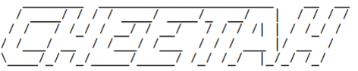
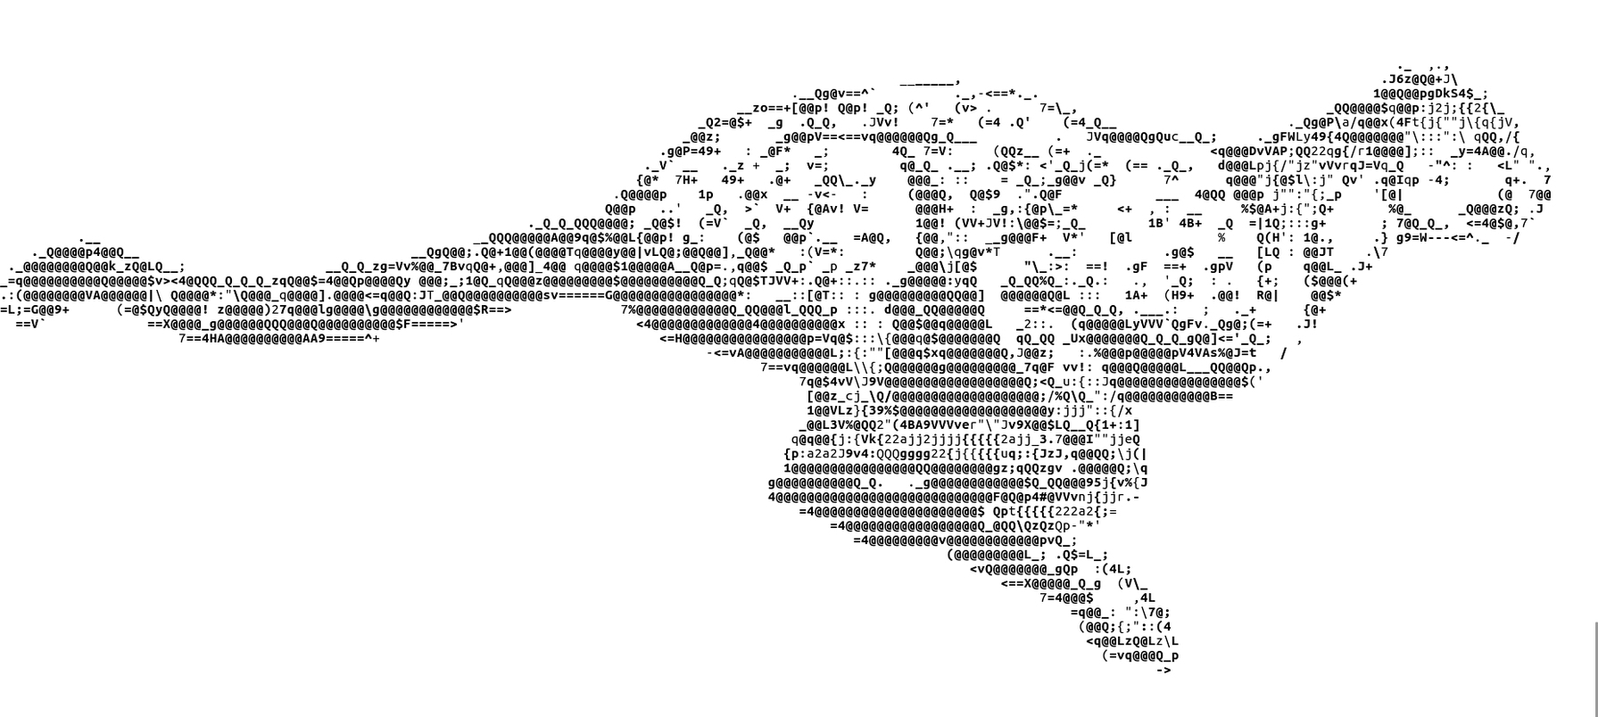

Cheetah: A Quantitative Approach to Counter-Misinformation

Using Neural Embedding Models to Analyze Misinformation in Big Data

By Jesse Waite

Copyright 2019

This work is dedicated to my uncle.

Freedom’s purest exercise is securing it for others.

Then retiring in Idaho.

Foreword

The ongoing goal of this work is task-identification and algorithm development for counter-misinformation: machine learning methods that are amenable to counter-misinformation and first attempts at justifying them. Despite abundant chatter, to date no attempts have been made to do so in a reproducible and data-comprehensive manner. Empirical counter-misinformation methods, and analyses of their generalization properties, are needed to determine the nature and extent of misinformation phenomena, and thereby provide decision-makers with actionable and unbiased information.

This work puts forth algorithmic and data extraction methods by which misinformation dynamics can be reverse-engineered in any language, using neural language modeling technology. The results are the first public demonstration of an adaptive, multi-language, and efficient method for robust counter-misinformation technology. Such methods have direct application to the detection of censorship, misinformation, and algorithmic bias, and other misinformation activity.

This work also adheres to the principle that the only empirically valid claims of misinformation are those that accept the falsifiability of models and data. Decision makers should be warned that if an organization does not abide the principle of falsification in their methods, or does not permit access to the means of their falsification (such as transparent quantitative methods and apis/datasets), such work should be viewed as unreliable. In part, this work is intended to defray the misinformation which already have propagated through the literature, and to act as an independent instructional guide for evaluating claims about misinformation and similar phenomena.

The ultimate goal of counter-misinformation is obtaining repeatable quantitative definitions of misinformation that operate “in advance of seeing the data”, and only thereby provide reliable assertions about the phenomenon. As a general rule: if any study of misinformation does not contradict its author’s assumptions, then it is probably flawed.

Jesse Waite

TODO:
-2016 Russian results gallery
-Hyper parameter selection methods

Introduction

Misinformation and disinformation have overlapping definitions: misinformation is the transmission of information (content) that is incorrect, biased, or incomplete, whereas the latter is deliberately or maliciously designed to propagate falsehood. Although concerns about these phenomena have increased, dilettante concerns about misinformation have themselves been used to deploy false claims about the phenomenon, to justify malicious disinformation operations [cite New Knowledge], or, ironically, to justify unprecedented forms of social surveillance and direct censorship [cite Google, China, Saudi]. In essence, while misinformation threats have increased, our technical capacity and willingness to describe them has decreased. Quantitative methods and open datasets promise to dissipate this qualitative self-confusion with repeatable quantitative studies of misinformation for this exciting new frontier of informatic security.

Misinformation and disinformation share the simple quantitative property of obeying deterministic partisan sentiment patterns over time. This is simply the complement of the null hypothesis, which assumes that content instead derives from spontaneous natural events emerging from an unbiased distribution over query targets: political figures, parties, and so on.

This determinism has two quantitative properties:
- Stationary long-term bias advocating for or against specific subjects: public figures, political parties, policies.
- Temporal biases with respect to external and presumably random natural events such as elections, warfare, and other socially-competitive environments.
- Heavy reliance on social dissemination mechanisms such as facebook and twitter, measured via their metrics (shares, impressions, comments, and other interaction measures).

For example, an organization with political affinities for candidate X will report more positive information about X and more negative content about their opposition. The task of quantifying misinformation reduces to the statistical and machine learning methods available—predominantly, natural language processing—for estimating consistent underlying sentiment biases of content pertaining to relevant topics, and disseminated by specific organizations.

Lexical Frameworks for Content Analysis

NLP and information retrieval methods traditionally rely on statistical bag-of-words models to estimate the properties of language over time. Many of these techniques simply extend centuries-old language-based cryptanalysis techniques [cite Singh]. For a specific set of documents returned by some query, the term co-occurrence matrix is computed by counting co-occurrences between terms, then calculating algebraic or statistical distance metrics such as positive pointwise mutual information (PPMI) or cosine distance to analyze the quantitative similarity between terms, documents, and signal lexica.

PPMI and cosine similarity can determine word similarity, and by extension, the similarity of topics to specific kinds of language, such as sentiment. Consider the co-occurrence of terms A and B. Cosine similarity utilizes the term co-occurrence matrix to compute their similarity as [definition]. The closer cossim(A,B) is to 1.0, the more similar these terms are in the document set, and the closer to -1.0, the more dissimilar. By generalizing this metric, we can derive a simple and effective method to detect the similarity between sets of documents and classes of language:

[insert simple signals-language distance algorithm]
A simple algorithm for computing the similarity between a kind of language defined by a lexicon and some target set of documents, where dist(*) is any distance metric (PPMI, cossim, etc)

A simple generalization of this algorithm can be used for sentiment analysis:

[insert algorithm]

Cosine similarity’s effectiveness is the transfer of information between semantically similar terms for which no co-occurrences are even observed, via their shared co-occurrence with other terms. This can be observed qualitatively by ranking other terms by similarity to find synonyms. Calculating the cosine similarity between all terms in a corpora amounts to calculating symmetric relationships, each of which entails vector multiplication, and thus matrix multiplication. Since average vocabularies range about 60,000 terms or more, this complexity is costly even with clever optimizations and despite the sparsity of co-occurrence matrices. The problem is that traditional datamining methods scale with data and vocabulary size, a problem addressed by neural language models.

These are just a few simple background representations and distance metrics. Language datamining tasks are defined by the choice of representation and distance metric, but also by the volume of content available (as always, the more the better). For instance, a key advantage of cosine similarity is that since it does not require direct co-occurrences to estimate similarity, less data can be used to generate signal estimates. Additionally, text normalization and the removal of superfluous “stop” words substantially improve signal estimates.

For the purpose of intelligent decision-making, every effective query engine for regional-misinformation monitoring should incorporate some approximation of the frameworks above. The reasoning is that a sufficient counter-misinformation method should not find it everywhere, but should also be capable of classifying where it is not—a property never mentioned by sellers of counter-misinformation technology and claims. These frameworks are a critical firewall against misleading subjective qualitative claims about misinformation.

Neural language encoding

Neural vector models reduce the complexity of raw co-occurrence methods by deriving clustered, lower-dimensional vector encodings (‘embeddings’) of terms and documents, using gradient descent to minimize co-occurrence loss functions. Term co-occurrences are especially sparse, and likewise the term-frequency distribution obeys Zipf’s law, compressibility properties which make language amenable to dimensionality-reduction methods. Roughly, the two neural-modeling approaches are sequential (recurrent networks, n-gram models, and so forth) and associative (Word2Vec, FastText, and other “embedding” models). The architectures of associative neural language models explicitly work to encode the properties of semantic similarity, and thus provide efficient representations for wide-ranging language analyses.

Term embeddings often range between and , a significant reduction compared with sparse co-occurrence vectors that scale with vocabulary size |V| (often R100000+). For example, computing the cosine similarity of two terms is reduced from vector products in to , where is often between 300-1000. This is a reduction in dimension, rather than algorithmic complexity. However, since these metrics often run within inner loops over documents, vocabularies, and other large inputs, the empirical improvement is significant.

Further approximations provide substantial reductions in algorithmic complexity. For example, documents are easily quantized by averaging all of the word-vectors they contain:

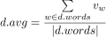

where are the word-vectors corresponding to each term in the document. This vector is the numerical representation of the document’s average subject matter. Given query terms as input, a simple but effective search engine could compute:

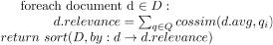

A similar method is used to generate signal lexica, detailed later.

Cheetah

Leveraging readily available pre-trained neural language models, or by training one’s own, precise lexical signal analyses can be performed on documents to assign a score defining their similarity with respect to any signal lexicon . The score is an algebraic description of the document’s distance to the signal language:

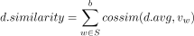

This can be generalized to perform sentiment analysis by calculating the cosine distance of its terms between examples of positive and negative signal terms:

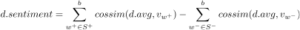

The beam parameter b determines the amount of both sentiment classes to include, and is often between 1000 and 6000. A larger beam results in greater computational complexity and more information, whereas a smaller beam yields faster computation with less information. Clustering or standard dimensionality reduction techniques may also be applied to derive a subset high-information prototype vectors from each class, for a more principled approach toward reducing algorithmic complexity. Lastly, although a full brute-force implementation would calculate cosine-similarity over all terms in each document, the approximation is used here for a more compact notation and because it is implemented in practice.

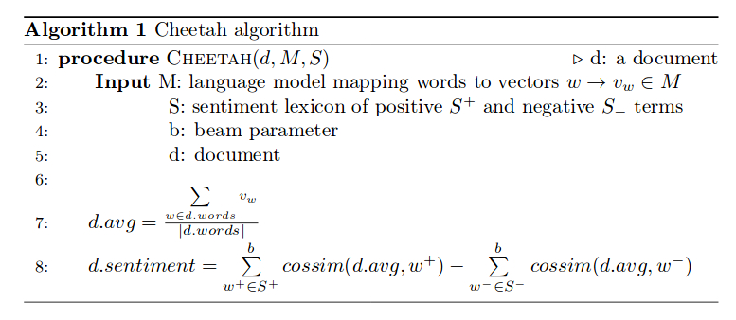

The method’s effectiveness is due to the amount of information it encodes:

- The input model term feature vectors inherently encode sentiment-based semantic similarity information due to such models’ training methods.
- Summing over signal lexica classes maximizes class similarity information.
- Cosine-similarity maximizes similarity information between entities.

From the model level of the term vectors, to the kernel level of cosine-similarity, Cheetah maximizes the amount of information for estimating sentiment. This allows analyzing the partisan affinities and other signal patterns of any content source. A trivial extension leads to a cursory estimate of social dissemination/impact, where ‘social_value’ is any estimate of dissemination or value (shares, retweets, impressions, inverse search-rank, et cetera):

Signal Lexica Acquisition

The clustering properties of the language model also make acquiring signal lexica a trivial task. Any signal lexicon can be obtained from THE PREVIOUS ALGORITHM, by setting Q to some subset of a target signal lexicon, for which a ranked list of similar terms will be returned. This can be extended to derive sentiment lexica, by ranking all terms in the model with respect to their distance between positive and negative language:

More advanced algebraic methods could be devised, but are not required in practice. The results returned by this semi-supervised learning algorithm above are exceptional, and provide a mapping from a sentiment lexicon to that of the model and the space of its training data.

The adaptive property of these models is that signal lexica (not necessarily sentiment-oriented) can be generated for any coherent entity-class, in any language, regardless of the underlying term-embedding model. The sentiment lexica provided in this work was refined from the Bing-Liu sentiment lexicon [CITE] using the above algorithm, to generate a sentiment lexica of 10,000 positive and negative terms ranked by similarity to positive or negative language. Ranked-based approaches can also be used for parameter selection, covered in a later section.

Given a sentiment lexicon, sentiment regression on all documents in a document set by calculating sum [1.x] (previous sum):

The advantages of Cheetah over traditional parametric methods are:
- The dimensionality is greatly reduced, from |V| to ,where k is the size of the term vectors.
- Model construction results in greater information flow between terms (clustering), which cosine similarity augments.
- Robust signal querying: lexica can be generated and refined for any type of language (sentiment, task-specific, or other) and any natural language (English, Russian, etc.), then used to perform queries.
- Space efficiency: vector models are compact and portable.
- Multi-language support: neural models operate in any language, with little preparation.
- Model agnostic: the method works regardless of the underlying term-embedding model.

Shortcomings

Cheetah is a descriptive metric for performing misinformation analyses efficiently using widely available pre-trained models in hundreds of languages. The method’s validity is derived from mathematical and observed performance of cosine-similarity and neural embedding models on other tasks, such as search and lexical generation. Its primary shortcoming is the lack of a supervised task by which to evaluate it, for which work is ongoing.

Notably, the output of the method includes the bias built into the neural language model by the training distribution. For instance, a model trained on datasets with plenty of positive information about cats will encode stronger net cosine similarity between cats and positive sentiment, and thus a built-in positive bias toward cats on unobserved documents. In many cases the objective is for the model to encode these relationships for a specific domain or organization, by retraining pre-trained models. The simple algebraic structure of the method also makes mitigating such biases easy, since one can subtract this prior bias from output cheetah scores, or perform other algebraic transformations.

Simple semi-supervised methods for determining neural language model hyperparameters

Results

A full, interactive query environment is provided at https://github.com/niceyeti/cheetah, with full instructions for installing and running. The repository includes a complete content dataset for the 2016 U.S. presidential election with pre-computed Cheetah scores. The environment allows the user to query the partisan/candidate preferences of every major online content/news source.

Using ABLE-ITEM, a deep web content extractor, extensive content was extracted for several leading tech and news sites. The data encompasses html landing-page snapshots, often multiple per day, providing comprehensive datasets describing the language distribution described by the respective sources, augmented by their corresponding objects from the Facebook Graph API. Additionally, [cite Shorenstein data] was used, consisting of 2.1 million content items during the 2016 election, which also includes Facebook share counts, but not full objects.

In this work, we evaluate the U.S. intelligence claim that Russian misinformation influenced the 2016 election, using the quantitative definition of misinformation from the introduction: stationary bias, temporal bias, and social impact. … naw, do a brief gallery: big tech, Russian misinformation, and long-term analyses of top organizations. Also, social share analyses.

Exec summary: based on these results, we can observe several key important properties, which contradict prevailing narratives in qualitative literature:
- Stationary anti-conservative partisan bias in establishment American media
- Temporal biases against conservative candidates with respect to key election events
- Built-in social network biases toward a specific distribution of anti-conservative content
- No evidence whatsoever of a Russian-media bias against Clinton, and in favor of Trump
- The biggest quantifiable misinformation threats are largely American, tech-based in origin

The user is encouraged to clone and run the provided code for reproduction of these claims, and to query other organizations as well. A full code and data repository is provided to reproduce these claims, and to query others. For the input neural language model, the Facebook FastText English model was used [CITE].

Future Work

Cheetah provides an unparalleled and simple quantitative solution to ascertain and measure the misinformation patterns of any organization online. This can be used to assess and publicize the information quality and reliability of online organizations, and to identify bona fide misinformation threat actors. Cheetah is provided open-source and free of charge for non-commercial use, as a demonstration platform at https://github.com/niceyeti/cheetah. In the future, I plan on replacing the native command line interface with a graphical web interface and a more public-friendly monitoring website.

Future algorithmic work lies in defining evaluation tasks to assess the quality of the method, incorporating multi-gram phrase-level embeddings, and using document embedding RNN models to analyze and predict social dissemination.

Hyper-parameter Selection

The motivation behind using neural language models is that they are capable of modeling complex term relationships which can be verified through simple task-based evaluation methods, rather than costly formal parametric methods. The standard is one of task-performance, rather than complicated statistics. The intrinsic meaning of the learn parameters is less important than observing that they work on a specific task. In this manner, machine learning development cuts directly to tasks, rather than byzantine formal processes that hinder research and development.

Cheetah relies on vector space models such as FastText and Word2Vec. A rank-based hyperparameter selection evaluation method was used to train a Word2Vec model and to evaluate the best selection of hyperparameters for the model, then used to generate sentiment signal lexica. The purpose of doing so is to define a task by which to evaluate an otherwise unsupervised training method.

The method works as follows: using an input sentiment lexicon from a canonical lexicon… This sentiment lexicon is a noisy set of target classes with known properties: we assume that these terms should cluster in opposite regions of the model’s vector space. Based on this assumption, we can then define whatever distance functions we want, to assert that a model has qualitatively-converged for class-based tasks when the distance between these classes is maximized. A similar approach could be derived from known synonym/antonym terms for a language: the model can be trained until the distance between these synonym/antonym pairs is maximized.

Further, observe that a members of given prototype entity class (e.g. positive terms) will rank more highly when assessed via their sum cosine similarity to the prototype class: [expression]. This summing operation maximizes the amount of similarity information between all terms and the prototype entity class. The most similar terms will be ranked highest, and the least similar will be ranked last.

By evaluating the ranking of members of the prototype class itself, we can say that the model is performing in a task-specific manner. Thus, the evaluation criteria is simply to determine when the ranking of the prototype entity class is maximized.

Several performance criterion were defined:
-list performance criteria
Over several hyperparameters:
-list parameters.

The search space of parameters was treated as independent.

