for eg the visual studio application name is webApp
go to the root folder and paste below content from docfxtemplate folder:
doc folder
moduleA folder
docfx.json
toc
index

now copy the doc folder from moduleA folder and paste it inside WebApp folder
delete the ModuleA folder

now open toc file in notepad from module-specific folder from doc folder in root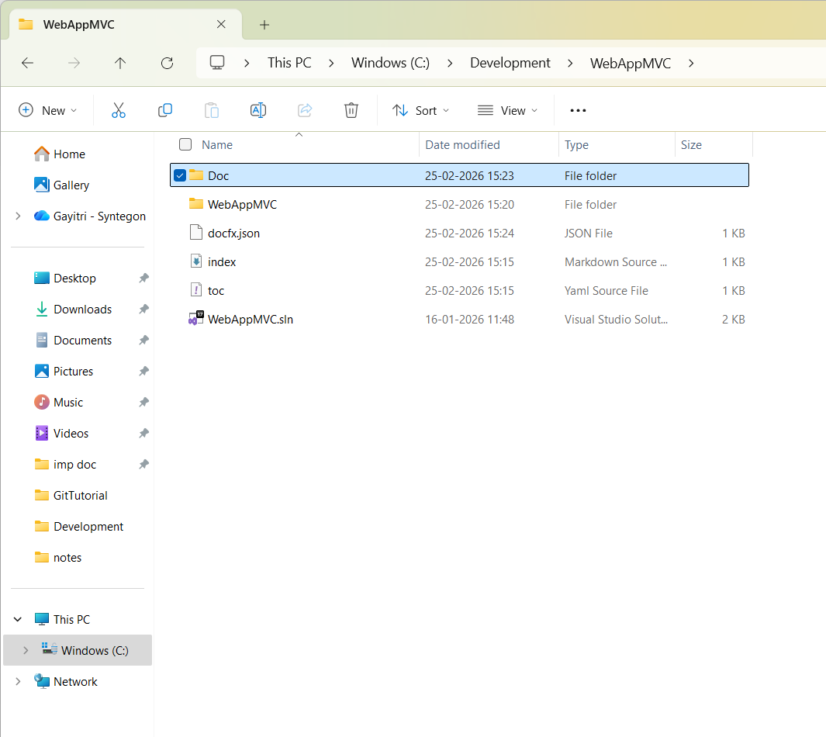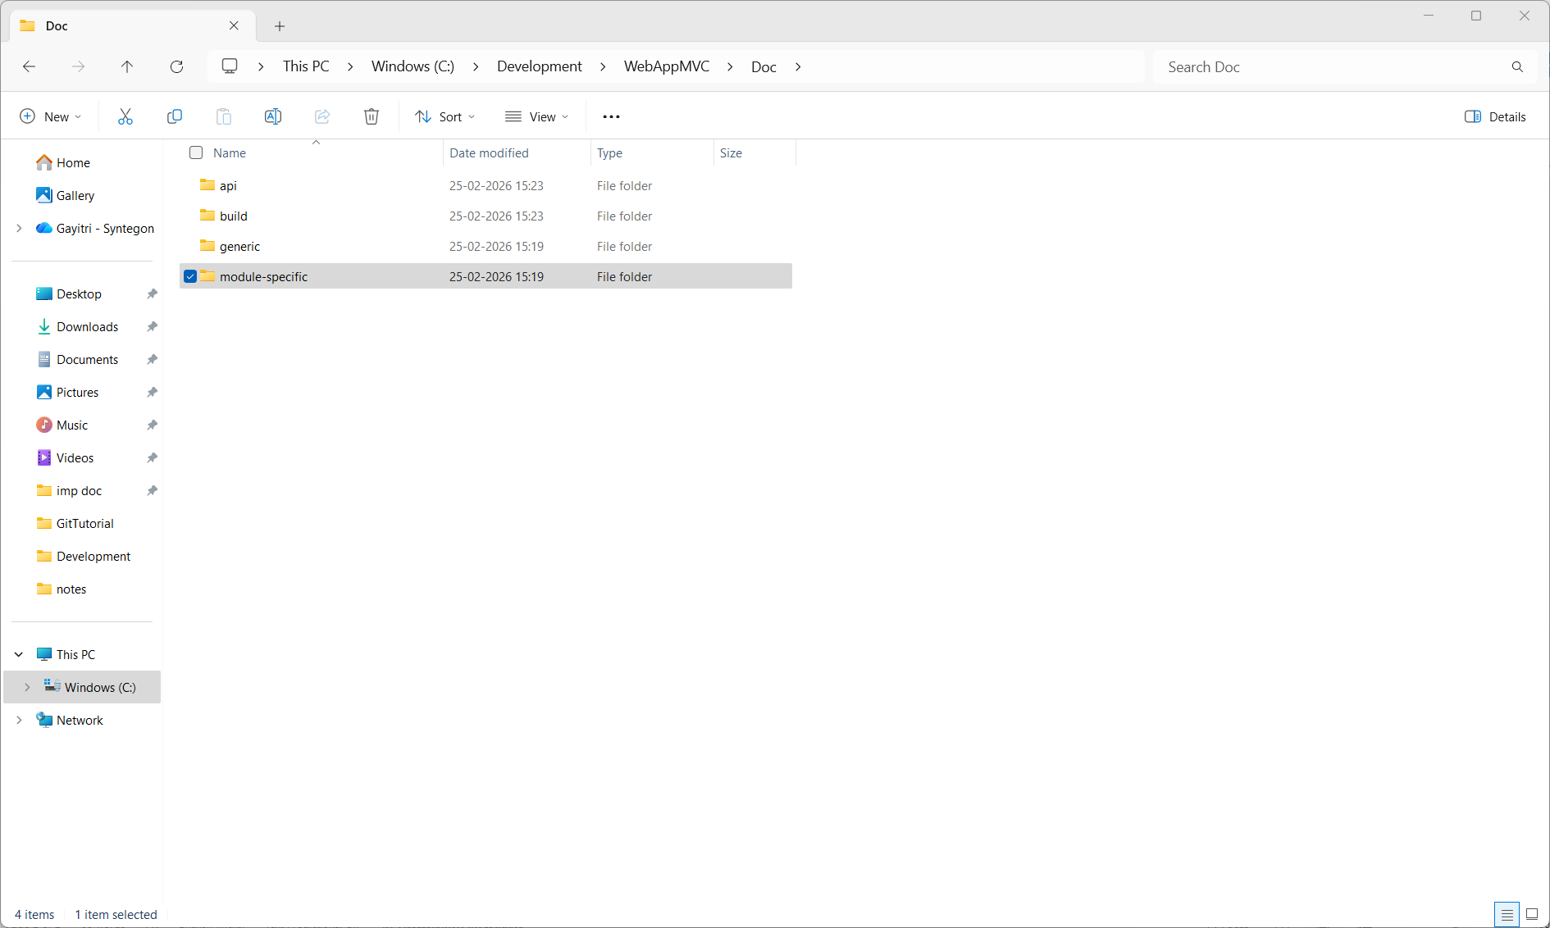
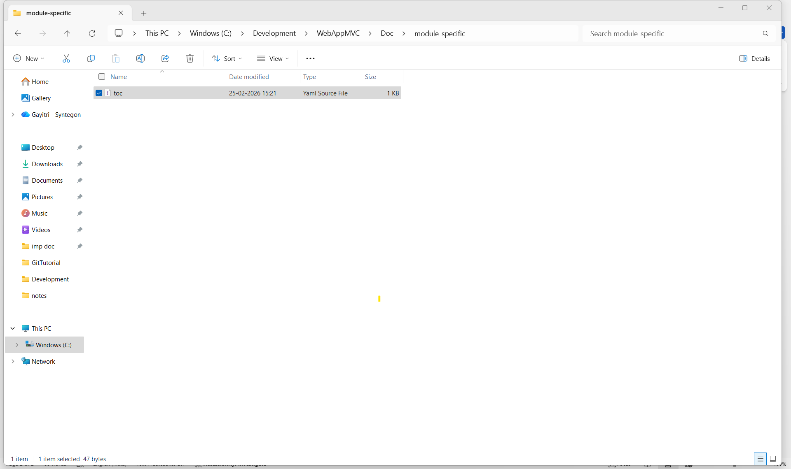
Change moduleA with the project name

Now go inside webapp/doc and open toc file
and Change moduleA with the project name
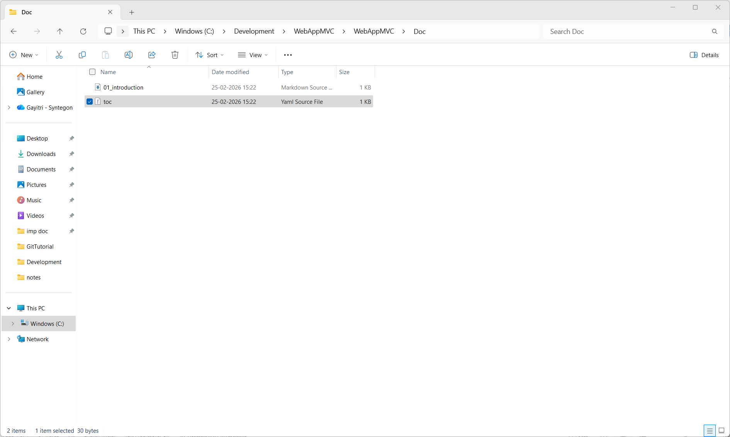

Now go inside webapp/doc and open introduction file
and Change moduleA with the project name
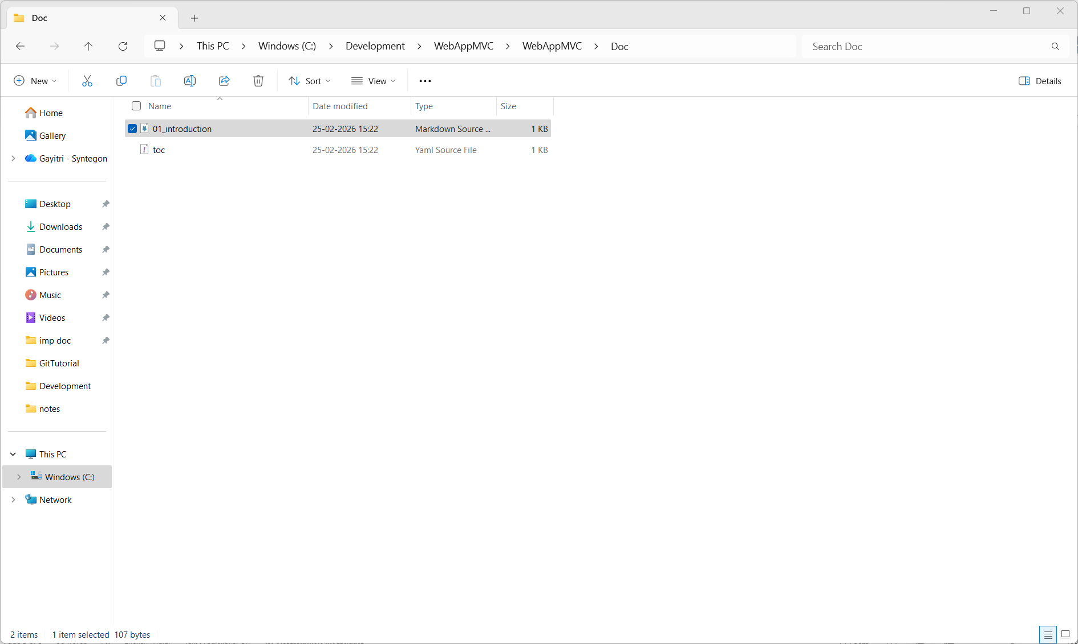

Run the command docfx --serve

