Vision-Based Intelligent Gait Environment Detection Algorithm for Assisting Stroke Patients with a Soft Ankle Exosuit
Gayoung Yang ¹ and Brian Byunghyun Kang^{1*}
¹ Intelligent Robotics Lab, School of Intelligent Mechatronics Engineering, Sejong University, Seoul 05006, Korea (didrkdud0512@sju.ac.kr, brianbkang@sejong.ac.kr)* Corresponding author

Abstract: Stroke survivors commonly face gait disturbances, particularly challenging during stair ascent due to increased lower limb muscular demands. To address these issues, we developed a soft exosuit prototype integrated with a tendon-driven mechanism for ankle support. A chest-mounted camera captures real-time gait environments, enabling our detection algorithm to enhance accuracy through visual input. A customized dataset, augmented for diversity, was prepared and systematically categorized into seven specific environments. The YOLOv8 algorithm, optimized through hyperparameter tuning, and an LSTM model were employed for real-time environment classification. Evaluations demonstrated high precision with 98.93% accuracy on test datasets. Experimental validation confirmed robust performance in distinguishing between different gait environments, showcasing adaptability and accuracy even during dynamic transitions. This research underscores the potential of integrating vision-based algorithms with wearable exosuits to improve functional independence and safety in stroke rehabilitation.

Keywords: Vision-based algorithm, soft exosuit, stroke patients, environment classification,

1. INTRODUCTION
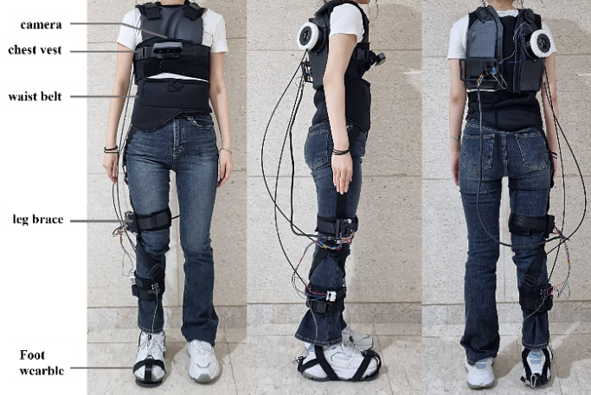
Fig. 1. Soft ankle exosuit prototype

Stroke survivors commonly exhibit functional impairments, with gait disturbance being a major factor limiting functional independence in activities of daily living (ADL). Particularly, stair gait is challenging for stroke patients due to increased demand on lower limb muscular strength compared to level ground gait [1]. Stroke patients face an increased risk of falls during stair ascent due to foot drop, resulting in inadequate dorsiflexion. Falls predominantly occur during the initial or final three steps, when walking environments transition. Therefore, ensuring walking stability through appropriate adaptations to changes in the gait environment is crucial.
Lower limb exosuit have been developed to assist stroke patients in both level ground and stair gait classifying gait environments. In previous research, a hip-worn exosuit integrating IMU and vision algorithm was developed [2]. Nevertheless, this approach was not specifically tailored for stroke patients. Stroke patients frequently exhibit greater asymmetry in ankle joint function than in their hip joints, underscoring the necessity for targeted ankle support to maintain stability.
In this paper, we developed a vision-based intelligent gait environment detection algorithm for a soft ankle exosuit for stroke patients. This algorithm improves environmental recognition and accuracy during transitions, enhancing the stability and adaptability of the wearable robot in dynamic walking conditions through refined classification of walking environments..

2. Materials and Methods

2.1 Exosuit Prototype

The soft exosuit is consists of flexible and soft materials that adapt to the user's movements, providing
assistance through a tendon - driven mechanism that transmit torque to the ankle. The exosuit is consists of a chest vest, a waist belt, a leg brace, and a foot wearable.
A chest-mounted camera angled 50 degrees relative to the central axis of the human body effectively captures the gait environment, enhancing the performance of the detection algorithm by providing crucial visual information.

2.2 Data Preparation

A dataset was created by recording a participant in an ankle exosuit walking on level ground and stairs at 960x540 resolution. Augmentation techniques were applied to 8,000 frames. These frames were split into 16,000 training images, with 2,000 images each for validation and testing in an 8:1:1 ratio. The customized dataset is categorized into seven specific environments to enhance accuracy during transition phases. These environments are: level ground, incline_prev, incline, incline_next, decline_prev, decline, decline_next.
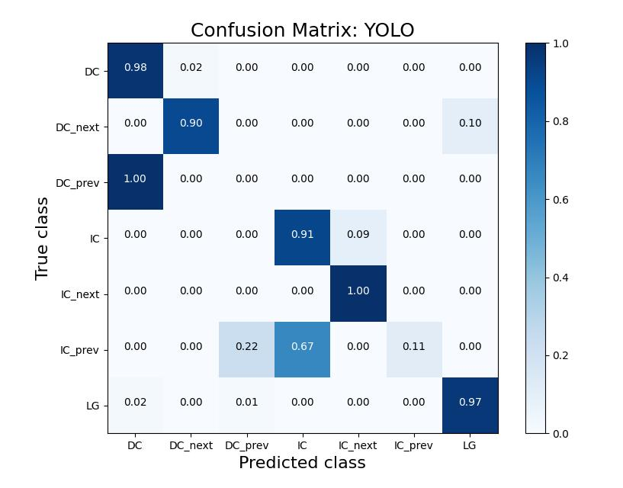
Fig. 2. confusion matrix for real-time YOLO performance

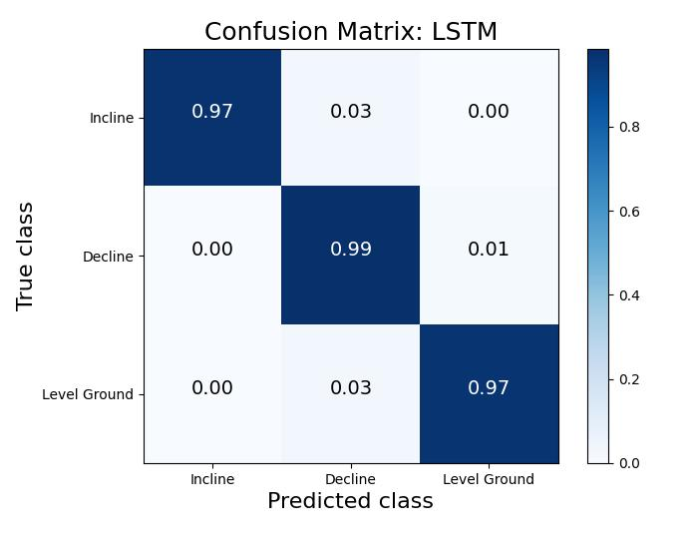
Fig. 3. confusion matrix for real-time LSTM performance

2.3 YOLO algorithm

YOLOv8, a CNN-based object detection framework, incorporates a modified CSP Darknet32 backbone to improve performance across various computer vision tasks. Renowned for its lightweight architecture, minimal computational requirements, and enhanced accuracy compared to its predecessors, YOLOv8 has established itself as a leading solution in the field of object detection.
Hyperparameter tuning optimized YOLOv8's performance, selecting the best parameters to maximize model efficacy. Training spanned 92 epochs out of a planned 100, employing a batch size of 8, a fixed learning rate of 0.0001, and the Adam optimizer.

2.4 LSTM-based environment classification

Gait, as a time series, exhibits dynamic variations in parameters such as walking environment and joint angles over time.
To leverage gait data's spatiotemporal information, we used the LSTM model, known for its ability to learn from sequences. It employed class probabilities from YOLO-framed data, with the highest probability class used for training. Frames were sampled at 10 FPS, labeling every fifth data point to generate sequential data with a stride of 2 frames, resulting in 5 labels per second.
The LSTM dataset is structured as (1403, 5, 8), with 1403 sequences, each containing 5 data points and 8 features per point. Validation was based on 171 sequences, maintaining an 8:1 train-to-validation ratio. The LSTM model was trained for 1000 epochs with a batch size of 32, learning rate set to 0.001, using the Adam optimizer. Evaluation on the test dataset achieved 98.93% accuracy, demonstrating its high precision.

3. Results

3.1 Experiment

To validate the real -time performance of our gait environment detection algorithm, experiments were conducted with a participant wearing an exosuit. The participant performed a sequence of movements, starting from level ground, ascending stairs, completing a loop, and descending stairs, while the exosuit's camera captured real-time walking environments for evaluation.

3.2 Results

Figure 3 illustrates the confusion matrix normalized between 0 and 1. Analysis of YOLO's real-time performance using evaluation metrics revealed misclassifications, particularly at the onset of incline and decline phases where labels were inaccurately detected. However, analyzing the confusion matrix of the algorithm combining YOLO and LSTM showed excellent performance in distinguishing between level ground, incline, and decline environments. Leveraging the spatiotemporal characteristics of LSTM-based gait environment data, the model demonstrated high adaptability and accurate recognition even during transition phases.

4. Conclusion

In conclusion, our study developed a vision-based intelligent gait environment detection algorithm integrated with a soft ankle exosuit to assist stroke patients. By utilizing a chest-mounted camera and advanced algorithms like YOLOv8 and LSTM, we achieved high precision in classifying various gait environments, crucial for enhancing stability and adaptability during dynamic movements. This research highlights the potential of vision-based systems in wearable exosuits to improve safety and independence in stroke rehabilitation.

REFERENCES

- Jesse V. Jacobs, “A review of stairway falls and stair negotiation: Lessons learned and future needs to reduce injury,” Gait & Posture, Volume 49, pp. 159-167, 2016.
- E. Tricomi et al., "Environment-Based Assistance Modulation for a Hip Exosuit via Computer Vision," in IEEE Robotics and Automation Letters, vol. 8, no. 5, pp. 2550-2557, May 2023.

