Name:   
Roll No.:   
No. of webpages:  
  
1) Screenshot:(Paste GDrive Folder Link containing remaining screenshots for each web page - Paste ONLY 2 screenshots below)

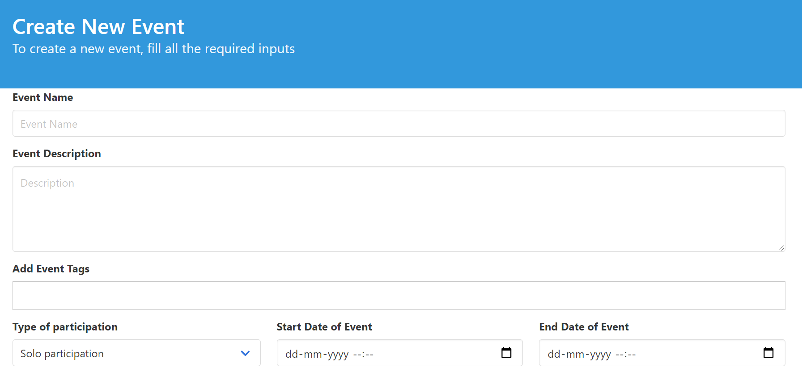



2) Description:

Description (Purpose in not more than 2 paragraphs):

3) Elements used in web page:

Field name, GUI Control used, Validation rule applied, Any specific Feature (mention only if element is dynamic)

|  |  |  |  |
| --- | --- | --- | --- |
| **Field Name** | **GUI Control** | **Validation Rule** | **Any Specific Feature** |
|  |  |  |  |
|  |  |  |  |
|  |  |  |  |

4) Code snippets: (DON'T COPY ALL CODE)

to illustrate special UI features(HTML5,CSS, JS) used in the design (not more than 3 pages in total – Do not include Full code)

Testing

|  |  |  |  |  |  |
| --- | --- | --- | --- | --- | --- |
| **Student Name** | **File/Module** | **Field** | **Input Given** | **Success/Failure** | **Reason for Failure** |
|  |  |  |  |  |  |
|  |  |  |  |  |  |
|  |  |  |  |  |  |
|  |  |  |  |  |  |
|  |  |  |  |  |  |