Name:- Gayatri Dilip Sapkale

Roll No:-169

Practical :-1

Practical Name:- Set up a GitHub account and send an email message to friend telling to your friend about the account

**Create a GitHub account:-**

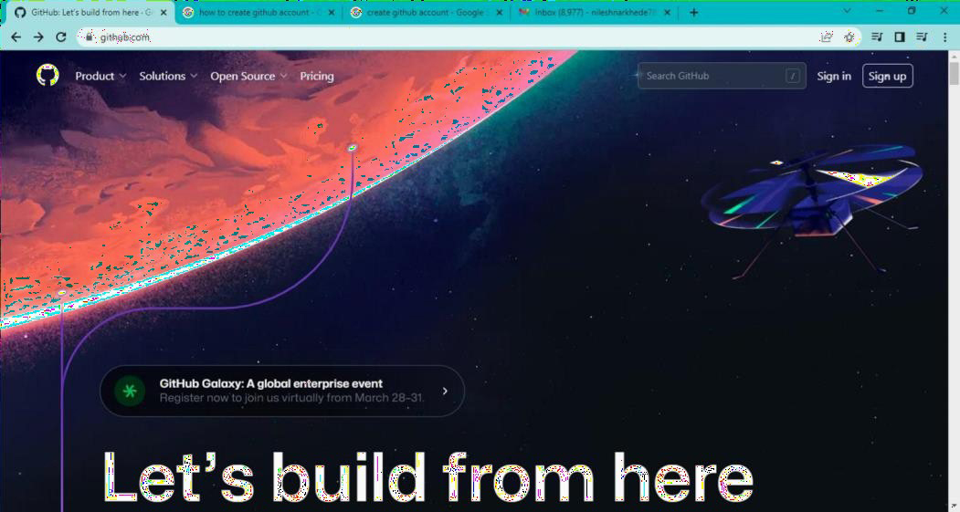if you don’t already have a GitHub account,here’s how to create one. 1.Open [https://github.com](https://github.com/) in a web browser and select the sign up.

1. 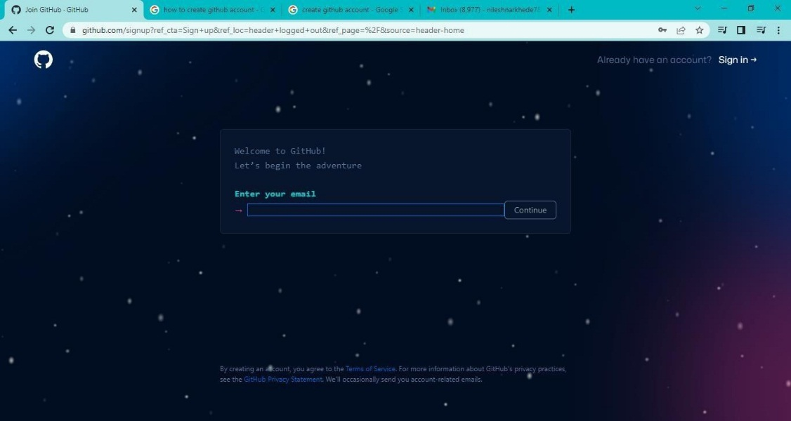Enter the email address
2. Create a password for your new GitHub account, and Enter a username ,too. Next choose whether you want to receive update and announcements via email,and then selwct continue.

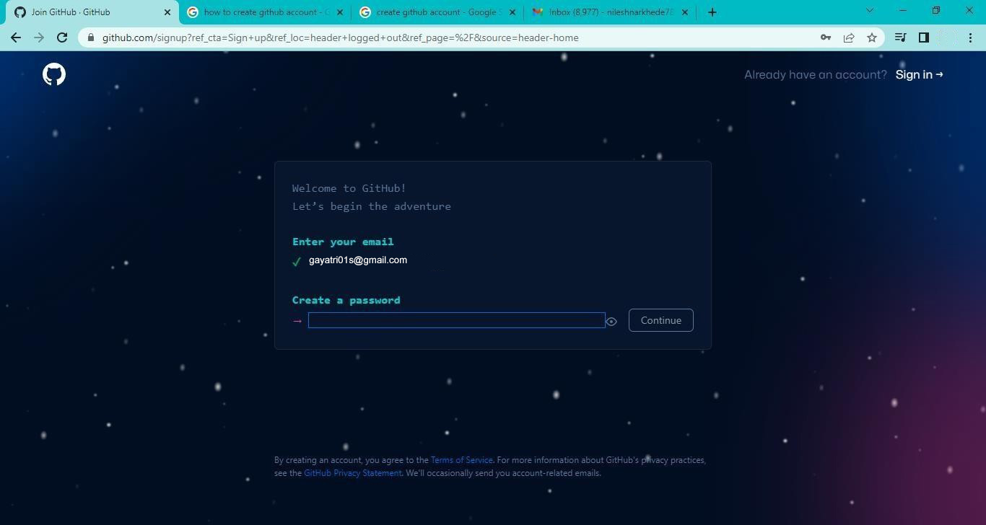

1. Enter the username

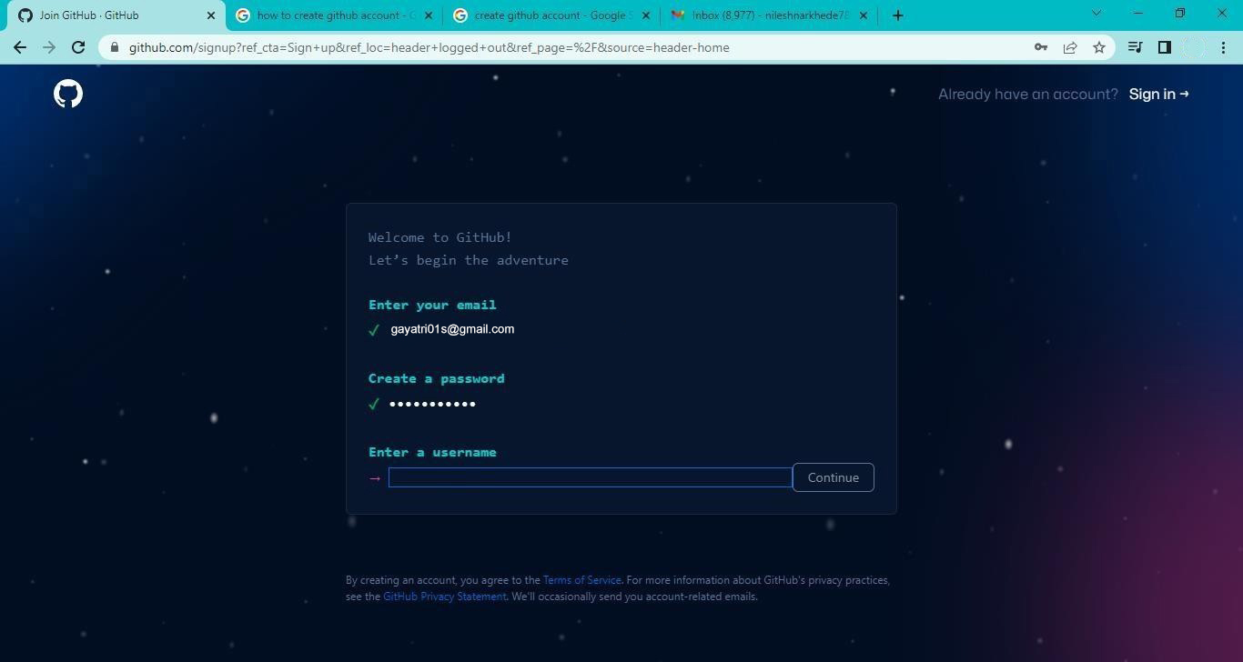

1. **Would you like to receive product updates and announcements via email? Type "y" for yes or "n" for no**

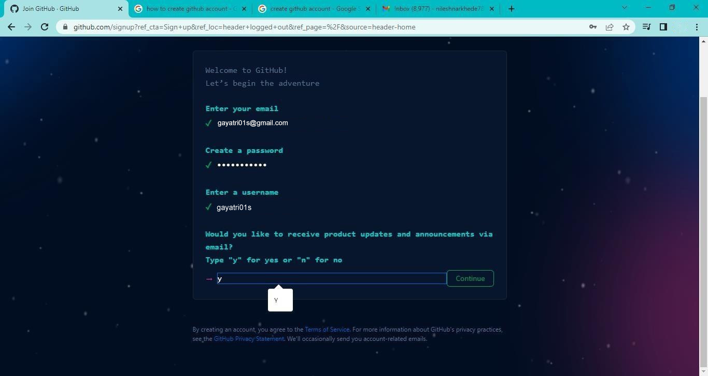

1. Verify your account by solving a puzzle .select the start puzzle button to do so, and then follow then follow the prompts.
2. After you verify your account, select the create account button.

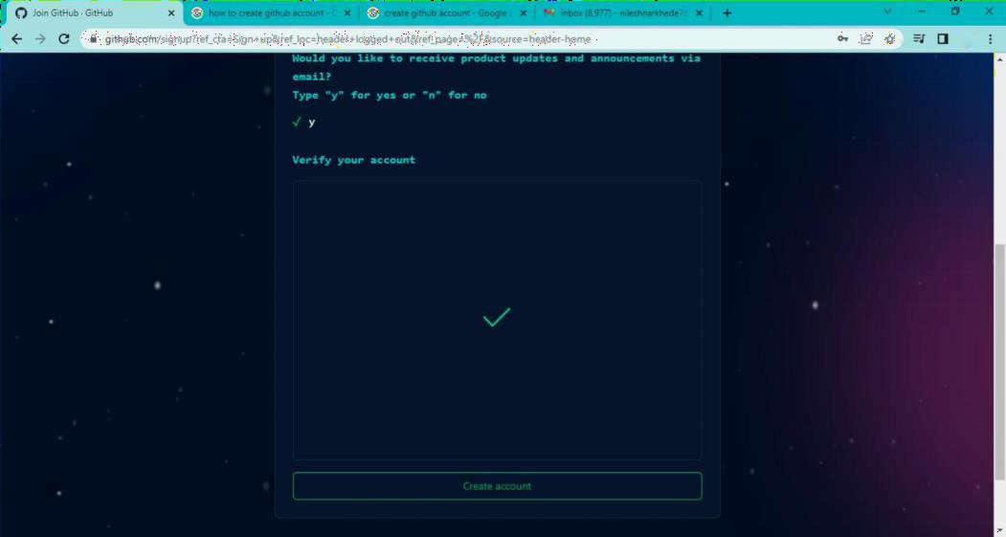

1. Next, GitHub send a launch code to your email address. Type that launch code in the enter code dialog , and then press enter.

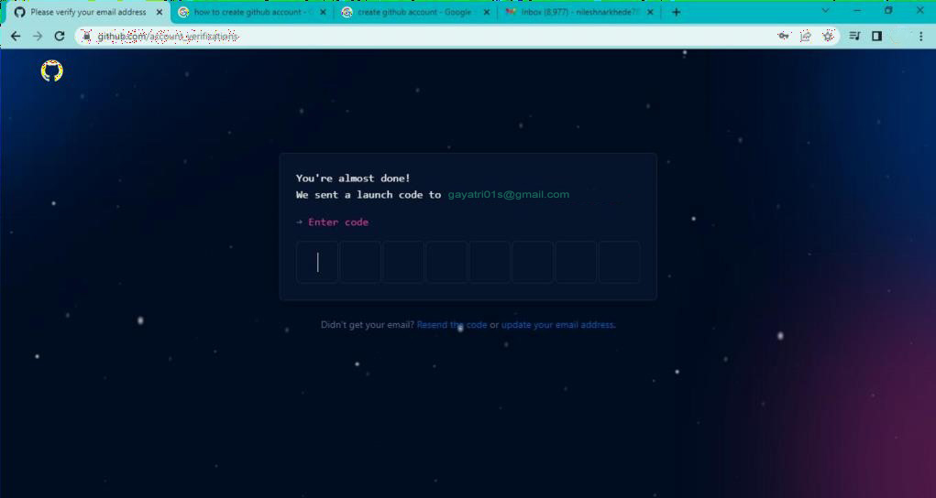

1. GitHub asks you some questions to help tailor your experience. choose the answer that apply to you in the following dialogs:
   * How many team members will be working with you?
   * What specific feature are you interested in using?
2. On the where team collaborate and ship screen,you can choose whether you want to use the free account or the team account. To choose the free account ,select the skip personalization button.

GitHub opens a personalized page in your browser.

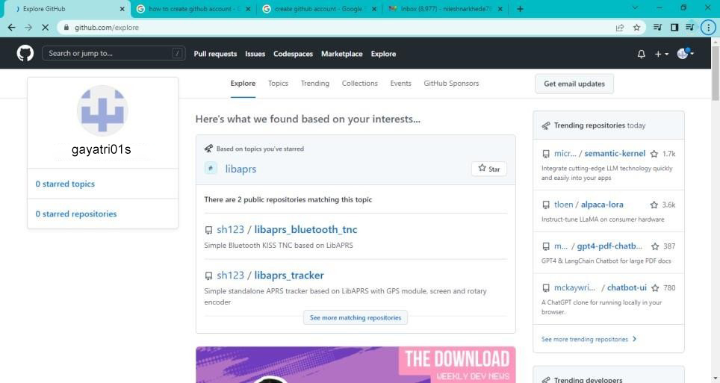

Congratulations! You’ve successfully created your GitHub account.

**Paste the screen shots of email which you had sended to your friend through GitHub.**

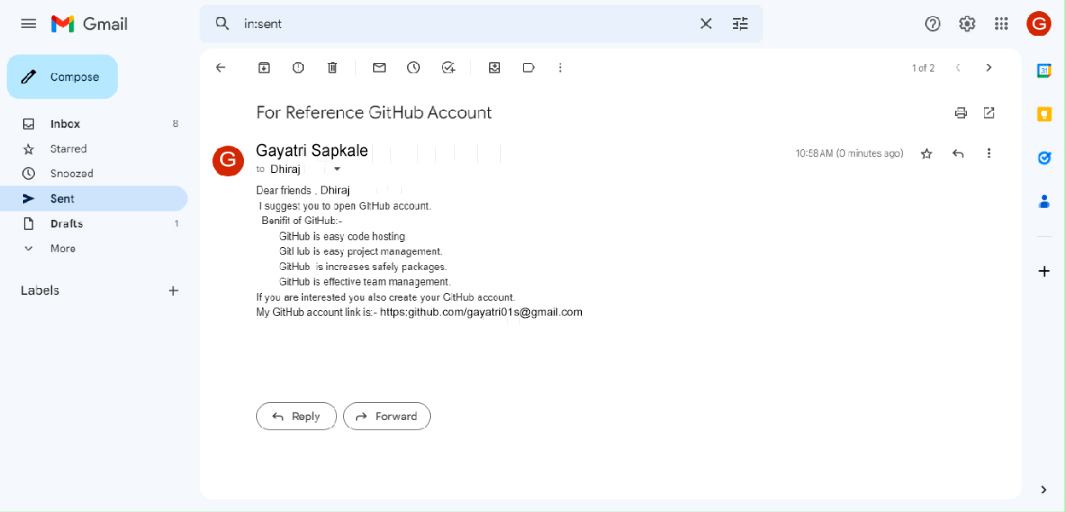

Roll No:-169

Name:- Gayatri Dilip Sapkale

Assigment NO:-02

Assigment Name:- Clone the repository at https://github.com/gayatri01s /KBCNMU

admin@DESKTOP-K3MVO4B MINGW64 ~

$ git --version

git version 2.40.0.windows.1

admin@DESKTOP-K3MVO4B MINGW64 ~

$ git --help usage: git [-v | --version] [-h | --help] [-C <path>] [-c <name>=<value>]

[--exec-path[=<path>]] [--html-path] [--man-path] [--info-path]

[-p | --paginate | -P | --no-pager] [--no-replace-objects] [--bare]

[--git-dir=<path>] [--work-tree=<path>] [--namespace=<name>]

[--config-env=<name>=<envvar>] <command> [<args>]

These are common Git commands used in various situations:

start a working area (see also: git help tutorial) clone Clone a repository into a new directory

init Create an empty Git repository or reinitialize an existing one

work on the current change (see also: git help everyday) add Add file contents to the index

mv Move or rename a file, a directory, or a symlink restore Restore working tree files

rm Remove files from the working tree and from the index

examine the history and state (see also: git help revisions) bisect Use binary search to find the commit that introduced a bug diff Show changes between commits, commit and working tree, etc

grep Print lines matching a pattern log Show commit logs show Show various types of objects status Show the working tree status

grow, mark and tweak your common history branch List, create, or delete branches commit Record changes to the repository merge Join two or more development histories together rebase Reapply commits on top of another base tip reset Reset current HEAD to the specified state switch Switch branches

tag Create, list, delete or verify a tag object signed with GPG

collaborate (see also: git help workflows)

fetch Download objects and refs from another repository pull Fetch from and integrate with another repository or a local branch push Update remote refs along with associated objects

'git help -a' and 'git help -g' list available subcommands and some concept guides. See 'git help <command>' or 'git help <concept>' to read about a specific subcommand or concept. See 'git help git' for an overview of the system.

admin@DESKTOP-K3MVO4B MINGW64 ~

$ git clone https://github.com/gayatri01s/KBCNMU.git Cloning into 'KBCNMU'...

remote: Enumerating objects: 3, done. remote: Counting objects: 100% (3/3), done. remote: Total 3 (delta 0), reused 0 (delta 0), pack-reused 0 Receiving objects: 100% (3/3), done.

1.Create Repositories

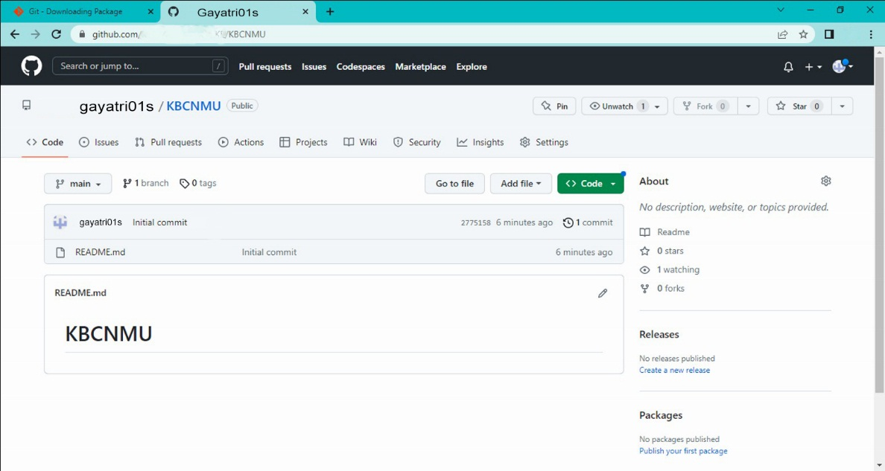

2.After cloning

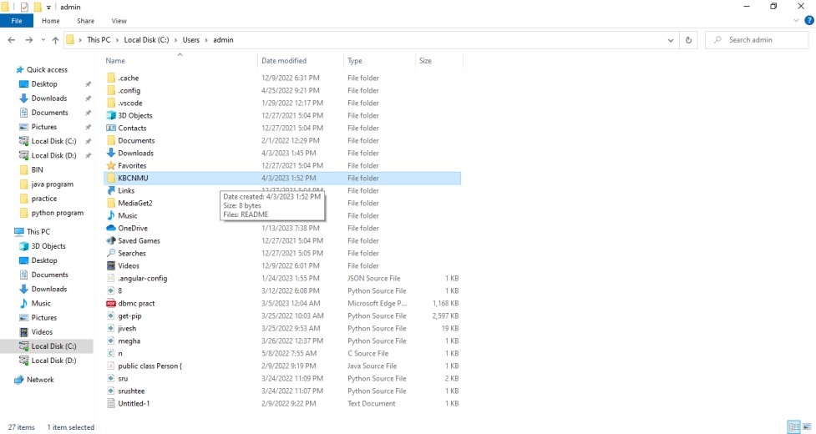

**Roll No:-169**

**Name:- Gayatri Dilip Sapkale**

**Practical N0:- 3**

**Practical Name:- Use git add to add the file to the repository use git commit to commit your change.**

admin@DESKTOP-K3MVO4B MINGW64 ~

$ cd KBCNMU

admin@DESKTOP-K3MVO4B MINGW64 ~/KBCNMU (main)

$ touch file.txt

admin@DESKTOP-K3MVO4B MINGW64 ~/KBCNMU (main)

$ git add file.txt

admin@DESKTOP-K3MVO4B MINGW64 ~/KBCNMU (main)

$ git commit -m "first commit"

[main e8434a1] first commit

1 file changed, 0 insertions(+), 0 deletions(-)

create mode 100644 file.txt

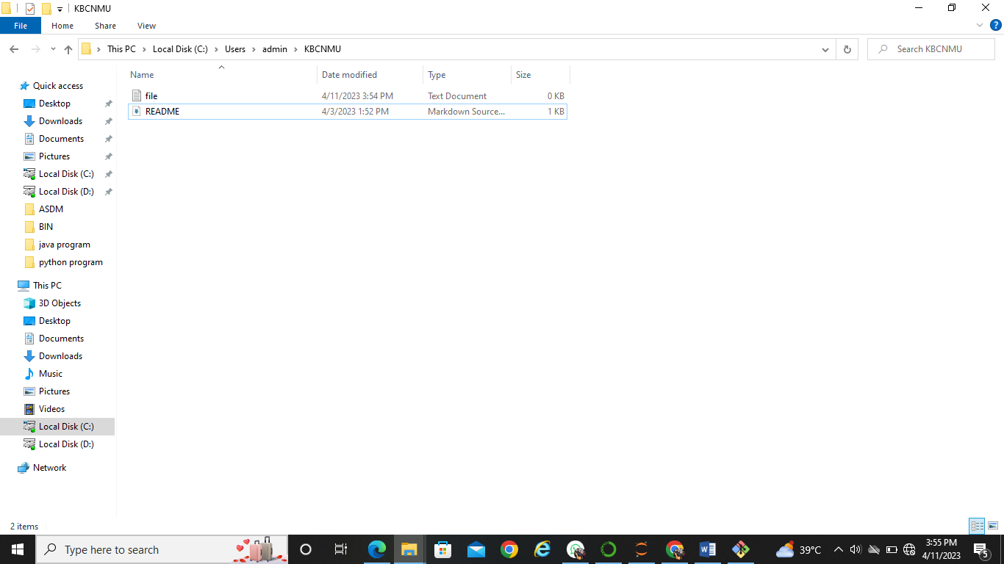

**Name:- Gayatri Dilip Sapkale**

**Roll No:-180**

**Practical No:-4**

**Practical Name:-Use git push to send your change to the primary repository. Look online to see if your change has been pushed.**

tanuj@DESKTOP-K44LLJ3 MINGW64 ~

$ git clone https://github.com/gayatri01s/MCA.git

Cloning into 'MCA'...

remote: Enumerating objects: 3, done.

remote: Counting objects: 100% (3/3), done.

remote: Total 3 (delta 0), reused 0 (delta 0), pack-reused 0

Receiving objects: 100% (3/3), done.

tanuj@DESKTOP-K44LLJ3 MINGW64 ~

$ cd MCA

tanuj@DESKTOP-K44LLJ3 MINGW64 ~/MCA (main)

$ git init MCA

Initialized empty Git repository in C:/Users/gayatri01s/MCA/MCA/.git/

tanuj@DESKTOP-K44LLJ3 MINGW64 ~/MCA (main)

$ touch MCA1.txt

tanuj@DESKTOP-K44LLJ3 MINGW64 ~/MCA (main)

$ git status

On branch main

Your branch is up to date with 'origin/main'.

Untracked files:

(use "git add <file>..." to include in what will be committed)

MCA/

MCA1.txt

nothing added to commit but untracked files present (use "git add" to track)

gayatri01s@DESKTOP-K44LLJ3 MINGW64 ~/MCA (main)

$ git add MCA1.txt

gayatri01s@DESKTOP-K44LLJ3 MINGW64 ~/MCA (main)

$ git commit -m "First commit"

[main 8865e63] First commit

1 file changed, 0 insertions(+), 0 deletions(-)

create mode 100644 MCA1.txt

gayatri01s@DESKTOP-K44LLJ3 MINGW64 ~/MCA (main)

$ git push -u origin main

Enumerating objects: 4, done.

Counting objects: 100% (4/4), done.

Delta compression using up to 8 threads

Compressing objects: 100% (2/2), done.

Writing objects: 100% (3/3), 277 bytes | 277.00 KiB/s, done.

Total 3 (delta 0), reused 0 (delta 0), pack-reused 0

To https://github.com/Tanujapatil29/MCA.git

fae9510..8865e63 main -> main

branch 'main' set up to track 'origin/main'.

gayatri01s@DESKTOP-K44LLJ3 MINGW64 ~/MCA (main)

$

**Create repository:-**

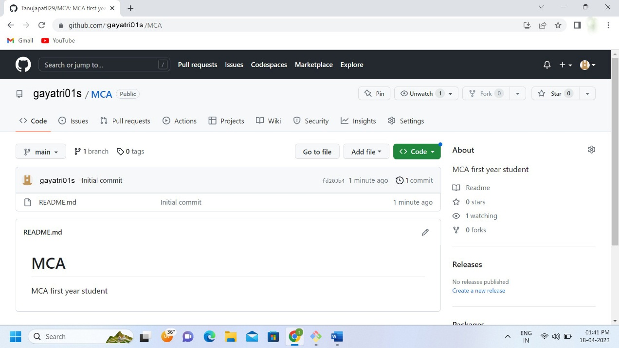

**Before push:-**

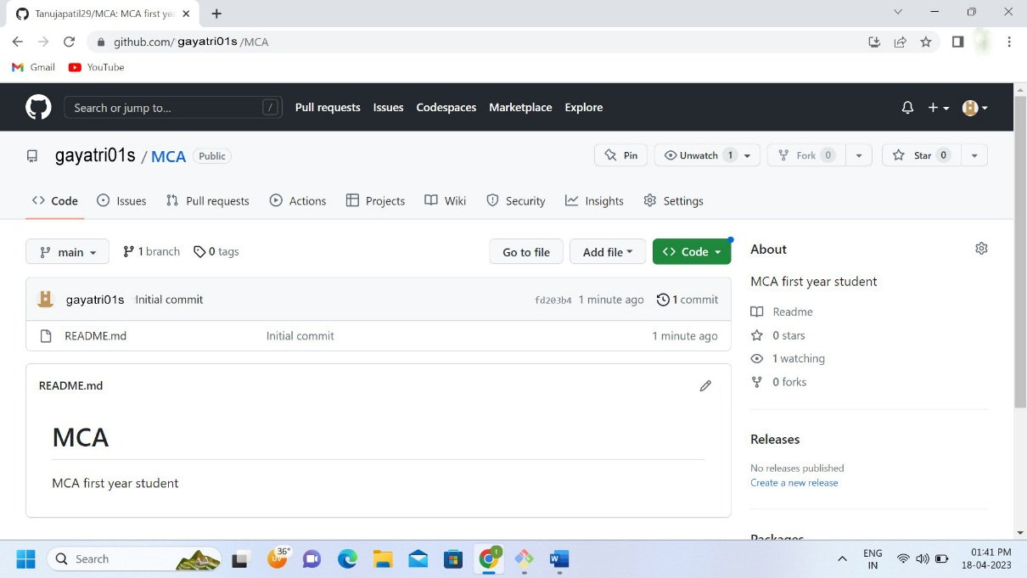

**Authentication :-**

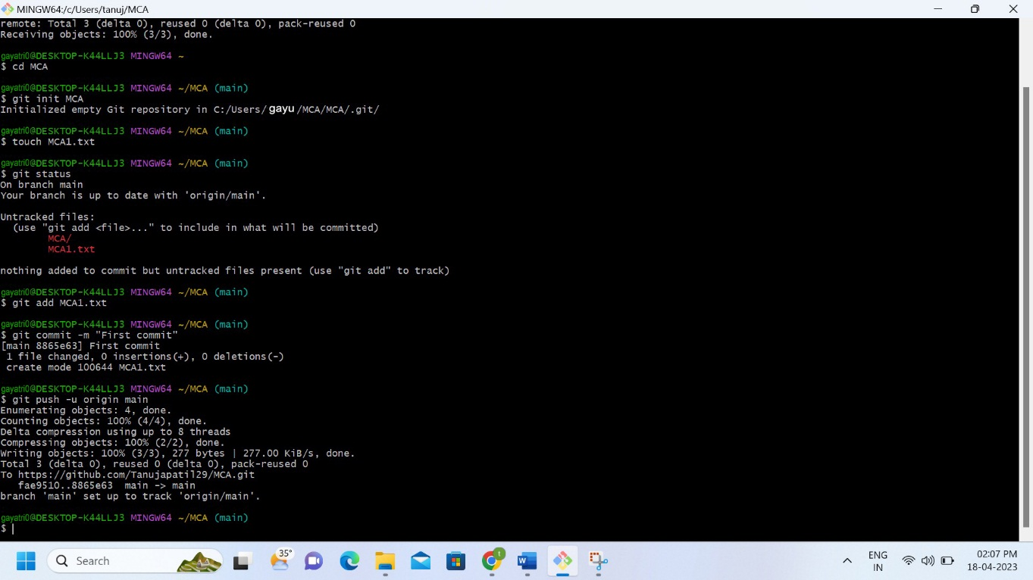

**After push:-**

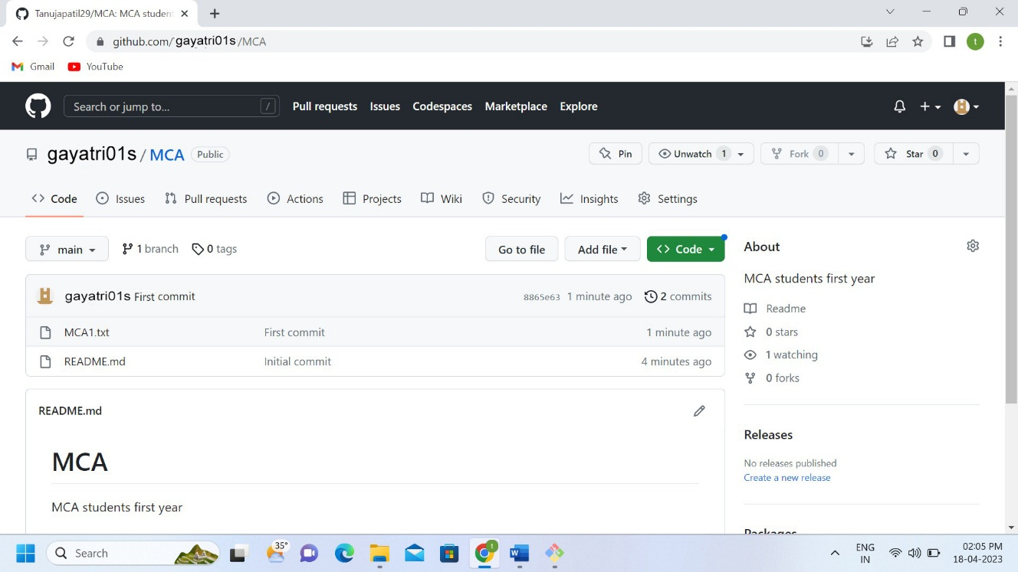

**Roll No :- 169**

**Name :- Gayatri Dilip Sapkale**

**Practical N0 :- 05**

**Practical Name :-** **Use git pull to get your partners change into your repository. Verify that you have the new files**.

admin@DESKTOP-K3MVO4B MINGW64 ~

$ cd MCA

admin@DESKTOP-K3MVO4B MINGW64 ~/MCA (main)

$ git init MCA

Initialized empty Git repository in C:/Users/admin/MCA/MCA/.git/

admin@DESKTOP-K3MVO4B MINGW64 ~/MCA (main)

$ git pull https://github.com/Gayatri01s/MCA.git

remote: Enumerating objects: 4, done.

remote: Counting objects: 100% (4/4), done.

remote: Compressing objects: 100% (3/3), done.

remote: Total 3 (delta 0), reused 0 (delta 0), pack-reused 0

Unpacking objects: 100% (3/3), 811.45 KiB | 480.00 KiB/s, done.

From https://github.com/Gayatri01s/MCA

* branch HEAD -> FETCH_HEAD

Updating e5432d0..1b8e5f9

Fast-forward

1practicals.pdf | Bin 0 -> 970191 bytes

1 file changed, 0 insertions(+), 0 deletions(-)

create mode 100644 1practicals.pdf

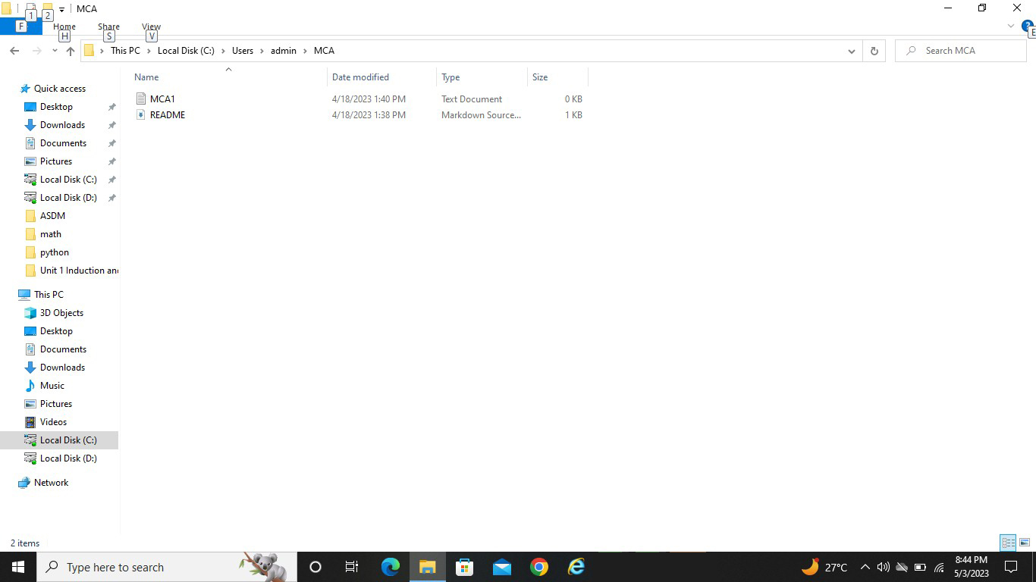

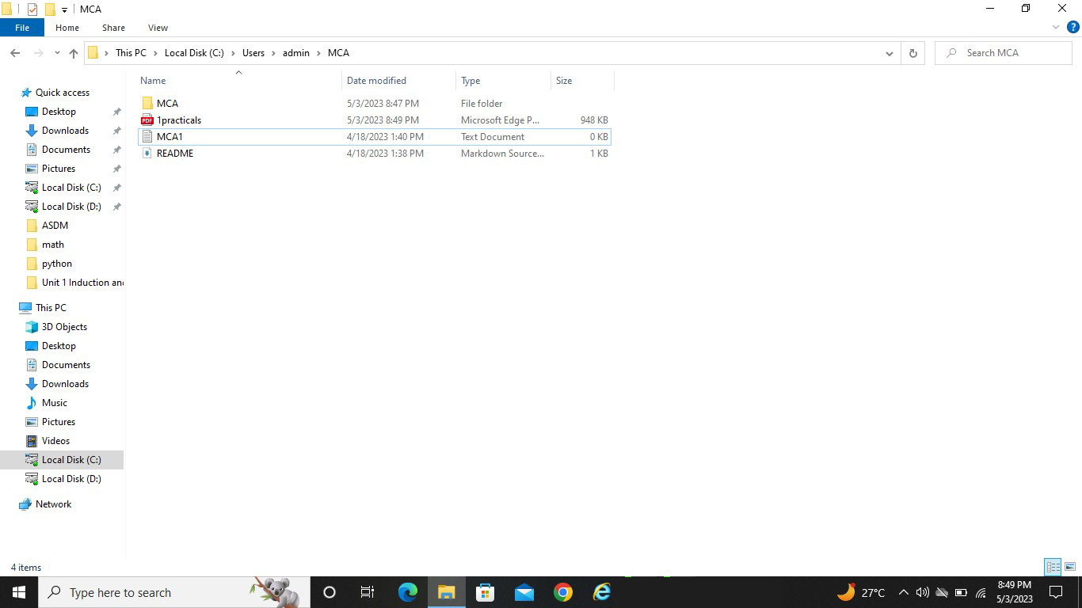

**Roll No:-169**

**Name:- Gayatri Dilip Sapkale**

**Practical N0:- 06**

**Practical Name:-** **Use git log or git log | less to see a list of changes to the repository.**

admin@DESKTOP-K3MVO4B MINGW64 ~

$ cd MCA

admin@DESKTOP-K3MVO4B MINGW64 ~/MCA (main)

$ git log

commit 1b8e5f97678c3e0b88c1066cf963ecd3bf5a3e5f (HEAD -> main)

Author: Gayatri01s <128398583+Gayatri01s@users.noreply.github.com>

Date: Wed May 3 20:46:49 2023 +0530

Add files via upload

commit e5432d06d29345adf215a849757342bafd17a297 (origin/main, origin/HEAD)

Author: unknown <gayatri01s>

Date: Tue Apr 18 13:41:53 2023 +0530

frist commit

commit 2632b1d25b7cf3e73bdf6d93c3bc8e0cbbae024f

Author: Gayatri01s <128398583+Gayatri01s@users.noreply.github.com>

Date: Tue Apr 18 13:22:05 2023 +0530

Initial commit

admin@DESKTOP-K3MVO4B MINGW64 ~/MCA (main)

$ git log --oneline

1b8e5f9 (HEAD -> main) Add files via upload

e5432d0 (origin/main, origin/HEAD) frist commit

2632b1d Initial commit

admin@DESKTOP-K3MVO4B MINGW64 ~/MCA (main)

$ git log --stat

commit 1b8e5f97678c3e0b88c1066cf963ecd3bf5a3e5f (HEAD -> main)

Author: Gayatri01s <128398583+Gayatri01s@users.noreply.github.com>

Date: Wed May 3 20:46:49 2023 +0530

Add files via upload

1practicals.pdf | Bin 0 -> 970191 bytes

1 file changed, 0 insertions(+), 0 deletions(-)

commit e5432d06d29345adf215a849757342bafd17a297 (origin/main, origin/HEAD)

Author: unknown <gayatri01s>

Date: Tue Apr 18 13:41:53 2023 +0530

frist commit

MCA1.txt | 0

1 file changed, 0 insertions(+), 0 deletions(-)

commit 2632b1d25b7cf3e73bdf6d93c3bc8e0cbbae024f

Author: Gayatri01s <128398583+Gayatri01s@users.noreply.github.com>

Date: Tue Apr 18 13:22:05 2023 +0530

Initial commit

README.md | 2 ++

1 file changed, 2 insertions(+)

admin@DESKTOP-K3MVO4B MINGW64 ~/MCA (main)

$ git log --patch

commit 1b8e5f97678c3e0b88c1066cf963ecd3bf5a3e5f (HEAD -> main)

Author: Gayatri01s <128398583+Gayatri01s@users.noreply.github.com>

Date: Wed May 3 20:46:49 2023 +0530

Add files via upload

**diff --git a/1practicals.pdf b/1practicals.pdf**

**new file mode 100644**

**index 0000000..2ad2582**

**--- /dev/null**

**+++ b/1practicals.pdf**

@@ -0,0 +1,35 @@

+Name:-Gayatri Dilip Sapkale

+Roll No:-105

+Practical :-1

+Practical Name:- Set up a GitHub account and send an email message to friend telling to your friend

+about the account

+Create a GitHub account:-

+if you don’t already have a GitHub account,here’s how to create one.

+1.Open https://github.com in a web browser and select the sign up.

+

+2. Enter the email address

+^L3. Create a password for your new GitHub account, and Enter a username ,too. Next choose

+whether you want to receive update and announcements via email,and then selwct continue.

+

+4. Enter the username

+^L5. Would you like to receive product updates and announcements via email?

+Type "y" for yes or "n" for no

+

+6. Verify your account by solving a puzzle .select the start puzzle button to do so, and then follow

+then follow the prompts.

+7. After you verify your account, select the create account button.

+^L8. Next, GitHub send a launch code to your email address. Type that launch code in the enter code

+dialog , and then press enter.

+

+9. GitHub asks you some questions to help tailor your experience. choose the answer that apply

+to you in the following dialogs:

+

+ o How many team members will be working with you?

+ o What specific feature are you interested in using?

+10. On the where team collaborate and ship screen,you can choose whether you want to use the

+free account or the team account. To choose the free account ,select the skip personalization button.

+ GitHub opens a personalized page in your browser.

+

+Congratulations! You’ve successfully created your GitHub account.

+Paste the screen shots of email which you had sended to your friend through GitHub.

+^L^L

commit e5432d06d29345adf215a849757342bafd17a297 (origin/main, origin/HEAD)

admin@DESKTOP-K3MVO4B MINGW64 ~/MCA (main)

$ git log -p

commit 1b8e5f97678c3e0b88c1066cf963ecd3bf5a3e5f (HEAD -> main)

Author: Gayatri01s <128398583+Gayatri01s@users.noreply.github.com>

Date: Wed May 3 20:46:49 2023 +0530

Add files via upload

**diff --git a/1practicals.pdf b/1practicals.pdf**

**new file mode 100644**

**index 0000000..2ad2582**

**--- /dev/null**

**+++ b/1practicals.pdf**

@@ -0,0 +1,35 @@

+Name:-Gayatri Dilip Sapkale

+Roll No:-169

+Practical :-1

+Practical Name:- Set up a GitHub account and send an email message to friend telling to your friend

+about the account

+Create a GitHub account:-

+if you don’t already have a GitHub account,here’s how to create one.

+1.Open https://github.com in a web browser and select the sign up.

+

+2. Enter the email address

+^L3. Create a password for your new GitHub account, and Enter a username ,too. Next choose

+whether you want to receive update and announcements via email,and then selwct continue.

+

+4. Enter the username

+^L5. Would you like to receive product updates and announcements via email?

+Type "y" for yes or "n" for no

+

+6. Verify your account by solving a puzzle .select the start puzzle button to do so, and then follow

+then follow the prompts.

+7. After you verify your account, select the create account button.

+^L8. Next, GitHub send a launch code to your email address. Type that launch code in the enter code

+dialog , and then press enter.

+

+9. GitHub asks you some questions to help tailor your experience. choose the answer that apply

+to you in the following dialogs:

+

+ o How many team members will be working with you?

+ o What specific feature are you interested in using?

+10. On the where team collaborate and ship screen,you can choose whether you want to use the

+free account or the team account. To choose the free account ,select the skip personalization button.

+ GitHub opens a personalized page in your browser.

+

+Congratulations! You’ve successfully created your GitHub account.

+Paste the screen shots of email which you had sended to your friend through GitHub.

+^L^L

commit e5432d06d29345adf215a849757342bafd17a297 (origin/main, origin/HEAD)

admin@DESKTOP-K3MVO4B MINGW64 ~/MCA (main)

$ git log --graph

* commit 1b8e5f97678c3e0b88c1066cf963ecd3bf5a3e5f (HEAD -> main)

| Author: Gayatri01s <128398583+Gayatri01s@users.noreply.github.com>

| Date: Wed May 3 20:46:49 2023 +0530

|

| Add files via upload

|

* commit e5432d06d29345adf215a849757342bafd17a297 (origin/main, origin/HEAD)

| Author: unknown <gayatri01s>

| Date: Tue Apr 18 13:41:53 2023 +0530

|

| frist commit

|

* commit 2632b1d25b7cf3e73bdf6d93c3bc8e0cbbae024f

Author: Gayatri01s <128398583+Gayatri01s@users.noreply.github.com>

Date: Tue Apr 18 13:22:05 2023 +0530

Initial commit

admin@DESKTOP-K3MVO4B MINGW64 ~/MCA (main)

$ git log --graph --oneline

* 1b8e5f9 (HEAD -> main) Add files via upload

* e5432d0 (origin/main, origin/HEAD) frist commit

* 2632b1d Initial commit

admin@DESKTOP-K3MVO4B MINGW64 ~/MCA (main)

$ git log -3

commit 1b8e5f97678c3e0b88c1066cf963ecd3bf5a3e5f (HEAD -> main)

Author: Gayatri01s <128398583+Gayatri01s@users.noreply.github.com>

Date: Wed May 3 20:46:49 2023 +0530

Add files via upload

commit e5432d06d29345adf215a849757342bafd17a297 (origin/main, origin/HEAD)

Author: unknown <gayatri01s>

Date: Tue Apr 18 13:41:53 2023 +0530

frist commit

commit 2632b1d25b7cf3e73bdf6d93c3bc8e0cbbae024f

Author: Gayatri01s <128398583+Gayatri01s@users.noreply.github.com>

Date: Tue Apr 18 13:22:05 2023 +0530

Initial commit

admin@DESKTOP-K3MVO4B MINGW64 ~/MCA (main)

$ git log --after="2021-01-20"

commit 1b8e5f97678c3e0b88c1066cf963ecd3bf5a3e5f (HEAD -> main)

Author: Gayatri01s <128398583+Gayatri01s@users.noreply.github.com>

Date: Wed May 3 20:46:49 2023 +0530

Add files via upload

commit e5432d06d29345adf215a849757342bafd17a297 (origin/main, origin/HEAD)

Author: unknown <gayatri01s>

Date: Tue Apr 18 13:41:53 2023 +0530

frist commit

commit 2632b1d25b7cf3e73bdf6d93c3bc8e0cbbae024f

Author: Gayatri01s <128398583+Gayatri01s@users.noreply.github.com>

Date: Tue Apr 18 13:22:05 2023 +0530

Initial commit

admin@DESKTOP-K3MVO4B MINGW64 ~/MCA (main)

$ git log --after="20 days ago"

commit 1b8e5f97678c3e0b88c1066cf963ecd3bf5a3e5f (HEAD -> main)

Author: Gayatri01s <128398583+Gayatri01s@users.noreply.github.com>

Date: Wed May 3 20:46:49 2023 +0530

Add files via upload

commit e5432d06d29345adf215a849757342bafd17a297 (origin/main, origin/HEAD)

Author: unknown <gayatri01s>

Date: Tue Apr 18 13:41:53 2023 +0530

frist commit

commit 2632b1d25b7cf3e73bdf6d93c3bc8e0cbbae024f

Author: Gayatri01s <128398583+Gayatri01s@users.noreply.github.com>

Date: Tue Apr 18 13:22:05 2023 +0530

Initial commit

admin@DESKTOP-K3MVO4B MINGW64 ~/MCA (main)

$ git log --after="2023-01-05" --befor="2023-02-11"

fatal: unrecognized argument: --befor=2023-02-11

admin@DESKTOP-K3MVO4B MINGW64 ~/MCA (main)

$ git log --after="2023-01-05"--befor="2023-02-11"

commit 1b8e5f97678c3e0b88c1066cf963ecd3bf5a3e5f (HEAD -> main)

Author: Gayatri01s <128398583+Gayatri01s@users.noreply.github.com>

Date: Wed May 3 20:46:49 2023 +0530

Add files via upload

commit e5432d06d29345adf215a849757342bafd17a297 (origin/main, origin/HEAD)

Author: unknown <gayatri01s>

Date: Tue Apr 18 13:41:53 2023 +0530

frist commit

commit 2632b1d25b7cf3e73bdf6d93c3bc8e0cbbae024f

Author: Gayatri01s <128398583+Gayatri01s@users.noreply.github.com>

Date: Tue Apr 18 13:22:05 2023 +0530

Initial commit

admin@DESKTOP-K3MVO4B MINGW64 ~/MCA (main)

$ git log --author="MCA1"

admin@DESKTOP-K3MVO4B MINGW64 ~/MCA (main)

$ git log --author="gayatri01s@gmail.com"

admin@DESKTOP-K3MVO4B MINGW64 ~/MCA (main)

$ git log --grep="commit message"

admin@DESKTOP-K3MVO4B MINGW64 ~/MCA (main)

$ git status

On branch main

Your branch is ahead of 'origin/main' by 1 commit.

(use "git push" to publish your local commits)

Untracked files:

(use "git add <file>..." to include in what will be committed)

MCA/

nothing added to commit but untracked files present (use "git add" to track)

**Name:- Gayatri Dilip Sapkale**

**Roll No:-169**

**Practical No:-7**

**Practical Name:-Use git branch to create a new branch and git checkout to switch to the branch.**

admin@DESKTOP-K3MVO4B MINGW64 ~

$ cd MCA

admin@DESKTOP-K3MVO4B MINGW64 ~/MCA (branch2)

$ git checkout main

Switched to branch 'main'

Your branch is ahead of 'origin/main' by 1 commit.

(use "git push" to publish your local commits)

admin@DESKTOP-K3MVO4B MINGW64 ~/MCA (main)

$ git init MCA

Reinitialized existing Git repository in C:/Users/admin/MCA/MCA/.git/

admin@DESKTOP-K3MVO4B MINGW64 ~/MCA (main)

$ git branch branch1

admin@DESKTOP-K3MVO4B MINGW64 ~/MCA (main)

$ git checkout branch1

Switched to branch 'branch1'

admin@DESKTOP-K3MVO4B MINGW64 ~/MCA (branch1)

$ touch MCA2.txt

admin@DESKTOP-K3MVO4B MINGW64 ~/MCA (branch1)

$ git add MCA2.txt

admin@DESKTOP-K3MVO4B MINGW64 ~/MCA (branch1)

$ git commit -m "First commit of branch first"

[branch1 e9eed8d] First commit of branch first

1 file changed, 0 insertions(+), 0 deletions(-)

create mode 100644 MCA2.txt

admin@DESKTOP-K3MVO4B MINGW64 ~/MCA (branch1)

$ git push -u origin branch1

Enumerating objects: 3, done.

Counting objects: 100% (3/3), done.

Delta compression using up to 4 threads

Compressing objects: 100% (2/2), done.

Writing objects: 100% (2/2), 232 bytes | 116.00 KiB/s, done.

Total 2 (delta 1), reused 0 (delta 0), pack-reused 0

remote: Resolving deltas: 100% (1/1), completed with 1 local object.

remote:

remote: Create a pull request for 'branch1' on GitHub by visiting:

remote: https://github.com/Gayatri01s/MCA/pull/new/branch1

remote:

To https://github.com/Gayatri01s/MCA.git

* [new branch] branch1 -> branch1

branch 'branch1' set up to track 'origin/branch1'.

**Before Pull and merge on remote repository:-**

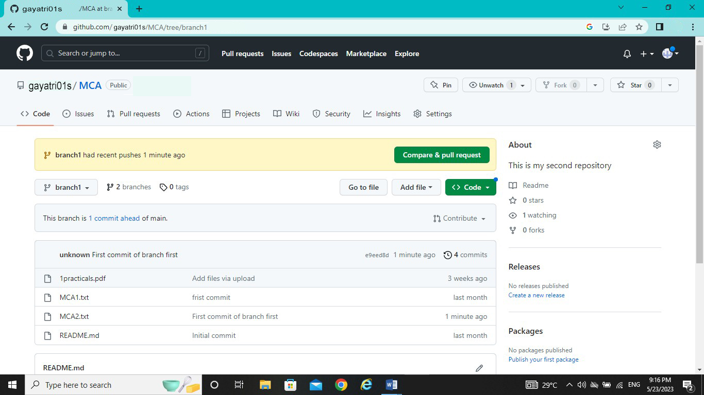

**Performing Pull request:-**

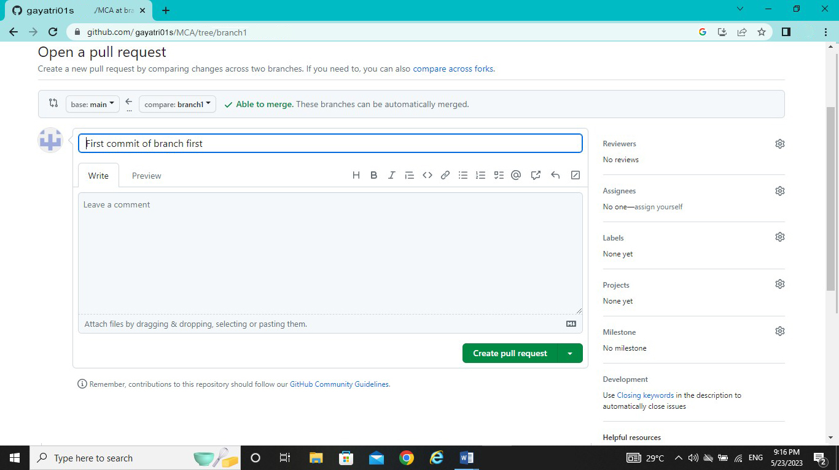

**After Pull performing Merge on remote repository at primary branch (main):-**

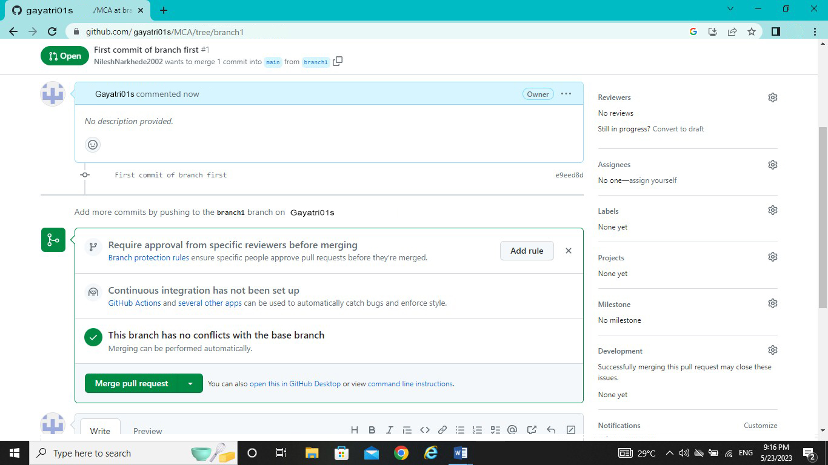

**After merge from firstbranch to primary branch (main) on remote repository:-**

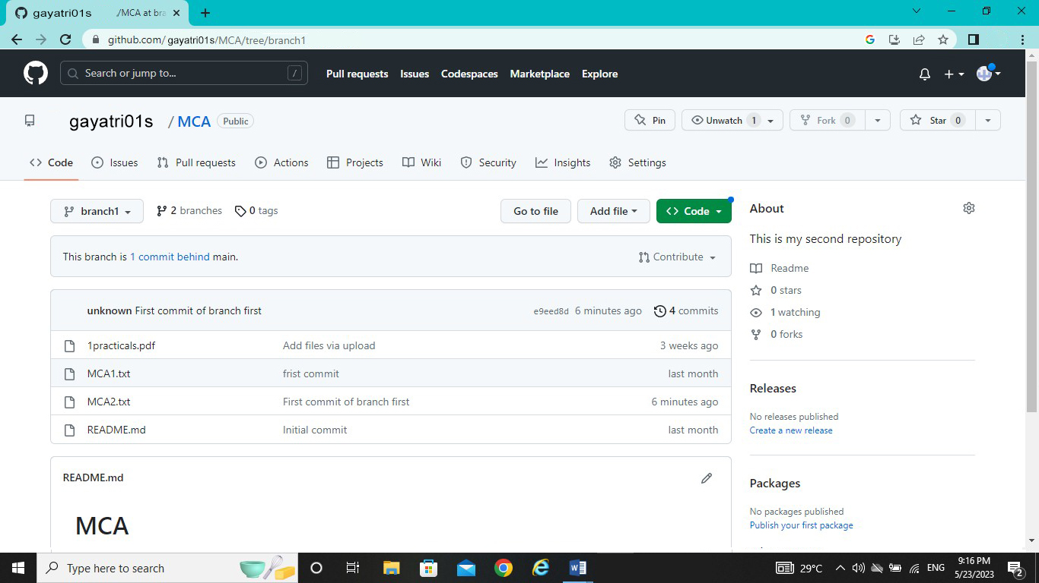

**Name:- Sapkale Gayatri Dilip**

**Roll No:-169**

**Practical No:-8**

**Practical Name:-** **Use git merge to merge you changes to the primary branch.**

admin@DESKTOP-K3MVO4B MINGW64 ~/MCA (branch1)

$ git merge main branch1

Already up to date.

admin@DESKTOP-K3MVO4B MINGW64 ~/MCA (branch1)

$ git branch --list

* branch1

branch2

main

admin@DESKTOP-K3MVO4B MINGW64 ~/MCA (branch1)

$ git checkout main

Switched to branch 'main'

Your branch is ahead of 'origin/main' by 1 commit.

(use "git push" to publish your local commits)

admin@DESKTOP-K3MVO4B MINGW64 ~/MCA (main)

$ git pull https://github.com/Gayatri01s/MCA.git

remote: Enumerating objects: 1, done.

remote: Counting objects: 100% (1/1), done.

remote: Total 1 (delta 0), reused 0 (delta 0), pack-reused 0

Unpacking objects: 100% (1/1), 633 bytes | 16.00 KiB/s, done.

From https://github.com/Gayatri01s/MCA

* branch HEAD -> FETCH_HEAD

Updating 1b8e5f9..a28b37c

Fast-forward

MCA2.txt | 0

1 file changed, 0 insertions(+), 0 deletions(-)

create mode 100644 MCA2.txt

Before Merge to local repository:-

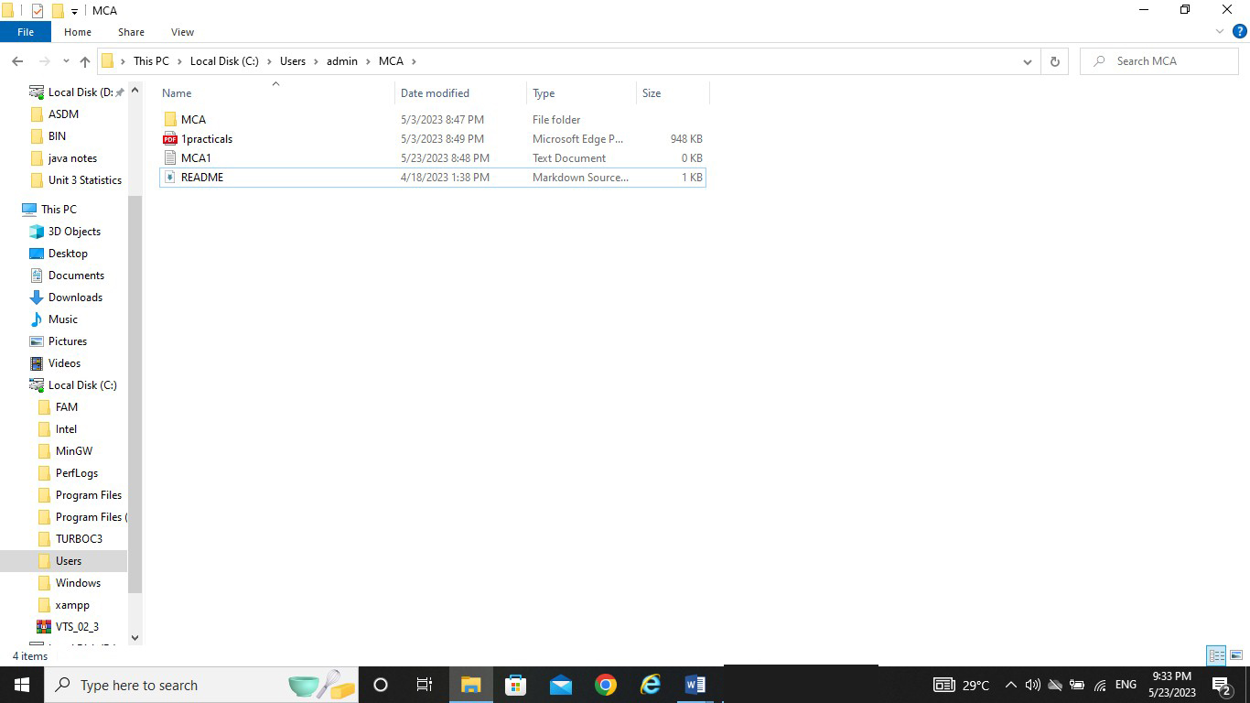

After Merge to local repository:-

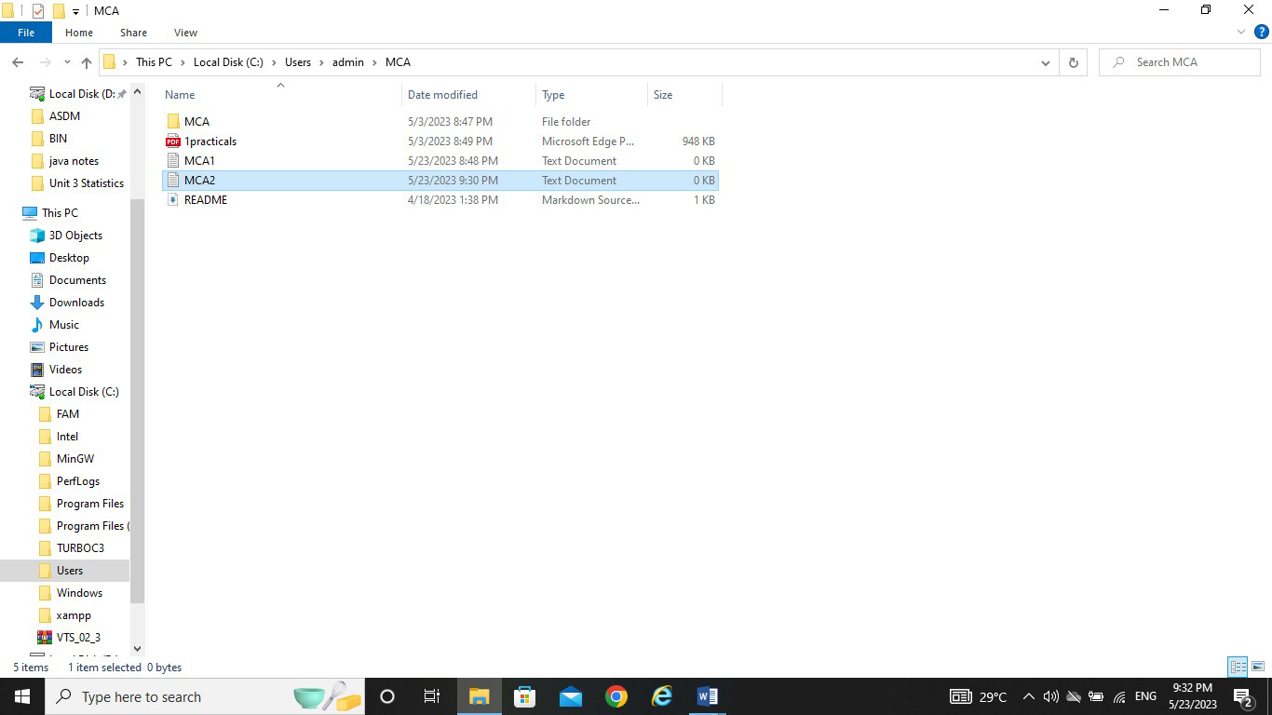

**Name:- Gayatri Dilip Sapkale**

**Roll No:-169**

**Practical No:-9**

**Practical Name:- Demonstrate the use of git diff command**

admin@DESKTOP-K3MVO4B MINGW64 ~

$ git clone https://github.com/Gayatri01s/KBCNMU2.git

Cloning into 'KBCNMU2'...

remote: Enumerating objects: 9, done.

remote: Counting objects: 100% (9/9), done.

remote: Compressing objects: 100% (5/5), done.

remote: Total 9 (delta 0), reused 0 (delta 0), pack-reused 0

Receiving objects: 100% (9/9), done.

admin@DESKTOP-K3MVO4B MINGW64 ~

$ cd KBCNMU2

admin@DESKTOP-K3MVO4B MINGW64 ~/KBCNMU2 (main)

$ git diff

**diff --git a/MCA b/MCA**

**index 8646659..17a37dc 100644**

**--- a/MCA**

**+++ b/MCA**

@@ -1 +1,2 @@

this is new file

+this is new file practical no 9

\ No newline at end of file

**diff --git a/MCA2 b/MCA2**

**index 9722bcf..c981179 100644**

**--- a/MCA2**

**+++ b/MCA2**

@@ -1 +1 @@

-this is second file

+MY name Gayatri

admin@DESKTOP-K3MVO4B MINGW64 ~/KBCNMU2 (main)

$ git diff --color-words

**diff --git a/MCA b/MCA**

**index 8646659..17a37dc 100644**

**--- a/MCA**

**+++ b/MCA**

@@ -1 +1,2 @@

this is new file

this is new file practical no 9

**diff --git a/MCA2 b/MCA2**

**index 9722bcf..c981179 100644**

**--- a/MCA2**

**+++ b/MCA2**

@@ -1 +1 @@

this is second fileMY name Gayatri

admin@DESKTOP-K3MVO4B MINGW64 ~/KBCNMU2 (main)

$ git branch branch2

admin@DESKTOP-K3MVO4B MINGW64 ~/KBCNMU2 (main)

$ git checkout branch2

Switched to branch 'branch2'

M MCA

M MCA2

admin@DESKTOP-K3MVO4B MINGW64 ~/KBCNMU2 (branch2)

$ touch branch2.txt

admin@DESKTOP-K3MVO4B MINGW64 ~/KBCNMU2 (branch2)

$ git add branch2.txt

admin@DESKTOP-K3MVO4B MINGW64 ~/KBCNMU2 (branch2)

$ git commit -m "commit branch2 diff"

[branch2 51f998b] commit branch2 diff

1 file changed, 0 insertions(+), 0 deletions(-)

create mode 100644 branch2.txt

admin@DESKTOP-K3MVO4B MINGW64 ~/KBCNMU2 (branch2)

$ git diff main branch2

**diff --git a/branch2.txt b/branch2.txt**

**new file mode 100644**

**index 0000000..e69de29**

admin@DESKTOP-K3MVO4B MINGW64 ~/KBCNMU2 (branch2)

$ git diff main branch2 --name-only

branch2.txt

admin@DESKTOP-K3MVO4B MINGW64 ~/KBCNMU2 (branch2)

$ git diff main

**diff --git a/MCA b/MCA**

**index 8646659..17a37dc 100644**

**--- a/MCA**

**+++ b/MCA**

@@ -1 +1,2 @@

this is new file

+this is new file practical no 9

\ No newline at end of file

**diff --git a/MCA2 b/MCA2**

**index 9722bcf..c981179 100644**

**--- a/MCA2**

**+++ b/MCA2**

@@ -1 +1 @@

-this is second file

+MY name Gayatri

**diff --git a/branch2.txt b/branch2.txt**

**new file mode 100644**

**index 0000000..e69de29**

admin@DESKTOP-K3MVO4B MINGW64 ~/KBCNMU2 (branch2)

$ git diff main...branch2

**diff --git a/branch2.txt b/branch2.txt**

**new file mode 100644**

**index 0000000..e69de29**

