**DCL (Data Control Language):**

DCL includes commands such as GRANT and REVOKE which mainly deal with the rights, permissions, and other controls of the database system.

List of  DCL commands:

* [**GRANT:**](https://www.geeksforgeeks.org/mysql-grant-revoke-privileges/)This commandgives users access privileges to the database.
* [**REVOKE:**](https://www.geeksforgeeks.org/difference-between-grant-and-revoke/)This command withdraws the user’s access privileges given by using the GRANT command.

Though many resources claim there to be another category of SQL clauses TCL – Transaction Control Language. So we will see in detail about TCL as well. TCL commands deal with the [transaction within the database](https://www.geeksforgeeks.org/sql-transactions/).

List of TCL commands: 

* [**COMMIT**](https://www.geeksforgeeks.org/sql-transactions/)**:**Commits a Transaction.
* [**ROLLBACK**](https://www.geeksforgeeks.org/sql-transactions/)**:**Rollbacks a transaction in case of any error occurs.
* [**SAVEPOINT**](https://www.geeksforgeeks.org/sql-transactions/)**:**Sets a savepoint within a transaction.
* [**SET TRANSACTION:**](https://www.geeksforgeeks.org/sql-transactions/)Specify characteristics for the transaction.

We have already learned about how to create users in MySQL using [MySQL | create user statement](https://www.geeksforgeeks.org/mysql-create-user-statement/). But using the Create User Statement only creates a new user but does not grant any privileges to the user account. Therefore to grant privileges to a user account, the GRANT statement is used. **Syntax:**

GRANT privileges_names ON object TO user;

**Parameters Used**:

* **privileges_name**: These are the access rights or privileges granted to the user.
* **object:**It is the name of the database object to which permissions are being granted. In the case of granting privileges on a table, this would be the table name.
* **user:**It is the name of the user to whom the privileges would be granted.

**Privileges**: The privileges that can be granted to the users are listed below along with the description: 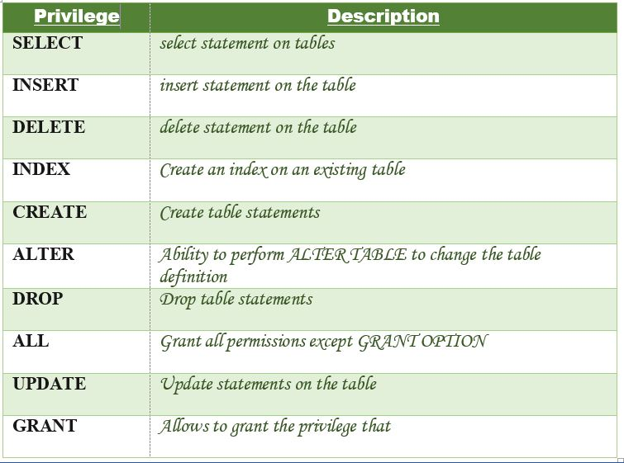 Let us now learn about different ways of granting privileges to the users:

1. **Granting SELECT Privilege to a User in a Table**: To grant Select Privilege to a table named “users” where User Name is Amit, the following GRANT statement should be executed.

GRANT SELECT ON Users TO'Amit'@'localhost;

1. **Granting more than one Privilege to a User in a Table**: To grant multiple Privileges to a user named “Amit” in a table “users”, the following GRANT statement should be executed.

GRANT SELECT, INSERT, DELETE, UPDATE ON Users TO 'Amit'@'localhost;

1. **Granting All the Privilege to a User in a Table**: To Grant all the privileges to a user named “Amit” in a table “users”, the following Grant statement should be executed.

GRANT ALL ON Users TO 'Amit'@'localhost;

1. **Granting a Privilege to all Users in a Table**: To Grant a specific privilege to all the users in a table “users”, the following Grant statement should be executed.

GRANT SELECT ON Users TO '*'@'localhost;

1. In the above example the “*” symbol is used to grant select permission to all the users of the table “users”.
2. **Granting Privileges on Functions/Procedures**: While using functions and procedures, the Grant statement can be used to grant users the ability to execute the functions and procedures in MySQL. **Granting Execute Privilege**: Execute privilege gives the ability to execute a function or procedure. **Syntax:**

GRANT EXECUTE ON [ PROCEDURE | FUNCTION ] object TO user;

Different ways of granting EXECUTE Privileges:

**Granting EXECUTE privileges on a function in MySQL.**: If there is a function named “CalculateSalary” and you want to grant EXECUTE access to the user named Amit, then the following GRANT statement should be executed.

GRANT EXECUTE ON FUNCTION Calculatesalary TO 'Amit'@localhost';

**Granting EXECUTE privileges to all Users on a function in MySQL.**: If there is a function named “CalculateSalary” and you want to grant EXECUTE access to all the users, then the following GRANT statement should be executed.

GRANT EXECUTE ON FUNCTION Calculatesalary TO '*'@localhost';

**Granting EXECUTE privilege to a Users on a procedure in MySQL.**: If there is a procedure named “DBMSProcedure” and you want to grant EXECUTE access to the user named Amit, then the following GRANT statement should be executed.

GRANT EXECUTE ON PROCEDURE DBMSProcedure TO 'Amit'@localhost';

**Granting EXECUTE privileges to all Users on a procedure in MySQL.**: If there is a procedure called “DBMSProcedure” and you want to grant EXECUTE access to all the users, then the following GRANT statement should be executed.

GRANT EXECUTE ON PROCEDURE DBMSProcedure TO '*'@localhost';

**Checking the Privileges Granted to a User**: To see the privileges granted to a user in a table, the SHOW GRANTS statement is used. To check the privileges granted to a user named “Amit” and host as “localhost”, the following SHOW GRANTS statement will be executed:

SHOW GRANTS FOR 'Amit'@localhost';

**Output:**

GRANTS FOR Amit@localhost

GRANT USAGE ON *.* TO `SUPER`@localhost`