SUMMER INTERNSHIP PROJECT
Report on
“WEB DESIGN”
at
FRONTLINE TECHNOLOGIES
Karur

Summer Training Project Report
Submitted in the partial fulfillment of M.Sc., Computer Science III Semester
PG & RESEARCH DEPARTMENT OF COMPUTER SCIENCE


GOVERNMENT ARTS COLLEGE (AUTONOMOUS), Karur-5.
(Affiliated to Bharathidasan University, Tiruchirapalli - 24)
(Re-Accredited with B⁺⁺ Grade By NAAC)
(2023-2025)

Mentor Submitted By
Dr. M. PRABAKARAN, M.Sc., M.Phil., M.Tech., Ph.D., Name: R. GAYATHRI
Associate Professor & Head Reg.no: 232513
Dept: COMPUTER SCIENCE

CERTIFICATE

This is to certify that the Internship work is done by R. GAYATHRI (Reg No: 232513) in partial fulfillment of the requirement for the award of degree of M.Sc., Computer Science(2023-2025) is the original work done by the candidate under my guidance and submitted to Bharathidasan University, Trichy, through Government Arts College(Autonomous), Karur-5.

Signature of the HOD Signature of the Mentor

Submitted for Viva – Voce Examination held on _________________

Signature of the Internal Examiner Signature of the External Examiner

COMPANY CERTIFICATE

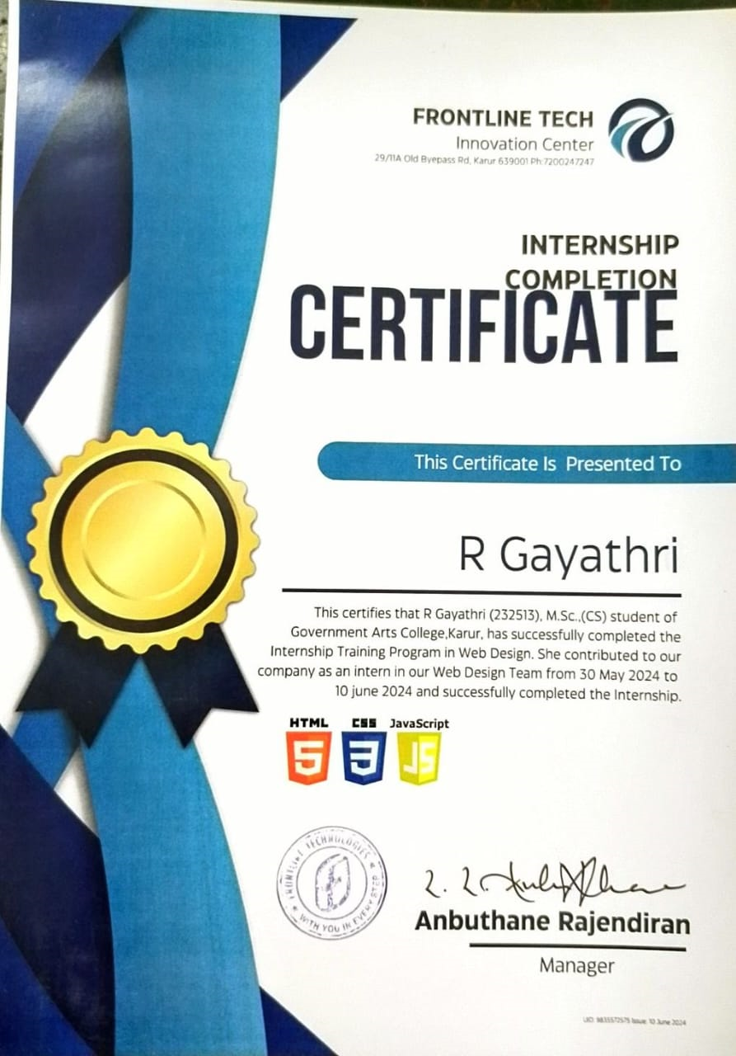

DECLARATION

I am R. GAYATHRI do here by declare that the Internship work has been undertaken by me as part of my studies in the degree M.Sc., Computer Science. I have completed this work under the guidance of Dr. M. PRABAKARAN Associate Professor & Head, PG and Research Department of Computer Science, Government Arts College (Autonomous), Karur-5 and FRONTLINE TECHNOLOGIES their guidance.
I also declare that this work has not been submitted for the award of any degree, diploma, associateship or fellowship or any other title in this University or any other University.

R. GAYATHRI

ACKNOWLEDGEMENT

I am indebted to many people who helped me to accomplish this internship successfully.
I thank Dr. S. ALEXANDER, M.A., M.Phil., Ph.D., Principal for granting permission to undertake this internship program.
I thank Dr. M. PRABAKARAN, M.Sc., M.Phil., M.Tech., Ph.D., Associate Professor & Head, PG and Research Department COMPUTER SCIENCE for his support and guidance during the course of my Internship.
I thank FRONTLINE TECHNOLOGIES for allowing me to undertake this internship program and supported me in gaining the knowledge to bridge the gap between the curriculum and the industry.
I thank my parents for their blessings and constant support, without which this internship would not have seen the light of day.

INDEX

S.NO | CONTENTS | PAGE NO
1 | Certificate | 02
2 | Company Certificate | 03
3 | Declaration | 05
4 | Acknowledgement | 06
5 | Introduction | 08
6 | Learning Objectives | 09
7 | Organization Profile | 10
8 | Domain Specification | 12
9 | Challenges and Opportunities | 13
10 | Technologies Used HTML, CSS, JAVASCRIPT | 15
11 | Conclusion | 18
12 | References | 19
13 | Appendix | 20

INTRODUCTION

- Web design encompasses many different skills and disciplines in the production and maintenance of websites. Often any individuals will work in teams covering different aspects of the design process, although some designers will cover then all
- The term “Web design” is normally used to describe the design process relating to the front – end (client side) design of a website including writing markup.
- Web designers use a variety of different tools depending on what part of the production process they are involved in.
- Web designers use both vector and raster graphics editors to create web formatted imagery or design prototypes.
- Technologies used to create websites include W3C standards like HTML and CSS, which can be hand – coded or generated by WYSIWYG editing software.
- Other tools web designers might use include markup validators and other testing tools for usability and accessibility to ensure their websites meet web accessibility guidelines.
- This internship report documents my experiences and learning during my web design internship at frontline technologies.
- The focus of this internship was on web design using HTML5, CSS3 and JAVASCRIPT. Throughout this period, I had the opportunity to work on various projects, enhancing my skills and understanding of web development.

LEARNING OBJECTIVES

- During the internship, I learned about:
- The structure and semantics of HTML5.
- Styling and layout techniques using CSS3.
- Interactive elements and dynamic content creation using JavaScript.
- Responsive design principles.
- Understand how to plan and conduct user research related to web usability.
- Develop skills in analyzing the usability of a website.

ORGANIZATION PROFILE



FRONTLINE TECHNOLOGIES

Frontline Technologies in Jawahar Bazaar, Karur is Known to satisfactorily cater to the demands of its customer base. The business came into existence n 2008 and has, since then, been a known name in its field. It stands located at No.29/11A Mani Traders, Near State Bank Of India, Old Bypass Road, Jawahar Bazaar-639001.Near State Bank Of India is a prominent landmark in the area and this establishment is in close proximity to the same.
The business strives to make for a positive experience through its offerings. The accepted modes of payment such as Cash, Debit Cards, Credit Card make every business transaction easy and seamless, contributing to making the entire process even more effective.

BRANDING

A Product’s reach in every aspect depends on how it is being promoted. Frontline Tech fusions all facets of branding to bring a unique solution to your business online. Our branding service encompasses creating logo, brand name, web designing, e-commerce trading, SEO/SMO, 3D, external/internal visualization and more. We develop solid strategic branding framework with inspirational ideas.

WEB DEVELOPMENT

Frontline Tech provides the combined services of web designing, website development and maintenance to our clients.

PRODUCT DEVELOPMENT

Frontline Tech provides complete product development services to especially bridge the gap between the clients and their customers.
- Developing right concept
- Market research/Analysis
- Designing/Engineering/Developing the product
- Testing and launching online

APP DEVELOPMENT

Android, IOS, Windows applications are provided as a part of our service, either be it native applications or any platform. We also extend our services to Internet of Things (IOT), home automation, wearable and watches, and connected devices. We design and build the same with best and trendy user interfaces for TV apps on:
- Apple TV (tvOS)
- Android TV
- Fire TV

CONTACT



Head office: 29/11A Old Bypass Road, Karur-639 001.
Telephone: +91 7200 247 247| +91 866 755 9595,+91 88834 88821
E-mail: info@frontlinetech.in

DOMAIN SPECIFICATION
DOMAIN NAME: WEB DESIGN
ABOUT
- Web design is the process of creating the visual look and layout of a website it involves arranging text, image and other elements to make the website attractive and easy to use.
- This includes choosing color, fonts and graphics as well as making sure the site is organized in a way that helps visitors find what they need.
- The goal is to create a site that is both visually appealing and functional, meeting the needs of its users the website is used for the user-friendly.
- The web design is the planning and creation of the websites

The Web Design in two words
WEB: The web allows people to find information, communicate and interact online
DESIGN: Design is the process of planning and creating something with a specific purpose or function in mind.

WED DESIGN CHALLENGES
Design: Ensuring that websites function well on various devices and screen sizes is a major challenge. This involves creating flexible layouts and images that adapt to different resolutions
Browser Compatibility: Websites need to work seamlessly across different web browsers. Differences in how browsers interpret code can cause inconsistencies in how a website is displayed
Performance Optimization: Fast loading times are crucial for user retention and SEO. This requires optimizing images, minimizing code, and leveraging techniques like lazy loading
User Experience (UX): Designing intuitive and engaging interfaces that provide a good user experience can be complex. This involves understanding user behavior, creating effective navigation, and ensuring accessibility.
Accessibility: Making websites accessible to people with disabilities is not only a best practice but also a legal requirement in many places. This includes providing alternative text for images, ensuring keyboard navigation, and using proper HTML semantics.
Security: Protecting websites from security threats like hacking, data breaches, and malware is essential. This involves implementing SSL certificates, secure coding practices, and regular security audits
Content Management: Managing and updating website content efficiently is important. Choosing the right content management system (CMS) and ensuring it’s user-friendly for content creators is a challenge.

OPPORTUNITIES
SCOPE OF WEB DESIGN IN FUTURE
Studying web design provides you with the technical and design-relate skills needed for a career in the web, software development an computer science industries
- Motion designer
- Web Developer
- UX Designer
- Front-end developers
- UI Designer
- Freelancing
- Startups
- In-House Roles
- E-commerce
- Specialization
- Education
- Voice User Interface
- 3D Graphics and Visuals
- AI and Automation

TOOLS AND TECHNOLOGIES USED

HTML

- HTML Stands for Hypertext Markup language. Hypertext means machine readable text, it is the method by which you can move anywhere on the internet by clicking on the links.
- Markup means it contains a set of Markup symbols, Tags, elements or codes that we insert in a file, which displays on WWW browser page.
- HTML is used to create web pages by using certain elements which are buildings blocks of HTML pages.

HTML 5

- HTML5 is an updated version of HTML that brings additional features to the Markup language.
- HTML doesn’t provide support for video and audio.HTML5 supports both audio and videos.
- HTML5 is a markup language used for structuring and presenting Hypertext document on the World Wide Web.
- HTML 5 is the fifth and current version of HTML. It has improved the markup available for documents and has introduced application programming interfaces (API) and Document Object Model (DOM).
- There are new graphics elements including vector graphics and tags.

CSS
- Cascading Style Sheets (CSS): CSS is defined as a method sheet language that provides web designers control over how an internet site communicates with web browsers including the formatting and display of their HTML documents.
- CSS stands for Cascading Style Sheets. CSS describes how HTML elements are to be displayed on screen paper or in other media.
- It can control the layout of multiple web pages all at once. External file style sheets are stored in CSS files. It is primarily used to provide styling to web pages, including color, layout, background, font, and border properties.
- The main objective of CSS is to improve content accessibility, provide enhanced flexibility and control, and specify presentation characteristics.

TYPES OF CSS
- Inline CSS: Styles added directly to the HTML element.
- Internal CSS: Styles defined at the head section of the document.
- External CSS: Styles defined in a separate file.

CSS3
- CSS3 stands for Cascading Style Sheets Level 3. It is an advanced version of CSS, used for structuring, styling, and formatting web pages.
- CSS3 introduces several new features and is supported by all modern web browsers. One of the most significant advancements in CSS3 is the splitting of CSS standards into separate modules, making it simpler to learn and use.css3 is simply CSS.

JAVASCRIPT
- JavaScript is a scripting language use to create and control dynamic website content.
- JavaScript is scripting or programming language that allows you to implement complex feature on webpage.
- JavaScript is a scripting language that enables you to create dynamically updating content, control multimedia, animate images.
- It is well-known for the development of web pages, and many non-browser environments also use it.
- JavaScript is a programming language that adds interactivity to your website.
- This happens in games, in the behavior of responses when buttons are pressed or with data entry on forms; with dynamic styling; with animation, etc.
- JavaScript can be used for Client-side developments as well as Server-side developments. JavaScript is both an imperative and declarative type of language.
- JavaScript contains a standard library of objects, like Array, Date, and Math, and a core set of language elements like operators, control structures, and statements.

CONCLUSION

This internship has been a valuable experience, providing me with practical skills and knowledge in web design. I have gained a deeper appreciation for the complexities of frontend development and feel more confident in my abilities to contribute to web development project. I started honing my HTML, CSS and Java Script skills , creating various layouts, and mastering advanced concepts. I learn many new things about the HTML,CSS, and Java Script and it was a wonderful learning experience to me while working on this internship.

REFERENCES

Reference for the front-End programs
- HTML
- CSS
- JAVASCRIPT
https://en.wikipedia.org/wiki/HTML
https://en.wikipedia.org/wiki/CSS
https://en.wikipedia.org/wiki/JAVASCRIPT
https://cherancbse.com

APPENDIX

HTML

BELOW EXAMPLE ILLUSRATE THE HTML CONTENT

<!DOCTYPE html>
<html>
<head>
<title>My web page</title>
</head>
<body>
<h1>Hello, world!</h1>
<p>This is my first web page.</p>
<p>It contains a
<strong>main heading</strong> and <em> paragraph </em>.
</p>
</body>
< /html>

OUTPUT

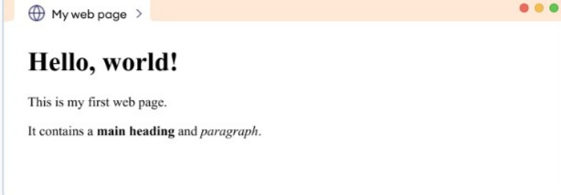

CSS

BELOW EXAMPLE ILLUSRATE THE CSS CONTENT

<!DOCTYPE html>
<html>
<head>
<title> HTML 5 Demo</title>
<style>
.intern{ font-size:40px; font-weight:bold; color:green;} body { text-align:center; }
</style>
</head>
<body>
<div class = "intern">Hello World!
</div> <aside> <div>This is Insiya Badshah</div> </aside>
</body>
</html>

OUTPUT

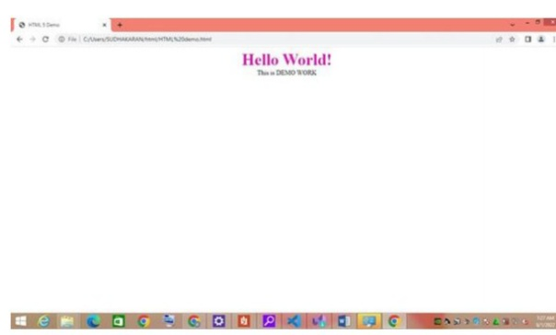

JAVASCRIPT

BELOW EXAMPLE ILLUSRATE THE JAVASCRIPT CONTENT

<html>
<body>
<h1>JavaScript Variables</h1>
<p>In this example, x, y, and z are variables.</p>
<p id="demo"></p>
<script>
var x = 5;
var y = 6;
var z = x + y;
document.getElementById("demo").innerHTML =
"The value of z is: " + z;
</script>
</body>
</html>

OUTPUT

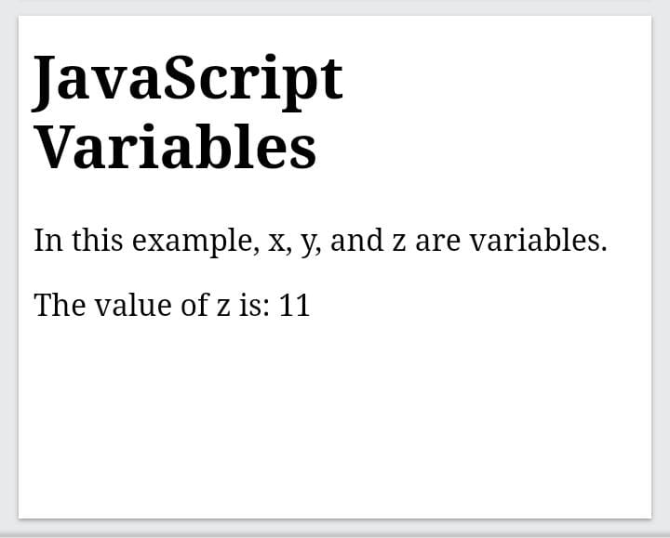

FRONTEND CODING

HTML CODING FOR HOME PAGE
<!DOCTYPE html>
<html>
<head>
<title>Cheran Universal Public School</title>
<link rel="stylesheet" href="style.css">
</head>
<body>
<header>
<div class="container">
<div class="logo">
<img src="logo.png" alt="Cheran Universal Public School">
</div>
<nav>
<ul>
<li><a href="#">Home</a></li>
<li><a href="#">About Us</a></li>
<li><a href="#">Academics</a></li>
<li><a href="#">Infrastructure</a></li>
<li><a href="#">Mandatory Disclosure</a></li>
<li><a href="#">Gallery</a></li>
</ul>
</nav>
<div class="contact">
<a href="#">9791775999</a>
<a href="#">cherancbse@gmail.com</a>
</div>
<div class="social">

<a href="#"><i class="fab far-facebook-f"></i></a>
<a href="#"><i class="fab fa-twitter"></i></a>
<a href="#"><i class="fab fa-linkedin-in"></i></a>
<a href="#"><i class="fab fa-google-plus-g"></i></a>
<a href="#"><i class="fab fa-instagram"></i></a>
<div class="language">
<select>
<option value="english">English</option>
<option value="hindi">Hindi</option>
</select>
</div>
<div class="login">
<a href="#">Login</a>
</div>
</header>
<section class="hero">
<div class="container">
<h1>HEARTY WELCOME TO CUPS</h1>
<h2>CHERAN UNIVERSAL PUBLIC SCHOOL</h2>
<img src="hero-image.jpg" alt="School Building">
</section>
<footer>
<div class="container">
<p>&copy; 2023 Cheran Universal Public School. All Rights Reserved.</p>
</div>
</footer>
<script src="https://kit.fontawesome.com/your-font-awesome-kit-id.js" crossorigin="anonymous"></script>
</body> </html>

CSS CODING FOR HOME PAGE

body {
font-family: sans-serif;
margin: 0;
padding: 0;
}
container {
max-width: 1200px;
margin: 0 auto;
padding: 0 20px;
}
header {
background-color: #f5f5f5;
padding: 20px 0;
}
.logo img {
width: 150px;
nav ul {
list-style: none;
margin: 0;
padding: 0;
display: flex;
justify-content: flex-end;
}
nav li {
margin-left: 20px;
}
nav a {

text-decoration: none;
color: #333;
}
.contact, .social, .language, .login {
display: inline-block;
margin-left: 20px;
}
.hero {
background-color: #fff;
padding: 80px 0;
text-align: center;
}
.hero h1 {
font-size: 48px;
margin-bottom: 20px;
}
.hero h2 {
font-size: 24px;
margin-bottom: 40px;
}
.hero img {
max-width: 100%;
height: auto;
}
footer {
background-color: #333;
color: #fff;
padding: 20px 0;
text-align: center;}

BACKEND CODING
JAVA SCRIPT CODING FOR HOME PAGE
const languageSelect = document.getElementById('language-select');
Const loginBtn = document.getElementById ('login-btn');
languageSelect.addEventListener('change', (e) => {
console.log(Language changed to ${e.target.value});
});
loginBtn.addEventListener('click', (e) => {
console.log('Login button clicked');
});
const heroSection = document.querySelector('.hero');
heroSection.animate([
{ opacity: 0 },
{ opacity: 1 }
], {
duration: 1000,
fill: 'for

OUTPUT
