1. SELECT CustomerName FROM Customers WHERE Country ='Germany';

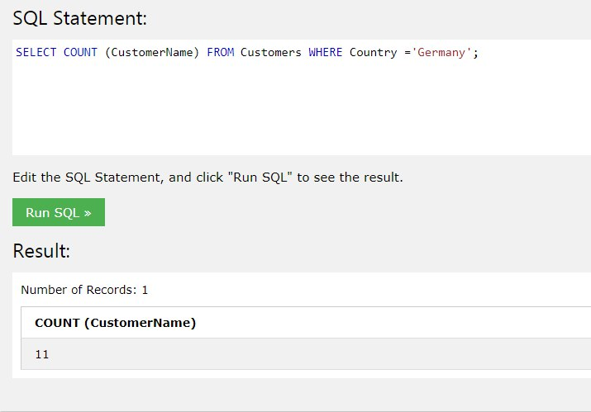

1. SELECT COUNT (CustomerName) FROM Customers WHERE CustomerName LIKE '%e';

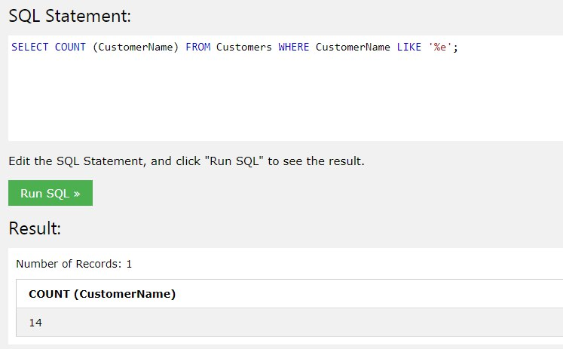

1. INSERT INTO Customers VALUES ('92', 'Anastasia Gazamatova', 'Anastasia', 'Dachnaya 34/1', 'Novosibirsk', '630000', 'Russia');

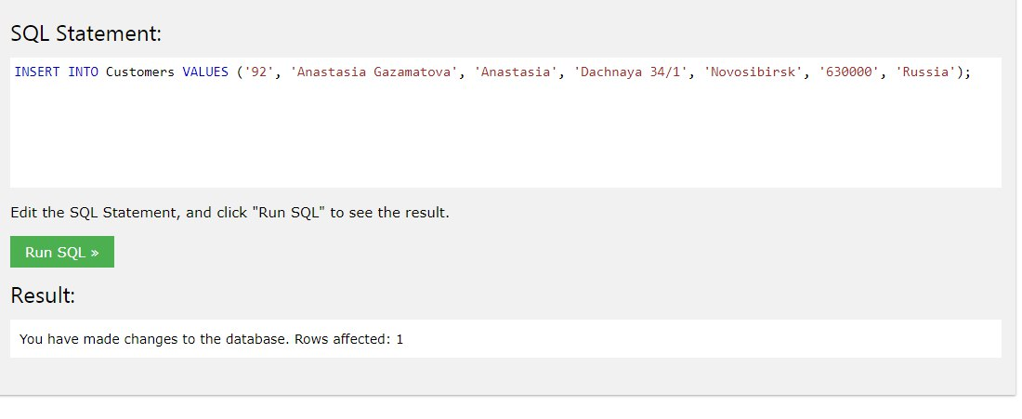

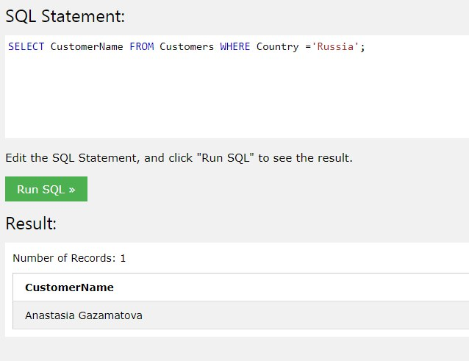

1. UPDATE Customers SET CustomerName = 'Nastja' WHERE CustomerID = '92'

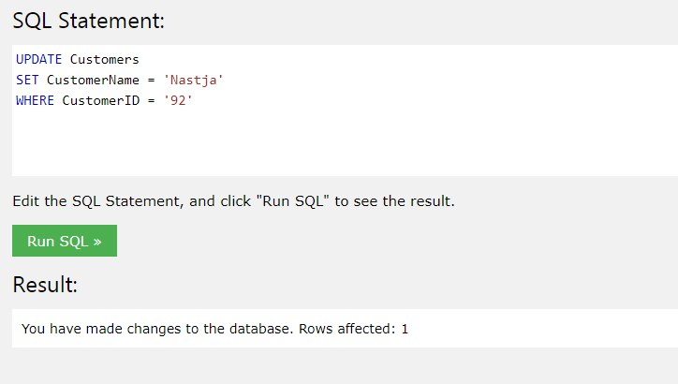

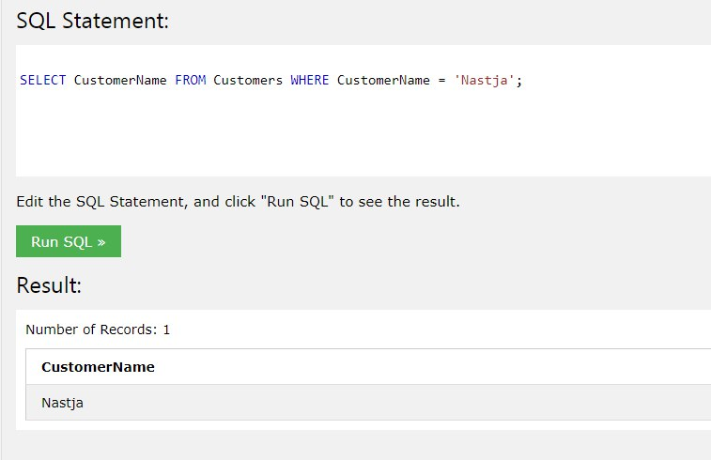

1. DELETE FROM Customers WHERE City='Nantes';

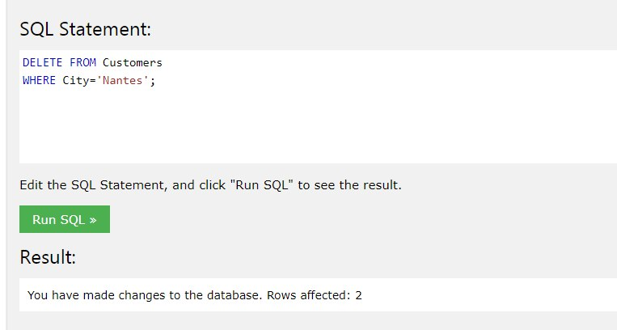

1. SELECT OrderID   
   FROM (Orders INNER JOIN Employees ON FirstName='Steven');

