SMARTSENSE PRO

Product and Compliance Specification
  - Mobile Application HMI Design, Alert Presentation, BLE Operating Logic and SAE J3309 Relationship

Document ID | TRD-SMS-2026-APP01
Revision | A - Initial SmartSense Pro mobile application HMI specification
Date | August 5, 2026
Product | SmartSense Pro Mobile Application - iOS and Android
Designated HMI | SmartSense mobile application only
Primary Safety Architecture | Gateway-primary threshold evaluation with immediate BLE safety-event delivery
Standards Basis | SAE J3309 OCT2024, Sections 5, 6 and 7
Target Audience | Mobile Developers, Gateway Firmware, Cloud, QA, Product, Compliance and OEM Technical Teams
Status | Draft implementation requirements intended to support J3309 conformity; not a certification statement
SmartSense Pro always includes the SmartSense Gateway. The SmartSense mobile application is the only driver HMI for SmartSense Pro. The Gateway remains the primary threshold evaluator and independently sends immediate BLE safety events to the mobile app and telemetry/events to the cloud. The mobile app does not originate TPMS cloud telemetry.

Prepared for SmartSense development partners, hardware suppliers, mobile developers and OEM technical review.

1. Executive Summary
Product role. The SmartSense Pro mobile application is the sole human-machine interface (HMI) used to communicate TPMS status to the driver. It receives current tire data and immediate safety events from the SmartSense Gateway through BLE and presents tire position, pressure, temperature, condition, warnings, malfunction status and Gateway connection state.
Gateway-primary safety decision. The Gateway receives TPMS sensor data, applies the active thresholds defined in the SmartSense cloud and sends an immediate BLE safety-event notification when a condition opens, materially changes or clears. The app presents the complete local warning without waiting for LTE, cloud processing or push-notification delivery.
Routine data and visible refresh are separate. The Gateway may push compact routine telemetry to the phone approximately once per second while Driving Mode or the live tire display is active. The app may receive and validate every packet without redrawing the complete interface for every packet. Visible gauges may update at a slower or state-dependent rate to reduce unnecessary battery use. Critical alerts never wait for routine telemetry or screen refresh.
Connection-loss protection. After a Gateway connection has been established, the phone independently detects BLE connection loss and displays a persistent warning within one second after confirmation. The visual warning cannot be cleared until a validated Gateway connection and current tire data are restored. The audible portion may be acknowledged or silenced.
Compliance relationship. SAE J3309 permits a cellular phone application to serve as an HMI. Conformance applies to the complete installed SmartSense Pro system, including TPMS sensors, Gateway, mobile app, configuration, communications and system testing. This document defines the mobile-app contribution and does not independently establish certification or conformity.

2. Product Scope and Baseline
Category | SmartSense Pro Mobile Application Baseline
Product function | Driver-facing TPMS HMI for SmartSense Pro towable RV and trailer applications.
Supported platforms | iOS and Android production applications.
Required hardware | SmartSense Gateway. Direct sensor-to-phone, dongle, repeater and dedicated-display configurations are outside this document.
HMI designation | The SmartSense mobile application is the only SmartSense Pro HMI.
BLE relationship | Connected BLE communication from the SmartSense Gateway to the mobile application.
Primary alert source | Immediate Gateway-generated BLE safety-event notification.
Routine telemetry | Configurable Gateway BLE telemetry; approximately 1 Hz may be used for a live driving display.
Cloud relationship | The Gateway independently reports TPMS telemetry/events to the cloud and receives approved thresholds/configuration. The app is not the source of TPMS cloud telemetry.
Minimum tire capacity | The HMI data model and display shall support at least 12 installed trailer tires.
Driver information | Tire position, pressure, temperature when available, status, warning, malfunction and Gateway connection state.
Offline behavior | Local Gateway-to-phone warning presentation shall not depend on cellular or cloud availability.
The mobile application must never show Monitoring Active when the Gateway BLE connection is unavailable, the active configuration is invalid, or required tire data is stale.

3. SmartSense Pro Architecture and Mobile HMI Responsibility
Figure 1 shows the required SmartSense Pro flow. The Gateway independently sends local HMI data and immediate safety events to the mobile application and sends telemetry/events to the cloud. The cloud sends approved thresholds and configuration to the Gateway. No mobile-app-to-cloud TPMS data path is required for the local safety function.
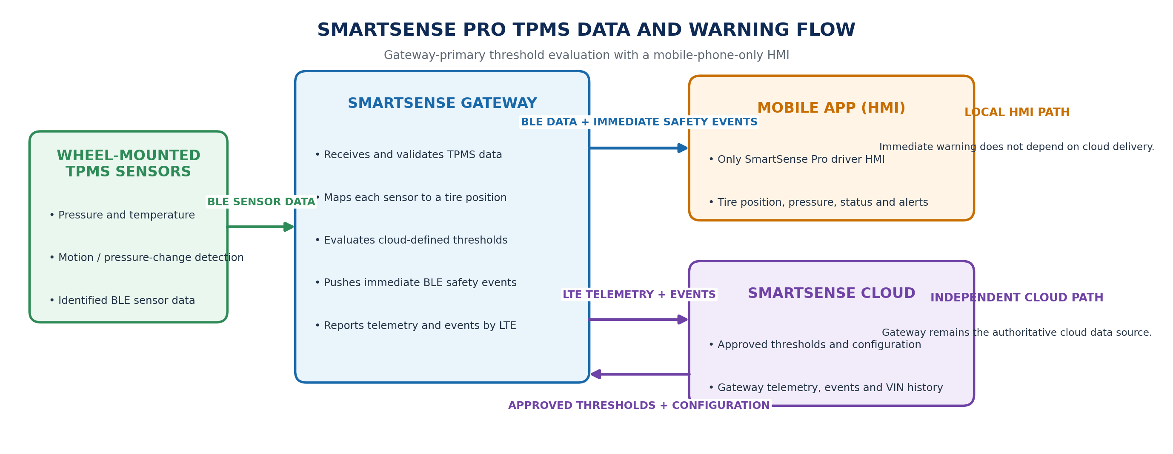
Figure 1. SmartSense Pro sensor, Gateway, mobile-app HMI and cloud data flow.
Element | Primary Responsibility | Required Mobile-App Interface
Wheel-Mounted TPMS Sensors | Measure pressure and temperature and transmit identified sensor data to the Gateway. | The app does not communicate directly with the wheel sensors.
SmartSense Gateway | Receives and validates sensor data, maps tire position, evaluates thresholds and independently sends BLE data/events to the app and LTE data/events to the cloud. | Provide routine telemetry, immediate safety events, event state, connection status, profile version and current data age.
SmartSense Mobile App (HMI) | Present the driver-facing TPMS status and warnings and locally detect Gateway BLE connection loss. | Receive Gateway BLE notifications, render alerts, maintain honest HMI states and support reconnection.
SmartSense Cloud | Define approved thresholds/configuration, receive Gateway telemetry/events and store VIN-based history. | Any cloud push received by the phone is secondary to the local BLE safety path and must not create a duplicate driver alert.

4. Mobile HMI Operating States
The application shall use explicit operating states so the absence of an alert is never interpreted as confirmation that all tires are normal.
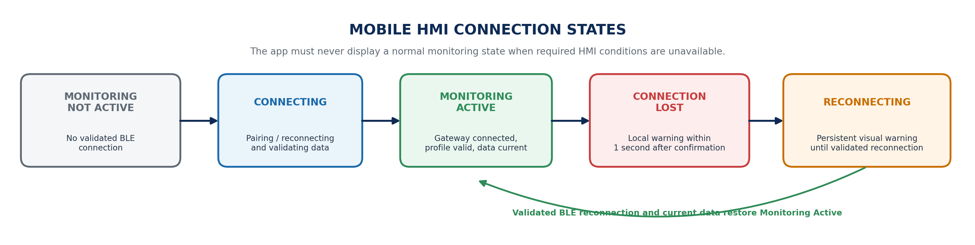
Figure 2. SmartSense Pro mobile HMI connection states and connection-loss behavior.
HMI State | Definition | Required Behavior
Monitoring Not Active | No validated Gateway BLE connection is available. | Do not show a protected or normal state. Display that local monitoring is not active and attempt connection when appropriate.
Connecting | The app is locating, pairing, reconnecting or validating the Gateway and current data. | Show connection progress. Do not enable Monitoring Active until required checks pass.
Monitoring Active | Gateway connected, configuration validated and tire data current. | Show active status, tire positions, current values and condition. Enable local safety-event presentation.
Connection Lost | An established Gateway BLE connection has been confirmed lost. | Generate the warning locally within one second. Keep the visual warning persistent and non-dismissible until validated reconnection.
Reconnecting | Automatic BLE reconnection is in progress. | Continue showing local monitoring unavailable. Audible warning may be silenced; visual state remains.
Cloud Offline | BLE monitoring remains active but internet/LTE/cloud reporting is unavailable. | Continue local monitoring and identify cloud status separately from Gateway connection.
Configuration Invalid | Required tire assignment, SSP or configuration/profile information is invalid or unavailable. | Do not claim full monitoring capability. Identify the configuration problem and required corrective action.

5. BLE Data Reception and Visible Display Refresh
Requirement ID | Mobile Application Requirement
APP-BLE-001 | Subscribe to Gateway BLE GATT telemetry and safety-event notifications or indications. The app shall not require one-second active read/poll operations.
APP-BLE-002 | Receive and validate routine telemetry at the Gateway-configured rate. Approximately one notification per second may be used during active driving or a live tire display.
APP-BLE-003 | Decouple BLE packet receipt from visible UI redraw. Receiving data every second does not require rebuilding or redrawing the complete screen every second.
APP-BLE-004 | Display immediate safety events without waiting for the next routine telemetry packet or visible dashboard refresh.
APP-BLE-005 | Validate event identity, sequence, current data age, tire position, configuration/profile version and required integrity fields.
APP-BLE-006 | Identify stale, missing, repeated, malformed or out-of-order data and prevent stale data from being presented as current.
APP-BLE-007 | Allow the visible display refresh rate to vary by foreground/background state, vehicle motion, active screen and alert condition.
APP-BLE-008 | Reduce unnecessary interface work, animation and database writes when the screen is not visible or values have not materially changed.
Critical safety events are event-driven. The Gateway pushes them immediately. Routine one-second telemetry supports data freshness and the live display, but it is not the critical-alert trigger.

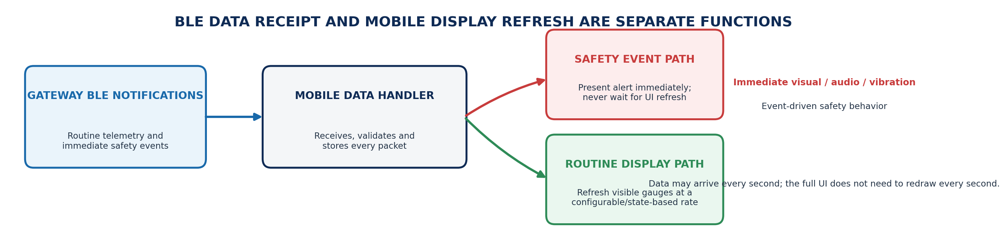
Figure 3. Mobile BLE packet receipt, immediate safety-event presentation and independent visible UI refresh.

6. Alert Presentation and Lifecycle
The Gateway remains the primary threshold evaluator. The mobile app converts the Gateway event code and associated values into the complete driver warning. The application shall not reinterpret or clear the Gateway event in a manner that conflicts with the canonical alert rules.
Condition | Event Source | Required Mobile Presentation | Clear Authority
Low Pressure | Gateway | Affected tire position, current pressure, status/severity and corrective action. | Gateway clear event after approved recovery criteria are satisfied.
High Pressure | Gateway | Affected tire position, current pressure, status/severity and corrective action. | Gateway clear event under approved hysteresis/clear rules.
Rapid Pressure Loss | Gateway | Immediate high-priority visual, audible and vibration warning with affected tire position. | Gateway clear/resolution event; acknowledgement does not clear.
High / Low Tire Temperature | Gateway | Affected tire position, current temperature/status and corrective action when enabled. | Gateway clear event.
Low Sensor Battery | Gateway | Affected tire position and service warning. | Gateway/sensor status returns to normal or sensor is replaced.
Missing / Offline Sensor | Gateway | Identify the unavailable tire position and monitoring malfunction. | Gateway confirms valid communication or approved configuration change.
Gateway Connection Lost | Phone | Persistent local warning that real-time HMI monitoring is unavailable. | Only validated BLE reconnection and current data restore the normal state.
Configuration Invalid | Gateway / Phone validation | Identify that SSP, tire assignment or profile information is missing, stale or incompatible. | Validated configuration is restored.

7. J3309 HMI Functional Requirements
Area | SmartSense Pro Mobile-App Requirement
Startup and active indication | On startup or connection, validate Gateway communication, required tire positions, active configuration/profile and current data. Show Monitoring Active only when required HMI functions are available.
Tire display | Graphically identify each monitored tire position and show current pressure and status. Show temperature when available and relevant to the condition.
Low / high pressure warning | Present the Gateway-generated warning while the TPMS is powered and the trailer is quasi-stationary or moving.
Visual recognition | Provide readable day and night presentation, clear status hierarchy and an unmistakable warning state.
Alert persistence | Acknowledgement may silence audio or record user awareness but shall not clear the underlying warning. The app follows the Gateway open/update/clear event state.
System malfunction | Present missing sensor, invalid configuration, computational or communication malfunction information delivered by the Gateway. The complete system must generate the required malfunction warning no later than 20 minutes after monitoring capability is lost.
HMI connection loss | Display a phone-generated connection-loss message within one second after confirmed BLE loss and keep it displayed until communication is restored.
Owner information | Support OEM-specific instructions explaining monitoring status, warnings, connection-loss behavior, corrective action and operating dependencies.

8. Connection-Loss and Reconnection Requirements
Requirement ID | Specification
APP-CON-001 | Continuously monitor the established BLE connection state while the phone is serving as the SmartSense Pro HMI.
APP-CON-002 | After confirmation of connection loss, create the warning locally within one second without reliance on the Gateway, LTE, cloud or push-notification service.
APP-CON-003 | Keep the visual connection-loss warning active and non-dismissible until BLE communication, configuration validity and current tire data are restored.
APP-CON-004 | Allow the user to acknowledge or silence the audible portion without removing the visual disconnected state.
APP-CON-005 | Automatically attempt reconnection using platform-supported BLE behavior and clearly show the Reconnecting state.
APP-CON-006 | Record disconnect confirmation time, warning display time, reconnection time, configuration/profile version and data-restoration time in the diagnostic log.
APP-CON-007 | If a connection was never established, display Monitoring Not Active rather than a connection-loss alert or normal state.
APP-CON-008 | Distinguish Gateway BLE loss from sensor malfunction and cloud/LTE unavailability. Each condition shall have separate text and status behavior.

9. Application State, Background Operation and Power
- Use BLE GATT notifications or indications rather than frequent active polling.
- Use platform-supported background BLE and automatic reconnection mechanisms. Verify behavior with the app foregrounded, backgrounded and the phone locked.
- Do not claim Monitoring Active when the operating system has suspended required HMI functionality or when the application cannot maintain current Gateway status.
- Make screen keep-alive optional and limited to an active driving display. The HMI safety path shall not require the screen to remain continuously illuminated.
- Receive compact routine telemetry without forcing a complete UI redraw, animation or database write for every packet.
- Reduce routine display refresh and nonessential processing when the trailer is stationary, the tire screen is not visible or no value has materially changed.
- Immediately present Gateway safety events regardless of the routine UI refresh schedule.
- Complete measured battery testing over representative 4-hour, 8-hour and 12-hour drives on supported iPhone and Android models.

10. Data Integrity, Security and Diagnostics
Requirement ID | Specification
APP-DAT-001 | Accept TPMS information only from the authenticated and authorized SmartSense Gateway associated with the active vehicle/VIN.
APP-DAT-002 | Validate protocol version, event identity, sequence, tire-position mapping, units, scaling, status and integrity fields before display.
APP-DAT-003 | Prevent malformed, stale, repeated or out-of-order packets from changing the displayed state incorrectly.
APP-DAT-004 | Preserve the Gateway Event ID/event key through local alert presentation so a later cloud notification for the same event can be suppressed.
APP-DAT-005 | Maintain a local diagnostic record of BLE receipt time, event presentation time, connection state, data age, acknowledgement, clear event and application version.
APP-DAT-006 | The mobile application shall not originate SmartSense Pro TPMS telemetry or safety events for cloud storage. The Gateway independently provides the authoritative cloud data path.
APP-DAT-007 | Any optional mobile threshold cross-check shall use the same active configuration/profile version and shall not override or conflict with the Gateway-generated event state.
APP-DAT-008 | Protect vehicle, sensor and user information in accordance with the approved SmartSense mobile security and privacy architecture.

11. Developer and QA Task Matrix
Team | Required Deliverable | Acceptance Outcome
Mobile iOS / Android | Implement HMI states, BLE subscriptions, event renderer, connection-loss detection, non-dismissible warning, decoupled data/UI refresh, automatic reconnection, local logs and supported background behavior. | Correct tire display; immediate Gateway-event presentation; connection-loss warning within one second; no false Monitoring Active state; measured battery results.
Gateway Firmware | Provide controlled telemetry and safety-event interfaces, active configuration/profile reference, event identity, current data age, connection support and clear-event behavior. | Mobile integration test passes for routine data, immediate events, event updates/clears, 12 tire positions, disconnect/reconnect and offline operation.
Cloud / Backend | Maintain approved threshold/configuration profiles and authoritative Gateway telemetry/event history; preserve event identity in any phone push notification. | Gateway receives correct profiles; cloud events match Gateway identity; optional push does not create duplicate driver alert.
QA / Systems | Test complete sensor-to-Gateway-to-mobile HMI path under bench, vehicle, signal-loss, stale-data, app-state and battery conditions. | Formal HMI, latency, persistence, reconnection, data-integrity, supported-device and J3309 test evidence.
Product / Compliance | Approve HMI terminology, driver messages, operating assumptions, owner instructions and J3309 conformity claims. | No unsupported certification statement; approved OEM-facing documentation and traceability are available.
OEM Integration | Provide tire layout, SSP, tire-position names, warning content and owner-specific instructions. | Correct model/VIN configuration and HMI representation for every approved trailer layout.

12. J3309 Requirements Traceability - Mobile App HMI Focus
J3309 Section | Requirement | SmartSense Mobile-App Implementation | Verification
5.1.1 | Startup system check and active indication | Connection/configuration/data validation and Monitoring Active/Not Active states. | Mobile + Gateway startup test
5.1.2 | Low/high pressure warning while powered | Immediate presentation of Gateway-generated pressure safety events while quasi-stationary or moving. | Bench and vehicle pressure tests
5.1.3 | Self-diagnostic / malfunction warning | Display Gateway missing-sensor, invalid configuration and processing/communication malfunction states. | System malfunction vehicle test
5.1.4 | Minimum 12 installed tires | Mobile data model and tire-position UI support at least 12 trailer tires. | Capacity and all-position HMI test
5.1.12 | Field-adjustable SSP | Display and use the active authorized SSP/configuration received through the Gateway path. | Configuration synchronization test
5.1.13-5.1.14 | Pressure and temperature accuracy | Display Gateway-decoded values without introducing unacceptable unit, scaling, rounding or presentation error. | End-to-end accuracy test
6.1.1 | Tire location, pressure and status on HMI | Graphical tire-position display with current pressure and condition/status. | Day/night HMI inspection
6.1.2-6.1.5 | Optical warning, activation and persistence | Prominent warning presentation; acknowledgement does not clear; follow Gateway open/update/clear state. | Pressure reduction, persistence and recovery tests
6.1.6 | Malfunction warning no later than 20 minutes | Present the Gateway-generated malfunction state and maintain it until recovery. | Communication-failure test
6.1.7 | Connection-loss message within one second and persistent | Phone-generated non-dismissible connection-loss state after confirmed BLE loss. | BLE disconnect/reconnect timing test
6.3.1 | Owner instructions | OEM-specific app/HMI instructions and explanation of monitoring dependencies and corrective actions. | Documentation review
7.1-7.4 | Complete system test procedures | Participate as the designated HMI in pressure, temperature, signal and malfunction testing. | Formal J3309 test reports
END OF DOCUMENT

