SMARTSENSE PRO

Product and Compliance Specification
  - TPMS Sensor Design, Operating Logic and SAE J3309 Relationship
━━━━━━━━━━━━━━━━━━━━━━━━━━━━━━━━━━━━━━━━━━━━━━━━━━━━
Document ID | TRD-SMS-2026-TPMS02
Revision | D - Removed Sections 12, 14 and 15; renumbered J3309 traceability section
Date | August 5, 2026
Product | SmartSense Pro internal valve-stem BLE TPMS Sensor
Application | Towable RVs and trailers under 26,000 lb GVWR
Standards Basis | SAE J3309 OCT2024; referenced SAE J1455, J2721, J1113 and 47 CFR Part 15
Target Audience | Sensor Supplier, Firmware, Gateway, Mobile, QA, Laboratory, Product and Compliance Teams
Status | Draft for engineering and hardware-partner review; not a certification or conformance statement

Key compliance boundary: SAE J3309 applies to the complete SmartSense Pro TPMS warning system. The wheel-mounted sensor provides pressure, temperature, identity and communication data to the SmartSense Gateway. The Gateway evaluates the approved thresholds and independently sends information to the SmartSense mobile app HMI and to the SmartSense cloud. The sensor alone cannot establish J3309 conformance.

Prepared for SmartSense development partners, hardware suppliers, laboratories and OEM technical review.

1. Executive Summary
Product role. The SmartSense TPMS Sensor is an internal valve-stem-mounted BLE device that measures tire pressure and tire temperature and communicates sensor identity, battery condition and status information to the SmartSense Gateway. The sensor is the first element in the safety-warning chain.
J3309 relationship. SAE J3309 defines performance for the complete trailer TPMS, including sensing, analysis, communications, malfunction detection and the driver HMI. The sensor directly supports the standard through measurement accuracy, sampling behavior, unique identification, RF reliability, durability and wheel-environment performance. For SmartSense Pro, the SmartSense Gateway, SmartSense mobile app HMI and SmartSense cloud complete the remaining system functions.
Current operating logic. The confirmed high-rate BLE timings are Roll Alert Mode every 200 milliseconds, Roll Mode every 1.5 seconds and DeltaP Mode every 200 milliseconds. Stationary behavior is currently represented as approximately every 15 minutes. State durations, pressure-change triggers and transition rules must be confirmed against the production firmware specification before customer release or formal testing.
Compliance objective. The SmartSense program shall maintain one requirements-to-test traceability matrix that maps each applicable J3309 requirement to the responsible component, SmartSense Pro system component, verification method and objective evidence. Component durability alone is insufficient; the complete SmartSense Pro sensor-to-gateway-to-mobile-app warning path must pass as an installed system.
This specification uses SAE J3309 section references and paraphrases the requirements. The licensed SAE document controls the final test limits and procedures.

2. Product Scope and Baseline
Category | Current SmartSense Baseline
Product function | Direct tire-pressure and tire-temperature monitoring for towable RV and trailer applications.
Installation | Internal valve-stem-mounted sensor installed within the tire/wheel assembly.
Communication | Bluetooth Low Energy communication from the wheel-mounted TPMS sensor to the SmartSense Gateway.
Measured / reported information | Tire pressure, tire temperature, sensor ID, battery condition and communication/status information.
Preliminary pressure range | 0 to 203 PSI; final production rating and accuracy shall be confirmed.
Preliminary temperature range | -40 °C to +125 °C product target; J3309 system operation is evaluated across its specified range.
Power | Sealed lithium battery; service-life claim must be supported by measured duty-cycle data.
Environmental target | IP67/IP68 target is a product claim requiring independent verification; it does not replace J3309/J1455 durability testing.
Vehicle association | Each sensor is assigned to one SmartSense Pro tire position and associated with the vehicle VIN through the Gateway and cloud record.
Replaceability | A sensor may be replaced or reassigned without replacing the vehicle record or disabling the other tire positions.

Preliminary brochure values are not release specifications. Final pressure range, temperature range, battery life, environmental rating, dimensions, valve hardware and firmware behavior require controlled production specifications.

3. SmartSense Pro J3309 System Flow and Sensor Responsibility
Figure 1 shows the SmartSense Pro data flow. The wheel-mounted TPMS sensor communicates to the SmartSense Gateway. The Gateway independently sends TPMS data and immediate safety events to the SmartSense mobile app HMI and sends telemetry and events to the SmartSense cloud. The cloud defines approved thresholds and configuration profiles and sends them to the Gateway. The mobile app does not send TPMS data to the cloud in this flow.
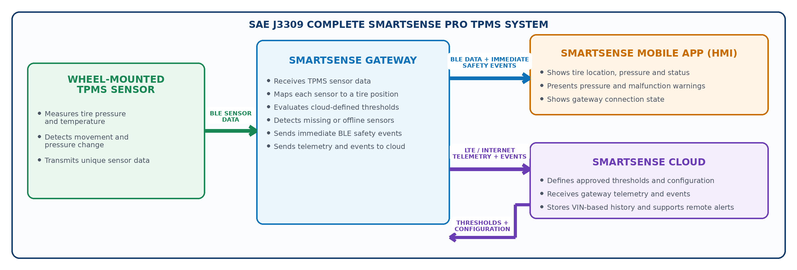
Figure 1. SmartSense Pro TPMS sensor, Gateway, mobile-app HMI, and cloud data flow.
Element | Primary Responsibility | Required Evidence
Wheel-Mounted TPMS Sensor | Measures tire pressure and temperature; provides unique identity, battery/status information and timely BLE sensor data to the SmartSense Gateway. | Accuracy, operating-mode timing, durability, proof pressure, rapid deflation, centrifugal, RF and environmental evidence.
SmartSense Gateway | Receives TPMS sensor data, maps each sensor to a tire position, evaluates cloud-defined thresholds, detects missing/offline sensors and independently sends data and events to the mobile app and cloud. | Protocol handling, threshold logic, tire-position mapping, sensor timeout, BLE event delivery, cloud reporting and malfunction testing.
SmartSense Mobile App (HMI) | Receives Gateway data and immediate BLE safety events; shows tire position, current pressure, status, warnings and Gateway connection state. | HMI inspection, alert timing, warning persistence, day/night visibility and connection-loss testing.
SmartSense Cloud | Defines approved thresholds and configuration profiles; sends configuration to the Gateway; receives Gateway telemetry/events; stores VIN-based history and supports remote notification. | Configuration control, versioning, audit history, Gateway synchronization and cloud event-processing evidence.

4. TPMS Sensor Operating Logic
The sensor changes BLE behavior based on pressure, movement and service state. These are sensor-to-receiver communication intervals, not cloud-reporting intervals.
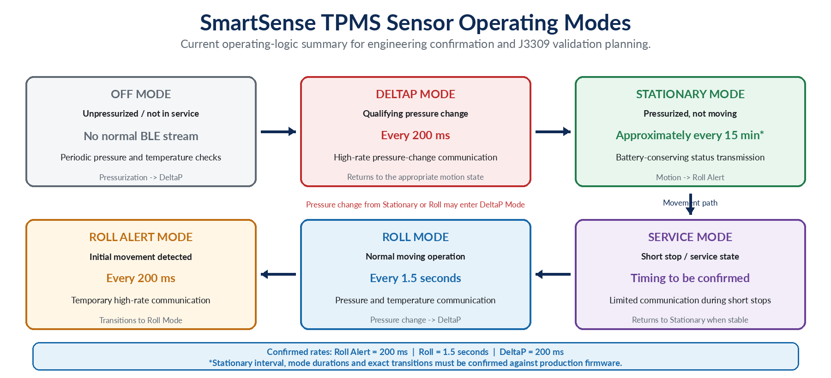
Figure 2. Current SmartSense TPMS operating-mode summary. Items marked for confirmation must be verified with the sensor firmware owner.
Mode | Condition | Current Behavior | Production Confirmation Required
Off Mode | Very low or no pressure / not in service | No normal BLE data stream; periodic pressure and temperature checks. | Exact pressure threshold and check interval.
DeltaP Mode | Qualifying pressure change | Transmits every 200 ms. | DeltaP threshold, window, duration, retransmission behavior and exit rule.
Stationary Mode | Pressurized and not moving | Reduced transmission; currently represented as approximately every 15 minutes. | Exact interval, jitter, temperature update behavior and missing-sensor timeout interaction.
Roll Alert Mode | Initial movement detected | Transmits every 200 ms. | Entry motion threshold, mode duration and transition to Roll Mode.
Roll Mode | Normal moving operation | Transmits every 1.5 seconds. | Motion detection method, packet content and transition to DeltaP or Service.
Service Mode | Short stop / service state | Limited transmissions to avoid immediate long-term stationary behavior. | Entry, duration, transmission interval and return-to-stationary logic.

The sensor operating rate must be sufficient to support the complete system response required by J3309. Formal latency claims must include sensor detection, sensor-to-receiver transmission, receiver evaluation and HMI presentation.

5. Sensor Data, Identity and Communication Requirements
Requirement ID | Specification
SNS-COM-001 | Each production sensor shall have a unique, non-ambiguous identifier traceable to manufacturing records.
SNS-COM-002 | Every valid transmission shall provide sufficient information for the approved receiver to determine sensor identity, pressure, temperature and current sensor status.
SNS-COM-003 | The protocol shall include a controlled version and a defined method for detecting malformed, stale, duplicated or corrupted data.
SNS-COM-004 | The receiving system shall reject unauthorized or incorrect cross-vehicle sensor association and maintain the correct tire-position mapping.
SNS-COM-005 | The sensor shall support the maximum intended tire count and coexist with adjacent SmartSense systems and expected Wi-Fi/Bluetooth interference without unacceptable data loss or cross-assignment.
SNS-COM-006 | Signal strength and packet-delivery performance shall be validated at every intended wheel position, with representative wheels, tires, trailer structures, loads and receiver locations.
SNS-COM-007 | Loss and restoration of sensor communication shall be detectable by the receiving system in both moving and stationary operating modes.
SNS-COM-008 | Wireless operation and marketed hardware shall complete applicable FCC authorization and Bluetooth qualification.

6. Measurement, Calibration and Threshold Support
Area | Requirement / Interpretation
Pressure measurement | J3309 Section 5.1.13 specifies the permitted pressure-device accuracy across the normal operating range. The sensor allocation should be tighter than the total system limit to preserve margin for encoding, gateway conversion and HMI display.
Temperature measurement | J3309 Section 5.1.14 specifies the permitted temperature-device accuracy across the normal operating range. Sensor response time and correlation to actual tire-air temperature must also be characterized.
Resolution and scaling | Pressure and temperature resolution, units, scaling, rounding, saturation and invalid-value behavior shall be formally specified and identical across receiver implementations.
Calibration | Production calibration, calibration coefficients, reference equipment, recalibration checks and end-of-line pass limits shall be documented and traceable to the sensor serial number.
Long-term stability | Accuracy and calibration drift shall remain within the approved product allocation after thermal, mechanical, pressure, battery-aging and chemical exposures.
Threshold support | The sensor supplies measurements; SSP, OSP, MAP, temperature compensation, hysteresis, warning persistence and clearing are system-level functions unless the production sensor firmware explicitly performs part of those calculations.

Do not validate only the sensor display value. The full chain must be checked: reference pressure/temperature -> sensor measurement -> BLE encoding -> receiver decoding -> threshold calculation -> HMI display and warning.

7. J3309 Functional Requirements Supported by the Sensor
J3309 Section | Topic | Sensor Contribution | System Dependency
5.1.3 | Self-diagnostic / malfunction | Provide predictable identity, status and transmission behavior so the system can detect no transmission, incompatible sensor or invalid data. | SmartSense Gateway and mobile app HMI create the malfunction warning.
5.1.4 | Minimum 12 installed tires | Support simultaneous operation in the intended 12-tire trailer configuration without unacceptable RF collision or identity ambiguity. | SmartSense Gateway data model and mobile app HMI must support all positions.
5.1.5-5.1.6 | Sampling and pressure signal | Provide sampling and communication rates sufficient for pressure comparison and warning determination for every configured tire. | SmartSense Gateway evaluates and communicates warning state.
5.1.8-5.1.10 | Wireless signal, integrity and EMI | Meet signal-strength, FCC, identity, data-integrity and applicable EMI expectations. | System installation and EMC testing remain required.
5.1.11 | Sensor environmental robustness | Wheel-mounted sensors are required to comply with SAE J1455. | Formal J1455-based component test plan and evidence.
5.1.13-5.1.14 | Pressure and temperature accuracy | Meet allocated sensor accuracy and preserve full-system compliance through encoding and display. | End-to-end system accuracy test.
5.1.15 | Tire performance / service | Sensor mounting shall not interfere with tire performance, fitment, mounting or dismounting. | Wheel/tire installation and service testing.
5.1.16 | Single sensor failure | Failure or replacement of one sensor shall not disable monitoring of the other tires. | SmartSense Gateway, mobile app and cloud continue other positions and identify the failed position.
5.1.17 | Operating conditions | Function across required speed, road, maneuver, load and temperature conditions. | Bench, vehicle and installation testing.

8. Mechanical, Tire and Environmental Requirements
Test Area | Requirement
Environmental - SAE J1455 | Thermal cycling, thermal shock, humidity, altitude, mechanical shock, drop, vibration and applicable combined conditions. Verify function before and after each exposure.
Corrosion / contamination | Use SAE J2721 or approved successor methods. Include tire lubricants, bead lubricant, sealants, moisture, corrosion products, cleaners and expected service chemicals.
Proof pressure | Expose the pressure-sensing device to the greater of 116 PSI or 150% of its maximum operating pressure for 30 minutes, then return to ambient and verify function.
Rapid deflation | Expose the device to 150% of maximum operating pressure for at least 16 hours, then depressurize to atmospheric pressure within one second and verify function.
Centrifugal | Expose the wheel-mounted device to at least 300 G for eight hours at 65 °C in the installed orientation, followed by inspection and functional verification.
Valve / pressure retention | Verify valve attachment, torque retention, pull/bend loading, orientation and leakage before and after environmental and mechanical tests.
Wheel vibration and road shock | Verify no reset, dropout, false alert, battery interruption, structural damage or unacceptable calibration shift.
Tire mounting / demounting | Repeated tire-service cycles using production tools shall not damage the sensor, valve, seal or tire-service process.
Moisture / claimed IP rating | Validate humidity, condensation, immersion or water-ingress claims independently of J3309/J1455 testing.

9. Battery, Reliability and Production Control
- Battery-life claims shall be calculated from measured current in every operating mode, the actual frequency and duration of each mode, temperature derating, self-discharge and production variation.
- Roll Alert and DeltaP 200 ms transmission behavior must be included in worst-case duty-cycle and pulse-current testing.
- Low-battery indication shall provide adequate service margin before loss of the required monitoring function.
- Battery interruption, weld/contact integrity, potting and solder-joint reliability shall be verified after centrifugal, vibration, shock and thermal exposure.
- Every production sensor shall complete recorded end-of-line checks for identity, pressure, temperature, RF transmission, battery condition and valve leakage.
- Hardware revision, firmware revision, calibration data, component lot and final test results shall be traceable to each sensor serial number.
- Packaging and shipping shall not activate the sensor unexpectedly, damage the valve assembly or materially reduce battery life.

10. SmartSense Pro Data Paths and Complete-System Validation
SmartSense Pro Path | Data Flow | Required J3309 / System Verification
Sensor Input | TPMS Sensor -> SmartSense Gateway | Validate BLE reception, unique identity, tire-position mapping, update behavior, packet integrity, range and maximum tire capacity.
Local HMI and Warning | SmartSense Gateway -> SmartSense Mobile App | Validate Gateway threshold evaluation, immediate BLE safety-event delivery, tire-position display, pressure/status display, warning persistence and connection-loss behavior.
Cloud Reporting | SmartSense Gateway -> SmartSense Cloud | Validate LTE event and telemetry reporting, offline buffering, VIN history, event identity and remote notification support.
Configuration | SmartSense Cloud -> SmartSense Gateway | Validate approved threshold/profile versioning, authorization, synchronization, audit history and Gateway application of the active configuration.

A sensor that passes component tests does not automatically establish SmartSense Pro system conformance. The complete sensor-to-Gateway-to-mobile-app HMI path, together with the Gateway cloud configuration and reporting functions, must be validated as the installed SmartSense Pro TPMS.

11. Developer and Hardware-Partner Task Matrix
Team | Required Deliverable | Acceptance Outcome
Sensor Supplier / Firmware | Issue controlled product and protocol specifications; confirm all operating modes, timings, transitions, packet fields, battery behavior and component ratings. | Production specification, firmware state diagram, packet definition, battery model and component validation reports.
SmartSense Gateway | Implement packet validation, identity/position mapping, data-age logic, missing/offline detection and required threshold/event behavior. | Protocol test report, maximum-sensor test, RF/installation results and alert/malfunction evidence.
SmartSense Mobile App / HMI | Display correct position, pressure and status; present warnings; support pairing/replacement and connection state. | HMI inspection, alert timing, persistence, supported-device and reconnect results.
Cloud / Backend | Control approved configurations, SSP and profiles; maintain VIN history and audit trail. | Versioned configuration and traceability evidence.
Laboratory / QA | Build the formal J3309 and component DVP&R using production-intent samples. | Calibrated raw data, test reports, photographs, sample IDs, deviations, failures and regression evidence.
Product / Compliance | Define the SmartSense Pro release configuration and claims; approve owner instructions and evidence package. | No unsupported certification claims; complete requirement-to-test matrix for the released SmartSense Pro system.

12. J3309 Requirements Traceability - TPMS Sensor Focus
J3309 Section | Requirement | Sensor Implementation / Contribution | Verification
5.1.3 | System malfunction capability | Stable identity/status; communication loss and invalid data are detectable. | Sensor-loss / invalid-data system test
5.1.4 | Minimum 12 tires | Coexistence and unique identity for intended maximum tire count. | 12-tire capacity and interference test
5.1.5-6 | Sampling and pressure signal | Approved update intervals and complete measurement payload. | Operating-mode and data-rate test
5.1.8-10 | Wireless / FCC / integrity / EMI | RF performance, identity, protocol integrity and applicable authorization. | FCC, protocol, RF range and EMC reports
5.1.11 | SAE J1455 sensor compliance | Complete wheel-sensor environmental program. | J1455-based component report
5.1.13 | Pressure accuracy | Allocated sensor error plus end-to-end verification. | Pressure chamber calibration test
5.1.14 | Temperature accuracy | Allocated sensor error, response and end-to-end verification. | Thermal chamber test
5.1.15 | No adverse tire effect | Valve/sensor installation and tire-service compatibility. | Mount/demount and wheel evaluation
5.1.16 | Single sensor failure | Failure isolated to affected position. | Multi-sensor failure/replacement test
5.1.17 | Operating environment | Required speed, road, load, maneuver and temperature performance. | Vehicle and environmental tests
5.2.1-6 | Environmental / corrosion / pressure / centrifugal / EMC | Complete component durability and RF evidence. | Formal laboratory reports
7.1-7.4 | Complete system tests | Sensor participates in pressure, temperature, signal-strength and malfunction procedures. | J3309 system conformance report

END OF DOCUMENT

