SMARTSENSE PRO

Developer Architecture Specification
  - Real-Time TPMS Local Safety Alerts and SAE J3309 HMI Requirements
━━━━━━━━━━━━━━━━━━━━━━━━━━━━━━━━━━━━━━━━━━━━━━━━━━━━
Document ID | TRD-SMS-2026-TPMS01
Revision | D - Event-Driven Alerts and Decoupled Mobile Refresh
Date | August 4, 2026
Designated HMI | SmartSense mobile application
Target Local Alert Latency | <= 500 ms from gateway event detection to phone presentation
Standards Basis | SAE J3309 OCT2024, Sections 5, 6 and 7
Target Audience | Gateway Firmware, Mobile, Cloud, QA, Product and Compliance Teams
Status | Implementation requirements intended to support J3309 conformity; not a certification statement

Final design decision: the gateway remains the primary safety evaluator and immediately pushes BLE safety events to the phone. Routine BLE telemetry is separate from the safety-event path. The app may receive routine data frequently, but it is not required to redraw the full interface for every packet. The phone also creates its own persistent connection-loss warning when BLE communication is lost.

Prepared for SmartSense development partners and OEM technical review.

1. Executive Summary
Current operation. TPMS sensors transmit tire data to the gateway. The gateway evaluates the readings against thresholds defined in the SmartSense cloud and synchronized to the gateway. When the gateway detects a violation, it sends the event to the cloud, and the cloud sends a push notification to the phone. Testing has shown that the cloud-delivered phone notification can sometimes take approximately 30 seconds.
Required safety improvement. The driver-facing alert must not depend on cellular coverage, cloud processing, routine telemetry timing, or push-notification delivery. The gateway will therefore send an immediate BLE safety event directly to the connected phone. The phone will use the cloud-synchronized alert presentation profile to generate the complete visual, audible and vibration warning locally.
Routine telemetry and display refresh. Routine TPMS telemetry may also be delivered to the phone through BLE GATT notifications at a configurable rate, including approximately once per second when a live driving display is desired. Receiving a packet and redrawing the mobile interface are separate functions. The app may receive and process each packet while updating visible gauges at a slower or state-dependent rate to reduce unnecessary battery use. Critical alerts never wait for the routine telemetry or screen-refresh interval.
Mobile HMI decision. SAE J3309 recognizes a cellular phone application as a possible human-machine interface. SmartSense will use the mobile application as the driver HMI. The application must clearly indicate whether local monitoring is active and must create a local connection-loss warning within one second after it confirms loss of BLE communication with the gateway.
Connection-loss behavior. The connection-loss warning is generated by the phone itself. It does not require a message from the gateway or cloud. The visual disconnected status remains active and cannot be cleared until BLE communication is restored. The user may silence the audible portion, but the app must continue showing that local real-time monitoring is unavailable.
This connection-loss design resolves the primary HMI communication concern after a gateway connection has been established. It does not create protection when the app was never started, the phone is absent or powered off, or a BLE connection was never established. The app must never display a normal monitoring state in those conditions.

2. Standards Basis and Key Interpretation
Topic | SmartSense Interpretation / Requirement
Phone as HMI | J3309 defines the HMI as the device that communicates system status to the driver and identifies a cellular phone application as an example. SmartSense designates the mobile app as the HMI.
Monitoring indication | When the TPMS is active, the HMI must indicate that the monitoring function is active. SmartSense must show a clear active, degraded or unavailable state.
Pressure warning | The system must warn the driver of low- and high-pressure conditions while powered, whether quasi-stationary or moving.
System malfunction | The system must identify when it cannot perform the required monitoring function. A malfunction indication must occur no later than 20 minutes after the monitoring capability is lost.
HMI connection loss | After the HMI confirms loss of connection, a connection-loss message must be shown within one second and remain until communication is restored.
HMI content | The HMI must graphically identify the tire position, current pressure and tire status, with adequate day and night visibility.
Conformance | J3309 is an SAE Recommended Practice. This specification supports implementation and testing but does not by itself establish conformance or certification.

3. System Authority and Responsibilities
Component | Primary Role | Required Responsibility
SmartSense Cloud | Configuration authority and permanent system of record | Defines versioned alert profiles, SSP values, thresholds, severity, messages, hysteresis, clear rules, malfunction timing and notification behavior. Synchronizes the approved profile to gateway and mobile app.
SmartSense Gateway | Primary edge safety evaluator | Receives TPMS data, applies the approved profile, generates event identity, sends immediate BLE safety events to the phone, sends LTE events to the cloud, and continues monitoring when the phone or cellular network is unavailable.
SmartSense Mobile App | Driver HMI and local alert presenter | Maintains the BLE HMI connection, renders gateway-generated safety events, receives routine telemetry, controls visible UI refresh independently from data receipt, detects gateway connection loss locally, displays active/degraded/unavailable status, and suppresses duplicate cloud notifications. An optional telemetry cross-check may be used for diagnostics or fallback but is not the primary safety decision.
Cloud Alert Services | Remote distribution and history | Stores VIN-based event history and delivers notifications to remote owners, OEMs, dealers, service centers and integrations using the same event identity.

4. System Architecture and Data Flow
Figure 1 shows the current cloud-delivered alert path and the recommended dual-path local safety architecture.
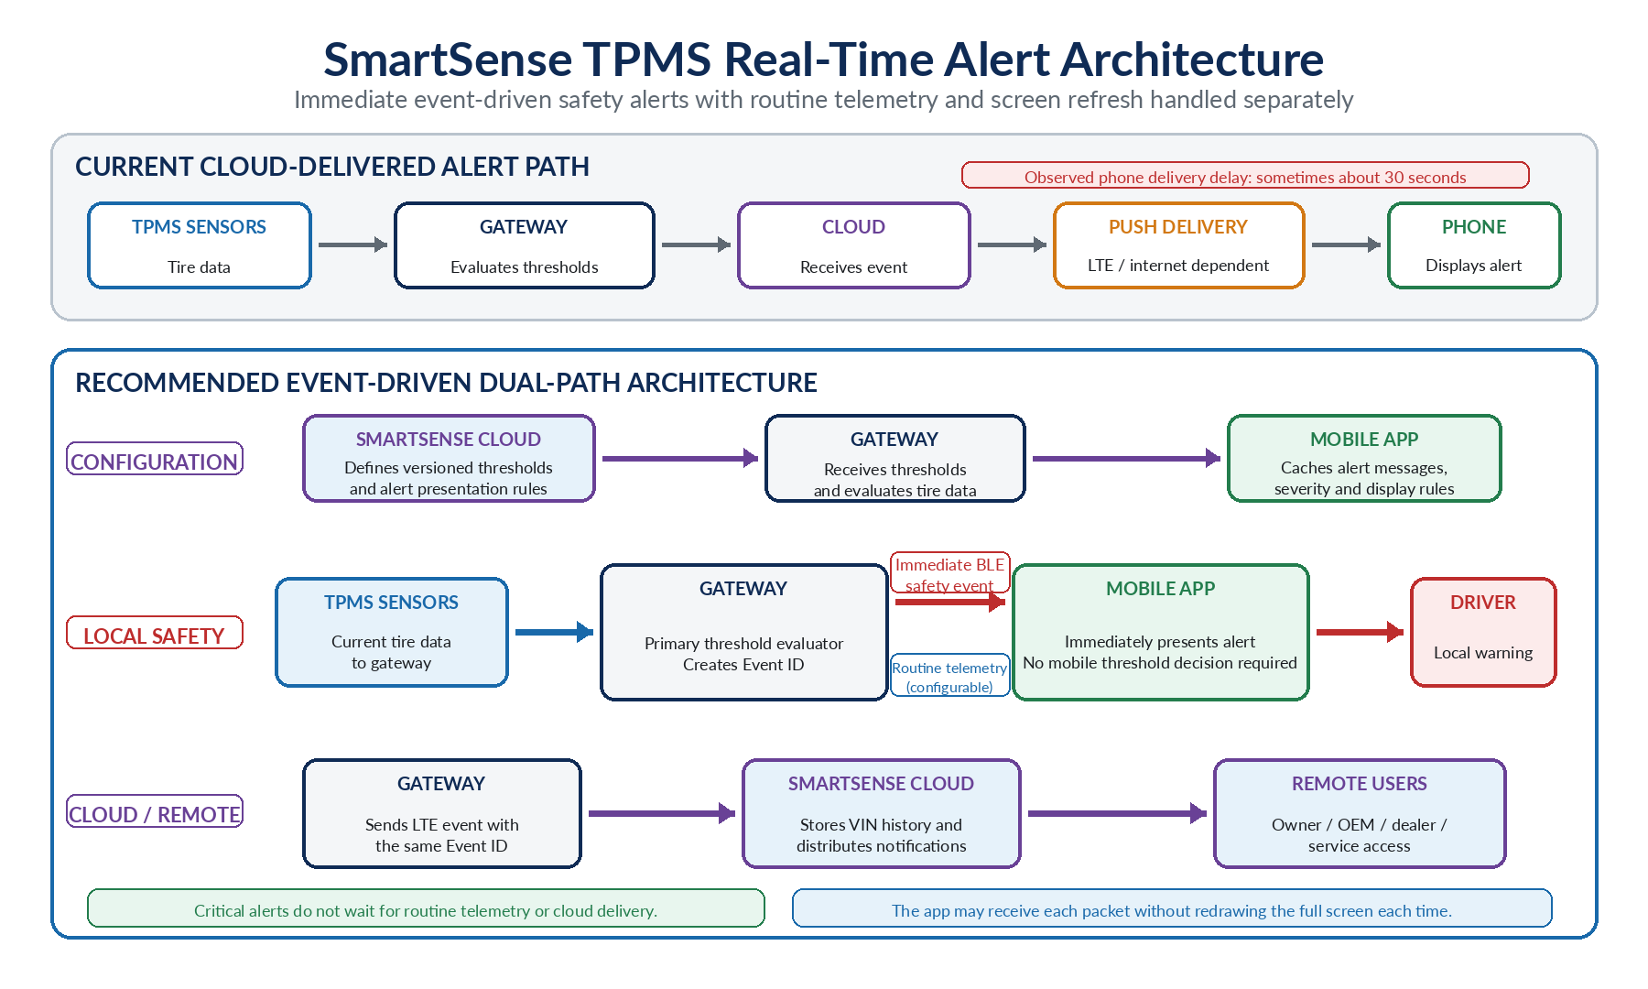
Figure 1. Gateway-primary threshold evaluation, immediate BLE safety-event delivery, configurable routine telemetry and continued cloud reporting.

5. Mobile HMI Operating States
The app must use explicit states so the absence of an alert is never misinterpreted as confirmation that all tires are normal.
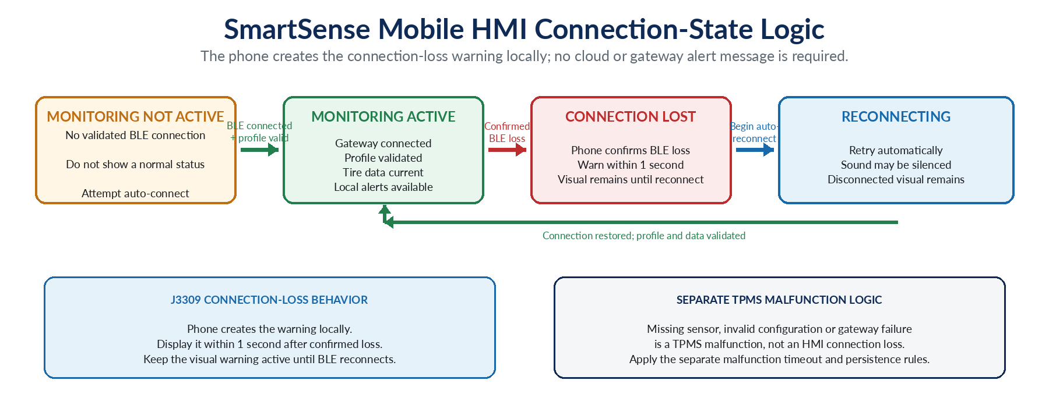
Figure 2. Mobile HMI connection states and local connection-loss behavior.
HMI State | Definition | Required Behavior
Monitoring Not Active | No validated gateway BLE connection is available. | Do not show a normal or protected state. Display that SmartSense local monitoring is not active and attempt connection when appropriate.
Monitoring Active | Gateway connected, active profile validated, and tire data current. | Display monitoring-active status, tire position, pressure and condition. Enable local safety alerts.
Connection Lost | An established BLE connection has been confirmed lost. | Generate the warning locally within one second. Make the visual warning persistent and non-dismissible until reconnection.
Reconnecting | Automatic BLE reconnection is in progress. | Continue showing local monitoring unavailable. Audible warning may be silenced; visual status remains.
Cloud Offline | BLE monitoring remains active but internet/LTE/cloud path is unavailable. | Continue local monitoring. Display cloud-offline status separately from gateway connection state.

6. Required Data Flows

6.1 Configuration Flow
- Alert profiles are defined and approved in the SmartSense cloud platform.
- Each profile receives a unique version and effective timestamp.
- The active profile is synchronized to both the gateway and mobile application.
- The gateway and app expose their active profile version for diagnostics.
- If internet service is unavailable, both continue using the most recently validated profile.
- An invalid, missing or mismatched profile creates a degraded or malfunction state; the app must not claim full monitoring capability.

6.2 Normal Driving Telemetry
- The TPMS sensor transmits pressure, temperature, battery and status information to the gateway according to the sensor operating mode.
- The gateway logs and evaluates every valid reading against the active profile.
- While the HMI connection is active, the gateway may send compact routine BLE GATT telemetry notifications at a configurable rate. Approximately one update per second may be used when a live driving display is desired, but this is not the primary safety-alert path.
- The app receives and processes the routine packets. The visible dashboard refresh rate is controlled separately and may be slower or state-dependent; the app is not required to redraw the complete interface for every packet.
- Critical safety events are delivered through the immediate BLE safety-event stream and do not wait for routine telemetry or the screen-refresh interval.
- Normal cloud reporting continues independently. Scheduled cloud reporting sends only data that changed since the previous report.

6.3 Immediate Local Safety Alert
- The gateway detects a threshold violation or gateway-generated condition.
- The gateway creates or assigns one Event ID and immediately sends a compact BLE safety-event notification.
- The app converts the condition code into the configured title, severity, message, recommended action, sound, vibration and visual presentation.
- The app records the alert locally and displays it without waiting for the cloud.
- The gateway sends the same Event ID through LTE to the cloud for remote notification and history.
- The app suppresses a later cloud push for the same Event ID so the driver does not receive a duplicate alert.

6.4 Phone-Generated Connection-Loss Alert
- The phone continuously monitors the BLE connection state while it is serving as the SmartSense HMI.
- After the app confirms loss of the gateway connection, it generates a local connection-loss warning within one second.
- This warning is generated entirely by the phone and does not rely on gateway, LTE, cloud or push-notification delivery.
- The visual warning remains displayed and cannot be dismissed while the gateway remains disconnected.
- The user may acknowledge or silence the audible warning, but the disconnected visual state remains.
- The app automatically attempts reconnection and clears the connection-loss state only after BLE communication, profile validity and current data have been restored.
- Disconnection and reconnection times are recorded in the local diagnostic log.

7. Gateway Firmware Requirements
Requirement | Specification
Threshold evaluation | Evaluate every valid TPMS reading using the active cloud-synchronized profile. Gateway evaluation remains the primary safety decision.
BLE method | Use connected BLE GATT notifications or indications. The phone must not need one-second read/poll operations.
Telemetry stream | Use a configurable routine telemetry rate based on vehicle state and user-interface needs. Approximately 1 Hz may be used for an active live dashboard, but routine telemetry is not the safety-alert trigger and must not delay immediate events.
Safety-event stream | Send immediately when an event opens, materially changes or clears. Do not wait for routine telemetry or the cloud interval.
Event identity | Use one Event ID or deterministic event key for both the BLE event and LTE/cloud event.
Offline operation | Continue sensor monitoring, threshold evaluation and BLE event delivery without cellular service. Buffer LTE events until service returns.
Diagnostics | Include sequence information, active profile version and data-integrity fields sufficient to detect stale, missing, repeated or corrupted data.
Malfunction generation | Generate missing-sensor, sensor-offline, configuration and gateway-processing malfunction conditions under the canonical rules.
Capacity | Support at least 12 simultaneously installed trailer tires and unique tire-position assignment.
Independent monitoring | Continue gateway monitoring and cloud reporting whether or not a phone is connected.

7.1 Recommended BLE Logical Streams
Logical Stream | Purpose | Timing | Required Information
TPMS Telemetry Characteristic | Routine live tire data | Configurable while connected; approximately 1 Hz may be used for a live dashboard. The app may refresh the visible UI at a different rate. | Sensor ID, tire position, pressure, temperature, battery/status, sequence, profile version or diagnostic reference, integrity check.
TPMS Safety Event Characteristic | Immediate event delivery | Immediately on event open, material update or clear. | Event ID, tire position, condition code, event state, current value, timestamp/sequence, profile version, integrity check.

Exact UUIDs, packet sizes and byte offsets remain proposed until the hardware and mobile teams jointly confirm gateway capabilities and device compatibility.

8. Mobile Application Requirements
Requirement | Specification
HMI startup | Attempt gateway connection and validate the current alert profile. Do not display Monitoring Active until the required checks pass.
BLE subscriptions | Subscribe to telemetry and safety-event streams and maintain platform-supported reconnection behavior.
Local alert rendering | Create the complete local alert from the gateway condition code plus the locally cached profile.
Connection-loss warning | Detect established BLE connection loss locally; display a persistent warning within one second; clear only after validated reconnection.
Routine telemetry handling | Receive and validate each BLE telemetry notification without requiring a full UI redraw for every packet. Update the visible tire display at a configurable rate based on foreground/background state, motion and alert status.
Optional threshold cross-check | A mobile telemetry cross-check may be implemented for diagnostics or fallback using the same profile version as the gateway. It is not required for the normal safety path and must not conflict with the gateway-generated event state.
HMI content | Show tire position, current pressure and status. Clearly distinguish low/high pressure, rapid loss, temperature, battery and malfunction conditions.
Alert persistence | Acknowledgement does not clear the underlying condition. Apply the canonical open, update and clear rules.
Deduplication | Merge BLE and cloud notifications using the same Event ID or event key.
Local diagnostics | Record BLE receipt time, alert display time, connection state, profile version, acknowledgement and relevant telemetry.
Cloud independence | Local alert generation and connection-loss warning must continue without internet service.
State honesty | Never indicate monitoring is active when BLE is disconnected, required data is stale, or the alert profile is invalid.

9. J3309 Alert and HMI Logic Requirements

9.1 Startup and Active Monitoring
- On startup or activation, perform a system check covering gateway communication, configured tire positions, sensor availability, active profile and local alert capability.
- Display a clear Monitoring Active state only when the required local HMI functions are available.
- Display Monitoring Not Active or Monitoring Degraded when required functions are unavailable.

9.2 Low- and High-Pressure Warnings
- Provide driver warnings while the TPMS is powered and the trailer is quasi-stationary or moving.
- Low-pressure delta must not exceed 20% of the Specified Service Pressure (SSP).
- The warning must activate at or before the applicable low-pressure threshold or Minimum Activation Pressure (MAP), whichever requires earlier warning.
- The complete calculation must account for measurement tolerance and the selected temperature-compensation method.

9.3 Alert Clearing
- Acknowledgement may silence or record user awareness but does not clear the condition.
- A low-pressure warning remains active until the tire reaches the required recovery pressure under the approved Operational Service Pressure (OSP) and temperature logic.
- Hysteresis, debounce, persistence and clear criteria must be defined in one canonical rule specification used by the gateway and cloud. If an optional mobile cross-check is implemented, it must use the same approved rules and profile version.

9.4 Malfunction and Connection Loss
- Phone-to-gateway BLE connection loss is an HMI connection condition and must be displayed within one second after confirmation.
- A missing tire sensor, invalid sensor, computational failure, incompatible configuration or other inability to monitor is a TPMS system malfunction and is separate from HMI connection loss.
- A malfunction warning must be generated no later than 20 minutes after the system loses its required monitoring capability; SmartSense may use shorter timeouts.

10. Canonical Alert Conditions
Condition | High-Level Definition
Low Pressure | Pressure below the configured threshold/MAP logic.
High Pressure | Pressure above the configured maximum.
Rapid Pressure Loss | Pressure-loss rate exceeds the approved rate and time window.
High Tire Temperature | Temperature above the configured maximum.
Low Tire Temperature | Temperature below the configured minimum, when enabled.
Low Sensor Battery | Sensor battery condition below configured limit or status flag.
Missing Sensor | An assigned sensor is not detected under the defined assignment and operating rules.
Sensor Offline | No valid communication within the configured timeout.
Gateway Connection Lost | Phone has confirmed loss of its established BLE HMI connection to the gateway.
Configuration Invalid | Required SSP, tire assignment or alert profile is missing, stale, corrupt or incompatible.

For every condition, the canonical rule specification must define threshold, unit, severity, message, recommended action, debounce/persistence, hysteresis, open/update/clear behavior, timeout and acknowledgement behavior.

11. Latency and Performance Requirements
Measurement | Target / Definition
Gateway detection to BLE safety-event transmission | Target <= 250 ms.
BLE safety-event receipt to local alert presentation | Target <= 250 ms.
Gateway detection to local phone alert | Target <= 500 ms under an established and supported HMI connection.
Confirmed BLE connection loss to visible warning | <= 1 second.
Routine dashboard data freshness | Configurable product/UI target. Approximately 1 to 2 seconds may be used while the live tire screen is visible; this is not a safety-alert latency requirement.
System malfunction warning | No later than 20 minutes after loss of required monitoring capability; shorter SmartSense limits may apply.
Physical tire event to phone alert | Measure separately by sensor operating mode, including sensor detection and sensor-to-gateway transmission time.
Optional telemetry cross-check | If implemented, evaluate received telemetry without delaying gateway event presentation. Do not represent this optional fallback as the guaranteed sub-500 ms safety path.

Do not claim sub-500 ms from the physical tire event unless the full sensor-to-gateway-to-phone path has been tested for the applicable TPMS operating mode.

12. Cloud and Backend Requirements
Requirement | Specification
Profile service | Maintain versioned profiles by OEM, model, VIN, tire specification or other authorized level.
Profile content | Include SSP, pressure/temperature thresholds, temperature compensation, hysteresis, debounce, clear logic, severity, messages, malfunction timeouts and event codes.
Synchronization | Deliver the approved profile to gateway and app and retain a complete audit history.
Event ingestion | Preserve the gateway Event ID/event key through cloud storage and notification.
Deduplication | Include the same event identity in push payloads so a phone that already presented the BLE alert suppresses a duplicate.
Historical record | Store event, readings, tire position, profile version, timestamps, acknowledgement, resolution and connection state under the VIN.
SSP administration | Allow authorized users to enter or adjust SSP values and audit all changes.

13. Application State, Background Operation and Power
Design objective. The mobile app should use platform-supported BLE background mechanisms so it can continue receiving gateway notifications and create a local connection-loss warning when the phone is locked or the app is backgrounded. Actual behavior must be validated separately on the approved iOS and Android device/OS matrix.
- Use event-driven BLE notifications rather than one-second polling reads.
- Receiving compact BLE data every second does not require redrawing the full screen every second. Decouple BLE receipt, data processing, database writes and visible UI refresh.
- Use automatic reconnection and platform-supported background BLE services.
- Do not claim monitoring is active if the operating system has suspended the required BLE or alert process.
- Make screen keep-awake optional and limited to user-selected Driving Mode.
- Reduce UI rendering and high-frequency processing when the screen is off while preserving required alert handling.
- Measure battery impact over 4-, 8- and 12-hour driving sessions, with screen on/off and vehicle power connected/disconnected.
- Owner instructions must explain that the phone/app must be available, paired and connected for the phone to serve as the HMI.
A local connection-loss alert can only occur after an HMI connection has been established. It does not solve a phone that is absent, powered off, never paired, or an app that was never started. The UI and owner instructions must make this operating dependency unmistakable.

14. Developer Task Matrix
Team | Required Deliverable | Acceptance Outcome
Gateway Firmware | Confirm BLE capability; implement configurable routine telemetry and immediate safety-event notifications; preserve gateway threshold evaluation; generate event identity; support diagnostics and LTE path. | Demonstrate immediate event delivery independent of routine telemetry, approved configurable telemetry rates, 12-tire support, offline BLE operation, LTE buffering and event identity consistency.
Mobile iOS / Android | Implement HMI states, BLE subscriptions, local alert renderer, connection-loss detection, persistent warning, profile cache, decoupled data/UI refresh, reconnection, deduplication and local logs. Optional threshold cross-check may be added for diagnostics. | Show immediate local safety alerts independent of routine refresh; show connection-loss warning within one second; prevent clearing until reconnection; demonstrate that UI rendering is decoupled from BLE packet receipt; suppress duplicate cloud push.
Cloud / Backend | Implement versioned J3309-aware profiles, SSP administration, event identity preservation, remote notification and VIN history. | Gateway/app profile versions match; cloud preserves event identity; audit trail includes SSP and profile changes.
QA / Systems | Build end-to-end tests across sensor, gateway, BLE, phone, LTE and cloud, including J3309 bench/vehicle conditions. | Produce latency, packet-loss, reconnection, persistence, accuracy, battery and J3309 traceability evidence.
Product / Compliance | Define approved HMI operating assumptions, owner instructions and conformance evidence package. | No unsupported certification claims; approved system description and evidence are available for OEM/RVIA review.

15. Acceptance Criteria
- The app displays Monitoring Active only after BLE connection, active profile and current tire data are validated.
- The gateway evaluates TPMS data against the correct approved profile without cellular service.
- The phone receives and validates routine telemetry through BLE notifications at the approved configurable rate.
- The app can receive each routine packet without redrawing the complete user interface for every packet.
- Critical safety events are displayed immediately and are not delayed by the routine telemetry or visible screen-refresh interval.
- A gateway-detected safety event is displayed locally within 500 ms under the defined connected test conditions.
- The local alert contains the correct tire position, pressure/status, severity, message and recommended action.
- The phone locally creates a connection-loss warning within one second after confirmed BLE disconnection.
- The visual connection-loss warning cannot be cleared until validated reconnection; audible warning may be silenced.
- The app never shows local monitoring as active while disconnected, stale or invalid.
- The gateway sends the same event identity through BLE and LTE, and the phone suppresses the duplicate cloud push.
- If the optional mobile telemetry cross-check is implemented, the app logs any discrepancy between telemetry and the gateway event stream without delaying or overriding the gateway-generated alert state.
- A missing or offline tire sensor produces a separate TPMS malfunction warning under the approved timeout logic.
- Low-pressure activation and clearing follow approved SSP, MAP, OSP, temperature-compensation and persistence rules.
- The system supports at least 12 installed trailer tires and a single sensor failure does not disable other positions.
- End-to-end pressure and temperature accuracy meet the approved J3309 limits across the operating range.
- Battery, reconnection and background behavior are measured on the approved iOS and Android device/OS matrix.

16. J3309 Requirements Traceability
J3309 Section | Requirement | SmartSense Implementation | Verification
5.1.1 | Startup system check and active indication | HMI startup validation and Monitoring Active/Not Active states | Mobile + Gateway functional test
5.1.2 | Low/high pressure warning while powered | Gateway threshold evaluation plus immediate BLE local alert | Bench and vehicle pressure tests
5.1.3 | Self-diagnostic / malfunction warning | Missing sensor, invalid configuration and processing-failure logic | System malfunction vehicle test
5.1.4 | Minimum 12 tires | Gateway/app/cloud data model supports 12 installed tires | Capacity and all-position test
5.1.12 | Field-adjustable SSP | Authorized cloud configuration and audit trail | Configuration and synchronization test
5.1.13-14 | Pressure and temperature accuracy | End-to-end measurement/display accuracy requirement | Environmental accuracy test
6.1.1 | Tire location, pressure and status on HMI | Mobile tire-position display and state/status UI | Day/night HMI inspection
6.1.3-5 | Warning activation and persistence | SSP/MAP/OSP logic; acknowledgement does not clear condition | Pressure reduction and recovery tests
6.1.6 | Malfunction no later than 20 minutes | Canonical malfunction timers | Communication-failure test
6.1.7 | Connection-loss message within 1 second and persistent | Phone-generated non-dismissible disconnected state | BLE disconnect/reconnect test
6.3.1 | Owner instructions | OEM-specific app/HMI and operating-dependency instructions | Documentation review
7.1-7.4 | System test procedures | Bench/vehicle pressure, temperature, signal and malfunction test plans | Formal test reports

17. Required Engineering Confirmations
- Can the gateway support simultaneous LTE reporting, configurable routine BLE telemetry and immediate BLE safety notifications at the required rates?
- Can the gateway send an immediate event notification independent of any routine telemetry cycle?
- What BLE MTU, payload and connection parameters are supported across the target device matrix?
- Can one event identity be retained through BLE, LTE buffering, cloud ingestion and push delivery?
- How will profile version, stale data and configuration failure be represented?
- What gateway-side conditions are already implemented for low/high pressure, rapid loss, temperature, battery, missing sensor and offline sensor?
- What are the measured sensor-to-gateway latencies in Roll Alert, Roll and DeltaP modes?
- Which iOS and Android background BLE mechanisms will be used, and under which app/phone states can local alerts be guaranteed?
- What owner/OEM instructions will define the phone availability and connection requirements for use as the HMI?
- Which independent laboratory or internal test process will produce the J3309 conformity evidence package?

18. Final Architecture Decision
Proceed with the gateway-primary, event-driven dual-path architecture. The gateway evaluates all TPMS data and sends immediate compact BLE safety events to the phone while continuing LTE/cloud reporting. Routine BLE telemetry is configurable and supports the live display, but it is not the critical-alert trigger. The phone receives and processes telemetry independently from its visible UI refresh, renders the full gateway-generated alert immediately, and creates a persistent connection-loss warning within one second after confirmed BLE loss. An optional mobile threshold cross-check may be used for diagnostics or fallback.

Source basis: SmartSense TPMS architecture discussions, the SmartSense Real-Time TPMS Edge Evaluation specification, and SAE J3309 OCT2024. SAE section references are paraphrased for implementation planning; teams should consult the controlled SAE document during formal conformity review.

