Annex 4 – OTA Update Procedures (Normative)
This document defines the complete Over-the-Air (OTA) firmware update procedures for the SmartSense™ Pro Gateway main controller. The procedure is aligned with the LwM2M Firmware Update state machine and applies to both Cloud (LTE) and BLE updates.
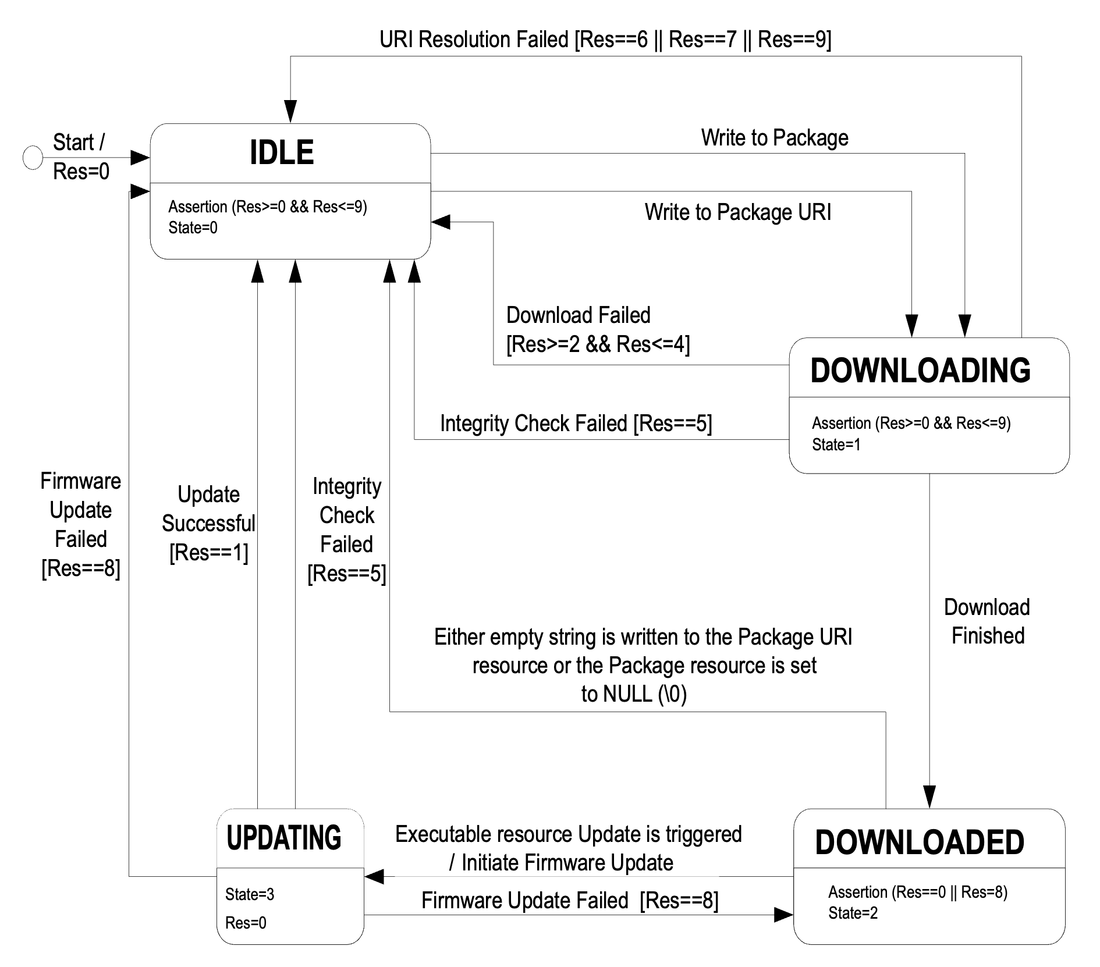
*Source OMA-Lightweight machine to machine technical specification

1. Firmware Update State & Result Model
OTA uses the following characteristics:
• State – Characteristic 53
• Result – Characteristic 54

1.1 Firmware Update State (53)
- 0 – Idle
- 1 – Downloading
- 2 – Downloaded
- 3 – Updating
- 4 – Error

1.2 Firmware Update Result (54)
- 0 – Initial / No result
- 1 – Success
- 2 – Not enough storage
- 3 – Out of memory
- 4 – Connection lost / Timeout
- 5 – Integrity check failed
- 6 – Unsupported / invalid image
- 7 – Update failed

2. Cloud OTA (LTE)
Cloud OTA is controlled via MQTT commands and HTTP GET image download.

2.1 Control Characteristics
51 – Firmware Package URL (*SET,51,{string})
55 – Download Trigger (*SET,55)
52 – Apply Update Trigger (*SET,52)

2.2 Image Size Discovery
The device SHALL determine the firmware image size by performing:
GET <Firmware Package URL>
The response SHALL be a plain integer representing image size in bytes.

2.3 Chunk Download
Firmware chunks SHALL be downloaded using:
GET <URL>/<chunk_size>/<n>
Where n is the chunk index starting from 0.

2.4 Download Procedure
- Server writes URL to characteristic 51 and receives MQTT ACK.
- Server issues SET,55 command.
- Device sets State=Downloading (53=1).
- Device downloads chunks sequentially.
- On success, device sets State=Downloaded (53=2).
- On failure, device sets State=Error (53=4) and Result (54).

2.5 Apply Update
Upon SET,52, the device applies the firmware, reboots, and reports Success or Failure via State (53) and Result (54).

3. BLE OTA
BLE OTA uses the same state machine with binary upload over BLE.

3.1 Flow Control
Firmware size (3 bytes), Packet size (2 bytes), Packet ID (2 bytes), Upload result (1 byte).

3.2 Binary Payload
Message ID (2 bytes), Binary data (x bytes), CRC-8 Maxim/Dallas (1 byte).

3.3 BLE OTA Procedure
- App writes flow control parameters.
- Device sets State=Downloading.
- App uploads binary packets sequentially.
- Device validates CRC and stores packets.
- Device verifies image and sets State=Downloaded or Error.
- Apply update follows Cloud OTA logic.

4. Command Acknowledgement
Every server-issued OTA command SHALL be acknowledged via MQTT uplink on topic ss/u/{IMEI}, including State (53), Result (54), and timestamp (257).

5. Common Rules
- OTA SHALL not erase buffered telemetry.
- Rollback is mandatory.
- Device SHALL remain operational on failure.
- State and Result SHALL always be readable.

