**Assignment #2. CSS Styling (Colors, Fonts,**

Layout)

Gaziza Bakir

SE-2439

[**https://gazizkaa.github.io/My-second-webpage/**](https://gazizkaa.github.io/My-second-webpage/)

# Task 1. Simple webpage layout (using <div> + positioning / floats — **no** Flexbox or Grid)

For this task, I created a basic webpage using only <div> and CSS positioning.

Added a header with the title.

Created a navigation bar with 4 links.

On the left side, I made a sidebar menu with 3 items.

On the right side, I placed the main content section with a heading and paragraph.

At the bottom, I added a footer.

CSS styling I used: background colors for each part, hover effects for links, float for sidebar/content, padding, margins, and borders.

# Task 2. Tribute page (Create a **tribute page** for a famous person of your choice.)

I made a tribute page for [Person’s Name].

Added headings and a short paragraph about their life.

Used ordered and unordered lists for events and contributions.

Added an image and some links, including a "Learn More" button.

For styling, I used Google Fonts, background color, text colors, and styled the image with border-radius and shadow.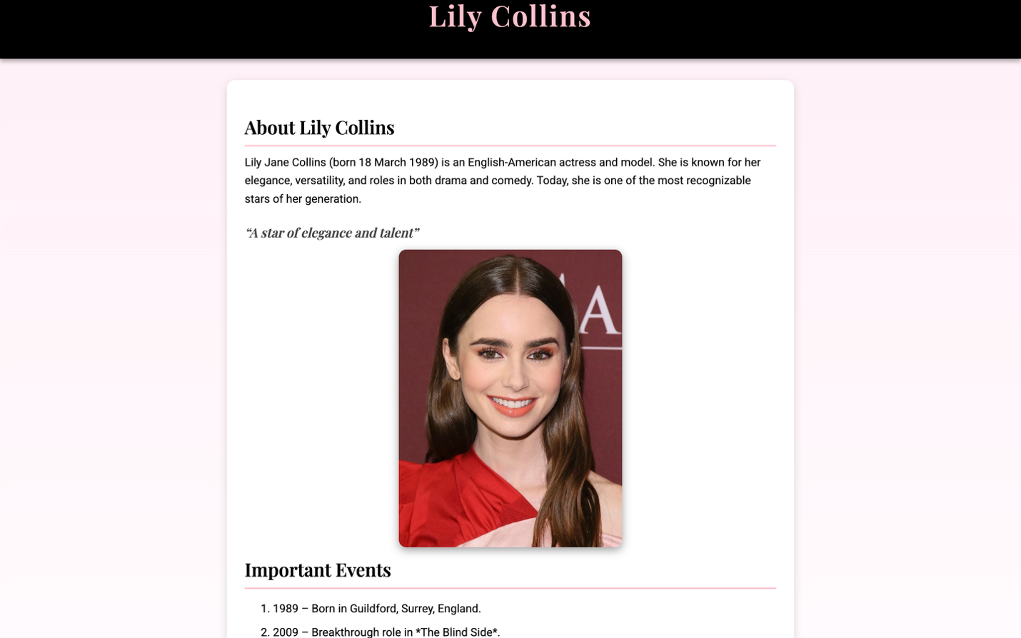

# Task 3.CSS Table and FORM

I created a table with student grades (Name, Subject, Grade).

Styled with borders, padding, alternate row colors, and a highlight row.

Centered the text and gave the header a background color. I made a feedback form with inputs for name, email, role, radio buttons, textarea, and submit button.

Styled it with background color, padding, rounded corners, and hover effect for the button.

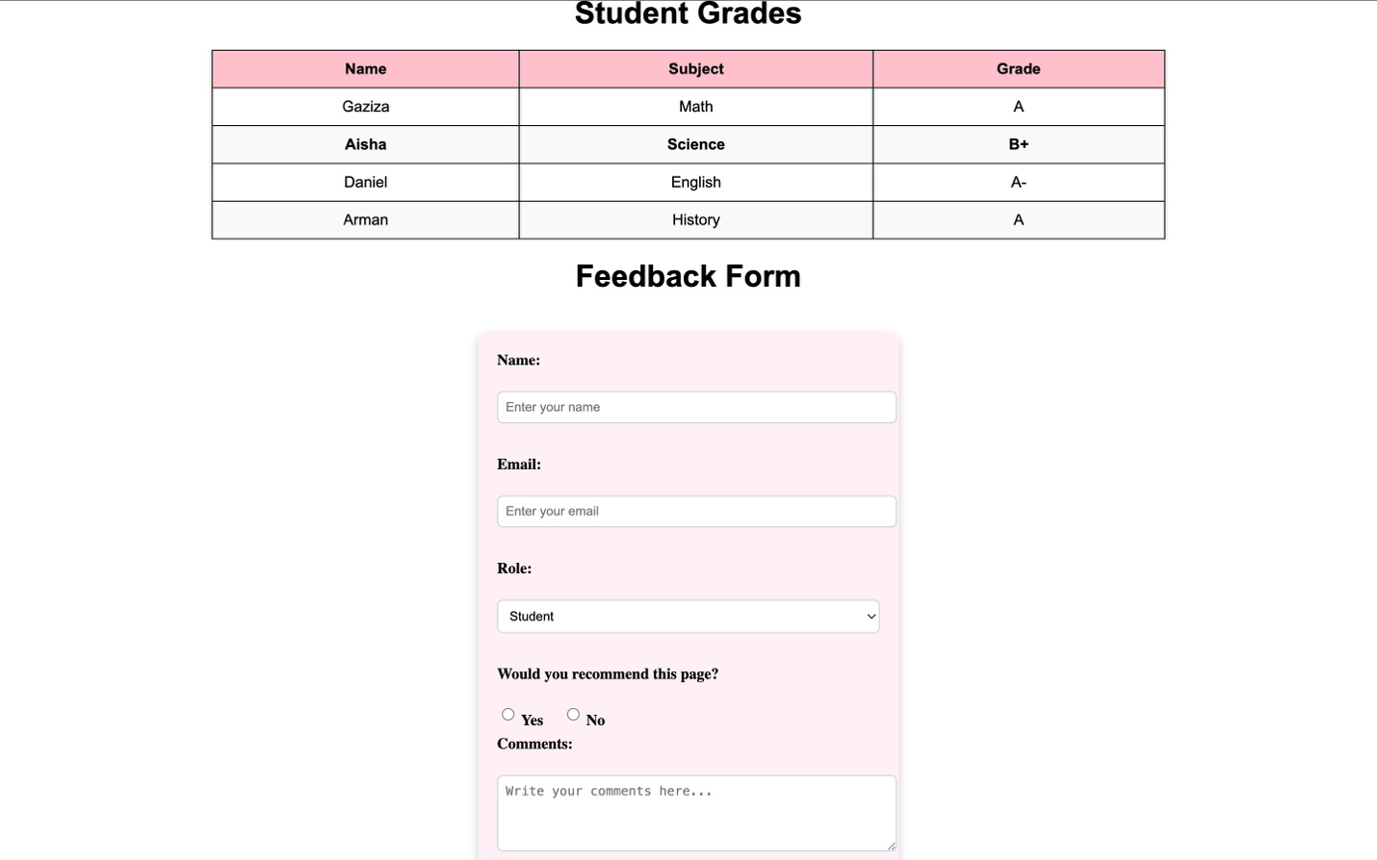

## Task 4. Midterm Project: Topic & Wireframe Design

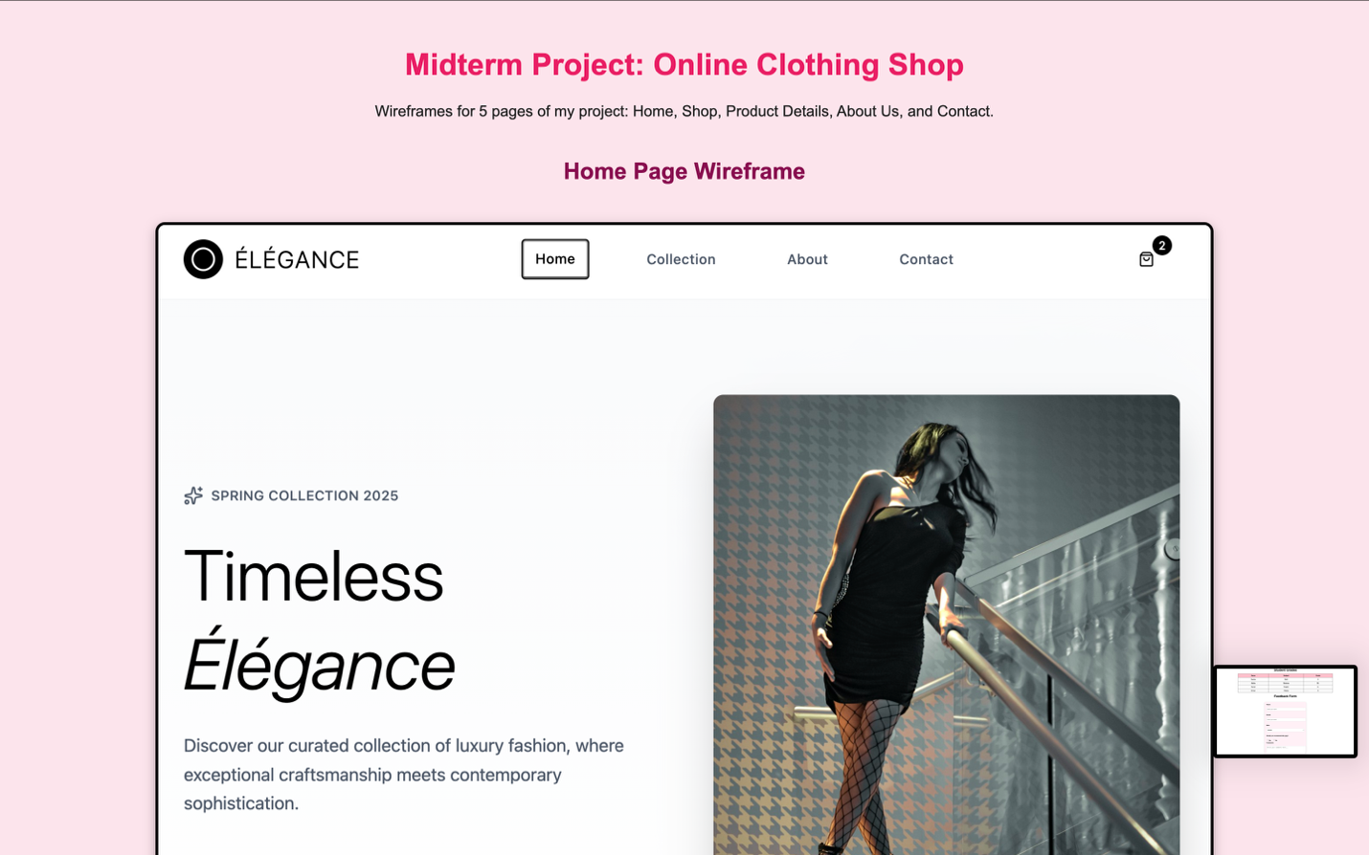

For my midterm project, I chose the topic: Online Clothing Shop

The website will have 5 pages with consistent header, footer, and navbar.

I created wireframes for each page showing layout (header, content, footer).

The goal is to make a simple and user-friendly site for girls.